🎍 New Year's Day in Japan (Shogatsu) Worksheet
Shogatsu: A Visit from the New Year God
Read the story. 英文を読もう。
Class ______ No. ____ Name ______________________________

🔊 音声を聞こう（スマホで読みとってね）
1 On January 1, the busy cities of Japan become very quiet. Government offices close from December 29 to January 3, and many families stay home together. This is Shogatsu, the Japanese New Year. For most people, it is the biggest holiday of the year.
2 Long ago, people believed that a god of the new year visited every home. To welcome this god, families put pine and bamboo decorations by the door. These decorations are called kadomatsu, and they help the god find the house. Families also make kagami mochi, two round rice cakes, one on top of the other.
3 On New Year's morning, some people get up early to see the first sunrise. Some climb mountains, and some walk to the beach in the cold. Then families eat osechi, special food in beautiful boxes. Each food has a wish. Black beans are for good health, and shrimp are for a long life. People also eat ozoni, a soup with mochi, but the recipe changes from region to region.
4 Many people send New Year cards called nengajo. The post office keeps the cards and delivers them all on January 1. Children love this day for another reason. Adults give them otoshidama, money in small and colorful envelopes.
5 Before 1873, Japan used a moon calendar, and New Year came in late January or February. That is why many cards still say 'New Spring' in the middle of winter. So if a Japanese friend says 'Akemashite omedeto,' just smile and say it back. It means 'Happy New Year!'
Words 単語
decoration（飾り） / pine（松） / believe（信じる） / welcome（迎える、歓迎する） / sunrise（日の出） / wish（願い） / region（地域、地方） / deliver（配達する、届ける） / envelope（封筒） / calendar（暦、カレンダー） / tradition（伝統、しきたり） / celebrate（祝う）

🎍 New Year's Day in Japan (Shogatsu) Worksheet
Reading Check
Choose the best answer. 正しいものを選ぼう。
Class ______ No. ____ Name ______________________________
1. What is the main idea of the reading?
(A) Japanese cities are very busy in winter. (B) Shogatsu is a big holiday with old customs and special food. (C) Children in Japan do not like New Year. (D) Japan still uses a moon calendar today.
2. When do government offices close for New Year?
(A) From December 25 to January 1 (B) Only on January 1 (C) From December 29 to January 3 (D) From January 1 to January 7
3. Why do families put kadomatsu by the door?
(A) To help the New Year god find the house (B) To keep the house warm (C) To tell the post office to come (D) To make the door stronger
4. What is the wish of the shrimp in osechi?
(A) Good health (B) A lot of money (C) A long life (D) Good grades
5. In paragraph 3, 'the recipe changes from region to region' means:
(A) Ozoni is the same all over Japan. (B) People make ozoni in different ways in different places. (C) Ozoni is only eaten in big cities. (D) The recipe is a secret.
6. Which is true about nengajo?
(A) People send them in February. (B) Only children send them. (C) They are a kind of soup. (D) They arrive together on January 1.
7. Why do New Year cards say 'New Spring' in winter?
(A) Because spring comes early in Japan (B) Because New Year used to be closer to spring (C) Because the cards are sent in April (D) Because spring is the coldest season
8. In the dialogue, what kind of mochi does Kenta's grandma use?
(A) Round mochi (B) Square mochi (C) Sweet bean mochi (D) She doesn't use mochi.
True or False? T か F に○
1. In Japan, January 1 is a national holiday. T / F
2. Kadomatsu is a kind of soup. T / F
3. Osechi is special food in beautiful boxes. T / F
4. Ozoni is the same in every part of Japan. T / F
5. Children get otoshidama from adults. T / F
6. Japan has used the same calendar since 1600. T / F

🎍 New Year's Day in Japan (Shogatsu) Worksheet
Word Work
単語のれんしゅう
Class ______ No. ____ Name ______________________________
① Match the pictures and the words. 絵と単語を線でむすぼう。
🌅 | ● | ● | soup
🍱 | ● | ● | lunch box
🦐 | ● | ● | sunrise
✉️ | ● | ● | kadomatsu
🪁 | ● | ● | party
🎍 | ● | ● | kite
🍲 | ● | ● | envelope
🎉 | ● | ● | shrimp
② Unscramble the words. 並べかえて単語にしよう。
1. N R S S U E I (日の出) → ____________________
2. P V N E L O E E (封筒) → ____________________
3. E P I N (松) → ____________________
4. H S W I (願い) → ____________________
5. R N I O E G (地域) → ____________________
6. A A C D N L E R (暦) → ____________________
③ Fill in the blanks. 語群から選んで入れよう。
[ pizza / envelope / money / card / Year / snowman / beans / sun / January / boxes / mochi / cold / summer ]
On (1) __________ 1, Yuna got up at five. It was dark and very (2) __________ . She walked to the beach with her dad. Many people were waiting. At last, the (3) __________ came up over the sea. Everyone said, "Happy New (4) __________ !" At home, her mom opened the (5) __________ of osechi. Yuna ate black (6) __________ for good health. Then she ate ozoni with two pieces of (7) __________ . After lunch, her grandpa gave her a small (8) __________ . There was (9) __________ inside! Yuna wrote a (10) __________ to her best friend.

🎍 New Year's Day in Japan (Shogatsu) Worksheet
Crossword Puzzle
ヒントを読んでクロスワードを完成させよう。
Class ______ No. ____ Name ______________________________
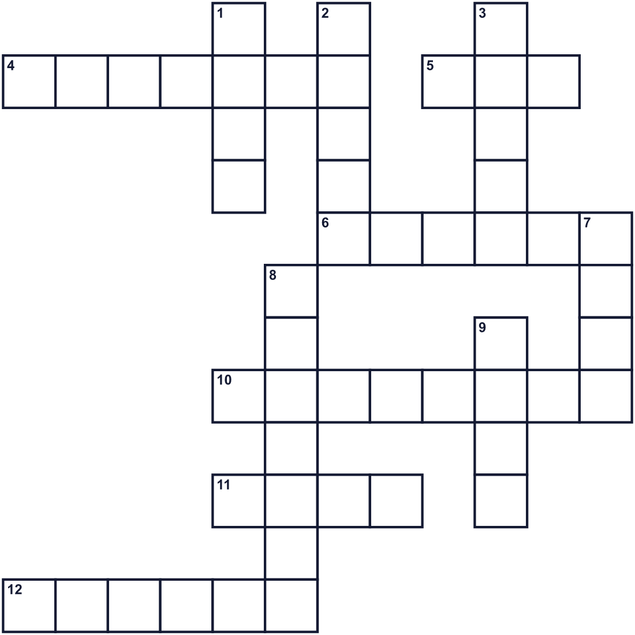
Across →
4. The time when the sun comes up in the morning. (7)
5. People believed this kind of spirit visited every home at New Year. (3)
6. A small sea animal. In osechi, it means a long life. (6)
10. You put a letter or money in this paper case. (8)
11. People send this to friends to say Happy New Year. (4)
12. Your mother, father, brothers, and sisters. (6)
Down ↓
1. A toy that flies high in the wind on a long string. (4)
2. Black ones in osechi are for good health. (5)
3. A soft and sticky Japanese rice cake. (5)
7. A tree with needles. It is green in winter too. (4)
8. The first month of the year. (7)
9. A hot dish you eat with a spoon. Ozoni is one. (4)

🎍 New Year's Day in Japan (Shogatsu) Worksheet
Word Search
かくれた単語をさがそう（→ ↓ ↘ ↗）
Class ______ No. ____ Name ______________________________
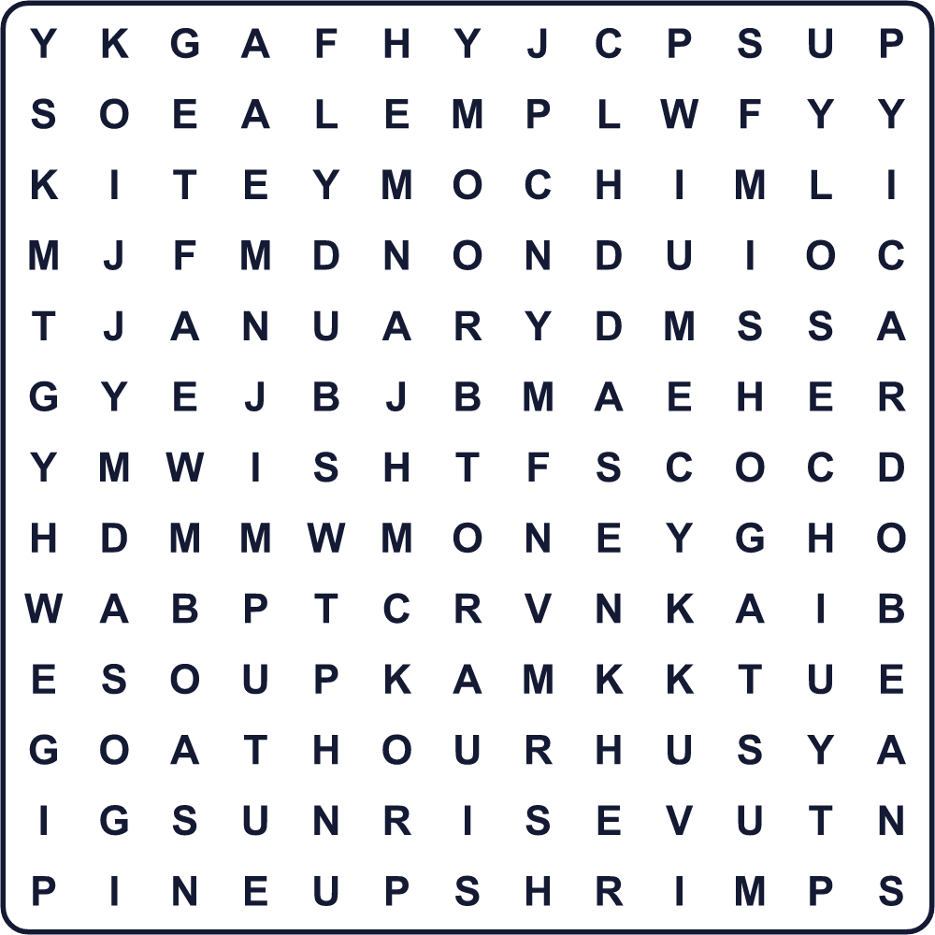
BEANS CARD FAMILY JANUARY KITE MOCHI MONEY OSECHI PINE SHOGATSU SHRIMP SOUP SUNRISE WISH
Secret Code 暗号を解こう
⚓=A ♣=E ♪=H ☎=N ✎=P ◆=R ♠=W ☀=Y
♪ ⚓ ✎ ✎ ☀ ☎ ♣ ♠ ☀ ♣ ⚓ ◆
______________________________________________________________

🎍 New Year's Day in Japan (Shogatsu) Worksheet
Maze & Sentences
Class ______ No. ____ Name ______________________________
Help the New Year god find the kadomatsu! 年神さまを門松まで連れていこう！
正しい道の文字を集めると、ひみつの言葉になるよ。 START ☁️ → GOAL 🎍
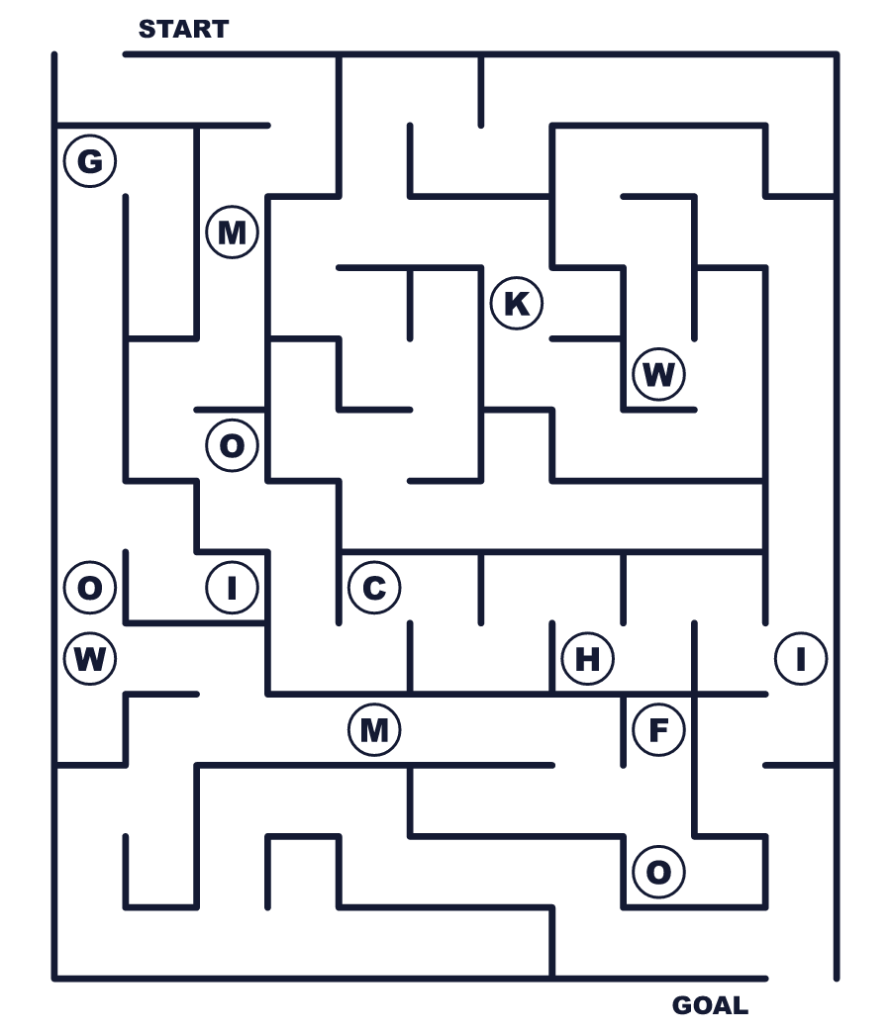
Secret word: ＿ ＿ ＿ ＿ ＿
Put the words in order. 並べかえよう。
1. Shogatsu / the / holiday / in / is / biggest / Japan . (お正月は日本でいちばん大きな休日です。)
______________________________________________________________
2. Year's / We / osechi / New / eat / on / Day . (私たちは元日におせちを食べます。)
______________________________________________________________
3. Each / a / in / wish / food / has / osechi . (おせちの料理にはそれぞれ願いがあります。)
______________________________________________________________
4. envelopes / get / in / Children / small / money . (子どもたちは小さな封筒に入ったお金をもらいます。)
______________________________________________________________
5. sunrise / first / the / watch / people / Many . (多くの人が初日の出を見ます。)
______________________________________________________________

🎍 New Year's Day in Japan (Shogatsu) Worksheet
Class Activity & Writing
Class ______ No. ____ Name ______________________________
Find Someone Who… クラスで聞いて回ろう！
Find someone who … | Name
… has seen the first sunrise of the year 初日の出を見たことがある
… likes black beans 黒豆が好き
… can name three osechi foods in English おせちの料理を英語で3つ言える
… has flown a kite at New Year お正月にたこあげをしたことがある
… knows how to make ozoni お雑煮の作り方を知っている
… has sent a New Year card to a friend 友だちに年賀状を送ったことがある
… likes square mochi more than round mochi 丸もちより角もちが好き
… knows what kadomatsu is for 門松が何のためにあるか知っている
Let's Write! 英語で書いてみよう。
On January 1, my family usually ______.
1月1日、私の家族はたいてい＿＿します。
______________________________________________________________
______________________________________________________________
My New Year wish is ______ because ______.
私の新年の願いは＿＿です。なぜなら＿＿だからです。
______________________________________________________________
______________________________________________________________
If I explain Shogatsu to a friend from abroad, I will say ______.
海外の友だちにお正月を説明するなら、＿＿と言います。
______________________________________________________________
______________________________________________________________

🎍 New Year's Day in Japan (Shogatsu) Worksheet
Trace & Color
なぞって書こう。絵に色をぬろう。
Class ______ No. ____ Name ______________________________
🌅 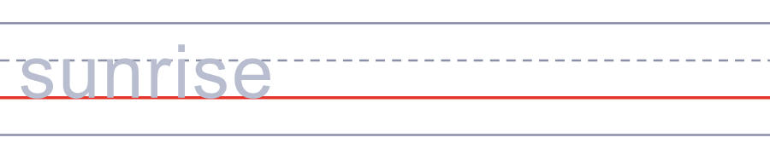

🍱 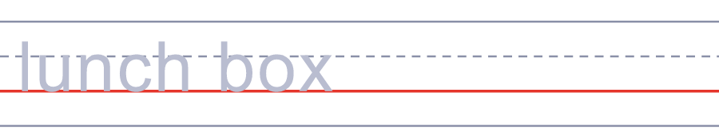
🦐 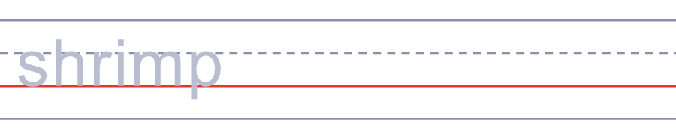
✉️ 
🪁 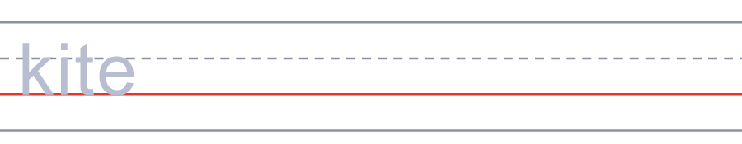
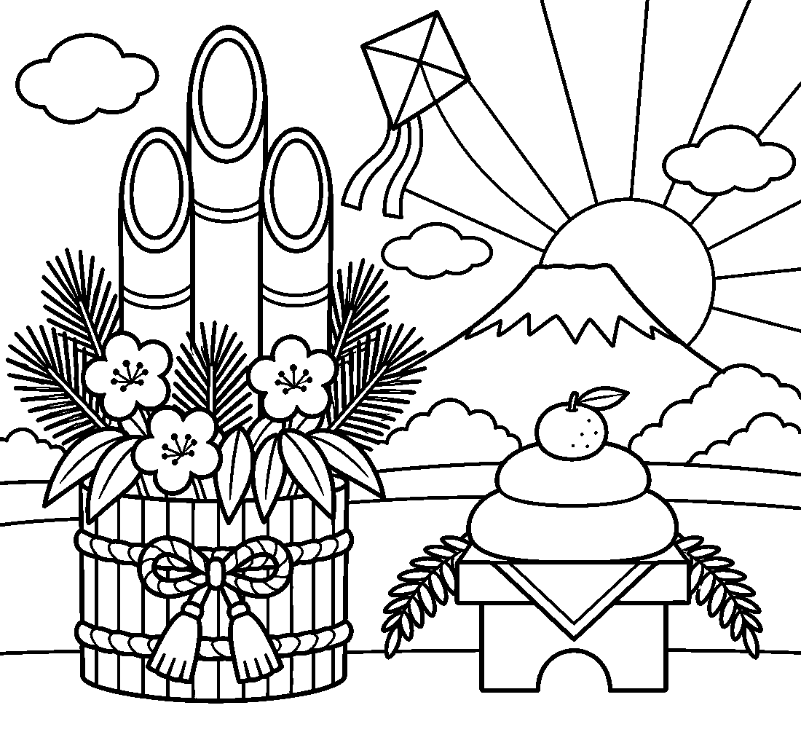

🎍 New Year's Day in Japan (Shogatsu) Worksheet
Answer Key 解答
Reading Check: 1.B 2.C 3.A 4.C 5.B 6.D 7.B 8.A
True or False: 1.T 2.F 3.T 4.F 5.T 6.F
Match: 🌅=sunrise 🍱=lunch box 🦐=shrimp ✉️=envelope 🪁=kite 🎍=kadomatsu 🍲=soup 🎉=party
Unscramble: 1.SUNRISE 2.ENVELOPE 3.PINE 4.WISH 5.REGION 6.CALENDAR
Fill in the blanks: (1)January (2)cold (3)sun (4)Year (5)boxes (6)beans (7)mochi (8)envelope (9)money (10)card
Sentence order: 1. Shogatsu is the biggest holiday in Japan. 2. We eat osechi on New Year's Day. 3. Each food in osechi has a wish. 4. Children get money in small envelopes. 5. Many people watch the first sunrise.
Secret Code: HAPPY NEW YEAR
Maze: MOCHI
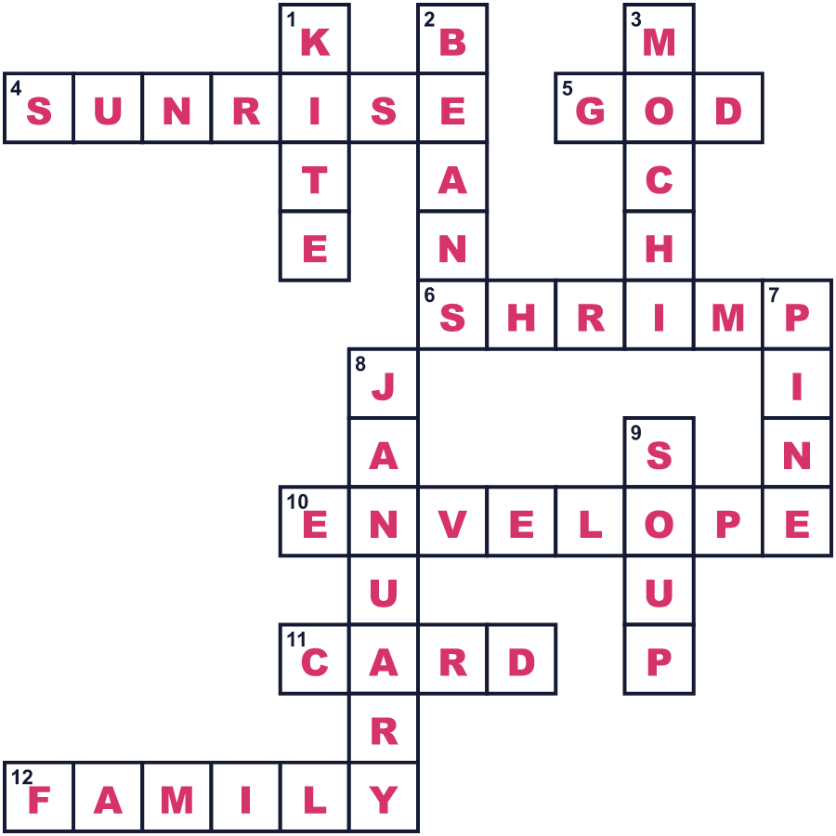
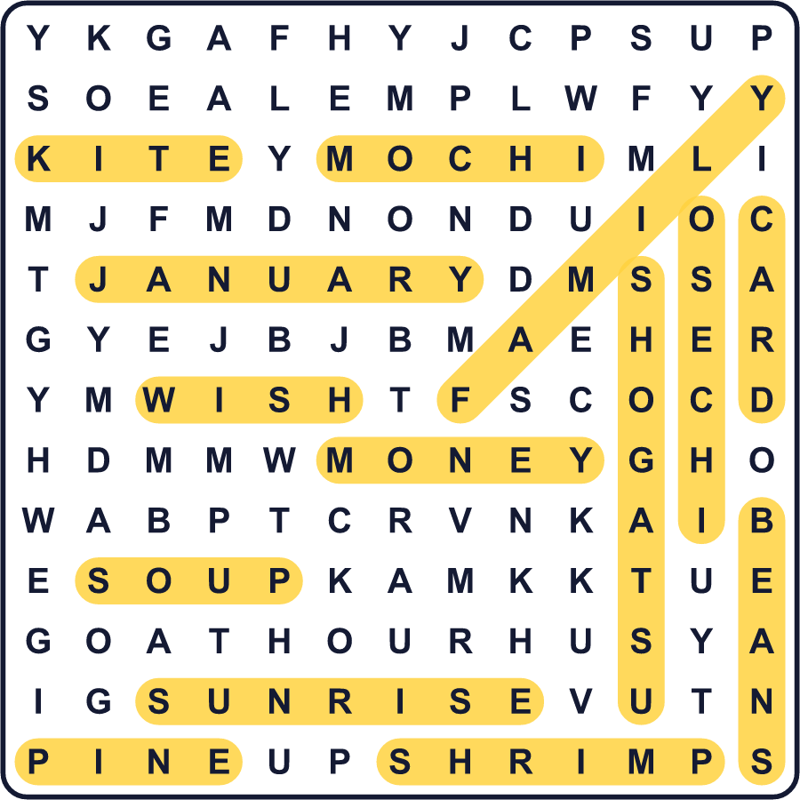
全訳
1 1月1日、日本のにぎやかな都会はとても静かになります。役所は12月29日から1月3日まで閉まり、多くの家族が家でいっしょに過ごします。これが日本のお正月です。ほとんどの人にとって、一年でいちばん大きな休日です。
2 昔の人は、新しい年の神さまがすべての家を訪れると信じていました。この神さまを迎えるために、家族は玄関に松と竹の飾りを置きました。この飾りは門松と呼ばれ、神さまが家を見つける助けになります。家族は鏡もちも作ります。丸いおもちを2つ重ねたものです。
3 元日の朝、早起きして初日の出を見る人もいます。山に登る人もいれば、寒い中を海岸まで歩く人もいます。それから家族は、きれいな箱に入った特別な料理、おせちを食べます。どの料理にも願いがこもっています。黒豆は健康のため、えびは長生きのためです。もち入りのお汁、お雑煮も食べますが、作り方は地域ごとに変わります。
4 多くの人が年賀状という新年のカードを送ります。郵便局はカードを預かり、1月1日にまとめて配達します。子どもたちには、この日が大好きな理由がもう一つあります。大人がお年玉をくれるのです。小さくてカラフルな封筒に入ったお金です。
5 1873年より前、日本は月の暦を使っていて、お正月は1月下旬か2月に来ました。だから多くの年賀状には、真冬なのに今も「新春」と書いてあるのです。だから日本の友だちが「あけましておめでとう」と言ったら、笑顔で同じ言葉を返しましょう。それは「ハッピーニューイヤー！」という意味です。

