📅 How Japan's Substitute Holidays Work Worksheet
Where Does the Holiday Go?
Read the story. 英文を読もう。
Class ______ No. ____ Name ______________________________

🔊 音声を聞こう（スマホで読みとってね）
1 Japan has 16 national holidays. But what happens when a holiday falls on a Sunday? Sunday is already a day off, so people lose a holiday. To stop this, Japan made a new rule in 1973. If a holiday is on a Sunday, the next day that is not a holiday becomes a day off. In English, this day is called a substitute holiday.
2 The first one came on April 30, 1973. That year, the Emperor's Birthday was on Sunday, April 29. So Monday became a holiday. At first, the substitute holiday was always the next day, a Monday. Many families got a long weekend.
3 Golden Week made the rule tricky. Since 2007, May 3, 4, and 5 have all been holidays. So if May 4 is a Sunday, Monday is already Children's Day. Now the day off moves to the first day that is not a holiday. In 2025, it was Tuesday, May 6. In 2026, it was even a Wednesday.
4 There is one more rule. A day between two holidays also becomes a day off. Some people call it an Othello holiday, like the board game. In Othello, a piece between two others changes color. On Tuesday, September 22, 2026, this rule gave people a day off. With the weekend, many people enjoyed five days off in a row. Before you plan a trip, check the calendar carefully!
Words 単語
national holiday（国民の祝日） / fall on（（日付が）〜に当たる） / day off（休みの日） / rule（決まり） / substitute（代わりの） / tricky（ややこしい、むずかしい） / between（〜の間に） / in a row（連続して）

📅 How Japan's Substitute Holidays Work Worksheet
Reading Check
Choose the best answer. 正しいものを選ぼう。
Class ______ No. ____ Name ______________________________
1. What is the main idea of this story?
(A) How to plan a trip for Golden Week (B) How Japan's rules for substitute holidays work (C) Why Japan has 16 holidays (D) How to play Othello
2. When was the first substitute holiday in Japan?
(A) May 6, 2025 (B) April 29, 1973 (C) September 22, 2026 (D) April 30, 1973
3. Why was the substitute holiday in 2025 on a Tuesday?
(A) Because Monday was already a holiday (B) Because Tuesday is always a holiday (C) Because the law changed in 2025 (D) Because it rained on Monday
4. In paragraph 3, "tricky" is closest in meaning to:
(A) easy (B) difficult (C) funny (D) short
5. In the dialogue, what is the day off called in the U.K.?
(A) An Othello day (B) A Golden day (C) A substitute day (D) A long Monday
True or False? T か F に○
1. Substitute holidays started in Japan in 1973. T / F
2. A substitute holiday is always on a Monday. T / F
3. A day between two holidays can become a day off. T / F
4. In Japan, a Saturday holiday moves to Monday. T / F

📅 How Japan's Substitute Holidays Work Worksheet
Word Work
単語のれんしゅう
Class ______ No. ____ Name ______________________________
① Match the pictures and the words. 絵と単語を線でむすぼう。
📅 | ● | ● | suitcase
😴 | ● | ● | calendar
🧳 | ● | ● | school
🏫 | ● | ● | national flag
⚽ | ● | ● | sleep
🎌 | ● | ● | soccer
③ Fill in the blanks. 語群から選んで入れよう。
[ happy / holiday / winter / soccer / substitute / calendar / tomorrow / pencil / Sunday ]
On Sunday night, Taro looks at the (1) __________ . "Oh no, I have a test (2) __________ ," he says. His sister laughs. "No, you don't! Tomorrow is a (3) __________ . The holiday was on (4) __________ , so Monday is a (5) __________ holiday." Taro is very (6) __________ . He decides to study and play (7) __________ on Monday.

📅 How Japan's Substitute Holidays Work Worksheet
Crossword Puzzle
ヒントを読んでクロスワードを完成させよう。
Class ______ No. ____ Name ______________________________
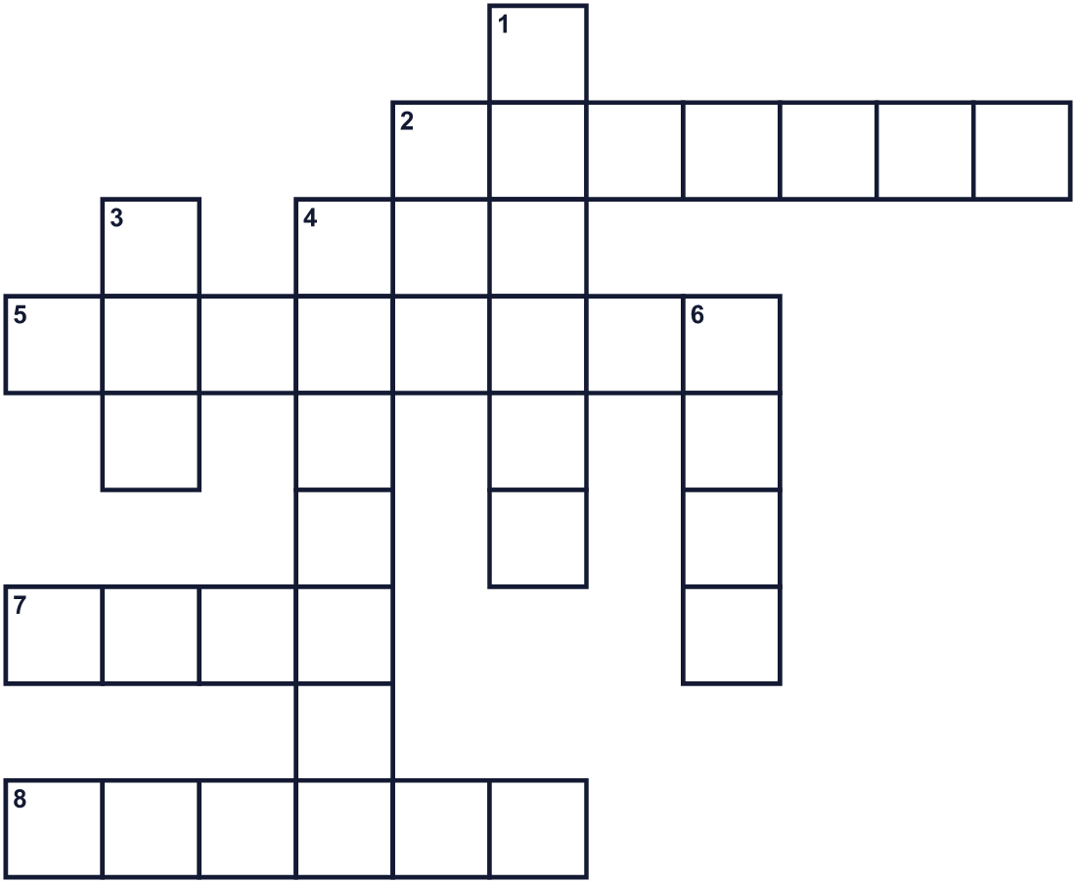
Across →
2. A special day when school is closed. (7)
5. It shows all the days and months of the year. (8)
7. Something you must follow, like no running in the hall. (4)
8. The day before Monday. (6)
Down ↓
1. The first day of the school week. (6)
3. The fifth month of the year. (3)
4. Saturday and Sunday together. (7)
6. To relax and not work. (4)

📅 How Japan's Substitute Holidays Work Worksheet
Word Search
かくれた単語をさがそう（→ ↓ ↘ ↗）
Class ______ No. ____ Name ______________________________
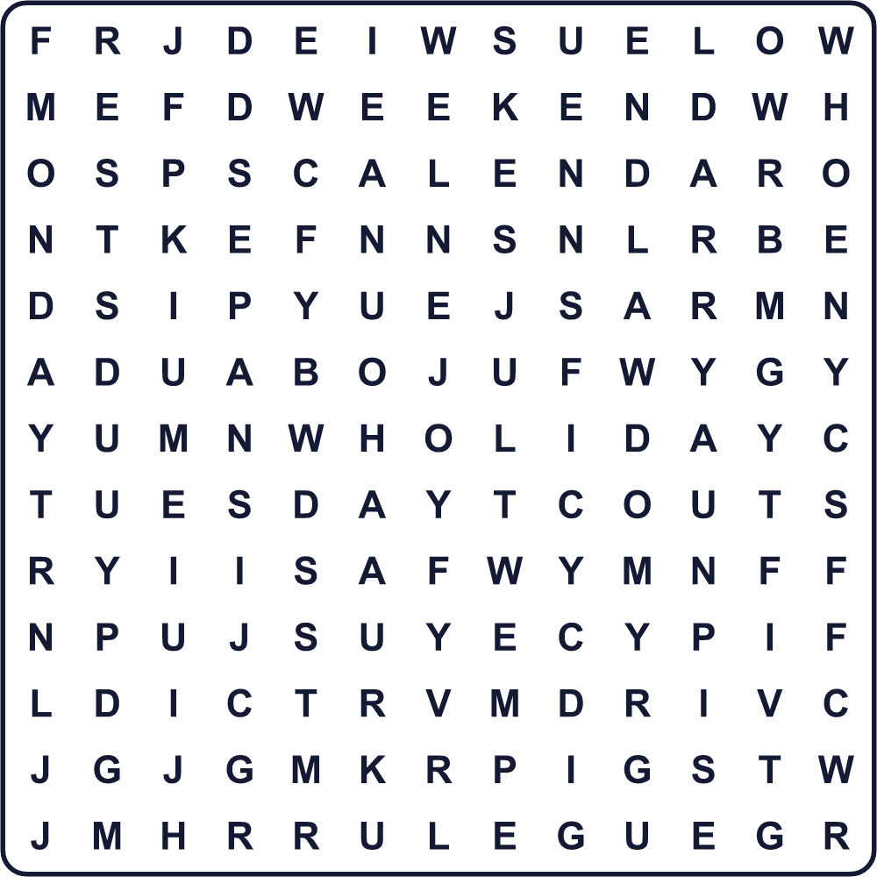
CALENDAR HOLIDAY LAW MAY MONDAY REST RULE SUNDAY TUESDAY WEEKEND

📅 How Japan's Substitute Holidays Work Worksheet
Maze & Sentences
Class ______ No. ____ Name ______________________________
Help the boy get to his day off! 男の子を休みの日まで連れていこう！
正しい道の文字を集めると、ひみつの言葉になるよ。 START 👦 → GOAL 📅
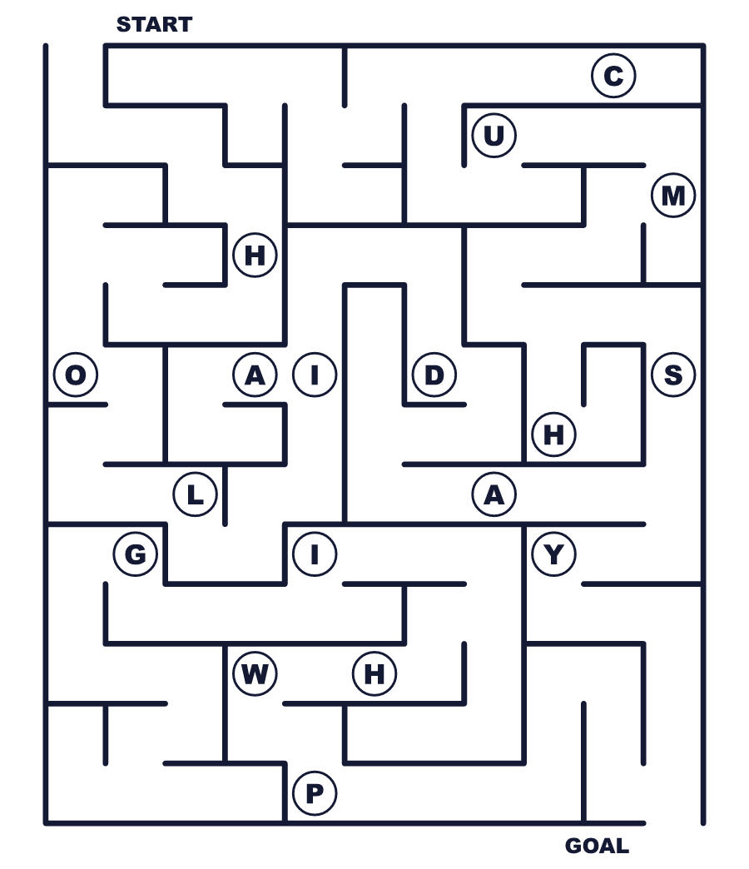
Secret word: ＿ ＿ ＿ ＿ ＿ ＿ ＿

📅 How Japan's Substitute Holidays Work Worksheet
Class Activity & Writing
Class ______ No. ____ Name ______________________________
Let's Write! 英語で書いてみよう。
On my next day off, I want to ______ because ______.
次の休みの日には______したいです。なぜなら______だからです。
______________________________________________________________
______________________________________________________________
If I could make a new holiday, it would be on ______ because ______.
新しい祝日を作れるなら、______にします。なぜなら______だからです。
______________________________________________________________
______________________________________________________________

📅 How Japan's Substitute Holidays Work Worksheet
Trace & Color
なぞって書こう。絵に色をぬろう。
Class ______ No. ____ Name ______________________________
📅 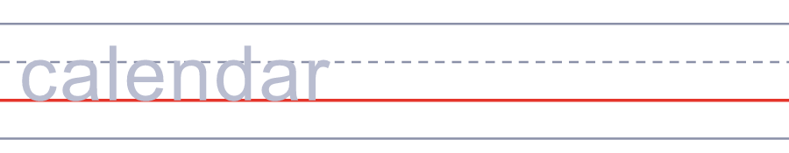

😴 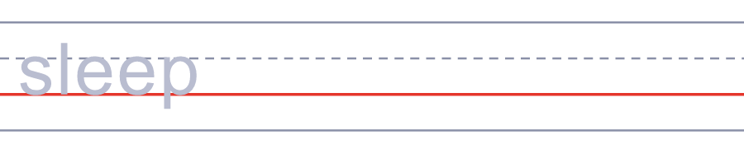
🧳 
🏫 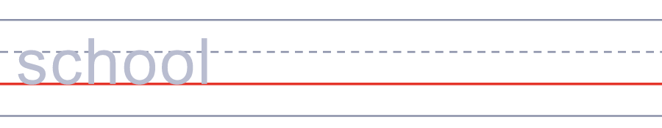
⚽ 

📅 How Japan's Substitute Holidays Work Worksheet
Answer Key 解答
Reading Check: 1.B 2.D 3.A 4.B 5.C
True or False: 1.T 2.F 3.T 4.F
Match: 📅=calendar 😴=sleep 🧳=suitcase 🏫=school ⚽=soccer 🎌=national flag
Fill in the blanks: (1)calendar (2)tomorrow (3)holiday (4)Sunday (5)substitute (6)happy (7)soccer
Maze: HOLIDAY
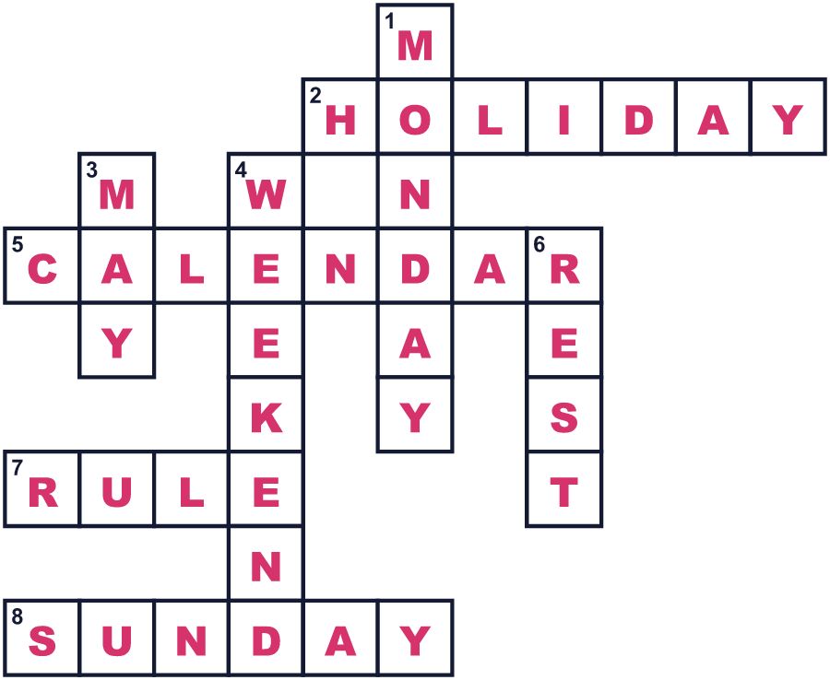
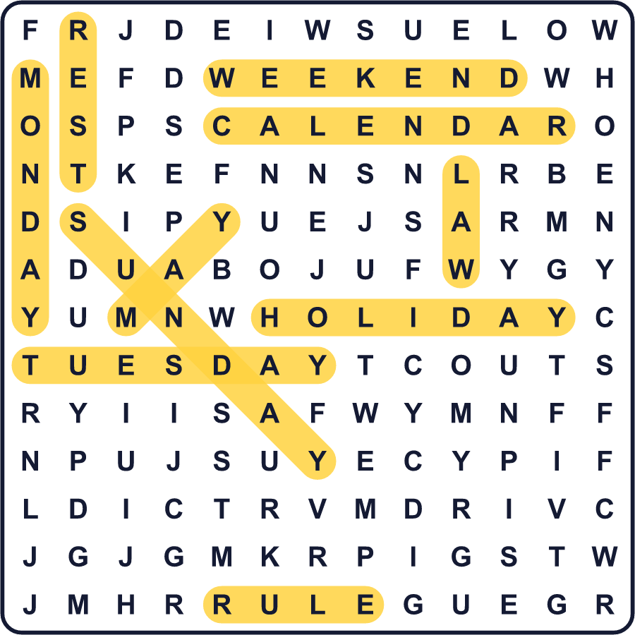
全訳
1 日本には16の国民の祝日があります。でも、祝日が日曜日に重なったらどうなるのでしょう。日曜日はもともと休みなので、祝日が1日なくなってしまいます。これを防ぐため、日本は1973年に新しいルールを作りました。祝日が日曜日なら、その次の祝日ではない日が休みになります。英語では、この日を substitute holiday と呼びます。
2 最初の振替休日は1973年4月30日でした。その年、天皇誕生日が4月29日の日曜日だったのです。そこで月曜日が休みになりました。はじめのころ、振替休日はいつも翌日の月曜日でした。多くの家族が3連休を手に入れました。
3 ゴールデンウィークが、このルールをややこしくしました。2007年から、5月3日、4日、5日はすべて祝日です。だから5月4日が日曜日なら、月曜日はすでにこどもの日です。今は、休みは祝日ではない最初の日に移ります。2025年は、5月6日の火曜日でした。2026年は、なんと水曜日でした。
4 もう1つルールがあります。2つの祝日にはさまれた日も休みになるのです。ボードゲームのように、オセロ休日と呼ぶ人もいます。オセロでは、2つの石にはさまれた石の色が変わります。2026年9月22日の火曜日、このルールで休みが生まれました。週末と合わせて、多くの人が5連休を楽しみました。旅行の計画を立てる前に、カレンダーをよく確かめましょう！

