🐈‍⬛ Friday the 13th Worksheet
Who Made Friday the 13th Scary?
Read the story. 英文を読もう。
Class ______ No. ____ Name ______________________________
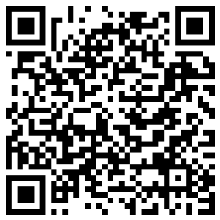
🔊 音声を聞こう（スマホで読みとってね）
1 Some people stay at home on Friday the 13th. They think it is an unlucky day. In the United States, millions of people are afraid of this date. But why? Nobody knows for sure.
2 There are a few ideas. Some people say 13 is unlucky because there were 13 people at the Last Supper. Friday was also an unlucky day in old Europe. But old books do not put Friday and 13 together before the 1800s. One of the first stories is about Rossini, a famous Italian composer. He died on Friday, November 13, 1868.
3 Then a movie made the day famous around the world. Friday the 13th came out in 1980. It was a cheap horror movie, but it made millions of dollars. The title came first, before the story was even finished. Many people think the killer is Jason in his hockey mask. But in the first movie, the killer is his mother! Jason first wears the mask in the third movie in 1982.
4 Different countries fear different days. In Spain and Greece, Tuesday is the unlucky day. In Italy, people worry about Friday the 17th. In Japan, some hotels and hospitals skip the numbers 4 and 9. Finland even uses Friday the 13th as a day to tell people to drive safely. Every year has at least one Friday the 13th, and some years have three.
Words 単語
unlucky（運の悪い、縁起の悪い） / afraid（こわがって） / supper（夕食） / composer（作曲家） / horror（恐怖、ホラー） / killer（殺人者、犯人） / skip（飛ばす） / fear（こわがる、恐怖）

🐈‍⬛ Friday the 13th Worksheet
Reading Check
Choose the best answer. 正しいものを選ぼう。
Class ______ No. ____ Name ______________________________
1. What is the main idea of the text?
(A) Friday the 13th is a holiday in Finland. (B) Nobody knows the true origin, but a movie made the day famous. (C) Jason was born on Friday the 13th. (D) Friday the 13th started in Japan.
2. When did Rossini die?
(A) On Friday, November 13, 1868 (B) On Friday, May 9, 1980 (C) On Tuesday, October 13, 1307 (D) On Friday, March 13, 1982
3. Who is the killer in the first movie?
(A) Jason (B) Rossini (C) A police officer (D) Jason's mother
4. In paragraph 4, "skip" is closest in meaning to:
(A) love (B) paint (C) not use (D) repeat
5. In the dialogue, why do some Japanese people worry about the number 4?
(A) It is the number of a scary movie. (B) It sounds like the word for death. (C) It is Jason's favorite number. (D) It is the fourth day of the week.
True or False? T か F に○
1. Every year has at least one Friday the 13th. T / F
2. Jason is the killer in the first Friday the 13th movie. T / F
3. In Italy, Friday the 17th is an unlucky day. T / F
4. Old books from the 1500s say Friday the 13th is unlucky. T / F

🐈‍⬛ Friday the 13th Worksheet
Word Work
単語のれんしゅう
Class ______ No. ____ Name ______________________________
① Match the pictures and the words. 絵と単語を線でむすぼう。
🐈‍⬛ | ● | ● | movie
🎬 | ● | ● | luck
🏒 | ● | ● | hockey
📅 | ● | ● | calendar
🍀 | ● | ● | black cat
🚗 | ● | ● | car
③ Fill in the blanks. 語群から選んで入れよう。
[ coin / points / sleepy / lucky / afraid / unlucky / summer / test / cat / laughed ]
It was Friday the 13th. Mia walked to school, and a black (1) __________ crossed the road. "Oh no," she said. "This is (2) __________ ." At school, she had a math (3) __________ . She was (4) __________ . But she got 100 (5) __________ ! After school, she found a (6) __________ on the street. "Maybe Friday the 13th is my (7) __________ day," she (8) __________ .

🐈‍⬛ Friday the 13th Worksheet
Crossword Puzzle
ヒントを読んでクロスワードを完成させよう。
Class ______ No. ____ Name ______________________________
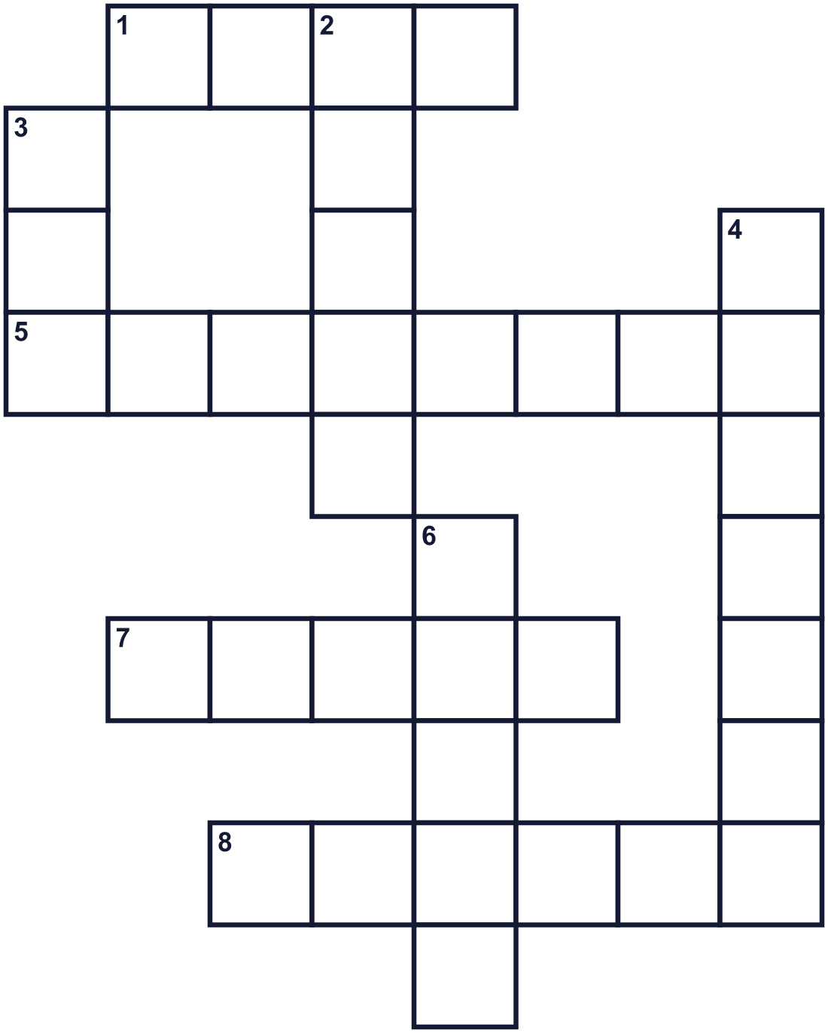
Across →
1. You wear it over your face. (4)
5. Twelve plus one. (8)
7. A level in a building. Some buildings skip number 13. (5)
8. The day before Saturday. (6)
Down ↓
2. It makes you afraid. (5)
3. A small pet. It says meow. (3)
4. Not lucky. Bad things happen. (7)
6. You watch it at a theater. (5)

🐈‍⬛ Friday the 13th Worksheet
Word Search
かくれた単語をさがそう（→ ↓ ↘ ↗）
Class ______ No. ____ Name ______________________________
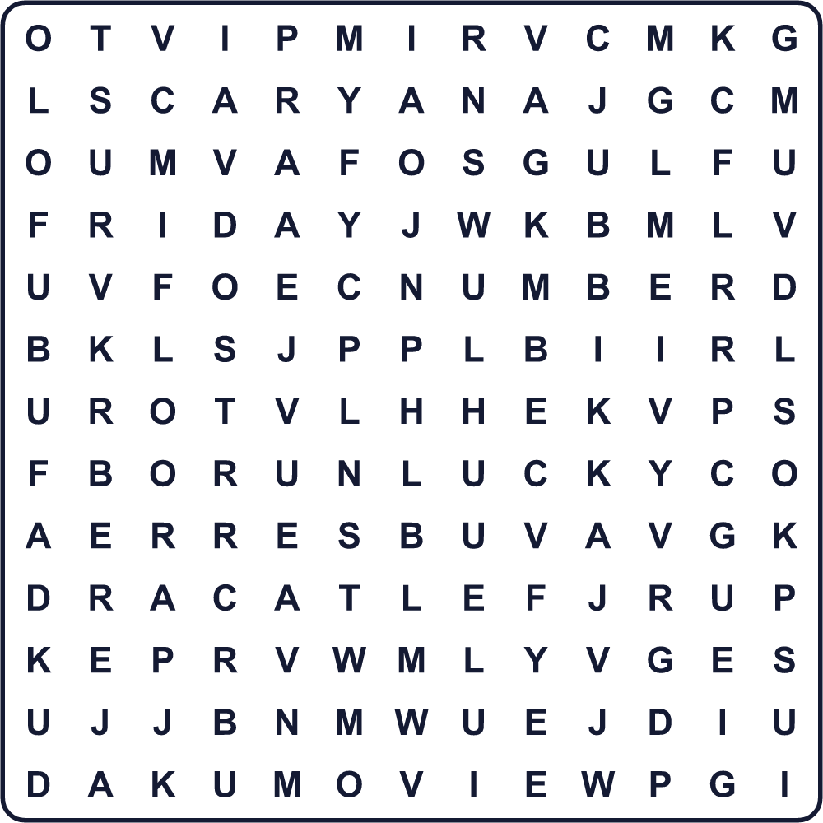
CAT FEAR FLOOR FRIDAY LUCK MASK MOVIE NUMBER SCARY UNLUCKY

🐈‍⬛ Friday the 13th Worksheet
Maze & Sentences
Class ______ No. ____ Name ______________________________
Help the black cat get home safely! 黒ネコを無事に家まで帰らせよう！
正しい道の文字を集めると、ひみつの言葉になるよ。 START 🐈‍⬛ → GOAL 🏠
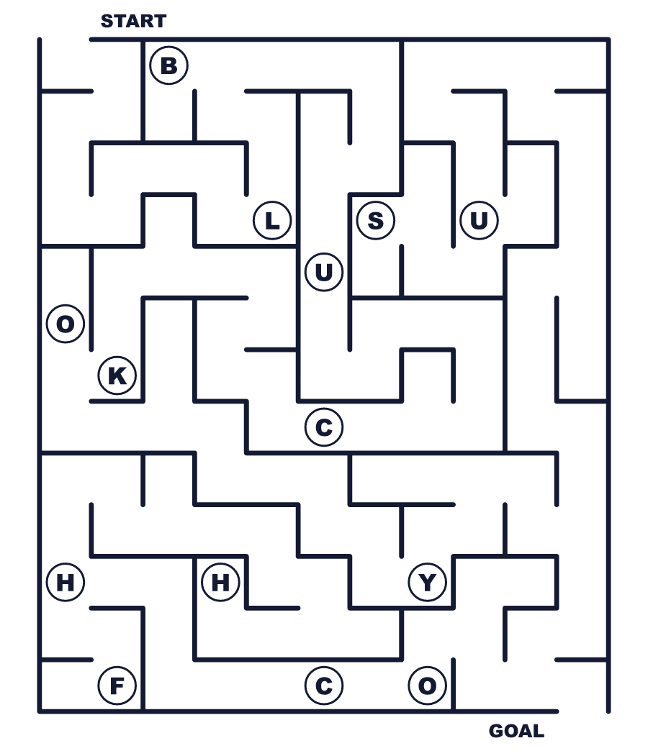
Secret word: ＿ ＿ ＿ ＿ ＿

🐈‍⬛ Friday the 13th Worksheet
Class Activity & Writing
Class ______ No. ____ Name ______________________________
Let's Write! 英語で書いてみよう。
My lucky number is ______ because ______.
私のラッキーナンバーは______です。なぜなら______だからです。
______________________________________________________________
______________________________________________________________
On Friday the 13th, I will ______.
13日の金曜日に、私は______します。
______________________________________________________________
______________________________________________________________

🐈‍⬛ Friday the 13th Worksheet
Trace & Color
なぞって書こう。絵に色をぬろう。
Class ______ No. ____ Name ______________________________
🐈‍⬛ 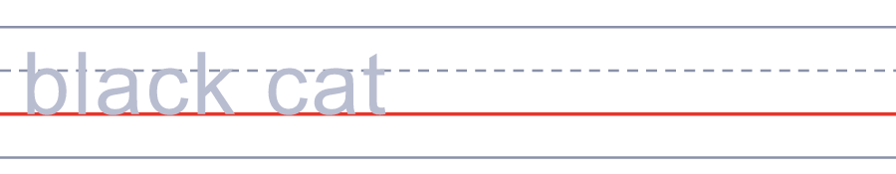

🎬 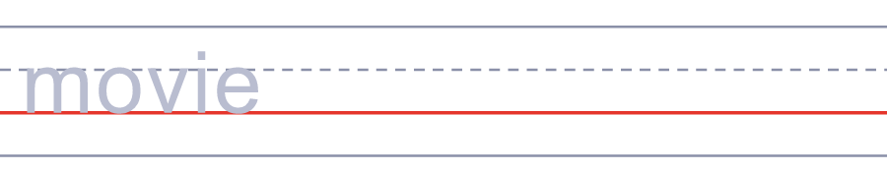
🏒 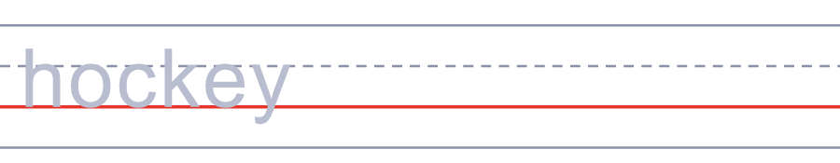
📅 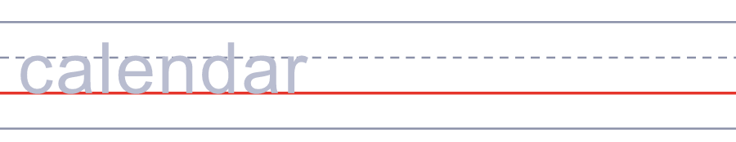
🍀 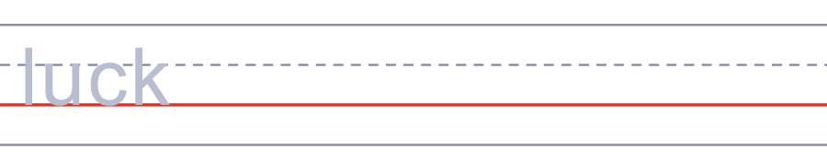

🐈‍⬛ Friday the 13th Worksheet
Answer Key 解答
Reading Check: 1.B 2.A 3.D 4.C 5.B
True or False: 1.T 2.F 3.T 4.F
Match: 🐈‍⬛=black cat 🎬=movie 🏒=hockey 📅=calendar 🍀=luck 🚗=car
Fill in the blanks: (1)cat (2)unlucky (3)test (4)afraid (5)points (6)coin (7)lucky (8)laughed
Maze: LUCKY
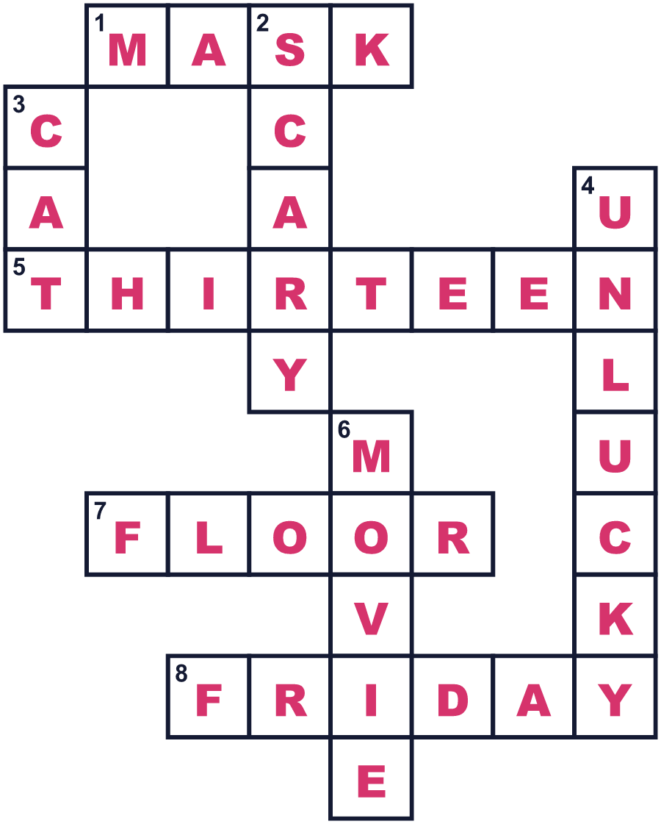
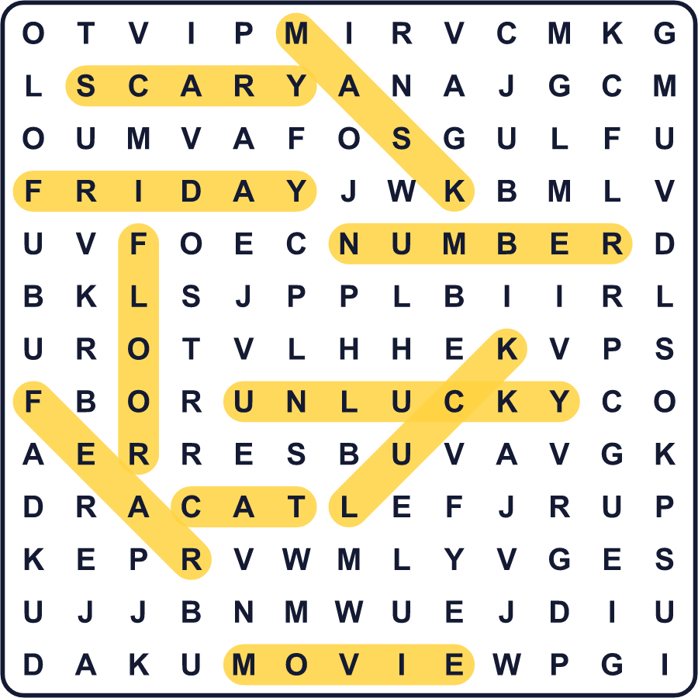
全訳
1 13日の金曜日には家から出ない人もいます。不吉な日だと思っているのです。アメリカでは、何百万人もの人がこの日付をこわがっています。でも、なぜでしょう。はっきりとはだれにもわかりません。
2 いくつかの説があります。最後の晩餐に13人がいたから13は不吉だ、と言う人もいます。昔のヨーロッパでは、金曜日も縁起の悪い日でした。でも、1800年代より前の古い本には、金曜日と13を組み合わせた話は出てきません。最初期の例のひとつは、イタリアの有名な作曲家ロッシーニについての話です。彼は1868年11月13日の金曜日に亡くなりました。
3 その後、ある映画がこの日を世界中で有名にしました。『13日の金曜日』は1980年に公開されました。低予算のホラー映画でしたが、何百万ドルもかせぎました。物語ができあがる前に、題名が先に決まっていました。多くの人は、犯人はホッケーマスクのジェイソンだと思っています。でも1作目の犯人は、彼の母親なのです！ジェイソンがマスクを初めてかぶるのは、1982年の3作目です。
4 国が違えば、こわい日も違います。スペインやギリシャでは、不吉なのは火曜日です。イタリアでは、17日の金曜日を気にします。日本では、4や9の番号を飛ばすホテルや病院もあります。フィンランドでは、13日の金曜日を安全運転を呼びかける日にまでしています。13日の金曜日はどの年にも少なくとも1回あり、3回ある年もあります。

