👔 Father's Day Worksheet
A Day for Dad
Read the story. 英文を読もう。
Class ______ No. ____ Name ______________________________

🔊 音声を聞こう（スマホで読みとってね）
1 In May 1909, a young woman sat in a church in Spokane, Washington. The pastor was talking about Mother's Day. Her name was Sonora Smart Dodd, and she had a question. Why was there no special day for fathers?
2 Sonora had a good reason to ask. Her mother died in 1898, when her sixth child was born. So her father, William, raised Sonora and her five little brothers alone. He had been a soldier, and he worked hard for his family. Sonora wanted to thank him in a big way.
3 She asked the pastors in her town to choose a day for fathers. The first Father's Day was on June 19, 1910. Young people wore roses to church that day. A red rose meant your father was alive. A white rose meant he had died.
4 But the idea grew slowly. Mother's Day became a national day in 1914. Father's Day had to wait until 1972, 62 years after the first one. Sonora was 90 years old by then, and she lived to see it. It was a very long wait for her.
5 Today, the United States and Japan celebrate Father's Day on the third Sunday in June. Families give cards, neckties, and good meals to their dads. But the date is not the same everywhere. In Spain and Italy, it is on March 19. In Taiwan, it is on August 8, because eight eight sounds like baba, a Chinese word for dad. And in Germany, many men go for a long walk with a cart full of beer!
Words 単語
honor（たたえる、敬意を表す） / raise（（子どもを）育てる） / alone（ひとりで） / pastor（（プロテスタントの）牧師） / church（教会） / celebrate（祝う） / alive（生きている） / national（国の、全国的な） / necktie（ネクタイ） / cart（手押し車、荷車） / grateful（感謝している） / tradition（伝統、ならわし）

👔 Father's Day Worksheet
Reading Check
Choose the best answer. 正しいものを選ぼう。
Class ______ No. ____ Name ______________________________
1. What is the main idea of the story?
(A) How a daughter's idea became Father's Day (B) Why fathers like neckties and beer (C) How to make a Father's Day card (D) Why Mother's Day is older than Christmas
2. When was the first Father's Day?
(A) May 1909 (B) June 19, 1910 (C) March 19, 1914 (D) June 5, 1972
3. How many children did Sonora's father raise alone?
(A) Two (B) Four (C) Five (D) Six
4. Why did Sonora want a day for fathers?
(A) Her father asked her to make one. (B) She wanted to thank her father, who raised his children alone. (C) Her town needed a new holiday in June. (D) She wanted to sell more neckties.
5. In the story, what does "raised" mean in "her father raised Sonora and her five little brothers"?
(A) lifted up (B) took care of and brought up (C) called loudly (D) paid money to
6. Which is true according to the story?
(A) Father's Day became a national day before Mother's Day. (B) A white rose meant your father was alive. (C) In Taiwan, Father's Day is on August 8. (D) Sonora died before 1972.
7. What can we guess from the story?
(A) Sonora gave up her idea quickly. (B) Most countries have Father's Day in March. (C) Sonora's father was a very important person to her. (D) Germany has no Father's Day.
8. In the dialogue, what will Lily give her father?
(A) A necktie (B) Yellow roses (C) A phone call (D) Breakfast
True or False? T か F に○
1. Father's Day started in Spokane, Washington. T / F
2. The first Father's Day was in 1972. T / F
3. Sonora's father raised his children alone. T / F
4. In Spain, Father's Day is on March 19. T / F
5. Every country has Father's Day on the same day. T / F
6. At the first Father's Day, a white rose meant your father was alive. T / F

👔 Father's Day Worksheet
Word Work
単語のれんしゅう
Class ______ No. ____ Name ______________________________
① Match the pictures and the words. 絵と単語を線でむすぼう。
👔 | ● | ● | golf
🌹 | ● | ● | necktie
💌 | ● | ● | gift
🎁 | ● | ● | card
⛪ | ● | ● | rose
🌻 | ● | ● | church
⛳ | ● | ● | sunflower
🍺 | ● | ● | beer
② Unscramble the words. 並べかえて単語にしよう。
1. A T F H R E (父) → ____________________
2. C N I K T E E (ネクタイ) → ____________________
3. S K A N T H (ありがとう) → ____________________
4. L A I Y F M (家族) → ____________________
5. D S N U A Y (日曜日) → ____________________
6. P N S R E E T (プレゼント) → ____________________
③ Fill in the blanks. 語群から選んで入れよう。
[ winter / school / different / ever / early / Sunday / kitchen / surprised / necktie / thank / card / angry / breakfast ]
Ken wants to (1) __________ his dad on Father's Day. It is on the third (2) __________ in June. Last year, Ken gave him a (3) __________ . This year, he wants to do something (4) __________ . He gets up (5) __________ and makes pancakes for (6) __________ . His sister writes a (7) __________ with yellow flowers on it. When their dad comes into the (8) __________ , he looks very (9) __________ . "This is the best Father's Day (10) __________ !" he says.

👔 Father's Day Worksheet
Crossword Puzzle
ヒントを読んでクロスワードを完成させよう。
Class ______ No. ____ Name ______________________________
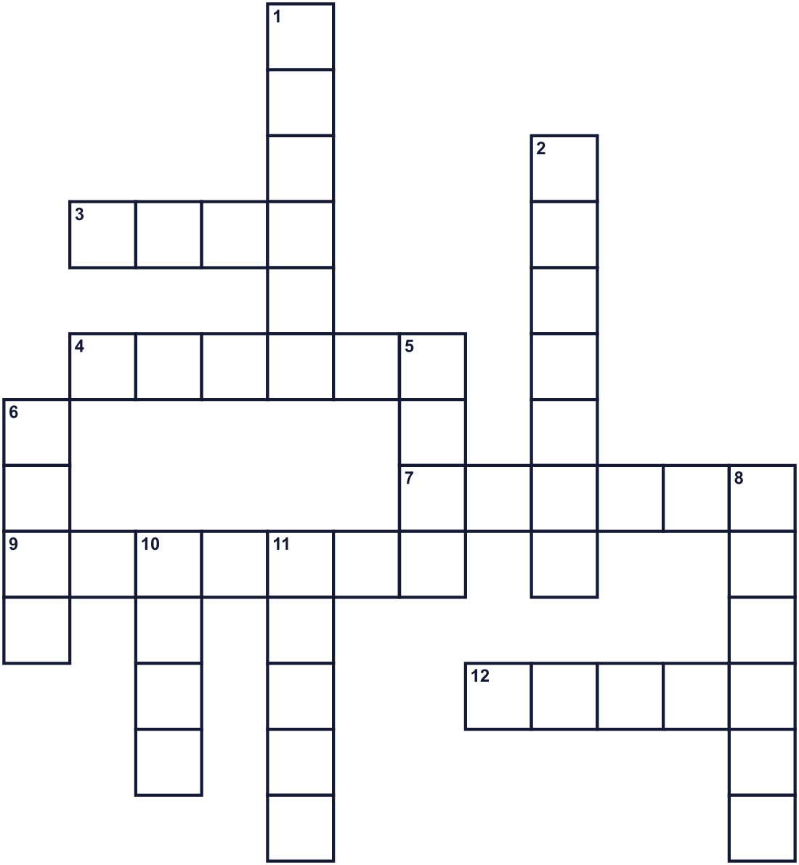
Across →
3. Some German men pull a cart full of this drink. (4)
4. Another word for dad. (6)
7. Father's Day in the U.S. is always on this day of the week. (6)
9. A long piece of cloth that men wear around the neck. (7)
12. Many dads cook meat on this outside. (5)
Down ↓
1. Sonora heard a talk about Mother's Day in this building. (6)
2. The city in Washington where Father's Day started. (7)
5. A flower. Red ones were worn for living fathers in 1910. (4)
6. The month of Father's Day in the U.S. and Japan. (4)
8. The color of Father's Day in Japan. (6)
10. You write a message on it and give it to someone. (4)
11. To say you are happy someone helped you. (5)

👔 Father's Day Worksheet
Word Search
かくれた単語をさがそう（→ ↓ ↘ ↗）
Class ______ No. ____ Name ______________________________
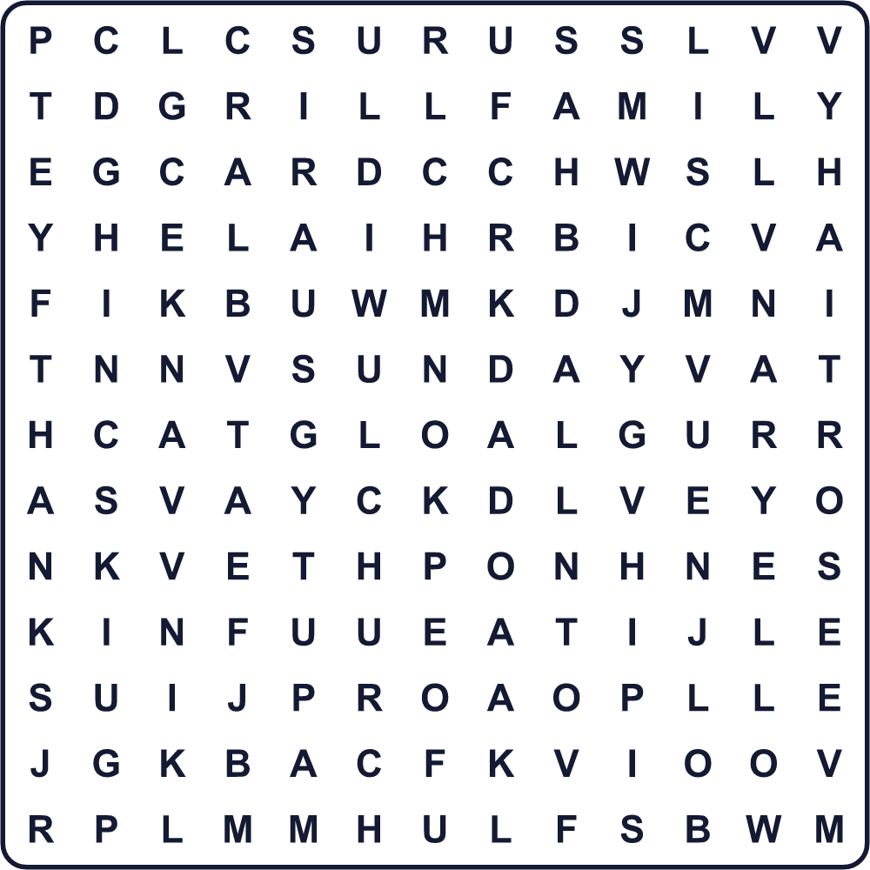
CARD CHURCH DAD FAMILY FATHER GIFT GRILL JUNE ROSE SUNDAY THANKS TIE YELLOW
Secret Code 暗号を解こう
⚓=A ☺=D ◎=H ⚑=K ★=N ♦=O ♪=T ☀=U ♠=Y
♪ ◎ ⚓ ★ ⚑ ♠ ♦ ☀ ☺ ⚓ ☺
______________________________________________________________

👔 Father's Day Worksheet
Maze & Sentences
Class ______ No. ____ Name ______________________________
Help Lily bring the card to Dad! リリーがお父さんにカードを届けられるように手伝おう！
正しい道の文字を集めると、ひみつの言葉になるよ。 START 👧 → GOAL 👨
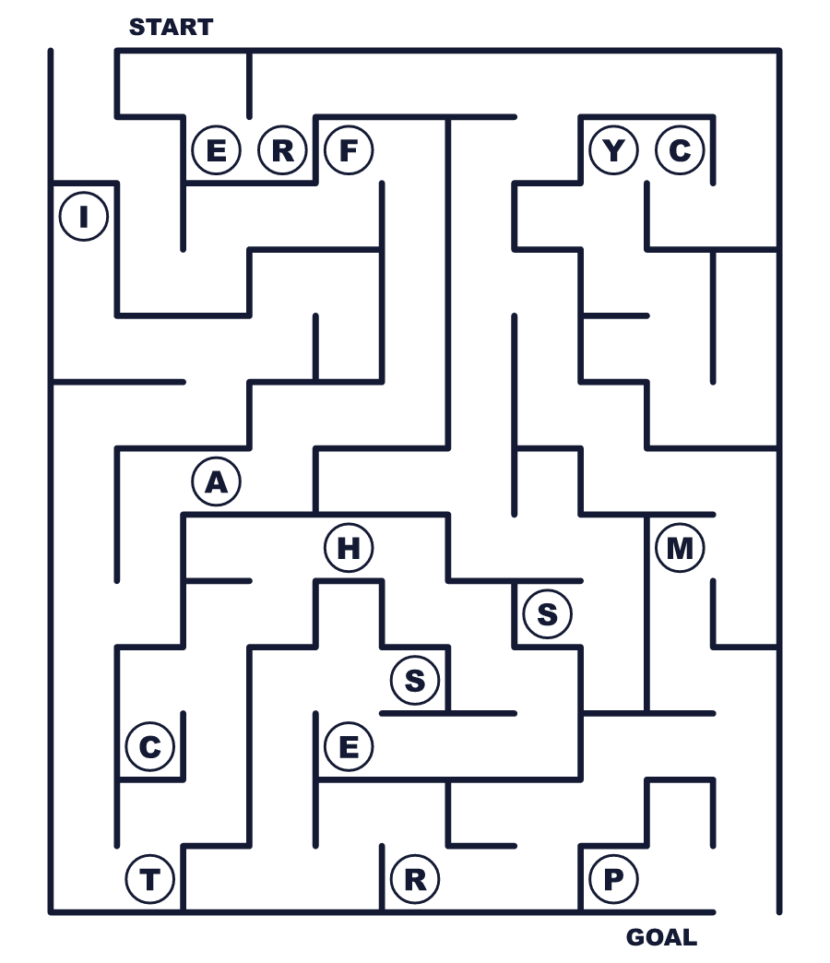
Secret word: ＿ ＿ ＿ ＿ ＿ ＿
Put the words in order. 並べかえよう。
1. in / in / started / Spokane / Day / 1910 / Father's . (父の日は1910年にスポケーンで始まりました。)
______________________________________________________________
2. alone / six / father / children / Her / raised . (彼女の父はひとりで6人の子どもを育てました。)
______________________________________________________________
3. to / people / church / roses / wore / Young . (若者たちはバラをつけて教会へ行きました。)
______________________________________________________________
4. Taiwan, / 8 / In / August / on / is / Father's / Day . (台湾では父の日は8月8日です。)
______________________________________________________________
5. for / make / breakfast / my / will / I / dad . (私はお父さんに朝ごはんを作ります。)
______________________________________________________________

👔 Father's Day Worksheet
Class Activity & Writing
Class ______ No. ____ Name ______________________________
Find Someone Who… クラスで聞いて回ろう！
Find someone who … | Name
… has given a card to his or her father お父さんにカードをあげたことがある
… has cooked something for his or her family 家族のために料理をしたことがある
… knows the date of Father's Day this year 今年の父の日の日付を知っている
… likes barbecue バーベキューが好き
… can say thank you in three languages 3つの言語で「ありがとう」が言える
… has played catch with his or her father お父さんとキャッチボールをしたことがある
… knows a country with Father's Day in March 3月に父の日がある国を知っている
… likes sunflowers ヒマワリが好き
Let's Write! 英語で書いてみよう。
My father (or a person like a father to me) is ______. I want to thank him because ______.
私の父（または父のような人）は＿＿です。＿＿なので、感謝したいです。
______________________________________________________________
______________________________________________________________
On Father's Day, I would like to ______ with my family because ______.
父の日には、家族と＿＿したいです。なぜなら＿＿だからです。
______________________________________________________________
______________________________________________________________
If I made a new Father's Day, it would be on ______ because ______.
もし新しい父の日を作るなら、＿＿にします。なぜなら＿＿だからです。
______________________________________________________________
______________________________________________________________

👔 Father's Day Worksheet
Trace & Color
なぞって書こう。絵に色をぬろう。
Class ______ No. ____ Name ______________________________
👔 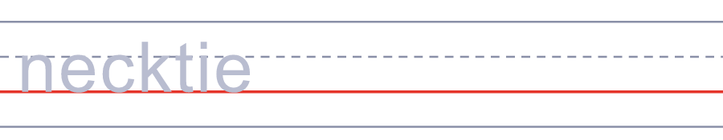

🌹 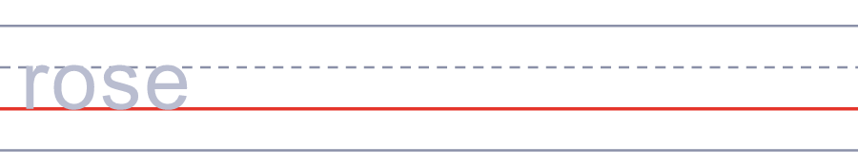
💌 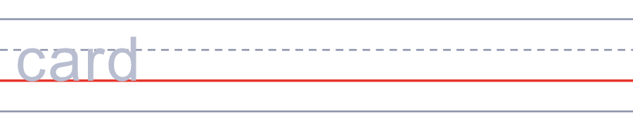
🎁 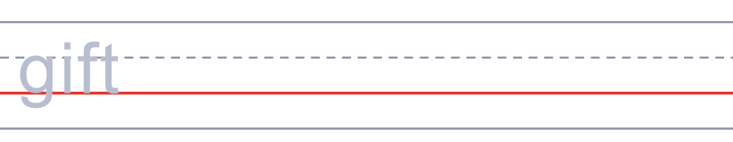
⛪ 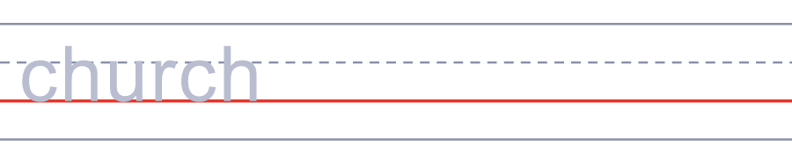
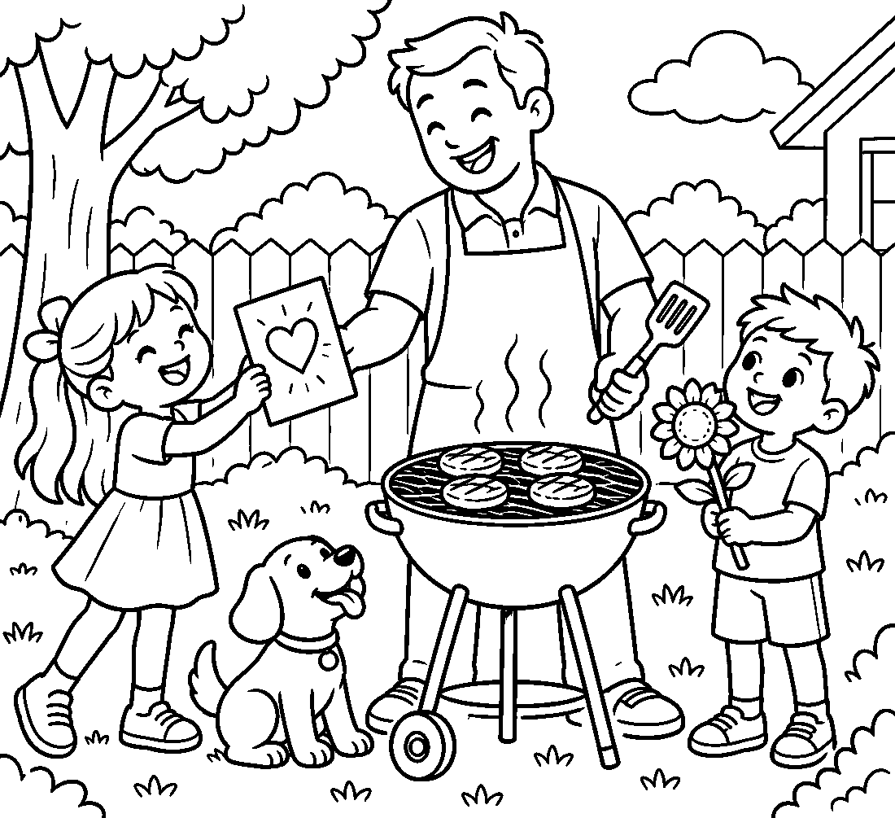

👔 Father's Day Worksheet
Answer Key 解答
Reading Check: 1.A 2.B 3.D 4.B 5.B 6.C 7.C 8.D
True or False: 1.T 2.F 3.T 4.T 5.F 6.F
Match: 👔=necktie 🌹=rose 💌=card 🎁=gift ⛪=church 🌻=sunflower ⛳=golf 🍺=beer
Unscramble: 1.FATHER 2.NECKTIE 3.THANKS 4.FAMILY 5.SUNDAY 6.PRESENT
Fill in the blanks: (1)thank (2)Sunday (3)necktie (4)different (5)early (6)breakfast (7)card (8)kitchen (9)surprised (10)ever
Sentence order: 1. Father's Day started in Spokane in 1910. 2. Her father raised six children alone. 3. Young people wore roses to church. 4. In Taiwan, Father's Day is on August 8. 5. I will make breakfast for my dad.
Secret Code: THANK YOU DAD
Maze: FATHER
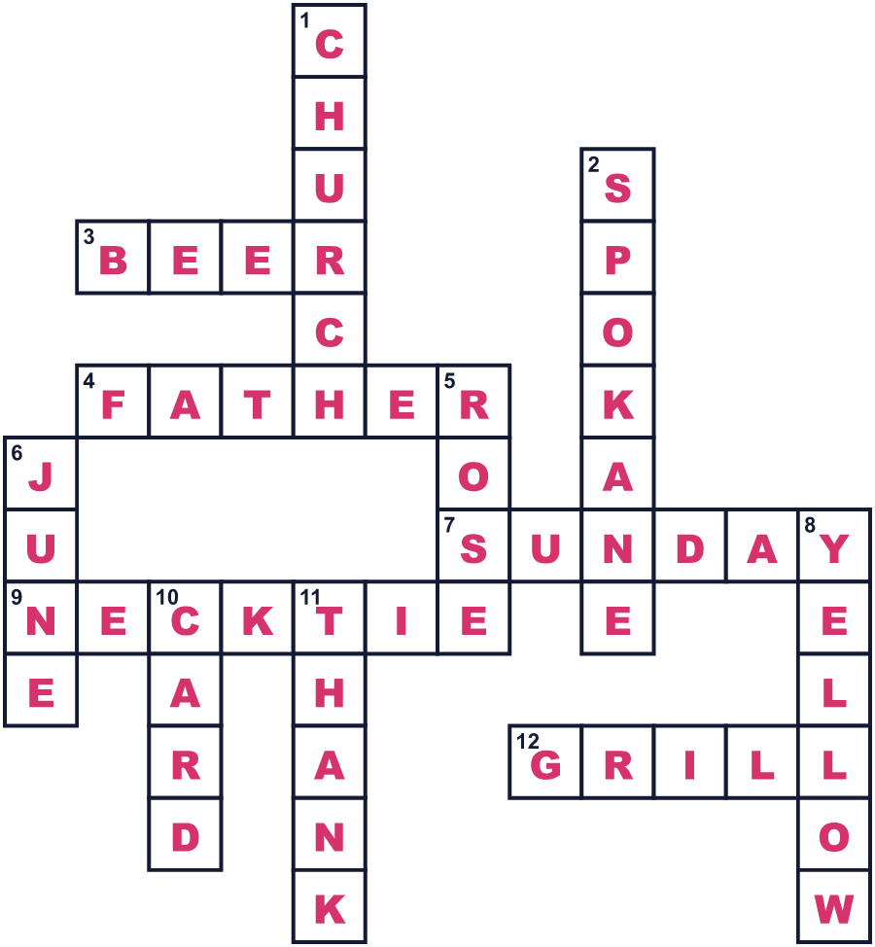
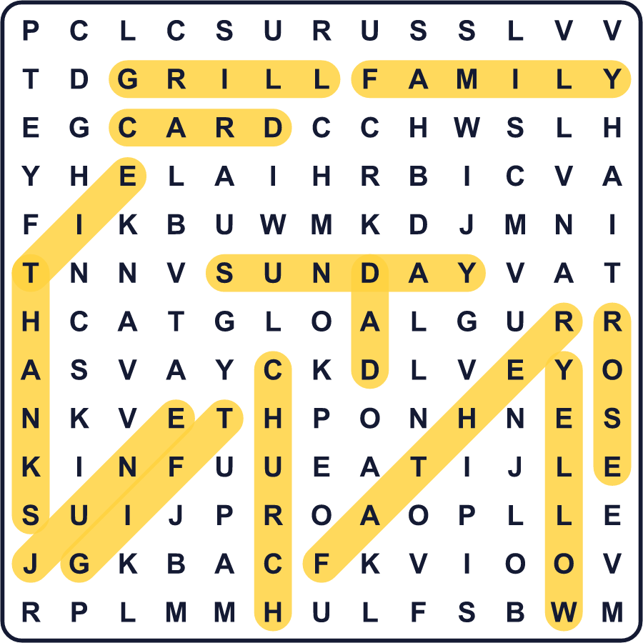
全訳
1 1909年5月、ひとりの若い女性がワシントン州スポケーンの教会に座っていました。牧師は母の日について話していました。彼女の名前はソノラ・スマート・ドッド。彼女にはある疑問がありました。どうしてお父さんのための特別な日はないのだろう？
2 ソノラがそう思うのには、ちゃんとした理由がありました。母は1898年、6人目の子が生まれたときに亡くなったのです。そこで父のウィリアムが、ソノラと5人の弟たちをひとりで育てました。父はかつて兵士で、家族のために一生けんめい働きました。ソノラは、そんな父に大きな形で感謝したいと思いました。
3 彼女は町の牧師たちに、父親のための日を決めてほしいと頼みました。最初の父の日は1910年6月19日でした。その日、若者たちはバラを身につけて教会へ行きました。赤いバラは、父親が生きているという意味でした。白いバラは、父親が亡くなっているという意味でした。
4 でも、この考えはなかなか広まりませんでした。母の日は1914年に国の記念日になりました。父の日は、最初の父の日から62年後の1972年まで待たなければなりませんでした。そのときソノラは90歳。彼女はその日を自分の目で見ることができました。彼女にとって、とても長い待ち時間でした。
5 今、アメリカと日本では6月の第3日曜日に父の日を祝います。家族はお父さんにカードやネクタイ、おいしい食事を贈ります。でも、日付はどこでも同じではありません。スペインとイタリアでは3月19日です。台湾では8月8日。中国語で「八八」が、お父さんを表す「爸爸（バーバー）」に似た音だからです。そしてドイツでは、たくさんの男性がビールを積んだ荷車を引いて、長い散歩に出かけます！

