🐣 Easter Worksheet
Eggs, Bunnies, and the Moon
Read the story. 英文を読もう。
Class ______ No. ____ Name ______________________________

🔊 音声を聞こう（スマホで読みとってね）
1 Early on a Sunday morning in spring, children run into the garden with baskets. They look under bushes and behind trees. Colorful eggs are hiding everywhere. Some are made of chocolate, and some are real eggs painted blue, pink, and gold. Who hid them? The Easter Bunny, of course.
2 Easter is the most important holiday for Christians. They believe that Jesus died on a cross on a Friday. Then on Sunday, he came back to life. Easter celebrates this new life. People go to church, sing happy songs, and eat big family meals.
3 The date of Easter changes every year, and the moon decides it. Easter is the first Sunday after the first full moon of spring. So it can be any Sunday from March 22 to April 25. Churches in Greece and Russia use an older calendar, so their Easter often comes later. In 2027, the two Easters will be five weeks apart.
4 Why eggs and bunnies? Long ago in Europe, people did not eat eggs for about 40 days before Easter. On Easter Sunday, they finally colored the eggs and ate them. The story of an egg-carrying bunny started in Germany in the 1600s. Later, German families took the bunny with them to America.
5 Today, each country has its own fun. In Poland, people throw water at each other on Easter Monday. In Australia, some children get chocolate bilbies, small native animals, instead of bunnies. And in Norway, many people spend the holiday reading crime stories. Easter is a day of new life, and every country celebrates it in its own special way.
Words 単語
basket（かご） / hide（隠す、隠れる） / Christian（キリスト教徒） / cross（十字架、十字） / come back to life（生き返る） / celebrate（祝う） / decide（決める） / full moon（満月） / calendar（暦、カレンダー） / color（色をつける） / native（その土地にもともといる） / instead of（～のかわりに）

🐣 Easter Worksheet
Reading Check
Choose the best answer. 正しいものを選ぼう。
Class ______ No. ____ Name ______________________________
1. What is the story mainly about?
(A) How to bake chocolate eggs (B) What Easter means and how people celebrate it (C) Why rabbits are pests in Australia (D) The history of Norway
2. What do Christians celebrate at Easter?
(A) The birth of Jesus (B) The first day of the year (C) Jesus coming back to life (D) The end of winter
3. What decides the date of Easter?
(A) The king (B) The weather (C) The sun only (D) The moon
4. Where did the story of the egg-carrying bunny start?
(A) In Germany (B) In America (C) In Australia (D) In Poland
5. In the story, what does "native" mean in "small native animals"?
(A) Very cute (B) From another country (C) Living there from long ago (D) Made of chocolate
6. Which sentence is true?
(A) Easter is always on April 1. (B) People in Europe did not eat eggs for about 40 days before Easter. (C) Churches in Greece always have Easter earlier. (D) People in Poland throw eggs on Easter Monday.
7. Why do Easter eggs have bright colors?
(A) Because people colored eggs to celebrate the end of the long wait (B) Because the bunny paints them at night (C) Because colored eggs are cheaper (D) Because the moon changes their color
8. In the dialogue, who really hides the eggs at Oliver's house?
(A) The Easter Bunny (B) Oliver's little sister (C) Mei (D) Oliver's mum
True or False? T か F に○
1. Easter is always on a Sunday. T / F
2. Easter is on the same date every year. T / F
3. The story of the Easter Bunny started in Germany. T / F
4. Easter is a national holiday in Japan. T / F
5. In Poland, people throw water on Easter Monday. T / F
6. Easter celebrates the birth of Jesus. T / F

🐣 Easter Worksheet
Word Work
単語のれんしゅう
Class ______ No. ____ Name ______________________________
① Match the pictures and the words. 絵と単語を線でむすぼう。
🥚 | ● | ● | church
🐰 | ● | ● | chocolate
🧺 | ● | ● | egg
🐑 | ● | ● | chick
🌕 | ● | ● | bunny
⛪ | ● | ● | lamb
🍫 | ● | ● | basket
🐣 | ● | ● | full moon
② Unscramble the words. 並べかえて単語にしよう。
1. Y B U N N (うさちゃん) → ____________________
2. T E A K S B (かご) → ____________________
3. P G N I S R (春) → ____________________
4. C C U H R H (教会) → ____________________
5. N D G A E R (庭) → ____________________
6. D I D N E H (隠された) → ____________________
③ Fill in the blanks. 語群から選んで入れよう。
[ lamb / Easter / basket / buns / pumpkin / Sunday / tree / Monday / chocolate / flowers / garden / snow / Bunny ]
It is Easter (1) __________ . Leo wakes up early and takes his (2) __________ . His grandma says, "The Easter (3) __________ came last night!" Leo runs into the (4) __________ . He finds a blue egg under a (5) __________ . He finds a pink egg next to the (6) __________ . Then he sees something brown in the grass. It is a big (7) __________ egg! At lunch, the family eats (8) __________ and hot cross (9) __________ . Leo shares his eggs with his little sister. "Happy (10) __________ !" they say.

🐣 Easter Worksheet
Crossword Puzzle
ヒントを読んでクロスワードを完成させよう。
Class ______ No. ____ Name ______________________________
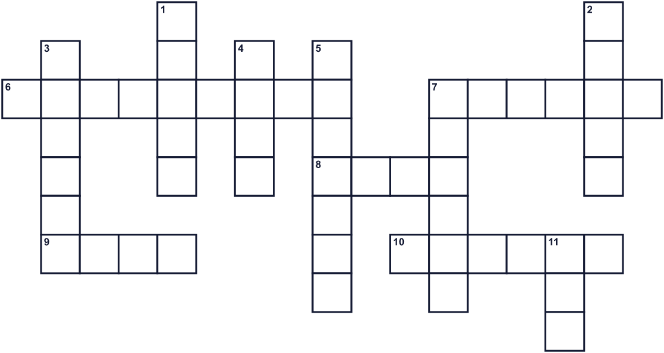
Across →
6. A sweet brown food. Many eggs are made of it. (9)
7. The season with flowers after winter. (6)
8. It shines at night. It decides the date of the holiday. (4)
9. To look for something, like hidden eggs. (4)
10. You carry eggs in this during the hunt. (6)
Down ↓
1. A shape like a plus sign. It is on hot buns. (5)
2. A cute word for a rabbit. It brings eggs in the story. (5)
3. Christians go to this building to pray. (6)
4. A baby sheep. (4)
5. The country where the bunny story started. (7)
7. The day of the week for this holiday. (6)
11. A chicken lays this. People color it for the holiday. (3)

🐣 Easter Worksheet
Word Search
かくれた単語をさがそう（→ ↓ ↘ ↗）
Class ______ No. ____ Name ______________________________
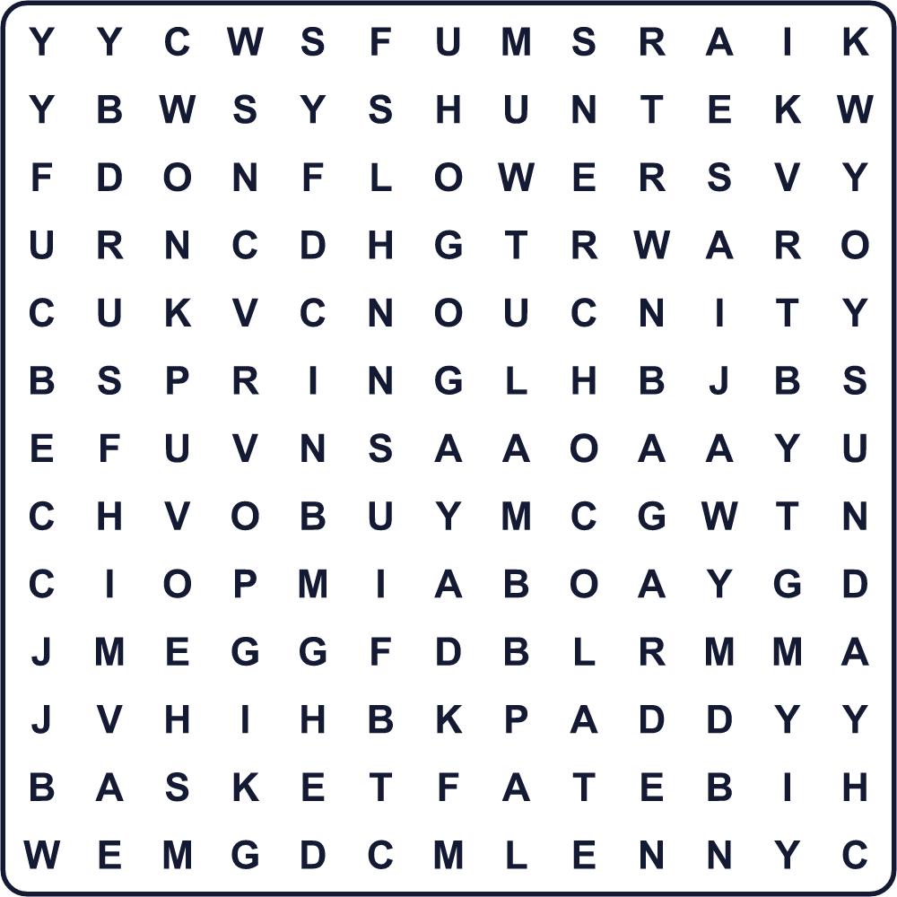
BASKET BUNNY CHOCOLATE CHURCH CROSS EGG FLOWERS GARDEN HUNT LAMB MOON SPRING SUNDAY
Secret Code 暗号を解こう
●=A ◆=E ♠=H ♦=P ⚑=R ☎=S ⚓=T ☘=Y
♠ ● ♦ ♦ ☘ ◆ ● ☎ ⚓ ◆ ⚑
______________________________________________________________

🐣 Easter Worksheet
Maze & Sentences
Class ______ No. ____ Name ______________________________
Help Leo find the golden egg! レオが金色の卵を見つけるのを手伝おう！
正しい道の文字を集めると、ひみつの言葉になるよ。 START 👦 → GOAL 🥚
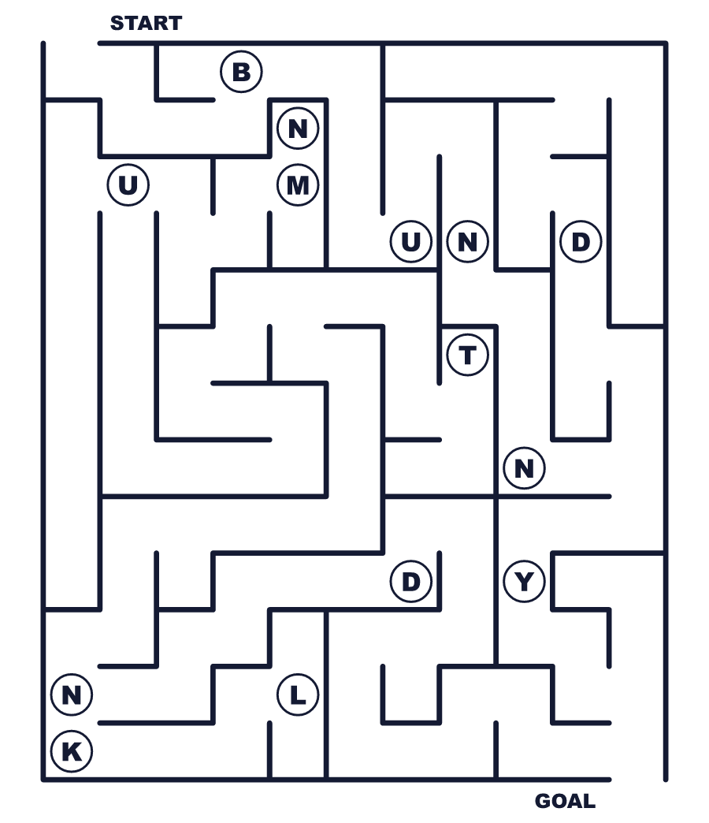
Secret word: ＿ ＿ ＿ ＿ ＿
Put the words in order. 並べかえよう。
1. in / for / eggs / Children / garden / the / look . (子どもたちは庭で卵をさがします。)
______________________________________________________________
2. moon / date / The / decides / Easter / of / the . (月がイースターの日付を決めます。)
______________________________________________________________
3. on / a / always / Sunday / is / Easter . (イースターはいつも日曜日です。)
______________________________________________________________
4. bunny / started / The / Germany / in / story . (ウサギの話はドイツで始まりました。)
______________________________________________________________
5. at / water / in / each / People / other / Poland / throw . (ポーランドの人々は水をかけ合います。)
______________________________________________________________

🐣 Easter Worksheet
Class Activity & Writing
Class ______ No. ____ Name ______________________________
Find Someone Who… クラスで聞いて回ろう！
Find someone who … | Name
… has colored an egg 卵に色をぬったことがある
… has a pet rabbit or wants one ウサギを飼っている、または飼いたい
… likes chocolate eggs チョコレートの卵が好き
… knows the date of Easter this year 今年のイースターの日付を知っている
… has been to a church 教会に行ったことがある
… has done an egg hunt エッグハントをしたことがある
… can name three spring flowers in English 春の花を英語で3つ言える
… likes spring the best 春がいちばん好き
Let's Write! 英語で書いてみよう。
If I were the Easter Bunny, I would hide eggs ______ because ______.
もし私がイースターバニーなら、卵を＿＿に隠します。なぜなら＿＿だからです。
______________________________________________________________
______________________________________________________________
My favorite Easter custom in the world is ______ because ______.
世界のイースターの習慣でいちばん好きなのは＿＿です。なぜなら＿＿だからです。
______________________________________________________________
______________________________________________________________
One new thing I want to start this spring is ______.
この春に始めたい新しいことの1つは＿＿です。
______________________________________________________________
______________________________________________________________

🐣 Easter Worksheet
Trace & Color
なぞって書こう。絵に色をぬろう。
Class ______ No. ____ Name ______________________________
🥚 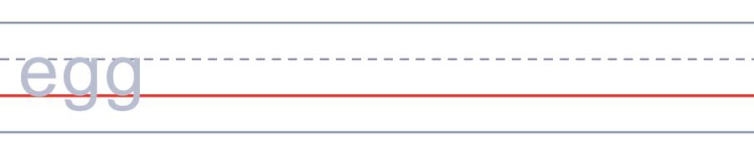

🐰 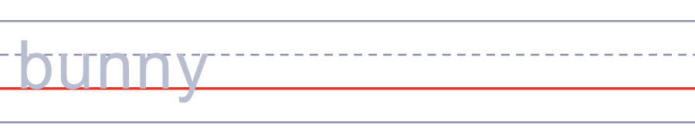
🧺 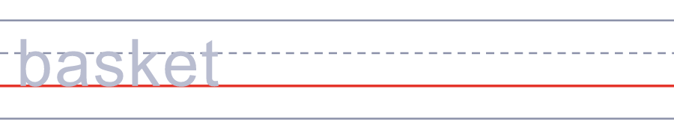
🐑 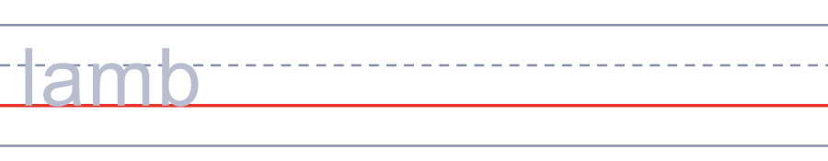
🌕 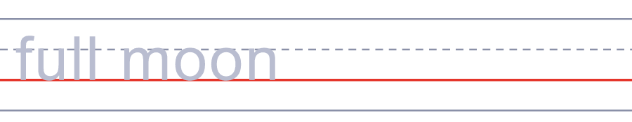
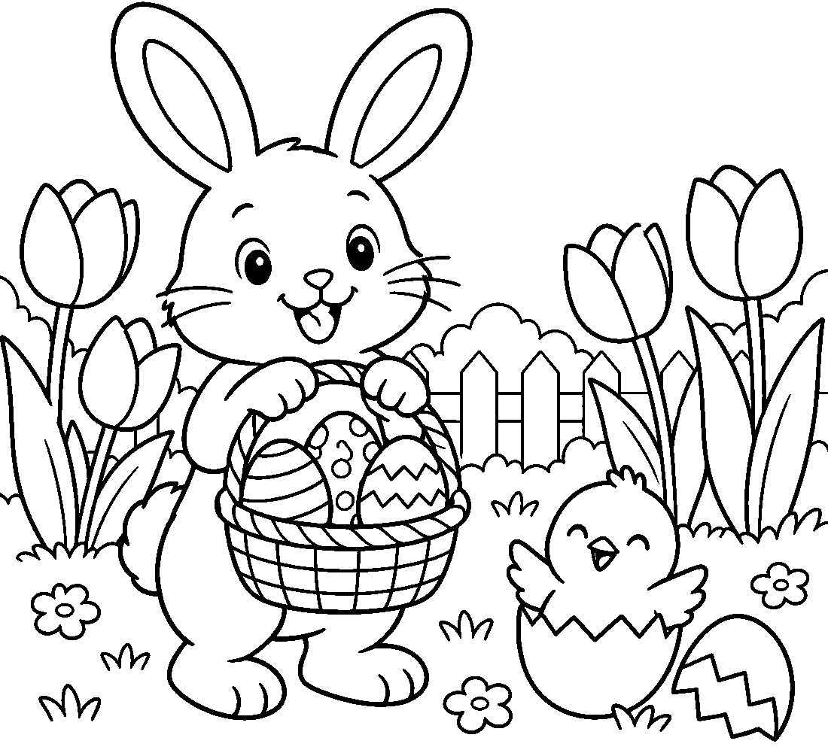

🐣 Easter Worksheet
Answer Key 解答
Reading Check: 1.B 2.C 3.D 4.A 5.C 6.B 7.A 8.D
True or False: 1.T 2.F 3.T 4.F 5.T 6.F
Match: 🥚=egg 🐰=bunny 🧺=basket 🐑=lamb 🌕=full moon ⛪=church 🍫=chocolate 🐣=chick
Unscramble: 1.BUNNY 2.BASKET 3.SPRING 4.CHURCH 5.GARDEN 6.HIDDEN
Fill in the blanks: (1)Sunday (2)basket (3)Bunny (4)garden (5)tree (6)flowers (7)chocolate (8)lamb (9)buns (10)Easter
Sentence order: 1. Children look for eggs in the garden. 2. The moon decides the date of Easter. 3. Easter is always on a Sunday. 4. The bunny story started in Germany. 5. People in Poland throw water at each other.
Secret Code: HAPPY EASTER
Maze: BUNNY
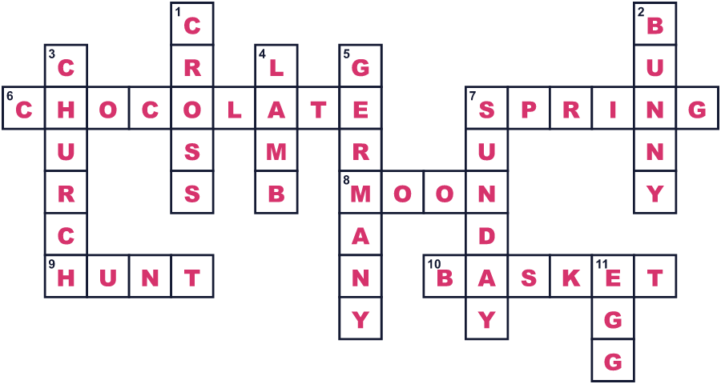
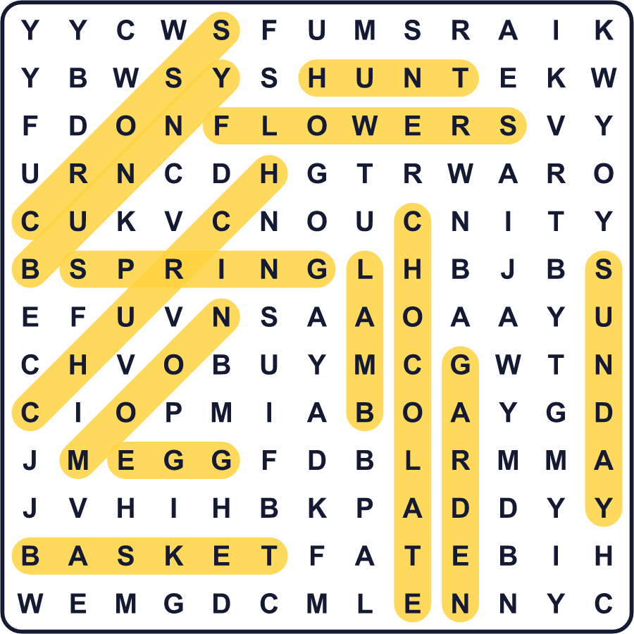
全訳
1 春のある日曜日の朝早く、子どもたちがかごを持って庭へ走り出します。茂みの下や木の後ろをのぞきます。色とりどりの卵が、あちこちに隠れています。チョコレートでできた卵もあれば、青やピンク、金色にぬった本物の卵もあります。誰が隠したのでしょう？もちろん、イースターバニーです。
2 イースターは、キリスト教徒にとっていちばん大切な祝日です。彼らは、イエスが金曜日に十字架の上で死んだと信じています。そして日曜日に、イエスはよみがえりました。イースターは、この新しい命を祝う日です。人々は教会へ行き、喜びの歌を歌い、家族でたくさんのごちそうを食べます。
3 イースターの日付は毎年変わり、それを決めるのは月です。イースターは、春の最初の満月の次の日曜日です。だから3月22日から4月25日までの、どの日曜日にもなりえます。ギリシャやロシアの教会は古い暦を使うので、イースターが遅くなることがよくあります。2027年には、2つのイースターが5週間も離れます。
4 なぜ卵とウサギなのでしょう？昔のヨーロッパでは、イースター前の約40日間、人々は卵を食べませんでした。イースターの日曜日に、ようやく卵に色をつけて食べたのです。卵を運ぶウサギの話は、1600年代のドイツで始まりました。のちに、ドイツの家族がそのウサギをアメリカへ連れていきました。
5 今日、それぞれの国に独自の楽しみがあります。ポーランドでは、イースターの翌日の月曜日に水をかけ合います。オーストラリアでは、ウサギのかわりに、小さな在来の動物ビルビーのチョコレートをもらう子もいます。そしてノルウェーでは、多くの人が休みを推理小説を読んで過ごします。イースターは新しい命の日。そしてどの国も、それぞれのやり方で祝っているのです。

