🌍 Earth Hour Worksheet
One Hour in the Dark
Read the story. 英文を読もう。
Class ______ No. ____ Name ______________________________
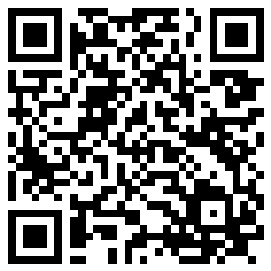
🔊 音声を聞こう（スマホで読みとってね）
1 On March 31, 2007, the lights went out in Sydney, Australia. The famous Opera House became dark. Even the big Harbour Bridge went dark. More than 2.2 million people turned off their lights for one hour. This was the first Earth Hour.
2 The idea came from WWF, a group that protects nature. They wanted to show that people care about the planet. Turning off a light is easy, so anyone can join. The next year, 50 million people in 35 countries took part. Google even made its home page black.
3 Today, Earth Hour happens on a Saturday in late March. It starts at 8:30 p.m. local time. Because the Earth turns, the darkness moves around the world like a wave. Some families eat dinner by candlelight. Others go outside and look at the stars. The Eiffel Tower in Paris and the pyramids in Egypt have joined. Now people in about 190 countries and territories take part.
4 Does one hour save a lot of energy? Not really, and WWF says this too. Earth Hour is a symbol, a sign that people want change. So now WWF asks people to give an hour to the Earth. In 2025, people gave more than 3 million hours to the planet. You can plant a tree, pick up trash, or learn about animals. Then you can keep doing these things after the lights come back on.
Words 単語
turn off（（電気などを）消す） / planet（惑星、地球） / take part（参加する） / local time（現地時間） / energy（エネルギー、電力） / symbol（象徴、シンボル） / dark（暗い） / trash（ごみ）

🌍 Earth Hour Worksheet
Reading Check
Choose the best answer. 正しいものを選ぼう。
Class ______ No. ____ Name ______________________________
1. What is the main idea of the reading?
(A) Earth Hour saves more energy than any other event. (B) Earth Hour began in Sydney and became a worldwide sign of care for the planet. (C) Earth Hour is a day when all the lights in the world must go off. (D) Earth Hour started in Paris and moved to Australia.
2. How many people took part in the first Earth Hour?
(A) More than 50 million (B) About 35,000 (C) About 190 (D) More than 2.2 million
3. Why does the darkness move around the world like a wave?
(A) Because the Earth turns and each place uses its own time. (B) Because WWF turns off the lights one by one. (C) Because the event moves to a new city every year. (D) Because the lights in Sydney go off last.
4. In the reading, what does "symbol" mean?
(A) A kind of light bulb (B) A large building in a city (C) A sign that shows an idea (D) A tool for saving money
5. In the dialogue, what does Riku want to do?
(A) Go to Sydney (B) Look at the stars outside (C) Turn the lights back on (D) Watch TV in the dark
True or False? T か F に○
1. The first Earth Hour was in Sydney. T / F
2. Earth Hour starts at 8:30 in the morning. T / F
3. WWF says Earth Hour saves a lot of energy. T / F
4. Earth Hour is usually on a Saturday in March. T / F

🌍 Earth Hour Worksheet
Word Work
単語のれんしゅう
Class ______ No. ____ Name ______________________________
① Match the pictures and the words. 絵と単語を線でむすぼう。
💡 | ● | ● | tree
🕯️ | ● | ● | candle
🌍 | ● | ● | light
⭐ | ● | ● | Earth
🌳 | ● | ● | star
🌙 | ● | ● | moon
③ Fill in the blanks. 語群から選んで入れよう。
[ energy / music / stars / candle / breakfast / Hour / sun / dark / lights ]
On Saturday night, Mia's family turned off the (1) __________ at 8:30. It was Earth (2) __________ . They ate dinner by (3) __________ light. Then they went outside. The sky was very (4) __________ , and they could see many (5) __________ . "Let's do this again," said Mia. Her father smiled and said, "We can also save (6) __________ every day."

🌍 Earth Hour Worksheet
Crossword Puzzle
ヒントを読んでクロスワードを完成させよう。
Class ______ No. ____ Name ______________________________
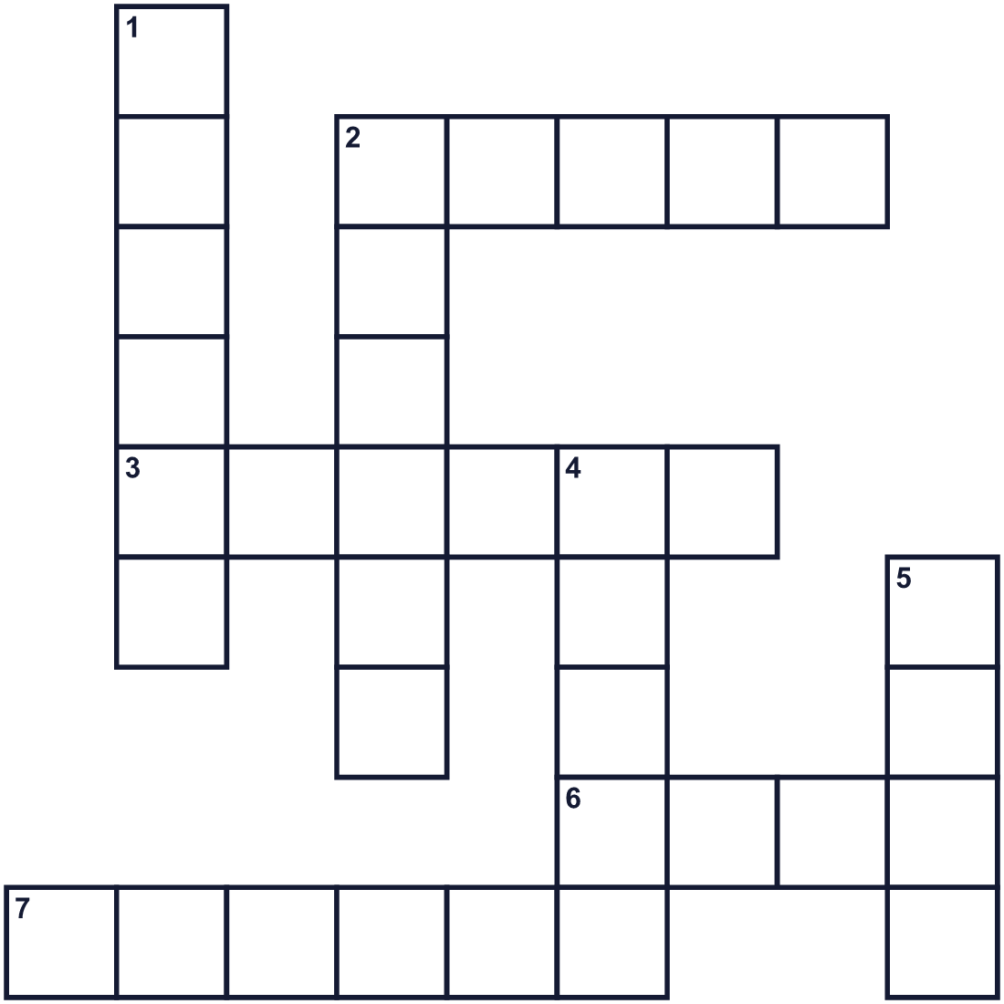
Across →
2. Small lights in the night sky. (5)
3. It has a small fire on top. People use it in the dark. (6)
6. Sixty minutes. (4)
7. The Earth is one. Mars is one, too. (6)
Down ↓
1. You push this on the wall to turn a lamp on or off. (6)
2. The city in Australia where this event started. (6)
4. You turn this on when a room is dark. (5)
5. The opposite of bright. (4)

🌍 Earth Hour Worksheet
Word Search
かくれた単語をさがそう（→ ↓ ↘ ↗）
Class ______ No. ____ Name ______________________________
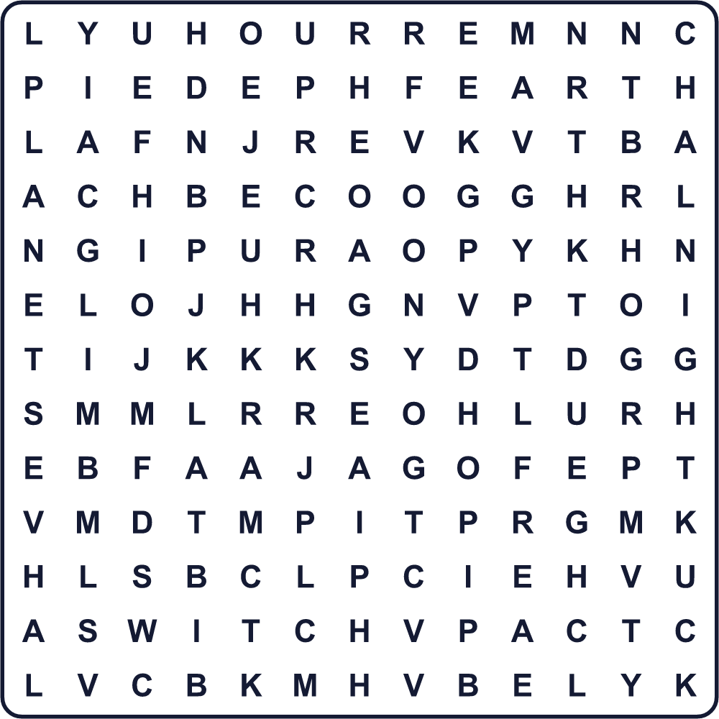
CANDLE DARK EARTH ENERGY HOUR LIGHT NIGHT PLANET STARS SWITCH

🌍 Earth Hour Worksheet
Maze & Sentences
Class ______ No. ____ Name ______________________________
Help Leo turn off the light! レオをスイッチのところまで連れていこう！
正しい道の文字を集めると、ひみつの言葉になるよ。 START 🧒 → GOAL 💡
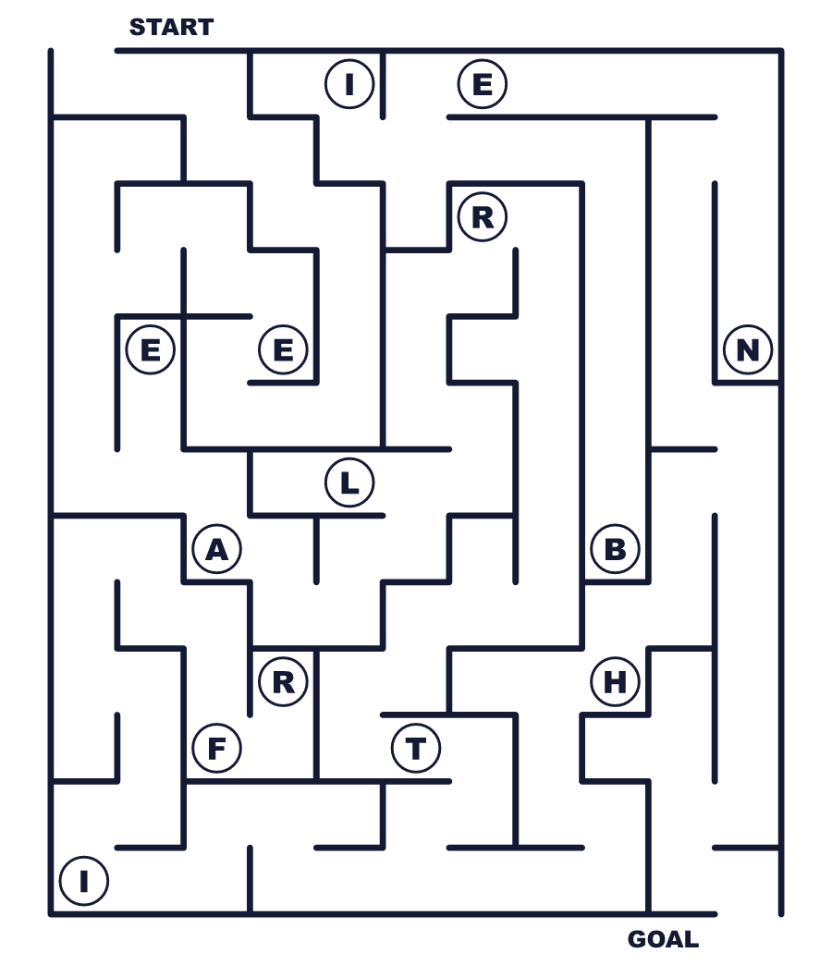
Secret word: ＿ ＿ ＿ ＿ ＿

🌍 Earth Hour Worksheet
Class Activity & Writing
Class ______ No. ____ Name ______________________________
Let's Write! 英語で書いてみよう。
During Earth Hour, I want to ______ because ______.
アースアワーの間、私は______したい。なぜなら______だから。
______________________________________________________________
______________________________________________________________
One thing I can do for the Earth every day is ______.
毎日地球のためにできることの1つは______です。
______________________________________________________________
______________________________________________________________

🌍 Earth Hour Worksheet
Trace & Color
なぞって書こう。絵に色をぬろう。
Class ______ No. ____ Name ______________________________
💡 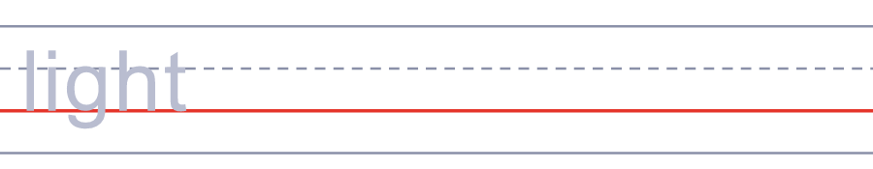

🕯️ 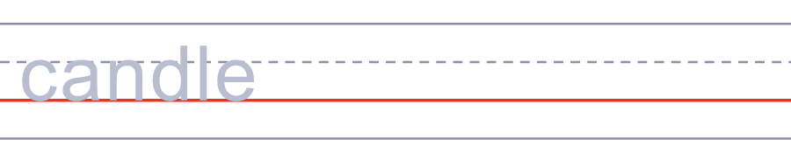
🌍 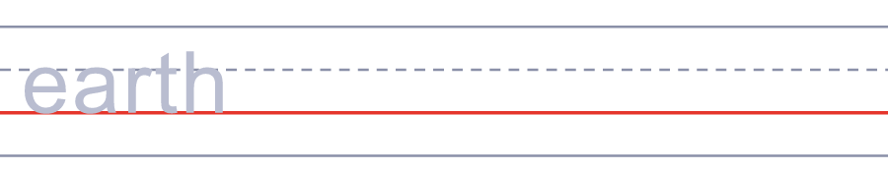
⭐ 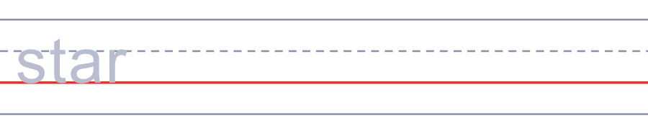
🌳 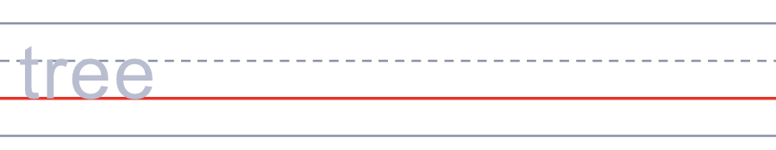

🌍 Earth Hour Worksheet
Answer Key 解答
Reading Check: 1.B 2.D 3.A 4.C 5.B
True or False: 1.T 2.F 3.F 4.T
Match: 💡=light 🕯️=candle 🌍=Earth ⭐=star 🌳=tree 🌙=moon
Fill in the blanks: (1)lights (2)Hour (3)candle (4)dark (5)stars (6)energy
Maze: EARTH
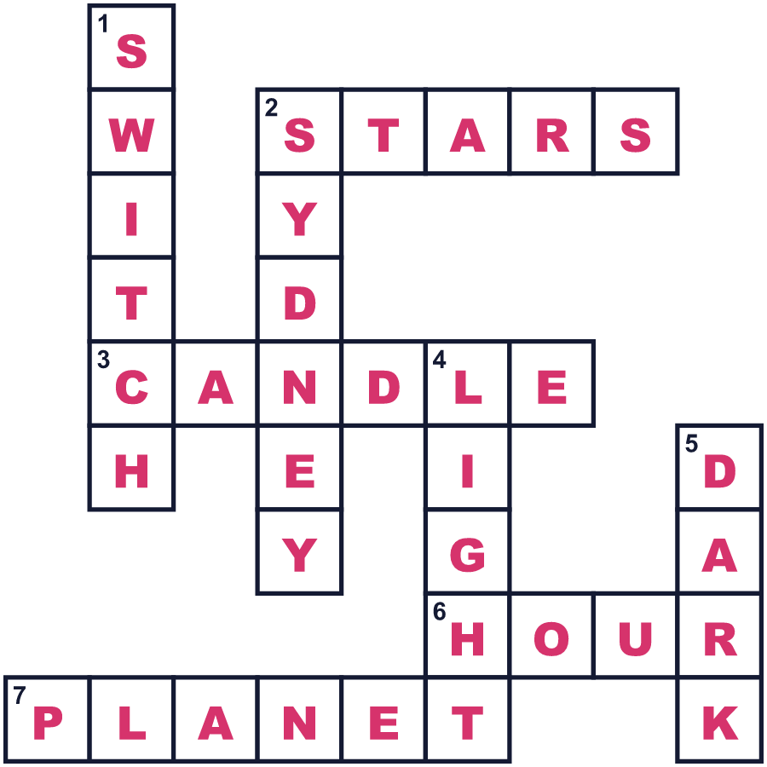
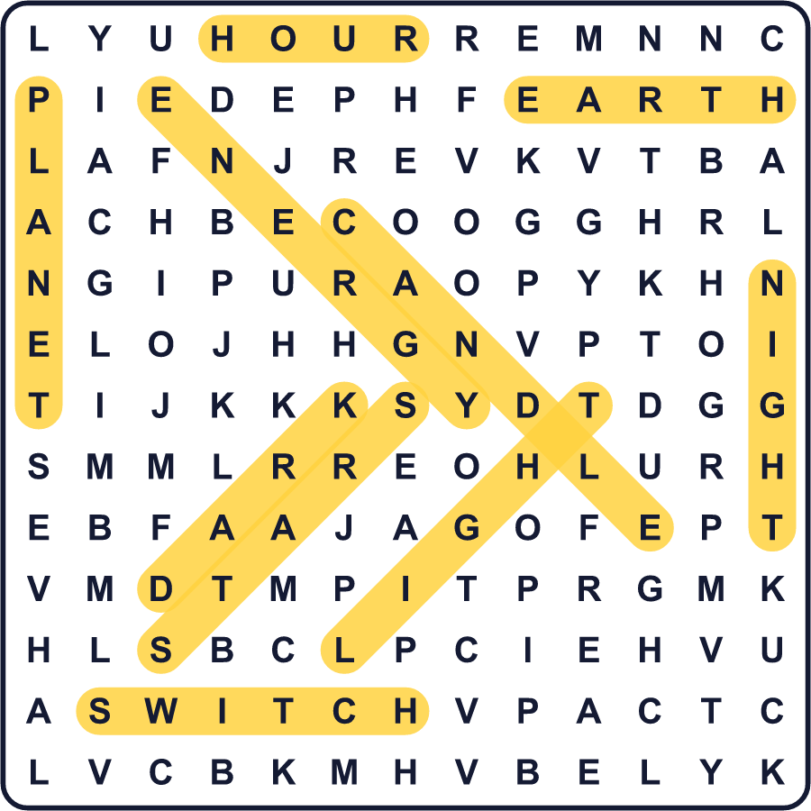
全訳
1 2007年3月31日、オーストラリアのシドニーで明かりが消えました。有名なオペラハウスも暗くなりました。大きなハーバーブリッジまで暗くなりました。220万人以上が、1時間明かりを消したのです。これが最初のアースアワーでした。
2 このアイデアは、自然を守る団体WWFから生まれました。人々が地球を大切に思っていることを示したかったのです。明かりを消すのはかんたんなので、だれでも参加できます。次の年には、35か国で5,000万人が参加しました。グーグルはトップページを黒くしたほどです。
3 今、アースアワーは3月下旬の土曜日に行われます。現地時間の夜8時30分に始まります。地球が回っているので、暗闇は波のように世界を回っていきます。ろうそくの明かりで夕食を食べる家族もいます。外に出て星をながめる人もいます。パリのエッフェル塔やエジプトのピラミッドも参加してきました。今では約190の国と地域の人たちが参加しています。
4 1時間で、たくさんのエネルギーが節約できるのでしょうか。じつはそうでもありません。WWFもそう言っています。アースアワーは象徴、つまり人々が変化を望んでいるというしるしなのです。そこで今、WWFは地球のために1時間を使おうと呼びかけています。2025年には、人々が300万時間以上を地球のために使いました。木を植えたり、ごみを拾ったり、動物について学んだりできます。そして明かりがついたあとも、それを続けていけばいいのです。

