🌍 Earth Day Worksheet
The Day 20 Million People Spoke Up
Read the story. 英文を読もう。
Class ______ No. ____ Name ______________________________
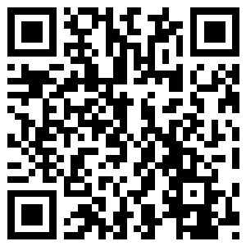
🔊 音声を聞こう（スマホで読みとってね）
1 In January 1969, oil began to pour into the sea near Santa Barbara, California. Black oil covered the beaches. More than 10,000 seabirds, dolphins, seals, and sea lions died. A few months later, a dirty river in Ohio caught fire. Many Americans were shocked and angry.
2 A senator named Gaylord Nelson had an idea. College students were already holding big meetings about the Vietnam War. Why not hold meetings about the environment, too? He asked a young student, Denis Hayes, to help. They chose April 22, a Wednesday between spring break and final exams. That way, many college students could join.
3 On April 22, 1970, about 20 million Americans took part in the first Earth Day. That was one in ten people in the country. In New York City, a famous street was closed to cars. People walked, talked, and cleaned up their towns. By the end of the year, the country had a new government agency to protect the environment.
4 Soon, Earth Day was not only for Americans. In 1990, 200 million people in 141 countries joined. In 2016, leaders from 174 countries and the European Union signed the Paris climate agreement on Earth Day. Today, children around the world plant trees, pick up trash, and learn about plastic.
5 There is even a Japanese bell at the United Nations in New York. It was made from coins from more than 60 countries. Every March, people ring it for another Earth Day. So what can you do on April 22? Turn off a light, carry your own bottle, or pick up one piece of trash. Small actions can add up to a big change.
Words 単語
oil（石油、油） / shocked（ショックを受けた） / senator（上院議員） / environment（環境） / exam（試験） / take part in（～に参加する） / agency（（政府の）機関、庁） / protect（守る） / agreement（協定、合意） / trash（ごみ） / coin（硬貨、コイン） / add up to（合計で～になる）

🌍 Earth Day Worksheet
Reading Check
Choose the best answer. 正しいものを選ぼう。
Class ______ No. ____ Name ______________________________
1. What is the reading mainly about?
(A) How oil is made under the sea (B) The story of Earth Day (C) Life in New York City (D) A famous bell in Japan
2. Why did the organizers choose April 22?
(A) It was a national holiday. (B) It was the senator's birthday. (C) The weather was always sunny. (D) College students were free from breaks and exams.
3. How many Americans took part in the first Earth Day?
(A) About 200 million (B) About 2 million (C) About 20 million (D) About 10,000
4. What happened to a river in Ohio?
(A) It caught fire. (B) It turned black with oil from the sea. (C) It became a new park. (D) It was closed to cars.
5. In paragraph 5, "add up to" means ...
(A) become smaller than (B) together become (C) take away from (D) run away from
6. Which sentence is true about the reading?
(A) The Japanese bell is made only of gold. (B) In 2016, many countries signed an agreement on Earth Day. (C) Earth Day is still only for Americans. (D) The oil spill happened in New York.
7. Why were many Americans shocked and angry in 1969?
(A) Their favorite TV show ended. (B) Students had too many exams. (C) They saw nature badly hurt by pollution. (D) The bell at the UN broke.
8. In the dialogue, what does Olivia ask Kenta to bring?
(A) A bike and a helmet (B) Some young trees to plant (C) A big bag of cans (D) Gloves and his own water bottle
True or False? T か F に○
1. The first Earth Day was in 1970. T / F
2. Earth Day started in Japan. T / F
3. About 20 million Americans joined the first Earth Day. T / F
4. Earth Day is always on the first Sunday of April. T / F
5. The Paris Agreement was signed on Earth Day in 2016. T / F
6. Earth Hour and Earth Day are the same event. T / F

🌍 Earth Day Worksheet
Word Work
単語のれんしゅう
Class ______ No. ____ Name ______________________________
① Match the pictures and the words. 絵と単語を線でむすぼう。
🌍 | ● | ● | light
🌳 | ● | ● | bike
♻️ | ● | ● | recycle
💡 | ● | ● | ocean
🚲 | ● | ● | bell
🌊 | ● | ● | earth
☀️ | ● | ● | sun
🔔 | ● | ● | tree
② Unscramble the words. 並べかえて単語にしよう。
1. E P N L A T (惑星) → ____________________
2. A N O E C (海、大洋) → ____________________
3. R E Y C C L E (リサイクルする) → ____________________
4. R T U A E N (自然) → ____________________
5. N R E G E Y (エネルギー) → ____________________
6. S T A L C I P (プラスチック) → ____________________
③ Fill in the blanks. 語群から選んで入れよう。
[ gloves / trash / snow / angry / lights / bottles / bags / tree / pizza / Earth / day / proud / beach ]
It was (1) __________ Day. Lily and her class went to the (2) __________ near their school. They wore (3) __________ and carried big bags. They found plastic (4) __________ , cans, and old fishing nets. "Fish can't live with all this (5) __________ ," said Lily. After two hours, they had ten full (6) __________ . Then they planted a small (7) __________ in the school garden. Lily's teacher said, "Every (8) __________ can be Earth Day." That night, Lily turned off the (9) __________ she did not need. She felt very (10) __________ .

🌍 Earth Day Worksheet
Crossword Puzzle
ヒントを読んでクロスワードを完成させよう。
Class ______ No. ____ Name ______________________________
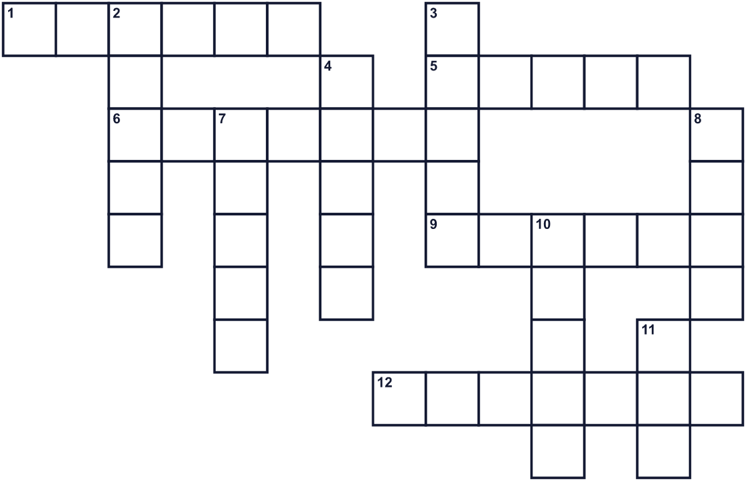
Across →
1. Power from the sun or the wind. (6)
5. Water that flows to the sea. One in Ohio caught fire. (5)
6. To use paper, cans, and bottles again in a new way. (7)
9. Trees, animals, mountains, and the sea. (6)
12. Many bottles and bags are made of this. (7)
Down ↓
2. The planet we live on. (5)
3. The color of leaves and grass. (5)
4. A very large area of salt water. (5)
7. Not dirty. (5)
8. A tall plant with leaves and branches. (4)
10. Things you throw away. (5)
11. A black liquid from under the ground. Cars use it. (3)

🌍 Earth Day Worksheet
Word Search
かくれた単語をさがそう（→ ↓ ↘ ↗）
Class ______ No. ____ Name ______________________________
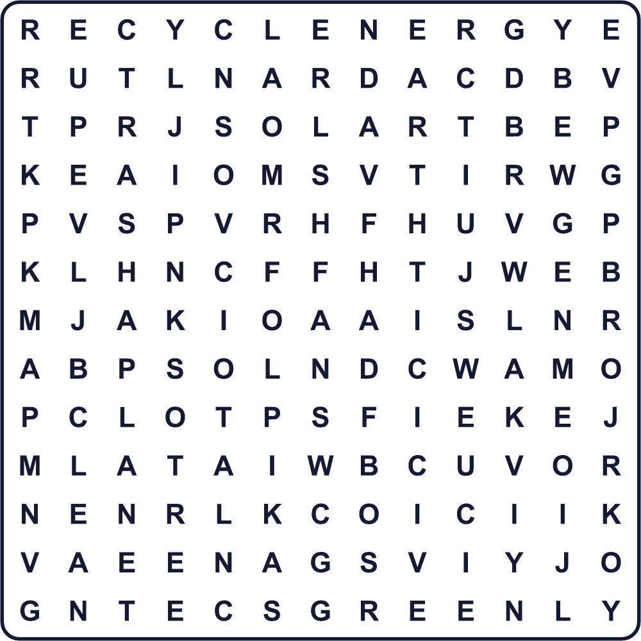
CLEAN EARTH ENERGY GREEN NATURE OCEAN PLANET PLASTIC RECYCLE RIVER SOLAR TRASH TREE
Secret Code 暗号を解こう
☾=A ✚=D ♦=E ☃=H ✈=I ⚑=R ◆=S ⚓=T ☀=V ☂=Y
♦ ☀ ♦ ⚑ ☂ ✚ ☾ ☂ ✈ ◆ ♦ ☾ ⚑ ⚓ ☃ ✚ ☾ ☂
______________________________________________________________

🌍 Earth Day Worksheet
Maze & Sentences
Class ______ No. ____ Name ______________________________
Help Kenta take the bottle to the recycling bin! ケンタがペットボトルをリサイクルの箱まで運べるように手伝おう！
正しい道の文字を集めると、ひみつの言葉になるよ。 START 👦 → GOAL ♻️
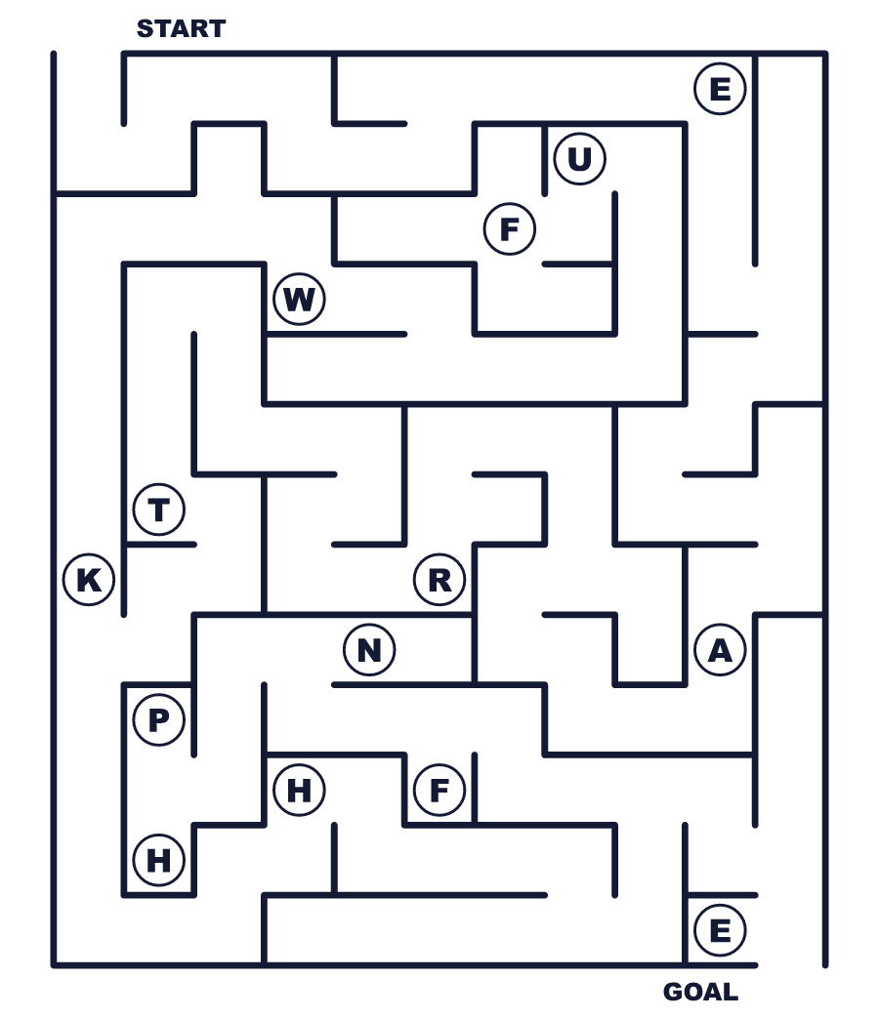
Secret word: ＿ ＿ ＿ ＿ ＿
Put the words in order. 並べかえよう。
1. 1970 / The / was / in / first / Day / Earth . (最初のアースデーは1970年でした。)
______________________________________________________________
2. in / the / trash / park / up / We / pick . (私たちは公園でごみを拾います。)
______________________________________________________________
3. off / Please / lights / turn / the . (明かりを消してください。)
______________________________________________________________
4. bottle / She / water / own / carries / her . (彼女は自分の水筒を持ち歩いています。)
______________________________________________________________
5. plant / Earth / people / Day / Many / on / trees . (多くの人がアースデーに木を植えます。)
______________________________________________________________

🌍 Earth Day Worksheet
Class Activity & Writing
Class ______ No. ____ Name ______________________________
Find Someone Who… クラスで聞いて回ろう！
Find someone who … | Name
… has picked up trash in a park 公園でごみ拾いをしたことがある
… has planted a tree or a flower 木や花を植えたことがある
… likes riding a bike 自転車に乗るのが好き
… can name three things we can recycle リサイクルできる物を3つ言える
… knows how to say Earth in another language 「地球」をほかの言語で言える
… has a reusable water bottle マイボトルを持っている
… knows what the Paris Agreement is パリ協定が何か知っている
… has seen the recycling symbol today 今日リサイクルマークを見た
Let's Write! 英語で書いてみよう。
On Earth Day, I will ______ because ______.
アースデーに、私は______します。なぜなら______だからです。
______________________________________________________________
______________________________________________________________
One thing I want to change in my town is ______.
私の町で変えたいことの1つは______です。
______________________________________________________________
______________________________________________________________
If I were the leader of my country, I would ______ to protect the Earth.
もし私が国のリーダーなら、地球を守るために______します。
______________________________________________________________
______________________________________________________________

🌍 Earth Day Worksheet
Trace & Color
なぞって書こう。絵に色をぬろう。
Class ______ No. ____ Name ______________________________
🌍 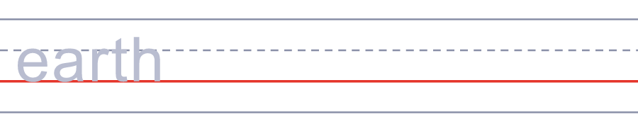

🌳 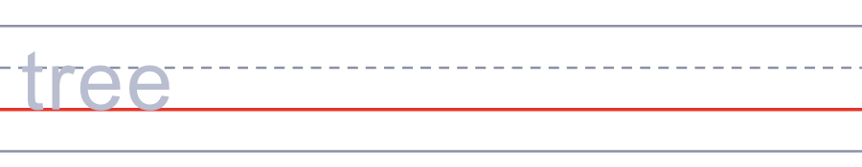
♻️ 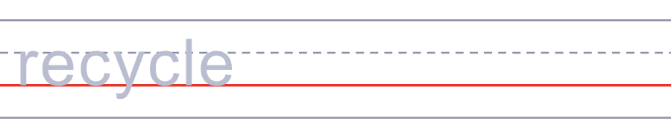
💡 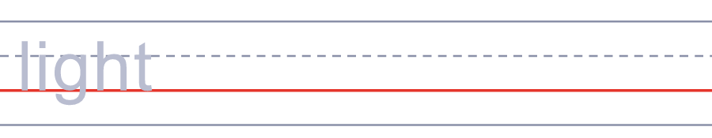
🚲 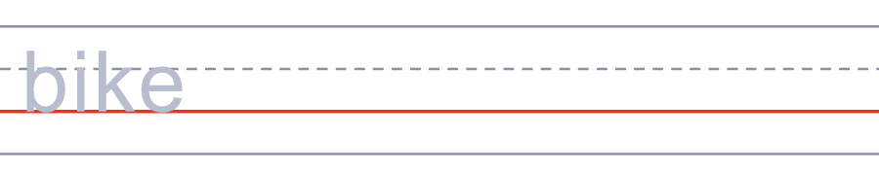
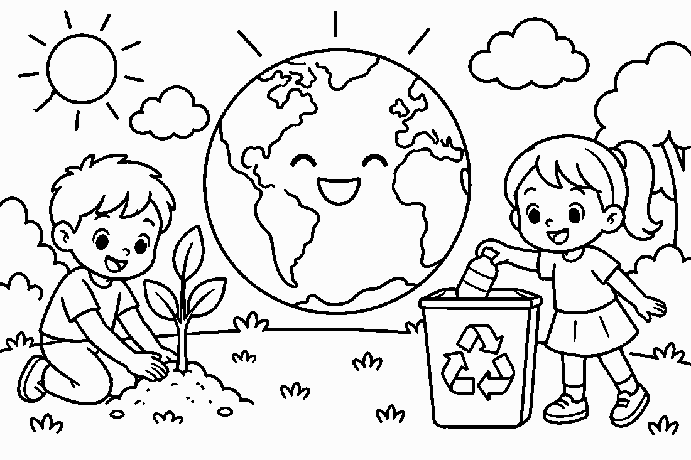

🌍 Earth Day Worksheet
Answer Key 解答
Reading Check: 1.B 2.D 3.C 4.A 5.B 6.B 7.C 8.D
True or False: 1.T 2.F 3.T 4.F 5.T 6.F
Match: 🌍=earth 🌳=tree ♻️=recycle 💡=light 🚲=bike 🌊=ocean ☀️=sun 🔔=bell
Unscramble: 1.PLANET 2.OCEAN 3.RECYCLE 4.NATURE 5.ENERGY 6.PLASTIC
Fill in the blanks: (1)Earth (2)beach (3)gloves (4)bottles (5)trash (6)bags (7)tree (8)day (9)lights (10)proud
Sentence order: 1. The first Earth Day was in 1970. 2. We pick up trash in the park. 3. Please turn off the lights. 4. She carries her own water bottle. 5. Many people plant trees on Earth Day.
Secret Code: EVERY DAY IS EARTH DAY
Maze: EARTH
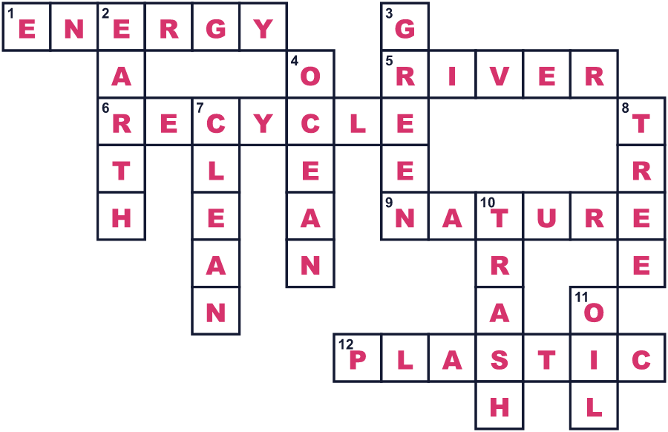
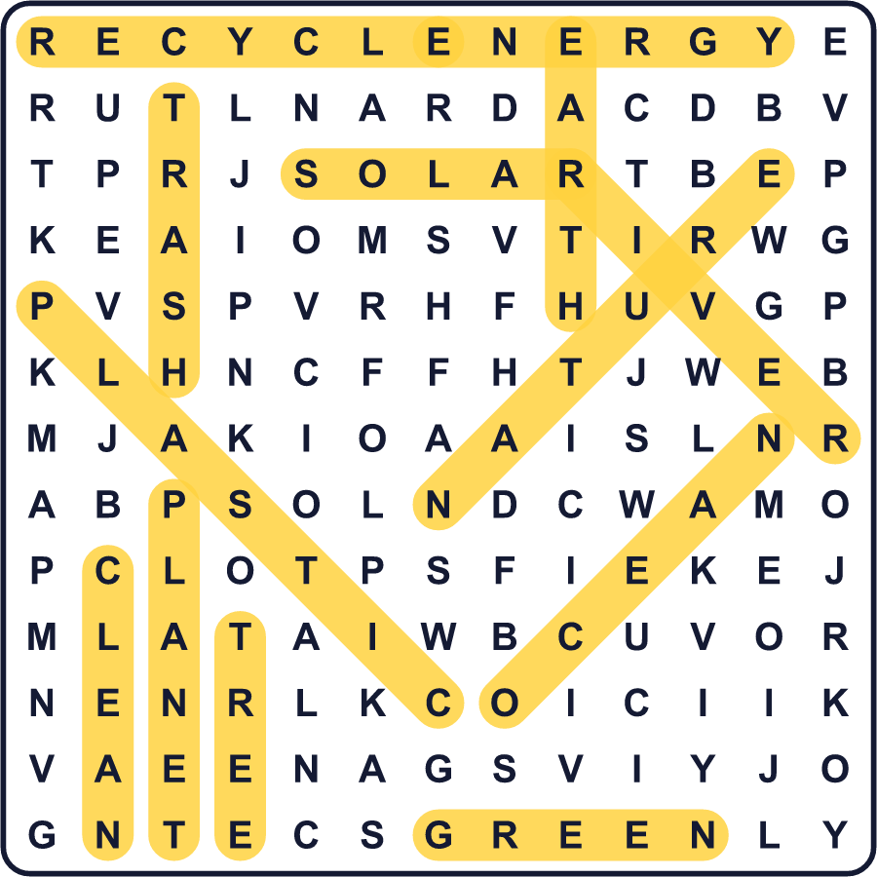
全訳
1 1969年1月、カリフォルニア州サンタバーバラの近くで、原油が海に流れ出し始めました。黒い油が海岸をおおいました。1万をこえる海鳥、イルカ、アザラシ、アシカが死にました。数か月後、オハイオ州の汚れた川が燃えました。多くのアメリカ人がショックを受け、怒りました。
2 ゲイロード・ネルソンという上院議員が、あることを思いつきました。大学生たちは、すでにベトナム戦争について大きな集会を開いていました。環境についても集会を開いたらどうだろう？彼は若い学生のデニス・ヘイズに協力を頼みました。2人が選んだのは、春休みと期末試験のあいだの水曜日、4月22日でした。そうすれば、たくさんの大学生が参加できるからです。
3 1970年4月22日、約2000万人のアメリカ人が最初のアースデーに参加しました。それは国民の10人に1人にあたりました。ニューヨークでは、有名な大通りが車両通行止めになりました。人々は歩き、語り合い、自分たちの町をきれいにしました。その年の終わりまでに、国には環境を守るための新しい政府機関ができていました。
4 やがて、アースデーはアメリカ人だけのものではなくなりました。1990年には、141か国の2億人が参加しました。2016年のアースデーには、174か国とEU（欧州連合）の代表が、気候変動についてのパリ協定に署名しました。今では世界中の子どもたちが、木を植え、ごみを拾い、プラスチックについて学んでいます。
5 ニューヨークの国連本部には、日本の鐘まであります。その鐘は、60をこえる国の硬貨から作られました。毎年3月、もう1つのアースデーのためにその鐘が鳴らされます。では、4月22日にあなたは何ができるでしょう？明かりを1つ消す、自分の水筒を持ち歩く、ごみを1つ拾う。小さな行動が積み重なれば、大きな変化になるのです。

