🐉 Dragon Boat Festival Worksheet
Boats, Dragons, and Rice in Leaves
Read the story. 英文を読もう。
Class ______ No. ____ Name ______________________________

🔊 音声を聞こう（スマホで読みとってね）
1 More than 2,000 years ago, a sad poet stood by a river in southern China. His name was Qu Yuan. He loved his country very much, but the king sent him away. When an enemy army took the capital, Qu Yuan jumped into the river.
2 The story says that local people jumped into their boats to find him. They rowed fast and beat drums to scare the fish away. They also threw rice into the water, so the fish would eat the rice and not the poet. This is how many people explain the start of the Dragon Boat Festival.
3 The festival is on the fifth day of the fifth month of the Chinese lunar calendar. So it usually comes in late May or June. Teams race long, thin boats with dragon heads. Twenty people paddle together, and one person beats a big drum at the front. Families eat zongzi, sticky rice wrapped in bamboo leaves. In the north, many people like sweet zongzi, but in the south, salty ones are popular.
4 Long ago, people believed the fifth month was a dangerous time. It was hot, and many people got sick. So they hung strong-smelling plants on their doors to keep bad things away. Children wore threads of five colors on their wrists for good luck.
5 This festival also traveled to Japan a long time ago. Today, Japanese families celebrate Children's Day on May 5. They eat chimaki, take baths with the same strong-smelling plant, and fly carp streamers. In an old Chinese story, a carp that swims up a waterfall becomes a dragon. So on May 5, there are dragons in Japan, too.
Words 単語
poet（詩人） / capital（首都、都） / row（（舟を）こぐ） / paddle（（パドルで）こぐ） / scare away（おどして追い払う） / lunar（月の、太陰の） / sticky（ねばねばした） / wrap（包む） / dangerous（危険な） / thread（糸） / carp（鯉（こい）） / waterfall（滝）

🐉 Dragon Boat Festival Worksheet
Reading Check
Choose the best answer. 正しいものを選ぼう。
Class ______ No. ____ Name ______________________________
1. What is the main idea of the reading?
(A) How to build a dragon boat (B) The story, customs, and Japanese connection of the Dragon Boat Festival (C) Why Qu Yuan was a bad minister (D) How to catch fish in a river
2. Why did people throw rice into the river?
(A) To feed the dragons (B) To make the water clean (C) So the fish would eat the rice and not the poet (D) To give a gift to the king
3. When does the Dragon Boat Festival usually come?
(A) In late May or June (B) In January (C) On May 5 every year (D) In December
4. How many people paddle in the boat in the reading?
(A) Five (B) Twelve (C) Fifteen (D) Twenty
5. In paragraph 4, what does keep bad things away mean?
(A) keep bad things in a box (B) stop bad things from coming near (C) buy bad things (D) forget bad things
6. Which sentence is true about the reading?
(A) Qu Yuan did not love his country. (B) Everyone in China likes sweet zongzi. (C) The festival traveled to Japan long ago. (D) Children wore threads of one color.
7. Why does the writer say there are dragons in Japan, too?
(A) Because Japan also has dragon boat races on May 5 in Tokyo. (B) Because Japanese people believe in real dragons. (C) Because a carp in an old story becomes a dragon, and families fly carp streamers. (D) Because the dragon is a Japanese symbol for May.
8. In the dialogue, what does Mei's grandma make?
(A) salty zongzi with pork and egg (B) sweet chimaki (C) carp streamers (D) a dragon boat
True or False? T か F に○
1. The Dragon Boat Festival is on May 5 every year in China. T / F
2. Qu Yuan was a poet. T / F
3. People eat zongzi during the festival. T / F
4. A dragon boat usually has only two paddlers. T / F
5. Japan's Children's Day is connected to this festival. T / F
6. Long ago, people thought the fifth month was a lucky and safe time. T / F

🐉 Dragon Boat Festival Worksheet
Word Work
単語のれんしゅう
Class ______ No. ____ Name ______________________________
① Match the pictures and the words. 絵と単語を線でむすぼう。
🐉 | ● | ● | fish
🚣 | ● | ● | wave
🥁 | ● | ● | drum
🍚 | ● | ● | carp streamer
🐟 | ● | ● | rice
🥚 | ● | ● | rowing
🎏 | ● | ● | dragon
🌊 | ● | ● | egg
② Unscramble the words. 並べかえて単語にしよう。
1. A D G N R O (竜) → ____________________
2. E I R R V (川) → ____________________
3. E P A L D D (こぐ) → ____________________
4. T P O E (詩人) → ____________________
5. R A U L N (月の（旧暦の）) → ____________________
6. A M T E (チーム) → ____________________
③ Fill in the blanks. 語群から選んで入れよう。
[ slowly / Hong / salty / boat / snow / second / piano / drum / together / paddlers / proud / eyes / zongzi ]
Mei lives in (1) __________ Kong. This year, she joins a dragon (2) __________ team at her school. There are twenty (3) __________ on the team. Her friend Leo plays the (4) __________ at the front. Before the race, a man paints the (5) __________ of the dragon head red. The race starts! Everyone paddles (6) __________ . Mei's team does not win, but they finish (7) __________ . After the race, they eat (8) __________ with their families. Mei's zongzi is (9) __________ . She feels very (10) __________ .

🐉 Dragon Boat Festival Worksheet
Crossword Puzzle
ヒントを読んでクロスワードを完成させよう。
Class ______ No. ____ Name ______________________________
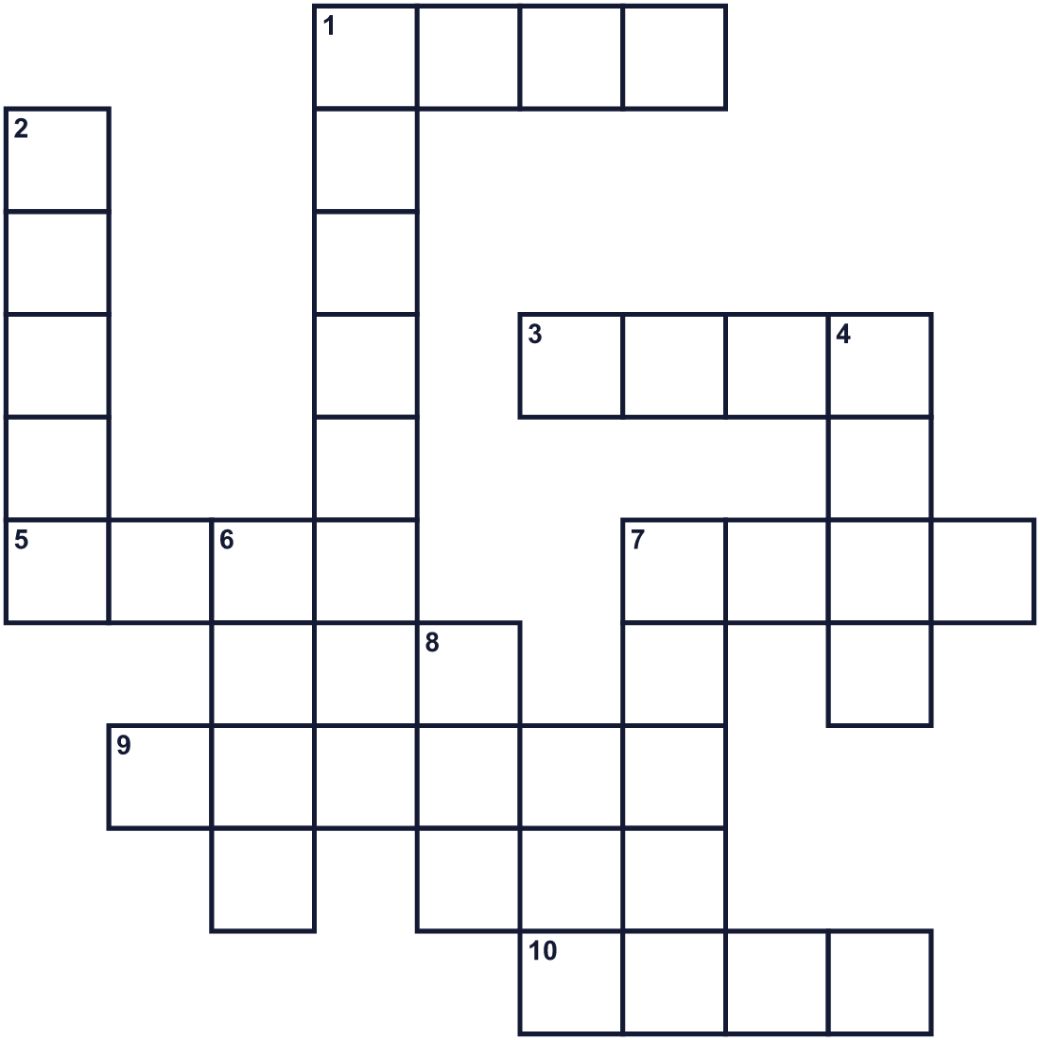
Across →
1. A person who writes poems. (4)
3. You ride in this on water. (4)
5. Small white grains. People in Asia eat it every day. (4)
7. A green part of a plant. Zongzi are wrapped in it. (4)
9. A big animal in stories. It can fly and has scales. (6)
10. You hit this to make a loud sound. (4)
Down ↓
1. To move a boat with a short pole with a wide end. (6)
2. Water that flows to the sea. (5)
4. A group of people who play or work together. (4)
6. A big fish. Japanese streamers on May 5 look like it. (4)
7. About the moon. This kind of calendar follows it. (5)
8. In Taiwan, people try to stand this up at noon. (3)

🐉 Dragon Boat Festival Worksheet
Word Search
かくれた単語をさがそう（→ ↓ ↘ ↗）
Class ______ No. ____ Name ______________________________
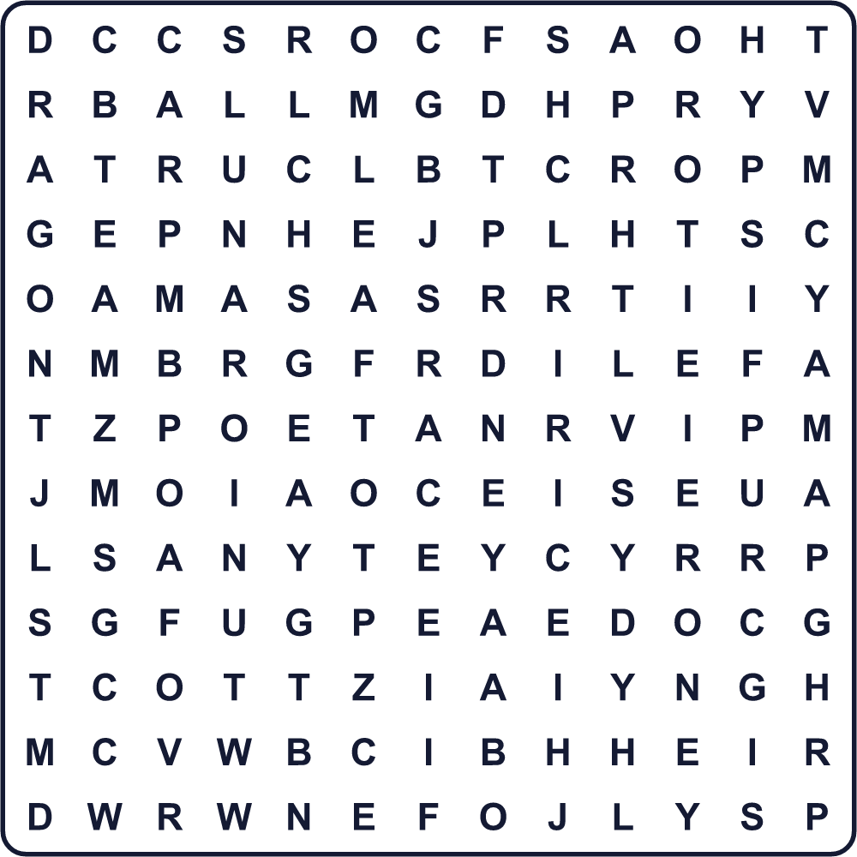
BOAT CARP DRAGON DRUM EGG LEAF LUNAR POET RACE RICE RIVER TEAM ZONGZI
Secret Code 暗号を解こう
✿=A ▲=D ✂=E ☎=G ⚓=H ✚=L ✉=O ◎=P ◆=R ☘=T
◎ ✿ ▲ ▲ ✚ ✂ ☘ ✉ ☎ ✂ ☘ ⚓ ✂ ◆
______________________________________________________________

🐉 Dragon Boat Festival Worksheet
Maze & Sentences
Class ______ No. ____ Name ______________________________
Help the dragon boat reach the finish line! ドラゴンボートをゴールまで連れていこう！
正しい道の文字を集めると、ひみつの言葉になるよ。 START 🚣 → GOAL 🏁
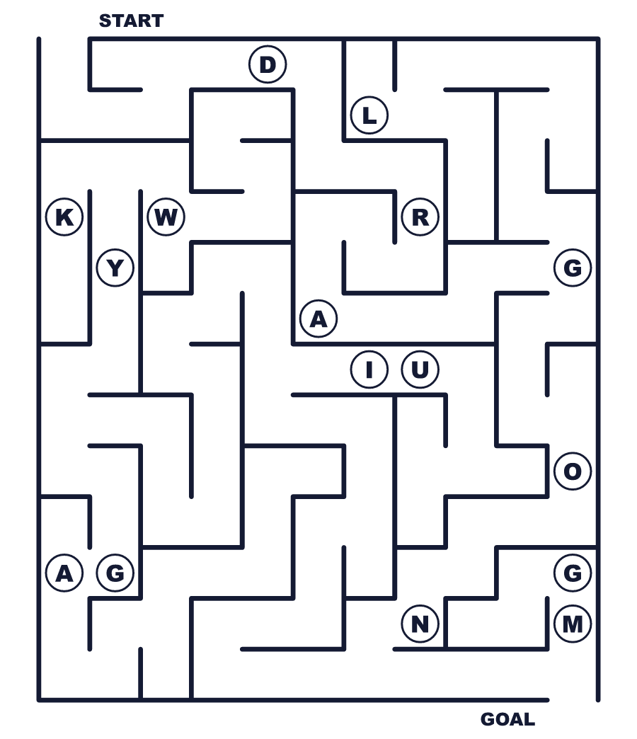
Secret word: ＿ ＿ ＿ ＿ ＿ ＿
Put the words in order. 並べかえよう。
1. Qu / in / China / Yuan / poet / a / was . (屈原は中国の詩人でした。)
______________________________________________________________
2. heads / race / People / with / dragon / boats . (人々は竜の頭のついた舟で競争します。)
______________________________________________________________
3. this / zongzi / day / on / We / eat . (私たちはこの日にちまきを食べます。)
______________________________________________________________
4. at / drum / the / front / person / a / One / beats . (1人が先頭で太鼓をたたきます。)
______________________________________________________________
5. Japanese / fly / May / carp / families / in / streamers . (日本の家族は5月にこいのぼりをあげます。)
______________________________________________________________

🐉 Dragon Boat Festival Worksheet
Class Activity & Writing
Class ______ No. ____ Name ______________________________
Find Someone Who… クラスで聞いて回ろう！
Find someone who … | Name
… has eaten chimaki or zongzi ちまきを食べたことがある
… has eaten kashiwa-mochi 柏餅を食べたことがある
… has taken a shobu bath 菖蒲湯に入ったことがある
… can stand an egg on its end 卵を立てられる
… has been in a boat 舟（ボート）に乗ったことがある
… knows the name of a famous poet 有名な詩人の名前を知っている
… likes sweet food more than salty food しょっぱい物より甘い物が好き
… can play the drum 太鼓が演奏できる
Let's Write! 英語で書いてみよう。
On the Dragon Boat Festival, people ______. In Japan on May 5, we ______.
端午節には人々は＿＿します。日本では5月5日に私たちは＿＿します。
______________________________________________________________
______________________________________________________________
I like ______ zongzi better because ______.
私は＿＿ちまきの方が好きです。なぜなら＿＿だからです。
______________________________________________________________
______________________________________________________________
If I joined a dragon boat team, I would want to be the ______ because ______.
ドラゴンボートのチームに入るなら、私は＿＿になりたいです。なぜなら＿＿だからです。
______________________________________________________________
______________________________________________________________

🐉 Dragon Boat Festival Worksheet
Trace & Color
なぞって書こう。絵に色をぬろう。
Class ______ No. ____ Name ______________________________
🐉 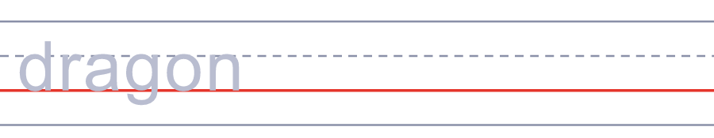

🚣 
🥁 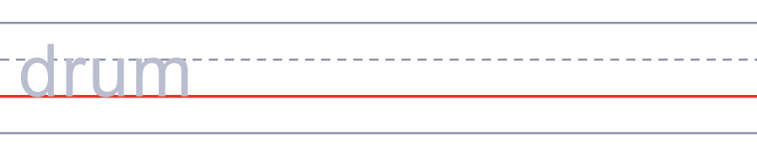
🍚 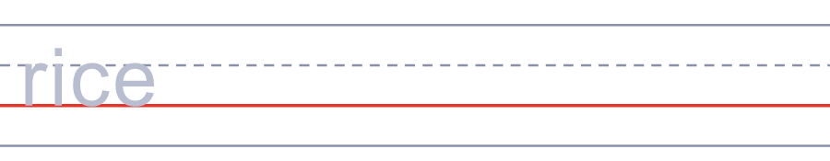
🐟 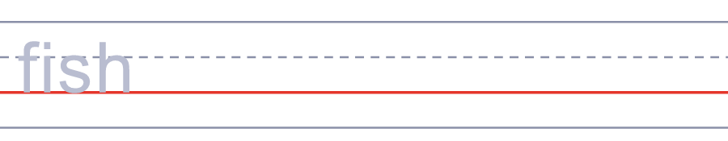
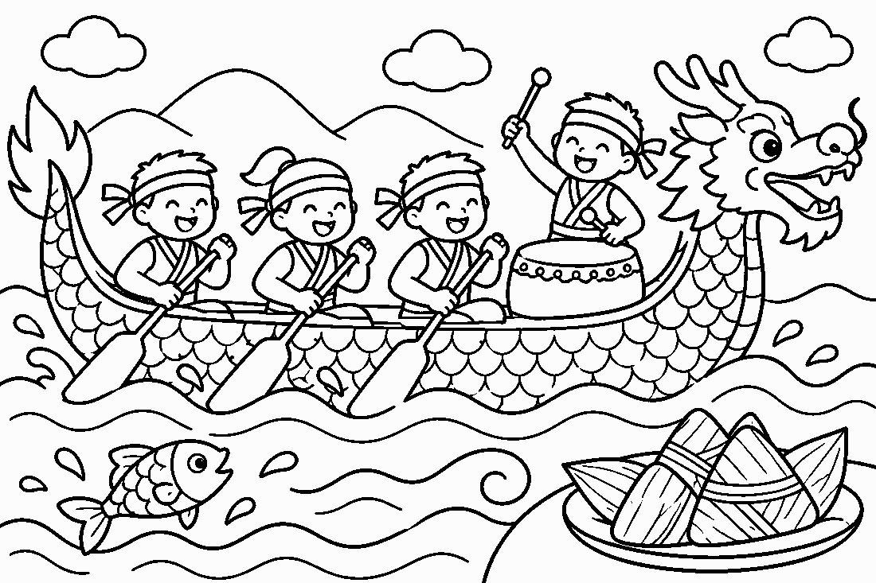

🐉 Dragon Boat Festival Worksheet
Answer Key 解答
Reading Check: 1.B 2.C 3.A 4.D 5.B 6.C 7.C 8.A
True or False: 1.F 2.T 3.T 4.F 5.T 6.F
Match: 🐉=dragon 🚣=rowing 🥁=drum 🍚=rice 🐟=fish 🥚=egg 🎏=carp streamer 🌊=wave
Unscramble: 1.DRAGON 2.RIVER 3.PADDLE 4.POET 5.LUNAR 6.TEAM
Fill in the blanks: (1)Hong (2)boat (3)paddlers (4)drum (5)eyes (6)together (7)second (8)zongzi (9)salty (10)proud
Sentence order: 1. Qu Yuan was a poet in China. 2. People race boats with dragon heads. 3. We eat zongzi on this day. 4. One person beats a drum at the front. 5. Japanese families fly carp streamers in May.
Secret Code: PADDLE TOGETHER
Maze: DRAGON
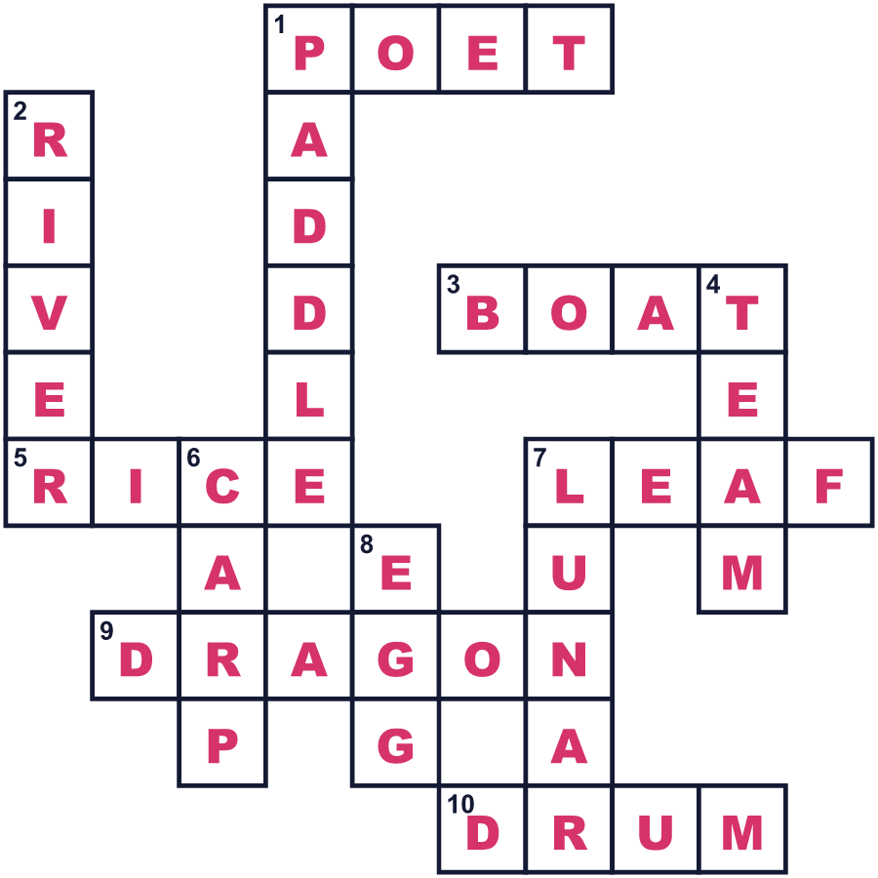
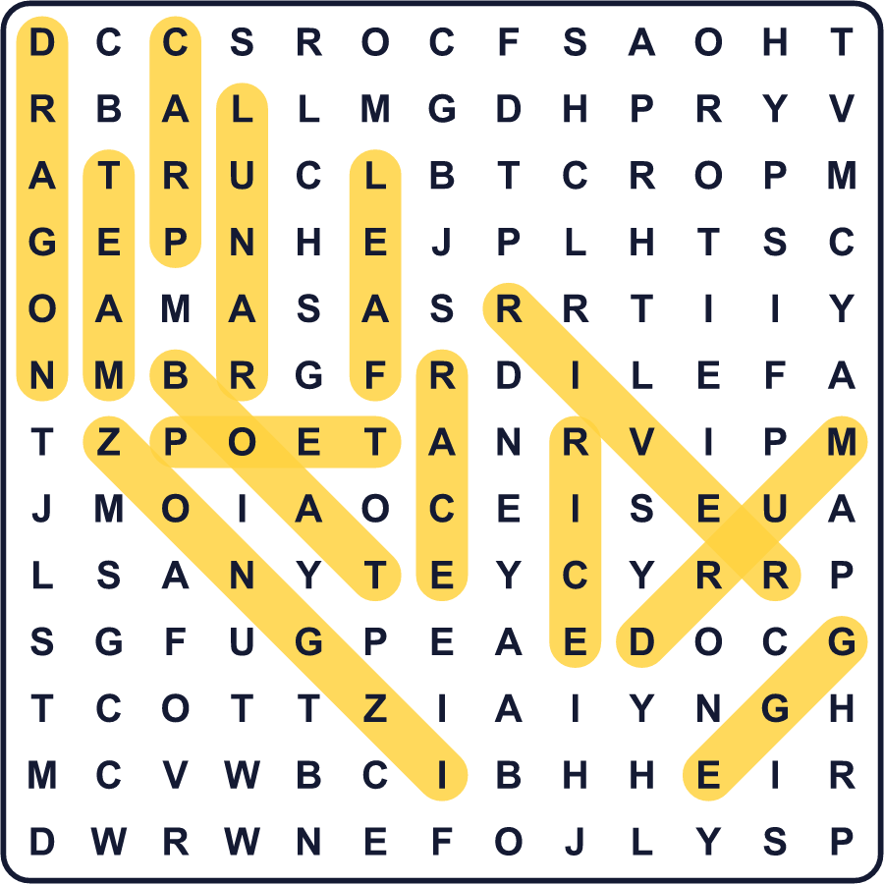
全訳
1 2000年以上前、中国南部のある川のそばに、悲しみにくれた一人の詩人が立っていました。名前は屈原といいました。彼は国を深く愛していましたが、王は彼を都から追い出しました。敵の軍が都を奪ったとき、屈原は川に身を投げました。
2 言い伝えによると、地元の人々は彼を探すために急いで舟に乗りこみました。人々は速く舟をこぎ、魚を追い払うために太鼓をたたきました。また、魚が詩人ではなく米を食べるように、米を川に投げ入れました。これが、多くの人が語る端午節の始まりです。
3 この祭りは、中国の旧暦の5月5日にあります。そのため、たいてい5月下旬か6月に来ます。チームが、竜の頭をつけた細長い舟で競争します。20人がいっしょにこぎ、1人が先頭で大きな太鼓をたたきます。家族は、竹の葉で包んだもち米のちまきを食べます。北では甘いちまきが好きな人が多く、南ではしょっぱいちまきが人気です。
4 昔、人々は5月が危険な時期だと信じていました。暑くて、病気になる人がたくさんいたのです。そこで、悪いものを遠ざけるため、香りの強い草を門にかけました。子どもたちは、幸運を願って手首に五色の糸を結びました。
5 この祭りは、ずっと昔に日本にも伝わりました。今、日本の家族は5月5日にこどもの日を祝います。ちまきを食べ、同じ香りの強い草を入れたお風呂に入り、こいのぼりをあげます。中国の古い物語では、滝をのぼった鯉は竜になります。だから5月5日には、日本にも竜がいるのです。

