🐂 Doyo no Ushi no Hi (Eel Day) Worksheet
The Eel Day of Summer
Read the story. 英文を読もう。
Class ______ No. ____ Name ______________________________

🔊 音声を聞こう（スマホで読みとってね）
1 In late July, a sweet and smoky smell fills the streets of Japan. It comes from grilled eel, called unagi. Long lines form outside eel shops, and supermarkets put up big flags with one letter, u. This is Doyo no Ushi no Hi, the Day of the Ox in summer.
2 The name comes from the old calendar. Doyo is a period of about 18 days before a new season starts. Ushi means ox, one of the 12 animals of the Chinese zodiac. In the old calendar, each day also has one of these animals, so an ox day comes every 12 days. Some summers have two ox days, and others have only one.
3 Why eel? A famous story says that a scholar named Hiraga Gennai helped an eel shop in the 1700s. Summer was a slow season for the shop. He told the owner to put up a sign that said, "Today is the Day of the Ox." But nobody knows if this story is true. Still, the idea is very old. A poem from about 1,300 years ago tells a thin friend to eat eel in summer.
4 Today, there are fewer eels in the wild. Japanese eels are born in the ocean near the Mariana Islands, about 2,000 kilometers away. Scientists in Japan can now raise eels from eggs, but it is still very expensive. So people are asking a new question. How can we keep this tasty summer custom and protect the eels at the same time?
Words 単語
grilled（（網や火で）焼いた） / smoky（煙のにおいがする、香ばしい） / zodiac（（十二支などの）干支、星座） / period（期間） / scholar（学者） / sign（看板、貼り紙） / custom（習慣、しきたり） / protect（守る）

🐂 Doyo no Ushi no Hi (Eel Day) Worksheet
Reading Check
Choose the best answer. 正しいものを選ぼう。
Class ______ No. ____ Name ______________________________
1. What is the main idea of the reading?
(A) Japanese people eat beef on a summer ox day. (B) Doyo no Ushi no Hi is a summer day for eating eel. (C) Eels are born in rivers in Tokyo. (D) Hiraga Gennai opened the first eel shop.
2. How often does an ox day come in the old calendar?
(A) Every 7 days (B) Every 18 days (C) Every 30 days (D) Every 12 days
3. What does the reading say about the Hiraga Gennai story?
(A) Nobody knows if it is true. (B) It is written in a 1,300-year-old poem. (C) It happened in winter. (D) It is a story from Canada.
4. In paragraph 3, what does "a slow season" mean?
(A) A season when people walk slowly (B) A season with very long days (C) A season when few customers come (D) A season when eels swim slowly
5. In the dialogue, why does Emily think they will eat beef?
(A) Because Sota likes steak. (B) Because the day is called the Day of the Ox. (C) Because eel is too expensive. (D) Because it is a Canadian custom.
True or False? T か F に○
1. Doyo no Ushi no Hi is on the same date every year. T / F
2. An ox day comes every 12 days in the old calendar. T / F
3. Everyone agrees that the Hiraga Gennai story is true. T / F
4. Japanese eels are born in the ocean far from Japan. T / F

🐂 Doyo no Ushi no Hi (Eel Day) Worksheet
Word Work
単語のれんしゅう
Class ______ No. ____ Name ______________________________
① Match the pictures and the words. 絵と単語を線でむすぼう。
🐂 | ● | ● | fire
🍚 | ● | ● | chopsticks
🔥 | ● | ● | ox
☀️ | ● | ● | ocean
🌊 | ● | ● | sun
🥢 | ● | ● | rice
③ Fill in the blanks. 語群から選んで入れよう。
[ snow / winter / cake / energy / smoky / shop / grilled / rice / Ox / July ]
It was a hot day in (1) __________ . Mom said, "Today is the Day of the (2) __________ !" We went to an old eel (3) __________ . The air smelled sweet and (4) __________ . The cook (5) __________ the eel over hot charcoal. Then he put it on (6) __________ in a red box. I ate every bite. Dad smiled and said, "Now we have (7) __________ for the summer!"

🐂 Doyo no Ushi no Hi (Eel Day) Worksheet
Crossword Puzzle
ヒントを読んでクロスワードを完成させよう。
Class ______ No. ____ Name ______________________________
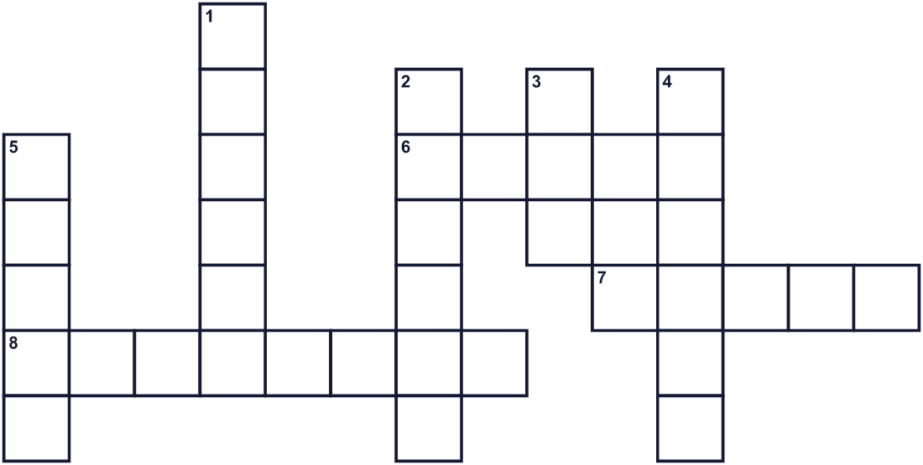
Across →
6. A very big sea. The Pacific is one. (5)
7. To cook food over a fire. (5)
8. Black fuel from burned wood. Cooks use it for unagi. (8)
Down ↓
1. The hottest season of the year. (6)
2. The 12 animals: rat, ox, tiger, rabbit and more. (6)
3. A long fish that looks like a snake. In Japanese, unagi. (3)
4. You need it to run and play. Food gives it to you. (6)
5. A sweet brown liquid you put on the fish. (5)

🐂 Doyo no Ushi no Hi (Eel Day) Worksheet
Word Search
かくれた単語をさがそう（→ ↓ ↘ ↗）
Class ______ No. ____ Name ______________________________
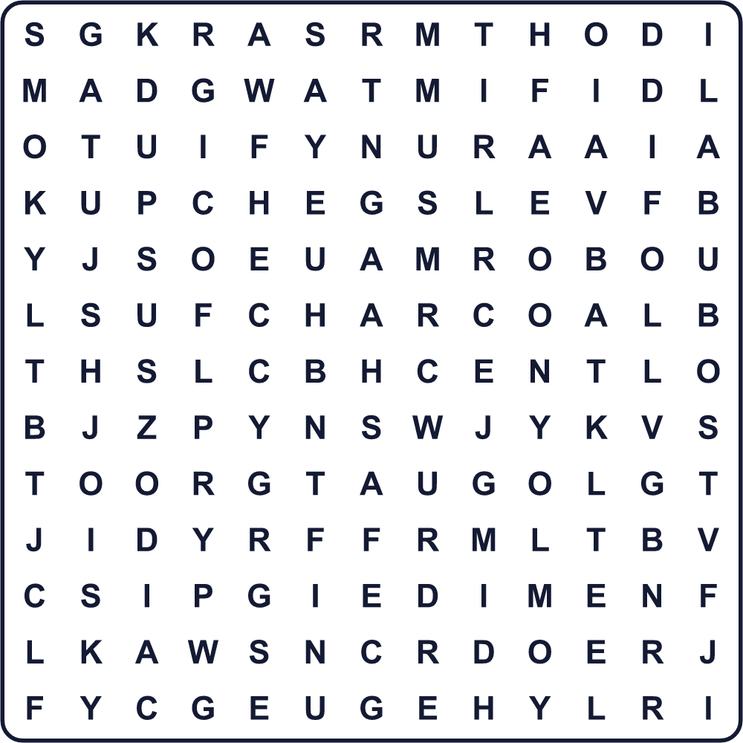
CHARCOAL EEL ENERGY GRILL JULY RICE SAUCE SMOKY SUMMER ZODIAC

🐂 Doyo no Ushi no Hi (Eel Day) Worksheet
Maze & Sentences
Class ______ No. ____ Name ______________________________
Help Sota get to the eel shop! ソウタをうなぎ屋まで連れていこう！
正しい道の文字を集めると、ひみつの言葉になるよ。 START 🧒 → GOAL 🍱
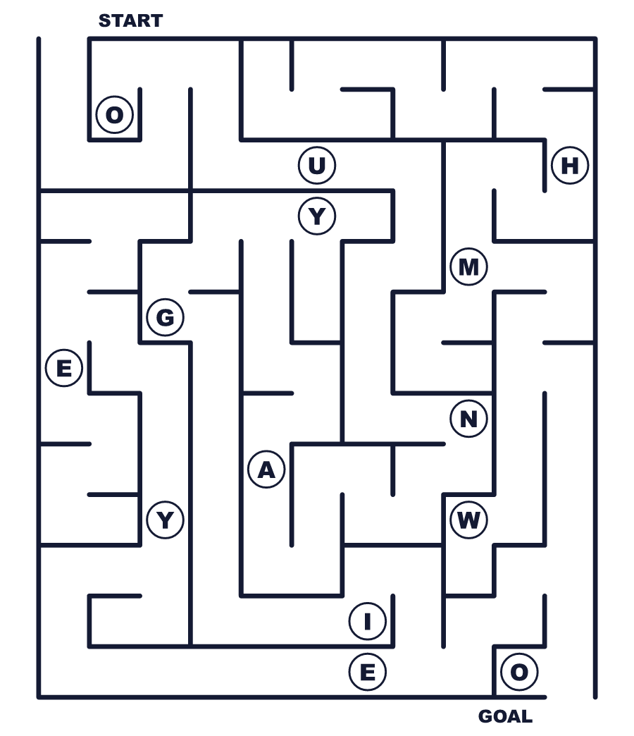
Secret word: ＿ ＿ ＿ ＿ ＿

🐂 Doyo no Ushi no Hi (Eel Day) Worksheet
Class Activity & Writing
Class ______ No. ____ Name ______________________________
Let's Write! 英語で書いてみよう。
To beat the summer heat, I like to eat ______ because ______.
夏の暑さに負けないように、私は＿＿を食べるのが好きです。なぜなら＿＿だからです。
______________________________________________________________
______________________________________________________________
If I explain the Day of the Ox to a friend from abroad, I will say, "______."
海外の友だちに土用の丑の日を説明するなら、「＿＿」と言います。
______________________________________________________________
______________________________________________________________

🐂 Doyo no Ushi no Hi (Eel Day) Worksheet
Trace & Color
なぞって書こう。絵に色をぬろう。
Class ______ No. ____ Name ______________________________
🐂 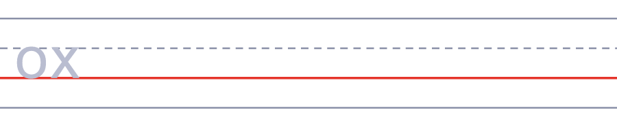

🍚 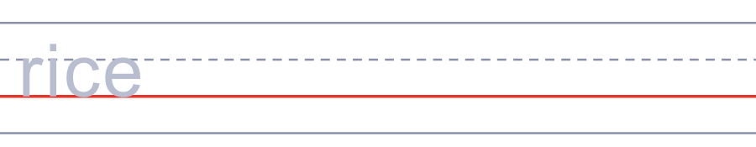
🔥 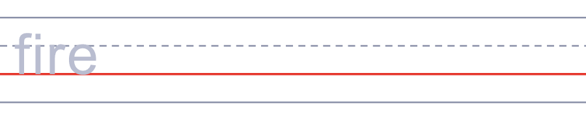
☀️ 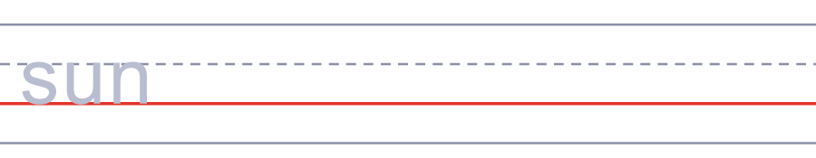
🌊 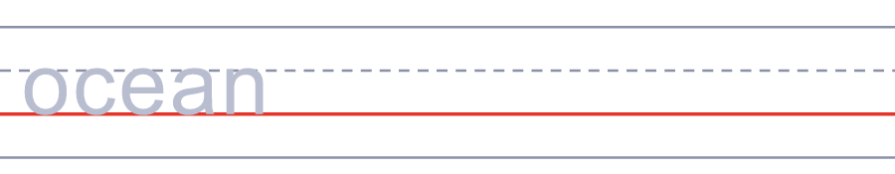

🐂 Doyo no Ushi no Hi (Eel Day) Worksheet
Answer Key 解答
Reading Check: 1.B 2.D 3.A 4.C 5.B
True or False: 1.F 2.T 3.F 4.T
Match: 🐂=ox 🍚=rice 🔥=fire ☀️=sun 🌊=ocean 🥢=chopsticks
Fill in the blanks: (1)July (2)Ox (3)shop (4)smoky (5)grilled (6)rice (7)energy
Maze: UNAGI
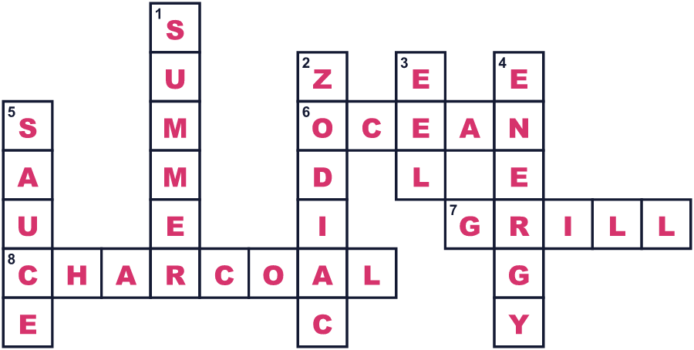
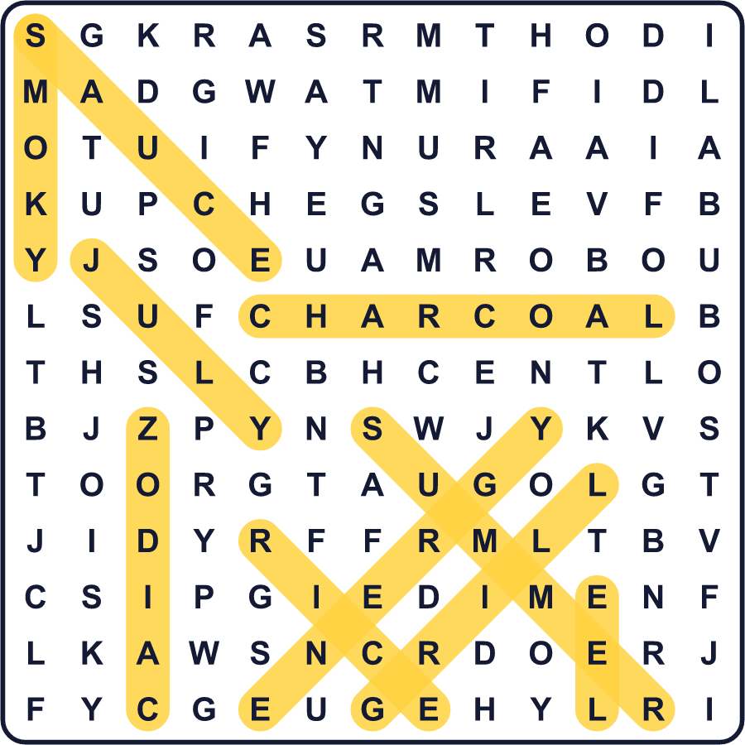
全訳
1 7月の終わり、日本の通りに甘くて香ばしいにおいが広がります。それは「うなぎ」と呼ばれる、焼いたうなぎのにおいです。うなぎ屋の前には長い列ができ、スーパーは「う」の1文字の大きな旗を立てます。これが土用の丑の日、夏の丑の日です。
2 この名前は昔の暦から来ています。土用とは、新しい季節が始まる前の約18日間のことです。丑は牛のことで、十二支の12の動物の一つです。昔の暦では、日にもこの動物が一つずつ割り当てられているので、丑の日は12日ごとに来ます。丑の日が2回ある夏もあれば、1回だけの夏もあります。
3 なぜうなぎなのでしょう。有名な話では、1700年代に平賀源内という学者がうなぎ屋を助けたと言われます。夏はそのお店にとって客の少ない季節でした。源内は店主に「本日丑の日」と書いた紙を貼るように言いました。でも、この話が本当かどうかは誰にもわかりません。それでも、この考え方はとても古いものです。約1300年前の歌に、やせた友人に夏はうなぎを食べるように言うものがあります。
4 今、自然の中のうなぎは減っています。ニホンウナギは、約2,000km離れたマリアナ諸島の近くの海で生まれます。日本の科学者は今では卵からうなぎを育てられますが、まだとてもお金がかかります。だから人々は新しい問いを考えています。このおいしい夏の習慣を守りながら、同時にうなぎも守るにはどうしたらよいのでしょう。

