📚 Book Week in Japan (Dokusho Shukan) Worksheet
Two Weeks for Books
Read the story. 英文を読もう。
Class ______ No. ____ Name ______________________________
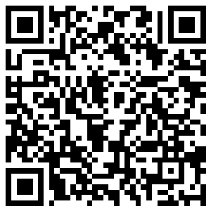
🔊 音声を聞こう（スマホで読みとってね）
1 In the fall of 1947, many cities in Japan still had burned buildings. The war had ended only two years before. Food was hard to find, but people still wanted to read. So publishers, bookstores, libraries, and newspapers came together. They started a new event called Dokusho Shukan, or Book Week.
2 Their message was simple: we can build a peaceful country through reading. About 30 groups joined, and the first Book Week was a big success. People said one week was not long enough. So from the next year, Book Week became two weeks long. Today it runs from October 27 to November 9. Culture Day, a national holiday on November 3, is right in the middle.
3 Every year, Book Week has a new slogan and a new poster. Anyone can send in an idea for the slogan. The slogan for 2026 is "Quiet, but on an adventure." A reader looks quiet, but in the story, the reader is traveling far away. During these two weeks, libraries hold story times, and bookstores set up special tables. In Tokyo, a street of old bookstores holds a big sale of about one million used books.
4 But reading in Japan is changing. In a government survey from 2024, about 63 percent of people aged 16 and over read no books in a month. Many people who read less said that phones and other devices take up their time. Book Week asks a simple question. When did you last read a book that you could not put down?
Words 単語
publisher（出版社） / peaceful（平和な） / slogan（標語、スローガン） / poster（ポスター） / adventure（冒険） / used（中古の） / survey（調査、アンケート） / page-turner（読み出したら止まらない本）

📚 Book Week in Japan (Dokusho Shukan) Worksheet
Reading Check
Choose the best answer. 正しいものを選ぼう。
Class ______ No. ____ Name ______________________________
1. What is the reading mainly about?
(A) How to write a good slogan (B) The history of Japanese newspapers (C) Book Week in Japan, from its start to today (D) Used bookstores around the world
2. Why did Book Week become two weeks long?
(A) People said one week was not long enough. (B) The government made a new law. (C) Libraries were closed for one week. (D) Culture Day moved to November.
3. In paragraph 3, what does "used books" mean?
(A) Books for school (B) New books from a publisher (C) Books about cooking (D) Books that someone owned before
4. What is true about reading in Japan, according to the reading?
(A) Most people read ten books a month. (B) Many people say phones take up their time. (C) Nobody reads books in the fall. (D) Libraries do not hold events.
5. In the dialogue, what does Yuki suggest to Ben?
(A) Making a new poster (B) Taking a day off on October 27 (C) Finding a page-turner at the library (D) Writing a slogan in English
True or False? T か F に○
1. Book Week in Japan started in 1947. T / F
2. Book Week is only one week long today. T / F
3. Book Week has a new slogan every year. T / F
4. Book Week is a national holiday, so schools are closed. T / F

📚 Book Week in Japan (Dokusho Shukan) Worksheet
Word Work
単語のれんしゅう
Class ______ No. ____ Name ______________________________
① Match the pictures and the words. 絵と単語を線でむすぼう。
📚 | ● | ● | fall leaves
🔖 | ● | ● | light
🍂 | ● | ● | lantern
💡 | ● | ● | books
📰 | ● | ● | newspaper
🏮 | ● | ● | bookmark
③ Fill in the blanks. 語群から選んで入れよう。
[ slowly / read / down / loud / October / mystery / festival / poster / lamp ]
It is the end of (1) __________ . There is a new (2) __________ in the school library. It says, "Quiet, but on an adventure." Sora finds a (3) __________ book and starts to (4) __________ . She cannot put it (5) __________ . At home, she reads under a warm (6) __________ . On Culture Day, she goes to a big (7) __________ of used books with her dad.

📚 Book Week in Japan (Dokusho Shukan) Worksheet
Crossword Puzzle
ヒントを読んでクロスワードを完成させよう。
Class ______ No. ____ Name ______________________________
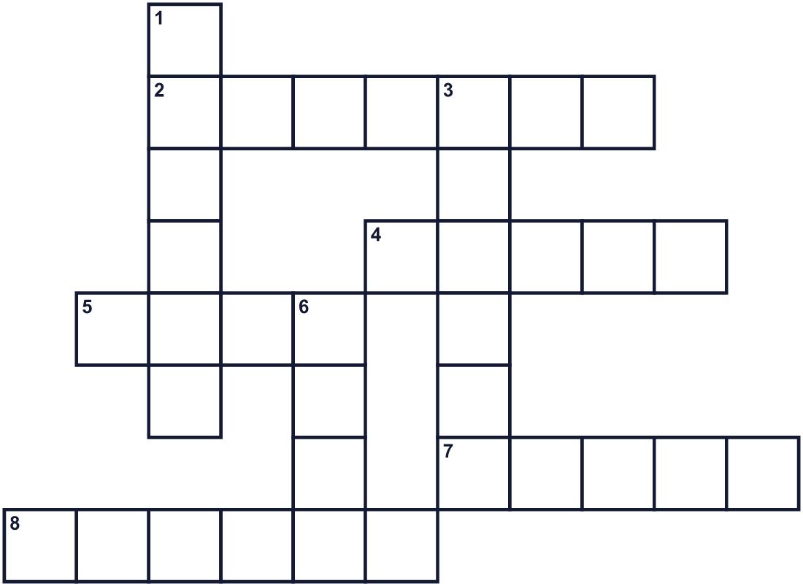
Across →
2. You can borrow books here for free. (7)
4. It has people, places, and things that happen. (5)
5. It gives you light at night. (4)
7. A long story in a book. (5)
8. A big picture on a wall. It often has a message. (6)
Down ↓
1. A short message that is easy to remember. (6)
3. The season after summer. Another word for fall. (6)
6. One side of a sheet of paper in a book. (4)

📚 Book Week in Japan (Dokusho Shukan) Worksheet
Word Search
かくれた単語をさがそう（→ ↓ ↘ ↗）
Class ______ No. ____ Name ______________________________
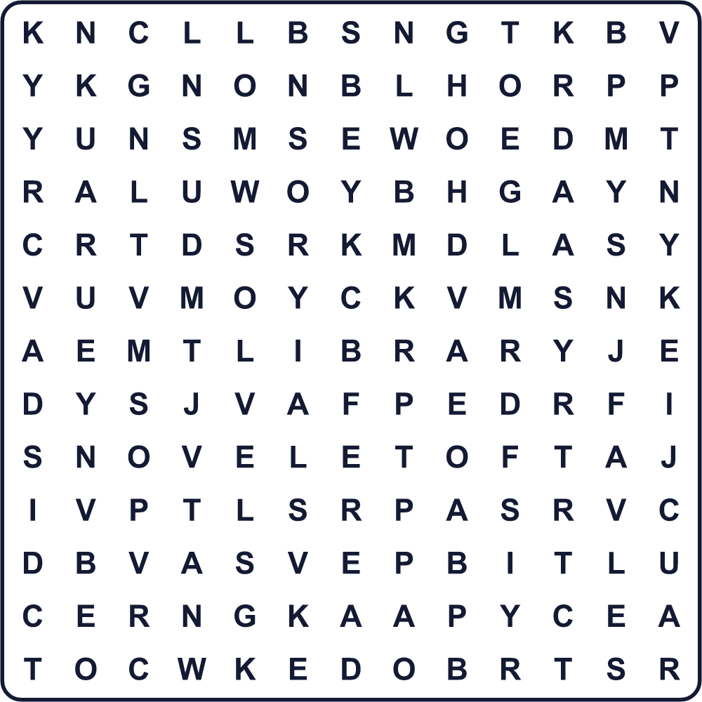
AUTUMN BOOK LAMP LIBRARY NOVEL PAGE POSTER READ SLOGAN STORY

📚 Book Week in Japan (Dokusho Shukan) Worksheet
Maze & Sentences
Class ______ No. ____ Name ______________________________
Help Sora get to the library! ソラを図書館まで連れていこう！
正しい道の文字を集めると、ひみつの言葉になるよ。 START 👧 → GOAL 📚
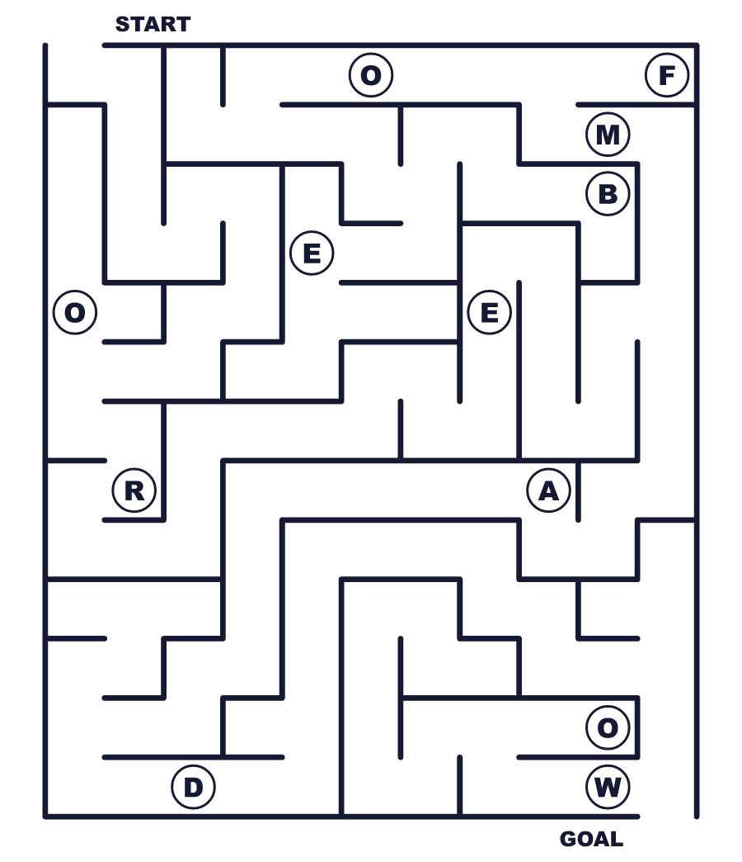
Secret word: ＿ ＿ ＿ ＿

📚 Book Week in Japan (Dokusho Shukan) Worksheet
Class Activity & Writing
Class ______ No. ____ Name ______________________________
Let's Write! 英語で書いてみよう。
My slogan for Book Week is "______" because ______.
私の読書週間の標語は「＿＿＿」です。なぜなら＿＿＿だからです。
______________________________________________________________
______________________________________________________________
The best book I read this year is ______. I want my friends to read it because ______.
今年読んだいちばんの本は＿＿＿です。友だちに読んでほしい理由は＿＿＿です。
______________________________________________________________
______________________________________________________________

📚 Book Week in Japan (Dokusho Shukan) Worksheet
Trace & Color
なぞって書こう。絵に色をぬろう。
Class ______ No. ____ Name ______________________________
📚 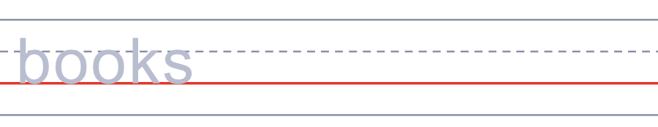

🔖 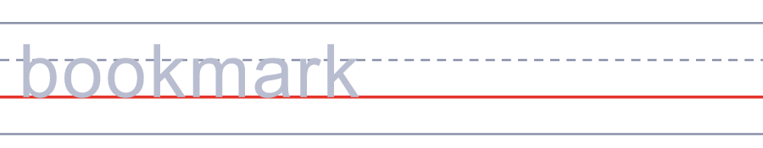
🍂 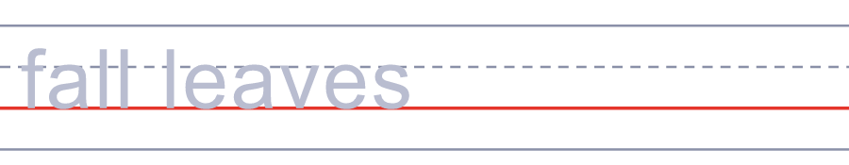
💡 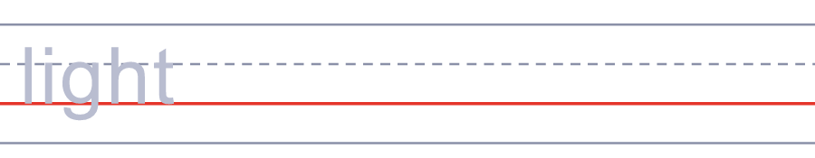
📰 

📚 Book Week in Japan (Dokusho Shukan) Worksheet
Answer Key 解答
Reading Check: 1.C 2.A 3.D 4.B 5.C
True or False: 1.T 2.F 3.T 4.F
Match: 📚=books 🔖=bookmark 🍂=fall leaves 💡=light 📰=newspaper 🏮=lantern
Fill in the blanks: (1)October (2)poster (3)mystery (4)read (5)down (6)lamp (7)festival
Maze: READ
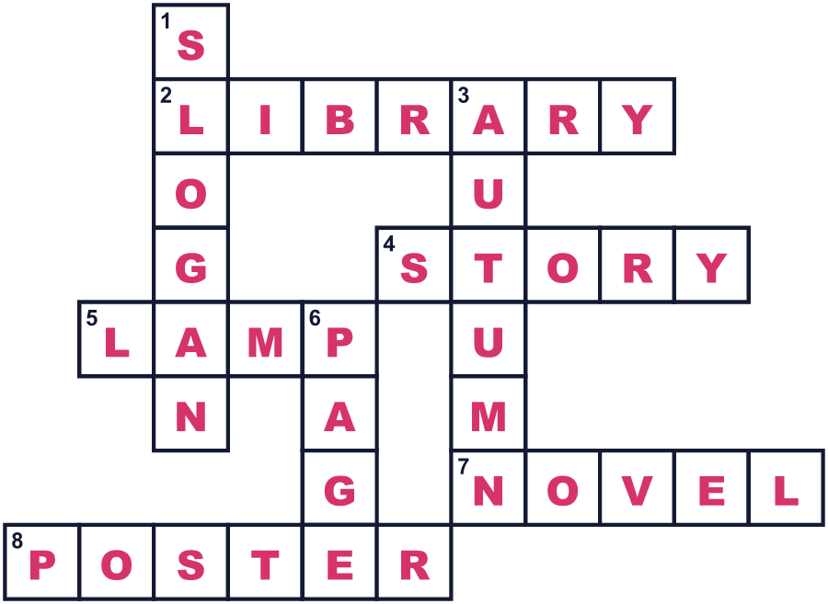
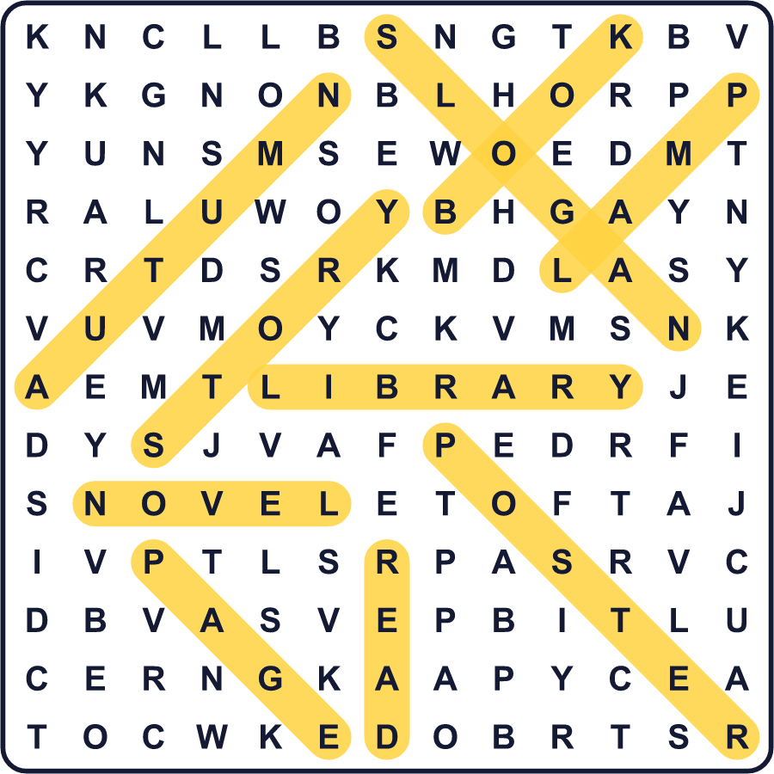
全訳
1 1947年の秋、日本の多くの町には、まだ焼けた建物が残っていました。戦争が終わって、まだ2年しかたっていませんでした。食べ物を手に入れるのは大変でしたが、それでも人々は本を読みたいと思っていました。そこで、出版社や書店、図書館、新聞社が集まりました。彼らは「読書週間」という新しい行事を始めました。
2 そのメッセージはシンプルでした。読書の力で平和な国を作ろう、というものです。約30の団体が参加し、第1回の読書週間は大成功でした。人々は「1週間では短すぎる」と言いました。そこで翌年から、読書週間は2週間になりました。今は10月27日から11月9日まで続きます。11月3日の祝日、文化の日がちょうど真ん中にあります。
3 読書週間には毎年、新しい標語と新しいポスターがあります。標語のアイデアは、だれでも応募できます。2026年の標語は「静かだけど、冒険中。」です。本を読む人は静かに見えますが、物語の中では遠くまで旅をしているのです。この2週間、図書館では読み聞かせが開かれ、書店には特別なコーナーができます。東京では、古本屋さんの並ぶ通りで、約100万冊の古本の大バーゲンが開かれます。
4 でも、日本の読書は変わりつつあります。2024年の国の調査では、16歳以上の約63%が1か月に1冊も本を読んでいませんでした。読む量が減った人の多くは、スマートフォンなどの機器に時間を取られると答えました。読書週間は、シンプルな問いを投げかけています。あなたが最後に、読み始めたら止まらない本を読んだのはいつですか？

