🪔 Diwali Worksheet
A Row of Lamps on the Darkest Night
Read the story. 英文を読もう。
Class ______ No. ____ Name ______________________________

🔊 音声を聞こう（スマホで読みとってね）
1 On one very dark night in autumn, millions of tiny lamps light up India. This is Diwali, the festival of lights. The name comes from an old word, Deepavali. It means a row of lamps. People in many other countries celebrate it too.
2 Diwali usually comes in October or November, on a night with no moon. The festival lasts five days, and Hindus, Jains, and Sikhs all celebrate it. Before it starts, families clean their homes from top to bottom. They buy new clothes and make sweets for friends and neighbors.
3 There are many stories behind Diwali. In the north of India, people remember Prince Rama. He came home after 14 years away and a long fight with an evil king. The night was dark, so people lit lamps to show him the way. In the south, many people remember how the god Krishna beat a demon.
4 On the main night, families pray to Lakshmi, the goddess of wealth and good luck. They put small clay lamps called diyas by their doors and windows. People believe the goddess visits bright and clean homes. In front of the door, they make rangoli, big colorful pictures of colored powder, rice, or flowers.
5 Diwali is also a time for sharing. People visit each other and give boxes of sweets. Many families enjoy fireworks, but some cities now limit them because of air pollution. In 2025, people in Ayodhya, Rama's home city, lit more than 2.6 million lamps in one night. It was a new world record for the festival of lights.
Words 単語
festival（祭り） / lamp（ランプ、灯り） / row（列） / clay（粘土） / goddess（女神） / wealth（富、財産） / demon（悪魔、鬼） / evil（悪い、邪悪な） / pray（祈る） / neighbor（近所の人） / pollution（汚染） / record（記録）

🪔 Diwali Worksheet
Reading Check
Choose the best answer. 正しいものを選ぼう。
Class ______ No. ____ Name ______________________________
1. What is the main idea of the story?
(A) How to make fireworks safely (B) A school trip to India in autumn (C) Why the moon is dark in November (D) A festival of lights and its stories
2. What does the word Deepavali mean?
(A) A row of lamps (B) A dark night (C) A new year (D) A sweet cake
3. How long does the festival last?
(A) One night (B) Three days (C) Five days (D) Fourteen years
4. Why did people light lamps for Prince Rama?
(A) To cook food for him (B) To show him the way on a dark night (C) To scare the evil king (D) To win a world record
5. In paragraph 4, what is "rangoli"?
(A) A kind of sweet (B) A song for the goddess (C) A small clay lamp (D) A colorful picture on the ground
6. Which sentence is true about the story?
(A) Diwali is always in the same week. (B) Families clean their homes before Diwali. (C) Lakshmi is the goddess of the sea. (D) No one uses fireworks now.
7. Why do some cities limit fireworks during Diwali?
(A) Because the air becomes dirty (B) Because fireworks are too expensive (C) Because the goddess does not like noise (D) Because there is no moon
8. In the dialogue, what does Priya give Kenta?
(A) A clay lamp (B) Some laddoo (C) A picture of Kisshoten (D) New clothes
True or False? T か F に○
1. Diwali is called the festival of lights. T / F
2. Diwali is always on the same date every year. T / F
3. People put small clay lamps by their doors and windows. T / F
4. Lakshmi is the goddess of wealth and good luck. T / F
5. Diwali is a spring festival with colored water. T / F
6. Only Hindus celebrate Diwali. T / F

🪔 Diwali Worksheet
Word Work
単語のれんしゅう
Class ______ No. ____ Name ______________________________
① Match the pictures and the words. 絵と単語を線でむすぼう。
🪔 | ● | ● | flower
🎆 | ● | ● | lotus
🪷 | ● | ● | dog
🍬 | ● | ● | lamp
🎁 | ● | ● | gift
🌸 | ● | ● | candy
🐕 | ● | ● | coin
🪙 | ● | ● | fireworks
② Unscramble the words. 並べかえて単語にしよう。
1. A P L M (ランプ) → ____________________
2. S S O E D D G (女神) → ____________________
3. S S T E E W (お菓子) → ____________________
4. L H G I T (光) → ____________________
5. R P A Y (祈る) → ____________________
6. R L O I N G A (ランゴーリ（床に描く絵）) → ____________________
③ Fill in the blanks. 語群から選んで入れよう。
[ rangoli / gift / lights / Diwali / snowman / dark / lamps / sweets / goddess / pumpkin / beach / night / clean ]
Asha lives in Delhi. Today is (1) __________ . In the morning, she helps her mother (2) __________ the house. In the afternoon, she makes a big (3) __________ with red and yellow powder at the door. When the sky gets (4) __________ , her family lights small clay (5) __________ . They pray to the (6) __________ Lakshmi. Then Asha's uncle comes with a box of (7) __________ . Asha gives him a (8) __________ too. After dinner, the family watches the bright (9) __________ in the street. "This is the best (10) __________ of the year!" Asha says.

🪔 Diwali Worksheet
Crossword Puzzle
ヒントを読んでクロスワードを完成させよう。
Class ______ No. ____ Name ______________________________
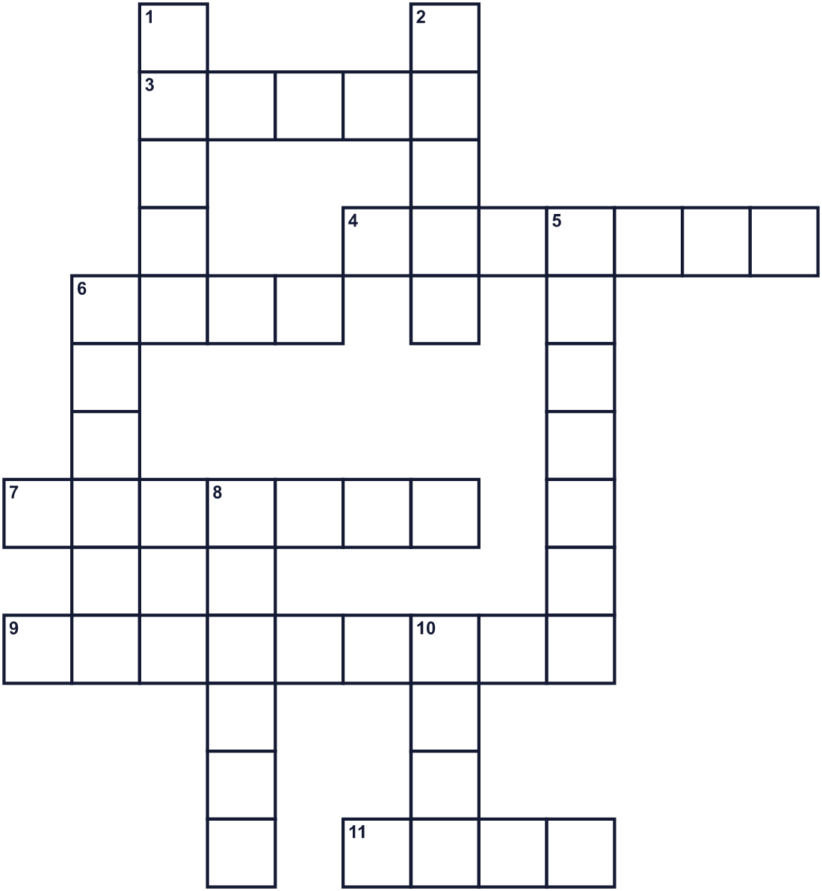
Across →
3. In this country, people thank dogs during the festival. (5)
4. A colorful picture made with powder in front of a house. (7)
6. A night with no moon is very ____. (4)
7. The goddess of wealth and good luck. (7)
9. They make big colorful flowers in the night sky. (9)
11. A small light. People put many by the door on this night. (4)
Down ↓
1. The country where this festival is biggest. (5)
2. Families do this to their homes before the festival. (5)
5. A female god. (7)
6. The festival of lights in India. (6)
8. People give boxes of these to friends. (6)
10. A prince who came home after 14 years. (4)

🪔 Diwali Worksheet
Word Search
かくれた単語をさがそう（→ ↓ ↘ ↗）
Class ______ No. ____ Name ______________________________
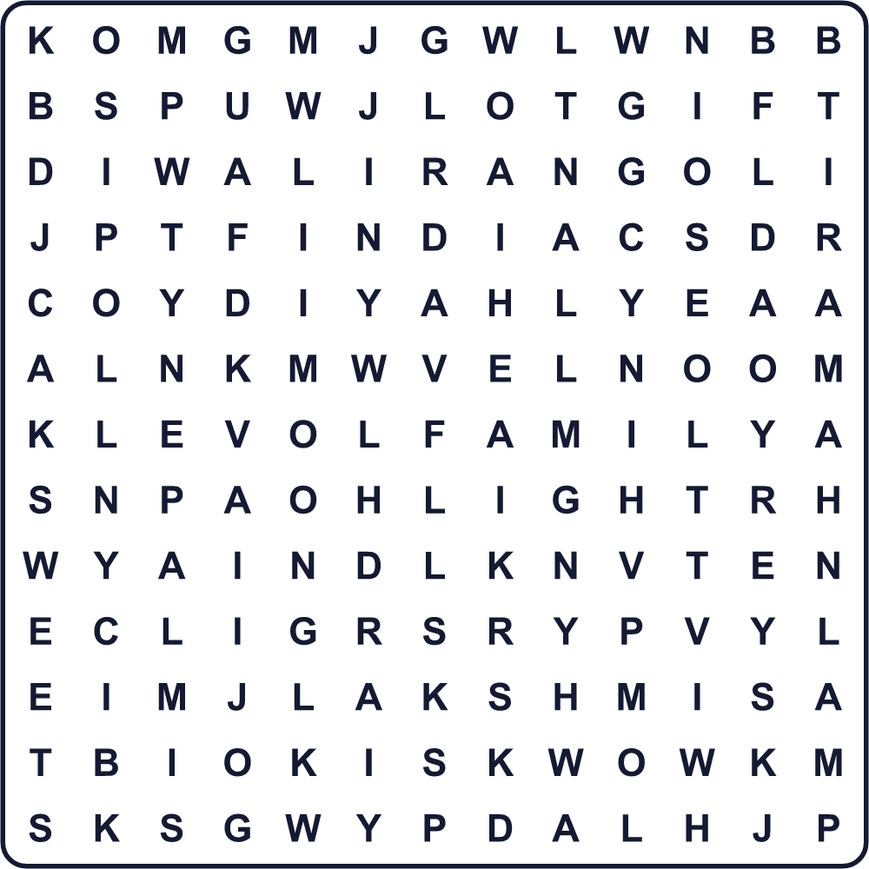
CLEAN DIWALI DIYA FAMILY GIFT INDIA LAKSHMI LAMP LIGHT MOON NEPAL RAMA RANGOLI SWEETS
Secret Code 暗号を解こう
♣=A ♪=D ●=H ☀=I ⚓=L ◎=P ✚=W ✈=Y
● ♣ ◎ ◎ ✈ ♪ ☀ ✚ ♣ ⚓ ☀
______________________________________________________________

🪔 Diwali Worksheet
Maze & Sentences
Class ______ No. ____ Name ______________________________
Help Prince Rama find his way home! ラーマ王子を家まで案内しよう！
正しい道の文字を集めると、ひみつの言葉になるよ。 START 🤴 → GOAL 🪔
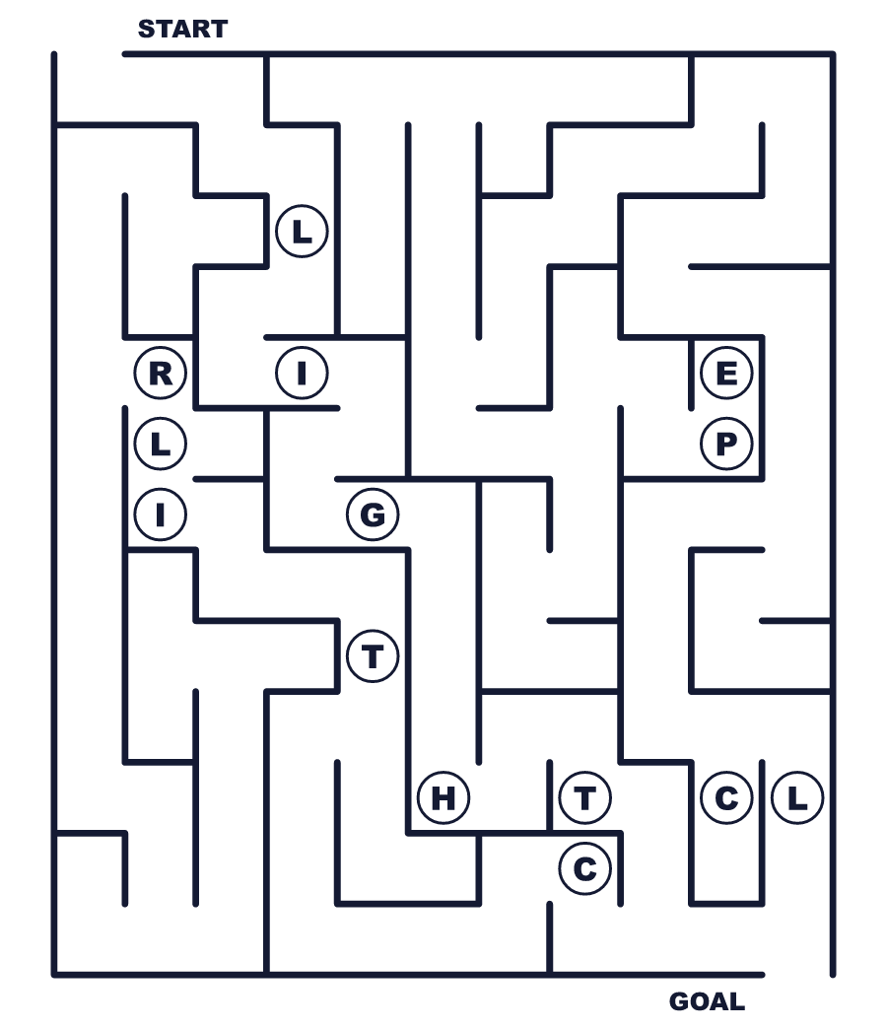
Secret word: ＿ ＿ ＿ ＿ ＿
Put the words in order. 並べかえよう。
1. festival / lights / the / of / is / Diwali . (ディワリは光の祭りです。)
______________________________________________________________
2. their / Diwali / homes / clean / before / Families . (家族はディワリの前に家を掃除します。)
______________________________________________________________
3. at / small / People / night / lamps / light . (人々は夜に小さなランプを灯します。)
______________________________________________________________
4. boxes / of / They / give / to / sweets / friends . (彼らは友だちにお菓子の箱を贈ります。)
______________________________________________________________
5. prince / after / home / came / fourteen / The / years . (王子は14年後に故郷に帰りました。)
______________________________________________________________

🪔 Diwali Worksheet
Class Activity & Writing
Class ______ No. ____ Name ______________________________
Find Someone Who… クラスで聞いて回ろう！
Find someone who … | Name
… has eaten Indian food インド料理を食べたことがある
… likes fireworks 花火が好き
… can draw a flower pattern 花の模様を描ける
… has cleaned the whole house 家全体の大掃除をしたことがある
… knows the name of a goddess 女神の名前を1つ知っている
… has seen Kisshoten or Enma at a temple お寺で吉祥天か閻魔さまを見たことがある
… likes sweet snacks 甘いお菓子が好き
… has given a gift to a neighbor 近所の人に贈り物をしたことがある
Let's Write! 英語で書いてみよう。
If I celebrated Diwali, I would put lamps ______ and make a rangoli of ______.
もしディワリを祝うなら、＿＿にランプを置き、＿＿のランゴーリを作りたい。
______________________________________________________________
______________________________________________________________
One thing that brings light to my life is ______ because ______.
私の人生に光をくれるものは＿＿です。なぜなら＿＿だから。
______________________________________________________________
______________________________________________________________
Diwali and Obon are similar because ______. But they are different because ______.
ディワリとお盆は＿＿という点で似ている。でも＿＿という点で違う。
______________________________________________________________
______________________________________________________________

🪔 Diwali Worksheet
Trace & Color
なぞって書こう。絵に色をぬろう。
Class ______ No. ____ Name ______________________________
🪔 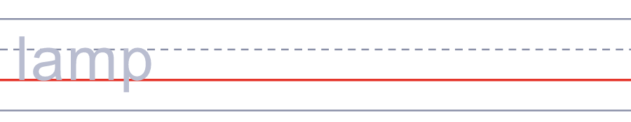

🎆 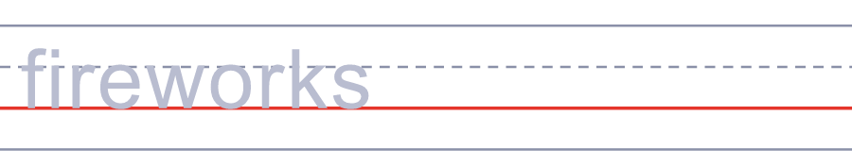
🪷 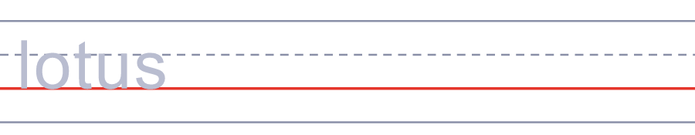
🍬 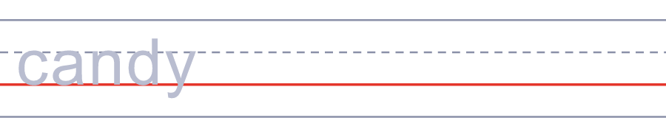
🎁 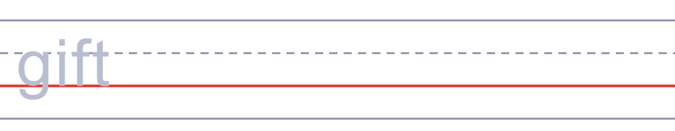
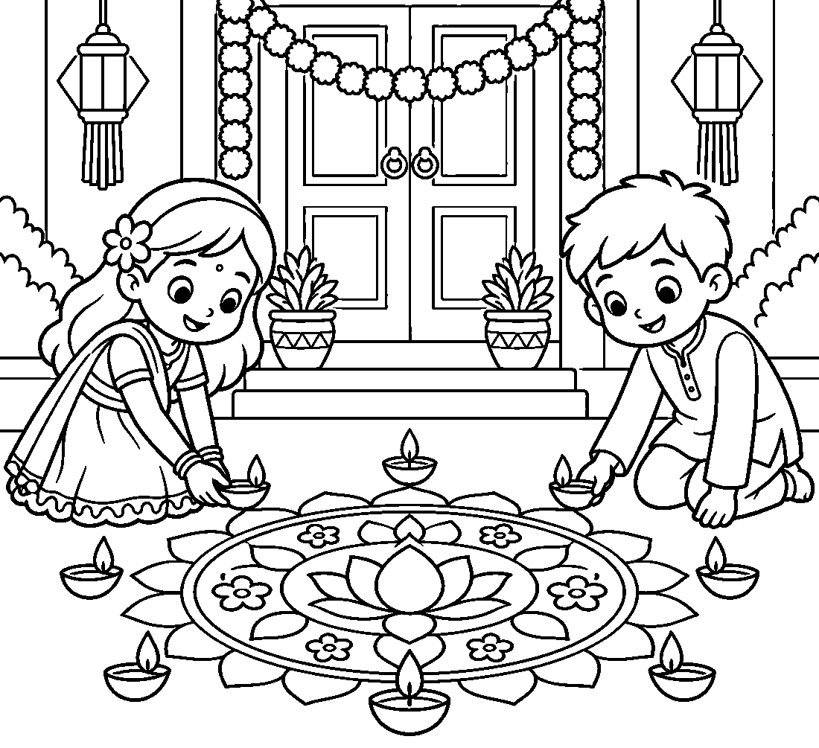

🪔 Diwali Worksheet
Answer Key 解答
Reading Check: 1.D 2.A 3.C 4.B 5.D 6.B 7.A 8.B
True or False: 1.T 2.F 3.T 4.T 5.F 6.F
Match: 🪔=lamp 🎆=fireworks 🪷=lotus 🍬=candy 🎁=gift 🌸=flower 🐕=dog 🪙=coin
Unscramble: 1.LAMP 2.GODDESS 3.SWEETS 4.LIGHT 5.PRAY 6.RANGOLI
Fill in the blanks: (1)Diwali (2)clean (3)rangoli (4)dark (5)lamps (6)goddess (7)sweets (8)gift (9)lights (10)night
Sentence order: 1. Diwali is the festival of lights. 2. Families clean their homes before Diwali. 3. People light small lamps at night. 4. They give boxes of sweets to friends. 5. The prince came home after fourteen years.
Secret Code: HAPPY DIWALI
Maze: LIGHT
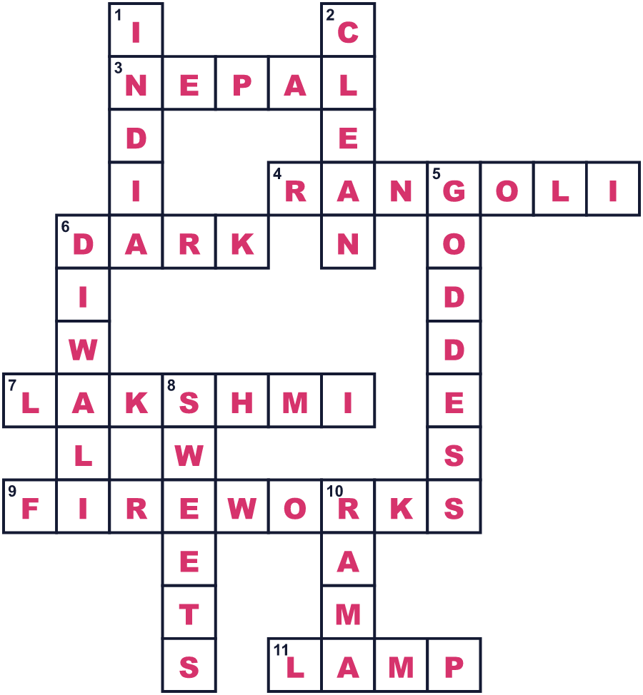
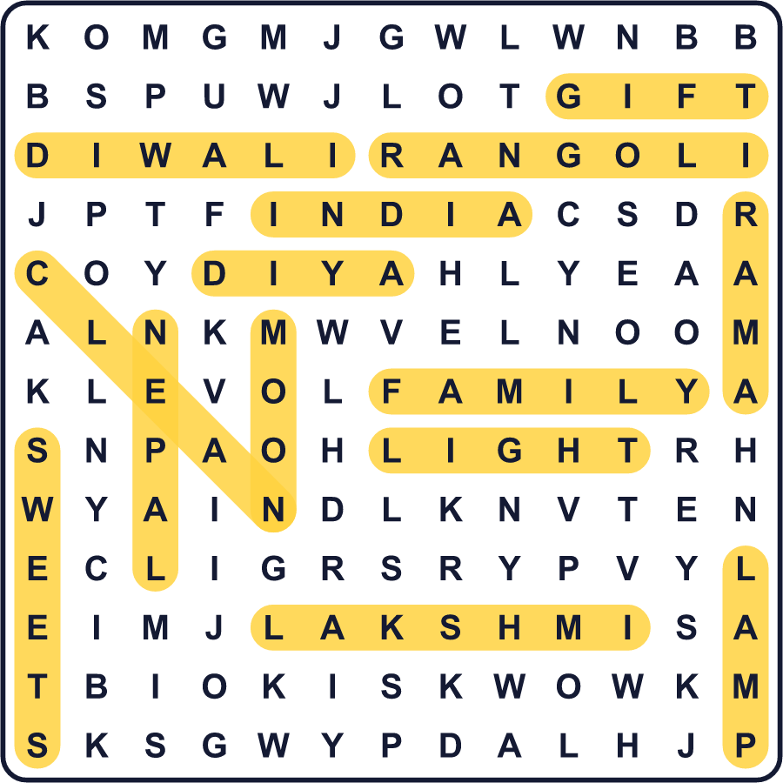
全訳
1 秋のある真っ暗な夜、何百万もの小さなランプがインドを照らします。これがディワリ、光の祭りです。名前は、ディーパーヴァリという古い言葉から来ています。「ランプの列」という意味です。ほかの多くの国の人たちもこの祭りを祝います。
2 ディワリはふつう10月か11月の、月のない夜にやってきます。お祭りは5日間続き、ヒンドゥー教徒もジャイナ教徒もシク教徒も祝います。始まる前に、家族は家をすみずみまで掃除します。新しい服を買い、友だちや近所の人のためにお菓子を作ります。
3 ディワリの背景には、たくさんの物語があります。北インドの人々は、ラーマ王子のことを思い出します。彼は14年の不在と、悪い王との長い戦いのあとで故郷に帰ってきました。夜は暗かったので、人々は彼に道を示すためにランプを灯しました。南では、多くの人がクリシュナ神が悪魔を倒した話を思い出します。
4 本番の夜、家族は富と幸運の女神ラクシュミーに祈ります。ディヤと呼ばれる小さな素焼きのランプを、ドアや窓のそばに置きます。人々は、女神が明るくきれいな家を訪れると信じています。ドアの前には、色の粉や米、花で大きなカラフルな絵、ランゴーリを描きます。
5 ディワリは分かち合いの時でもあります。人々はお互いの家を訪ね、お菓子の箱を贈ります。多くの家族が花火を楽しみますが、大気汚染のために花火を制限する町も出てきています。2025年、ラーマの故郷の町アヨーディヤーでは、ひと晩で260万個以上のランプが灯されました。それは光の祭りの新しい世界記録になりました。

