💀 Day of the Dead Worksheet
A Path of Orange Petals
Read the story. 英文を読もう。
Class ______ No. ____ Name ______________________________

🔊 音声を聞こう（スマホで読みとってね）
1 On the night of November 1, a little girl in Mexico throws orange petals on the ground. She is making a path from the cemetery to her house. Her grandfather died last year, and tonight she wants him to find his way home.
2 This is the Day of the Dead, or Día de Muertos in Spanish. It is celebrated on November 1 and 2. Many families believe that the spirits of their loved ones come back to visit for a short time. In many places, children who died are remembered on the first day, and adults on the second day.
3 At home, families build an altar called an ofrenda. They put photos, candles, water, and the favorite food of the dead person on it. There is sweet bread with bone shapes on top, and there are colorful skulls made of sugar. Bright marigold flowers are everywhere, because people say their strong smell helps the spirits find the way.
4 Some people think the Day of the Dead is a Mexican Halloween, but it is very different. It is not a night to be scared. It is a family reunion. In some towns, families stay at the cemetery all night. They play music, tell funny stories, and share food next to the graves.
5 In 2008, UNESCO added this festival to its list of important world traditions. In 2017, the movie Coco showed it to millions of people around the world. But for the little girl, it is simple. As long as she remembers her grandfather, he is not really gone.
Words 単語
spirit（魂、霊） / loved one（愛する人、大切な家族） / altar（祭壇） / cemetery（墓地） / grave（墓） / petal（花びら） / marigold（マリーゴールド） / skull（頭蓋骨、ガイコツ（の頭）） / reunion（再会、再会の集まり） / remember（覚えている、しのぶ） / favorite（大好きな、いちばん好きな） / tradition（伝統、しきたり）

💀 Day of the Dead Worksheet
Reading Check
Choose the best answer. 正しいものを選ぼう。
Class ______ No. ____ Name ______________________________
1. What is the main idea of the passage?
(A) The Day of the Dead is a scary night like Halloween. (B) The Day of the Dead is a sad day when no one talks. (C) The Day of the Dead is a time when families welcome and remember loved ones. (D) The Day of the Dead is a new holiday made by a movie.
2. Why does the girl throw orange petals on the ground?
(A) To make a path for her grandfather's spirit (B) To clean the street (C) To play a game with friends (D) To sell flowers
3. In many places, who is remembered on November 2?
(A) Only famous people (B) Children who died (C) Pets (D) Adults who died
4. According to the passage, why are marigolds used?
(A) Because they are cheap (B) Because their strong smell helps the spirits find the way (C) Because they are the national flower of Japan (D) Because children like to eat them
5. In paragraph 4, the word reunion means ___.
(A) a meeting of people who have been apart (B) a long trip (C) a kind of bread (D) a scary story
6. Which is true according to the passage?
(A) The Day of the Dead is only one day long. (B) UNESCO added the festival to its list in 2017. (C) Some families stay at the cemetery all night. (D) People put only flowers on the ofrenda.
7. What does the last sentence suggest about the girl?
(A) She has forgotten her grandfather. (B) She feels her grandfather lives on in her memory. (C) She is afraid of her grandfather's spirit. (D) She wants to watch the movie again.
8. In the dialogue, why is there a glass of water on the ofrenda?
(A) Because the flowers need water (B) Because Haruto is thirsty (C) Because Lucía forgot to drink it (D) Because the grandmother's spirit will be thirsty after a long trip
True or False? T か F に○
1. The Day of the Dead is on November 1 and 2. T / F
2. The Day of the Dead is the same holiday as Halloween. T / F
3. Families put the favorite food of the dead on an altar. T / F
4. The Day of the Dead is a very quiet and scary night. T / F
5. UNESCO added the Day of the Dead to its list in 2008. T / F
6. The Mexico City parade has a history of more than 500 years. T / F

💀 Day of the Dead Worksheet
Word Work
単語のれんしゅう
Class ______ No. ____ Name ______________________________
① Match the pictures and the words. 絵と単語を線でむすぼう。
💀 | ● | ● | photo
🕯️ | ● | ● | guitar
🌼 | ● | ● | dog
🍞 | ● | ● | bread
🎸 | ● | ● | water
🐕 | ● | ● | skull
📷 | ● | ● | candle
💧 | ● | ● | flower
② Unscramble the words. 並べかえて単語にしよう。
1. S L L U K (ガイコツの頭) → ____________________
2. A A T R L (祭壇) → ____________________
3. R I T P S I (魂) → ____________________
4. P E T L A (花びら) → ____________________
5. V G R A E (墓) → ____________________
6. O R N E U N I (再会) → ____________________
③ Fill in the blanks. 語群から選んで入れよう。
[ bread / petals / candles / home / November / photo / altar / school / song / cemetery / snow / water / pizza ]
Every (1) __________ , Sofia and her mother make an (2) __________ at home. They put a (3) __________ of Grandpa on it. Grandpa loved sweet (4) __________ , so Sofia buys pan de muerto. She also puts a glass of (5) __________ and some (6) __________ on the table. Then she makes a path of orange (7) __________ from the door to the street. At night, the family goes to the (8) __________ . They sing Grandpa's favorite (9) __________ . Sofia is not sad. She feels that Grandpa is (10) __________ again.

💀 Day of the Dead Worksheet
Crossword Puzzle
ヒントを読んでクロスワードを完成させよう。
Class ______ No. ____ Name ______________________________
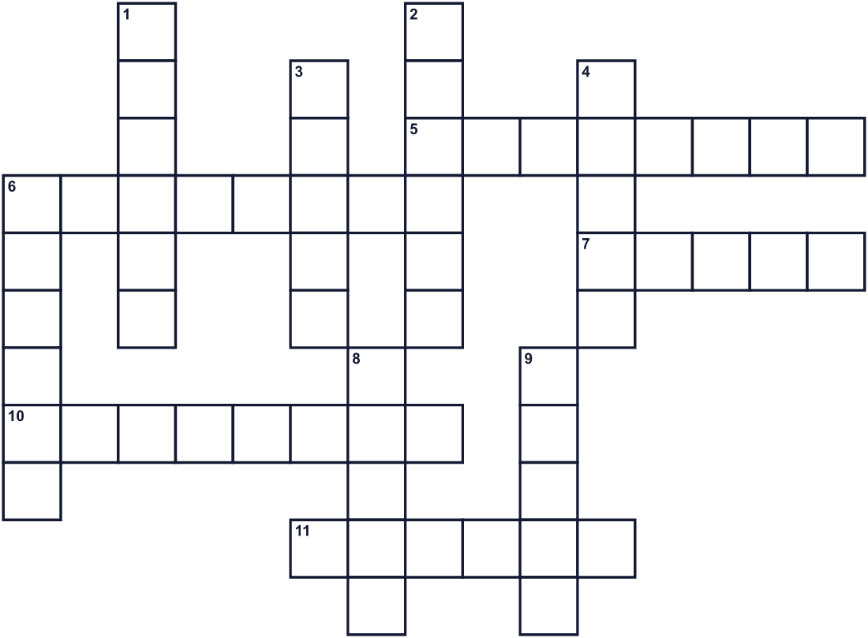
Across →
5. The month of this festival. It comes after October. (8)
6. An orange flower with a strong smell. (8)
7. A special table with photos, candles, and food for the dead. (5)
10. A place with many graves. (8)
11. Your parents, brothers, sisters, and grandparents. (6)
Down ↓
1. The part of a person that some believe comes back to visit. (6)
2. It gives a small light. People put many on graves at night. (6)
3. A picture of a person. Families put one on the altar. (5)
4. One small colored part of a flower. (5)
6. The country where this festival is famous. (6)
8. Pan de muerto is a sweet kind of this food. (5)
9. The bones of your head. People make them from sugar. (5)

💀 Day of the Dead Worksheet
Word Search
かくれた単語をさがそう（→ ↓ ↘ ↗）
Class ______ No. ____ Name ______________________________
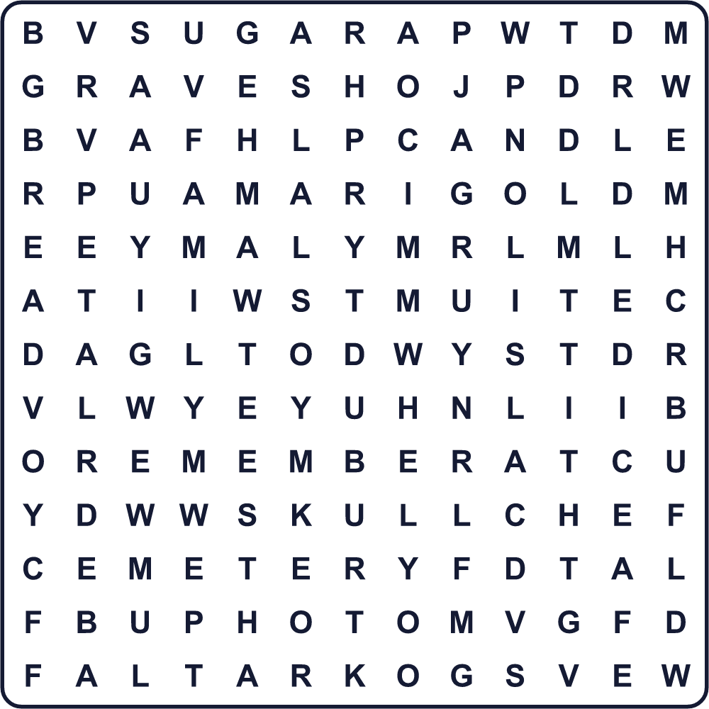
ALTAR BREAD CANDLE CEMETERY FAMILY GRAVE MARIGOLD MUSIC PETAL PHOTO REMEMBER SKULL SPIRIT SUGAR
Secret Code 暗号を解こう
⚓=B ✎=E ☺=M ✈=O ⚑=R ♣=U ☀=W ★=Y
☀ ✎ ⚑ ✎ ☺ ✎ ☺ ⚓ ✎ ⚑ ★ ✈ ♣
______________________________________________________________

💀 Day of the Dead Worksheet
Maze & Sentences
Class ______ No. ____ Name ______________________________
Follow the petals to Grandma's house! 花びらをたどって、おばあちゃんの家へ行こう！
正しい道の文字を集めると、ひみつの言葉になるよ。 START 🌼 → GOAL 🏠
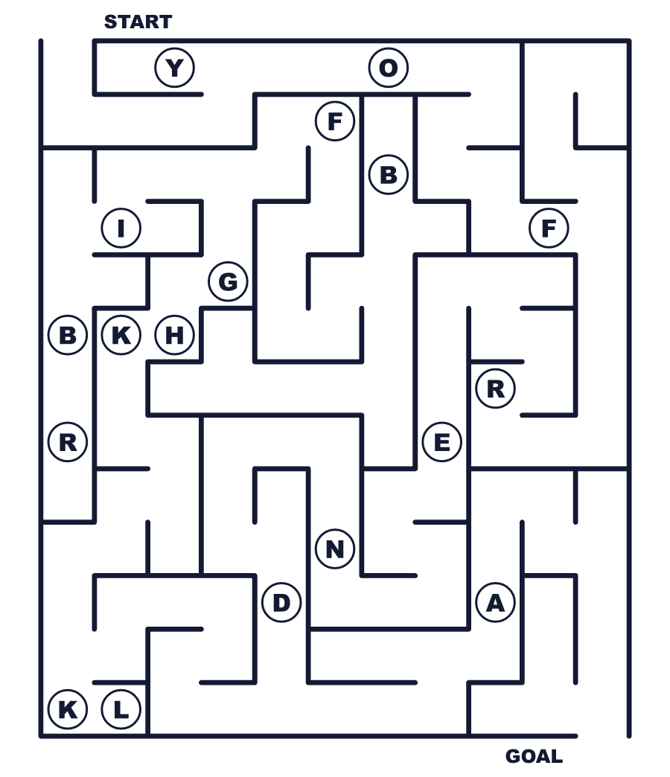
Secret word: ＿ ＿ ＿ ＿ ＿ ＿ ＿
Put the words in order. 並べかえよう。
1. an / the / altar / for / Families / make / dead . (家族は死者のために祭壇を作ります。)
______________________________________________________________
2. a / once / year / spirits / home / come / The . (魂は年に一度家に帰ってきます。)
______________________________________________________________
3. orange / puts / the / on / She / petals / ground . (彼女は地面にオレンジの花びらをまきます。)
______________________________________________________________
4. scary / not / of / is / The / the / Dead / Day . (死者の日はこわくありません。)
______________________________________________________________
5. We / love / with / remember / our / grandparents . (私たちは愛をこめて祖父母をしのびます。)
______________________________________________________________

💀 Day of the Dead Worksheet
Class Activity & Writing
Class ______ No. ____ Name ______________________________
Find Someone Who… クラスで聞いて回ろう！
Find someone who … | Name
… has seen the movie Coco 映画『リメンバー・ミー』を見たことがある
… has visited a family grave this year 今年、家族のお墓参りをした
… likes sweet bread 甘いパンが好き
… knows the color of marigolds マリーゴールドの色を知っている
… can say hello in Spanish スペイン語でこんにちはと言える
… has made a cucumber horse for Obon お盆にキュウリの馬を作ったことがある
… knows a story about a grandparent 祖父母のエピソードを1つ知っている
… likes to draw skulls or skeletons ガイコツや骸骨の絵をかくのが好き
Let's Write! 英語で書いてみよう。
If I made an ofrenda, I would put ______ on it because ______.
もし祭壇を作るなら、私は＿＿＿を置きます。なぜなら＿＿＿だから。
______________________________________________________________
______________________________________________________________
The Day of the Dead is different from Halloween because ______.
死者の日は＿＿＿という点でハロウィンと違います。
______________________________________________________________
______________________________________________________________
One thing I want to remember about my family is ______.
家族について覚えておきたいことの1つは＿＿＿です。
______________________________________________________________
______________________________________________________________

💀 Day of the Dead Worksheet
Trace & Color
なぞって書こう。絵に色をぬろう。
Class ______ No. ____ Name ______________________________
💀 

🕯️ 
🌼 
🍞 
🎸 
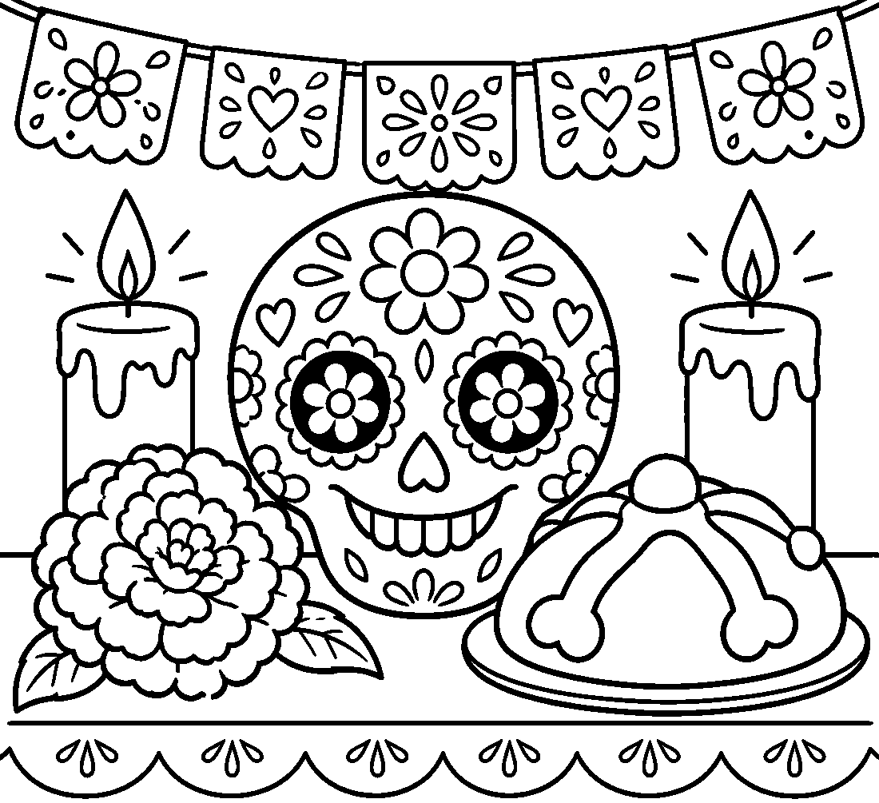

💀 Day of the Dead Worksheet
Answer Key 解答
Reading Check: 1.C 2.A 3.D 4.B 5.A 6.C 7.B 8.D
True or False: 1.T 2.F 3.T 4.F 5.T 6.F
Match: 💀=skull 🕯️=candle 🌼=flower 🍞=bread 🎸=guitar 🐕=dog 📷=photo 💧=water
Unscramble: 1.SKULL 2.ALTAR 3.SPIRIT 4.PETAL 5.GRAVE 6.REUNION
Fill in the blanks: (1)November (2)altar (3)photo (4)bread (5)water (6)candles (7)petals (8)cemetery (9)song (10)home
Sentence order: 1. Families make an altar for the dead. 2. The spirits come home once a year. 3. She puts orange petals on the ground. 4. The Day of the Dead is not scary. 5. We remember our grandparents with love.
Secret Code: WE REMEMBER YOU
Maze: OFRENDA
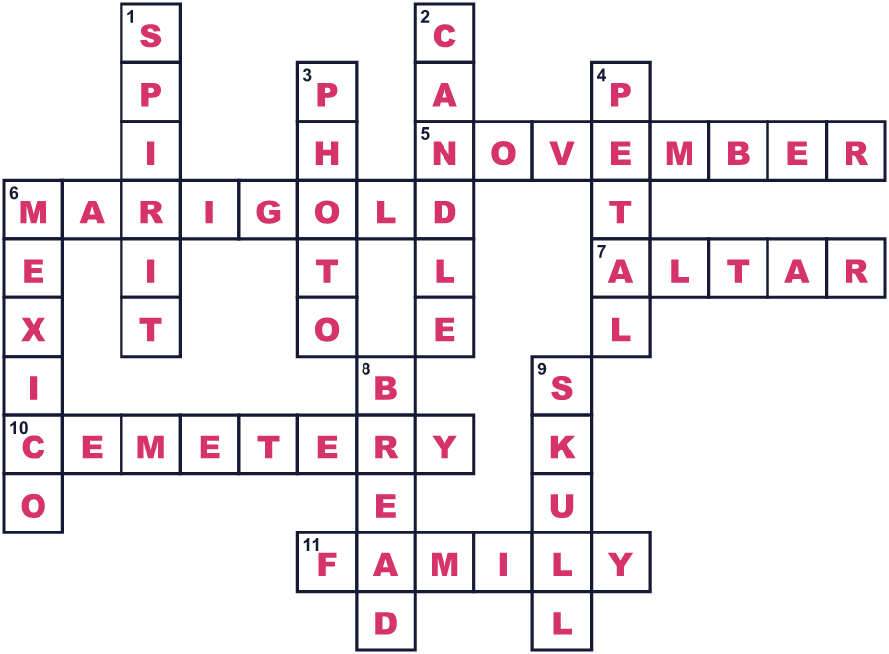
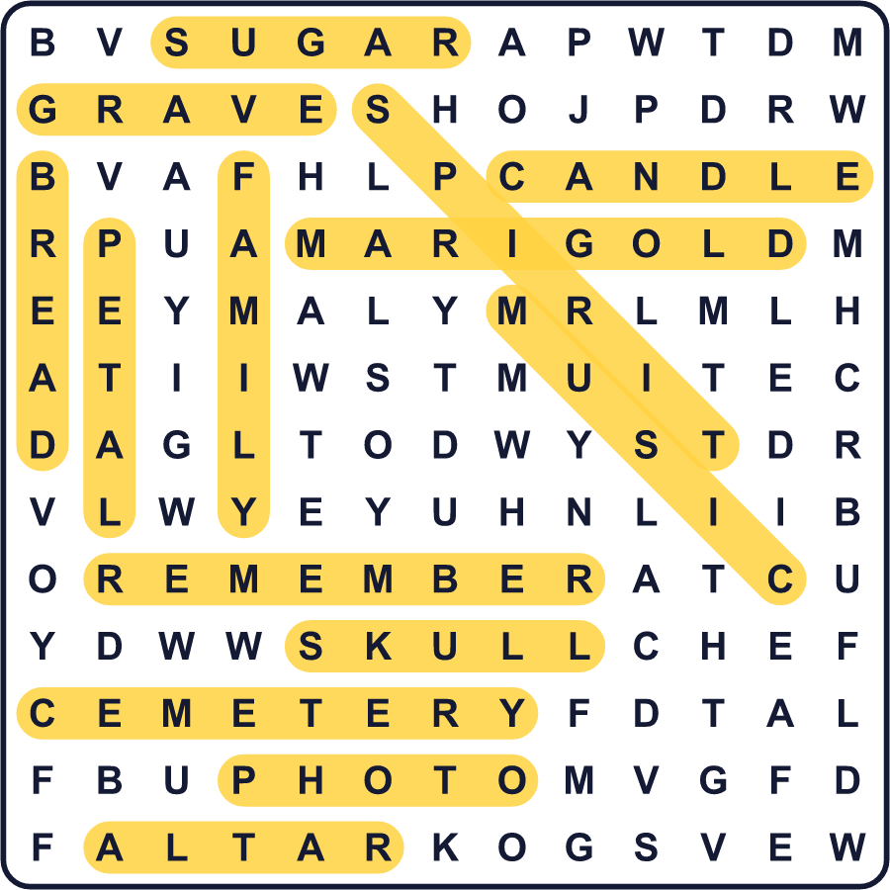
全訳
1 11月1日の夜、メキシコの小さな女の子が、地面にオレンジ色の花びらをまいています。墓地から自分の家までの道を作っているのです。おじいちゃんは去年亡くなりました。今夜、おじいちゃんが家への道を見つけられるようにしたいのです。
2 これが死者の日、スペイン語で Día de Muertos です。11月1日と2日に祝われます。多くの家族は、愛する人の魂が少しの間、会いに帰ってくると信じています。多くの地域で、1日目には亡くなった子どもたちを、2日目には大人たちをしのびます。
3 家では、家族がオフレンダと呼ばれる祭壇を作ります。そこに写真、ろうそく、水、そして亡くなった人の好物を置きます。上に骨の形がついた甘いパンや、砂糖でできたカラフルなガイコツもあります。あざやかなマリーゴールドの花がいたるところにあります。その強い香りが魂の道案内になると言われているからです。
4 死者の日をメキシコのハロウィンだと思う人もいますが、まったく違います。こわがる夜ではありません。家族の再会なのです。町によっては、家族が一晩じゅう墓地で過ごします。お墓のそばで音楽を演奏し、おもしろい話をし、食べ物を分け合います。
5 2008年、ユネスコはこの祭りを世界の大切な伝統のリストに加えました。2017年には、映画『リメンバー・ミー（Coco）』が、世界中の何百万人もの人にこの祭りを見せました。でも、あの小さな女の子にとっては、話はかんたんです。彼女がおじいちゃんのことを覚えているかぎり、おじいちゃんは本当にいなくなったわけではないのです。

