🇲🇽 Cinco de Mayo Worksheet
The Day a Small Army Won
Read the story. 英文を読もう。
Class ______ No. ____ Name ______________________________

🔊 音声を聞こう（スマホで読みとってね）
1 Many people in the United States think May 5 is Mexico's birthday. But that is not true. Mexico's Independence Day is September 16. Cinco de Mayo means May 5 in Spanish, and it remembers a famous battle.
2 In 1861, Mexico did not have enough money to pay its debts. So France sent a strong army to take control of the country. About 6,000 French soldiers marched toward the city of Puebla. They were sure they would win in one day. But a smaller Mexican army was waiting on two hills above the city. Its leader, General Ignacio Zaragoza, was only 33 years old.
3 The fight started around noon on May 5. Again and again, the French ran up the hills, and again and again, they fell back. By evening, they gave up and walked away. Zaragoza sent a short message to the president: Our army is covered in glory. But the war was not over. One year later, a much bigger French army came back and took Mexico City.
4 So why is Cinco de Mayo so big in the United States? The news of the battle reached California about three weeks later. Mexican people there were very happy, and they started to hold parties every year. In the 1960s and 1970s, young Mexican Americans used the day to show pride in their culture. Later, in the 1980s, beer companies made big ads for it.
5 Today, cities like Los Angeles and Chicago have parades with mariachi bands and bright dresses. People eat tacos and guacamole. In Puebla, thousands of students and soldiers march through the streets. And in Japan, May 5 is also Children's Day, so you can celebrate two holidays at once.
Words 単語
battle（戦い、戦闘） / army（軍隊、陸軍） / debt（借金） / independence（独立） / general（将軍） / march（行進する、進軍する） / glory（栄光、ほまれ） / pride（誇り、プライド） / culture（文化） / celebrate（祝う） / ad（広告） / parade（パレード、行進）

🇲🇽 Cinco de Mayo Worksheet
Reading Check
Choose the best answer. 正しいものを選ぼう。
Class ______ No. ____ Name ______________________________
1. What is the main idea of the reading?
(A) Cinco de Mayo is Mexico's Independence Day. (B) Cinco de Mayo remembers a battle and grew big in the U.S. (C) Cinco de Mayo is a day to eat food from France. (D) Cinco de Mayo started in Japan as Children's Day.
2. When is Mexico's Independence Day?
(A) May 5 (B) July 4 (C) September 16 (D) December 12
3. Why did France send an army to Mexico?
(A) Mexico asked France for help. (B) Mexico could not pay its debts. (C) France wanted to buy Mexican beer. (D) Mexico attacked France first.
4. What happened one year after the battle?
(A) Mexico won the war. (B) General Zaragoza became president. (C) The first party started in California. (D) A bigger French army took Mexico City.
5. In paragraph 3, what does fell back mean?
(A) went back (B) fell asleep (C) fell in love (D) won easily
6. Which sentence is true about the reading?
(A) The French army was smaller than the Mexican army. (B) The fight started early in the morning. (C) General Zaragoza was 33 years old. (D) The news reached California the next day.
7. Why do many Mexican Americans feel proud on Cinco de Mayo?
(A) Because a small army beat a strong army that day. (B) Because Mexico won the whole war that day. (C) Because beer companies told them to feel proud. (D) Because it is the birthday of the U.S.
8. In the dialogue, what will Sota eat today?
(A) rice cakes (B) mole sauce (C) French bread (D) tacos
True or False? T か F に○
1. Cinco de Mayo means May 5 in Spanish. T / F
2. Cinco de Mayo is Mexico's Independence Day. T / F
3. The French army was bigger than the Mexican army at Puebla. T / F
4. After the battle, the French army never came back to Mexico. T / F
5. Mexican people in California celebrated the victory in the 1860s. T / F
6. In most of Mexico, all adults have the day off on May 5. T / F

🇲🇽 Cinco de Mayo Worksheet
Word Work
単語のれんしゅう
Class ______ No. ____ Name ______________________________
① Match the pictures and the words. 絵と単語を線でむすぼう。
🌮 | ● | ● | taco
🥑 | ● | ● | corn
🎺 | ● | ● | trumpet
🎸 | ● | ● | horse
💃 | ● | ● | avocado
🥁 | ● | ● | dancer
🐴 | ● | ● | drum
🌽 | ● | ● | guitar
② Unscramble the words. 並べかえて単語にしよう。
1. L T E A B T (戦い) → ____________________
2. A Y R M (軍隊) → ____________________
3. P A E A R D (パレード) → ____________________
4. N I H A S P S (スペイン語) → ____________________
5. R O V Y T I C (勝利) → ____________________
6. D E P R I (誇り) → ____________________
③ Fill in the blanks. 語群から選んで入れよう。
[ proud / sad / march / mole / dress / Puebla / flag / snow / parade / battle / 5 / Tokyo / army ]
Lucia lives in (1) __________ , a city in Mexico. Every year on May (2) __________ , her school joins a big (3) __________ . This year, Lucia will (4) __________ with her friends. She wears a white (5) __________ and holds a small (6) __________ . Her grandpa tells her the story of the (7) __________ in 1862. A small (8) __________ won against a strong one. After the parade, the family eats chicken with dark (9) __________ sauce. Lucia feels (10) __________ of her city.

🇲🇽 Cinco de Mayo Worksheet
Crossword Puzzle
ヒントを読んでクロスワードを完成させよう。
Class ______ No. ____ Name ______________________________
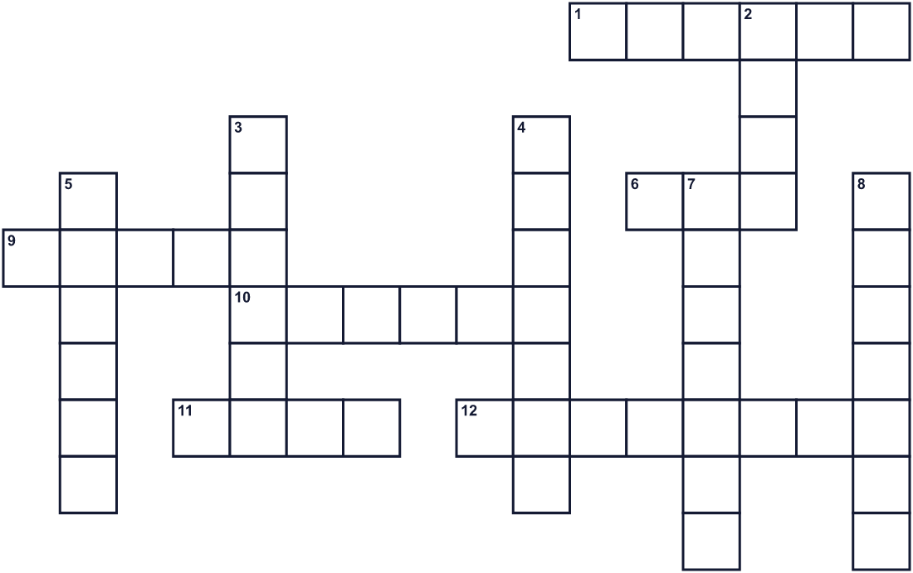
Across →
1. People walk, play music, and dance down the street in this. (6)
6. The fifth month of the year. (3)
9. A happy feeling about who you are and where you come from. (5)
10. A fight between two armies. (6)
11. Mexican food. Meat and vegetables in a corn tortilla. (4)
12. A Mexican band with trumpets, violins, and guitars. (8)
Down ↓
2. A large group of soldiers. (4)
3. The Mexican city where the battle happened in 1862. (6)
4. Zaragoza was this. He led the soldiers. (7)
5. This European country sent an army to Mexico. (6)
7. A green fruit. People make guacamole with it. (7)
8. The main language of Mexico. (7)

🇲🇽 Cinco de Mayo Worksheet
Word Search
かくれた単語をさがそう（→ ↓ ↘ ↗）
Class ______ No. ____ Name ______________________________
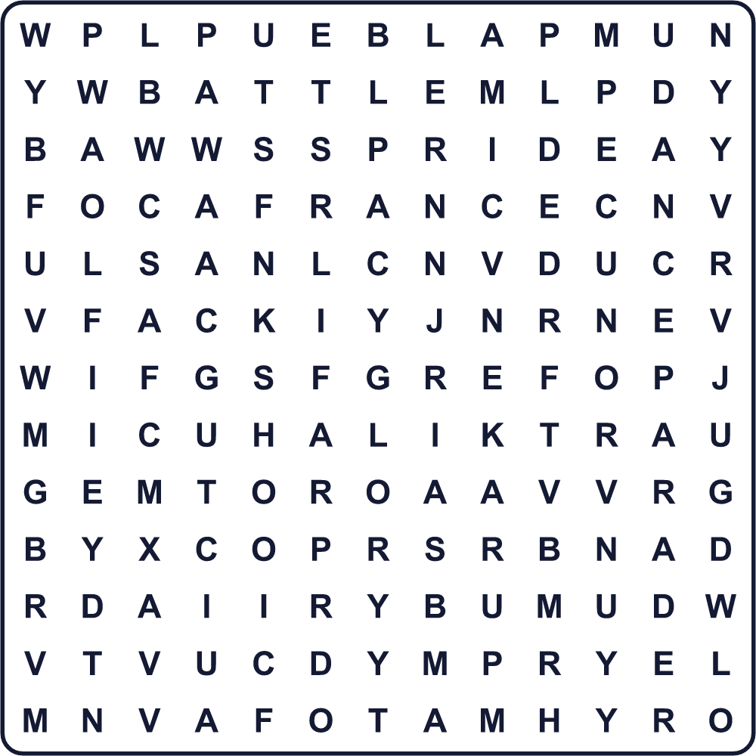
ARMY BATTLE DANCE FLAG FRANCE GLORY MEXICO MUSIC PARADE PRIDE PUEBLA TACO VICTORY
Secret Code 暗号を解こう
✉=A ▲=C ★=E ♦=I ◆=M ☎=O ◎=V ☾=X
◎ ♦ ◎ ✉ ◆ ★ ☾ ♦ ▲ ☎
______________________________________________________________

🇲🇽 Cinco de Mayo Worksheet
Maze & Sentences
Class ______ No. ____ Name ______________________________
Help Lucia get to the parade! ルシアをパレードまで連れていこう！
正しい道の文字を集めると、ひみつの言葉になるよ。 START 👧 → GOAL 🎺
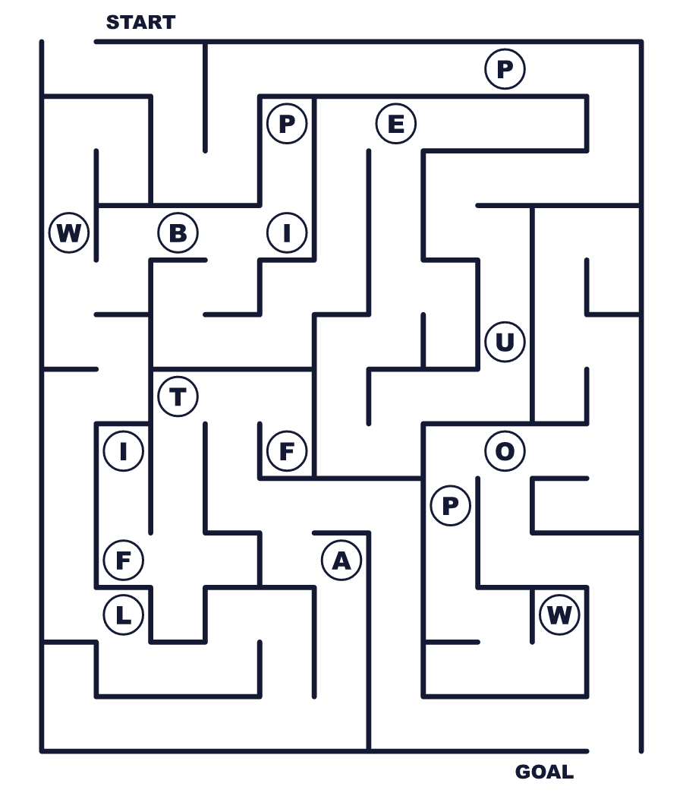
Secret word: ＿ ＿ ＿ ＿ ＿ ＿
Put the words in order. 並べかえよう。
1. de / Spanish / Mayo / means / May / Cinco / 5 / in . (シンコ・デ・マヨはスペイン語で「5月5日」という意味です。)
______________________________________________________________
2. army / small / big / battle / a / won / A . (小さな軍が大きな戦いに勝ちました。)
______________________________________________________________
3. in / Independence / September / Day / Mexico's / is . (メキシコの独立記念日は9月です。)
______________________________________________________________
4. Angeles / in / the / Los / dance / in / street / People . (ロサンゼルスの人々は通りで踊ります。)
______________________________________________________________
5. tacos / eat / on / 5 / May / and / We / guacamole . (私たちは5月5日にタコスとワカモレを食べます。)
______________________________________________________________

🇲🇽 Cinco de Mayo Worksheet
Class Activity & Writing
Class ______ No. ____ Name ______________________________
Find Someone Who… クラスで聞いて回ろう！
Find someone who … | Name
… has eaten tacos タコスを食べたことがある
… likes avocados アボカドが好き
… can say a word in Spanish スペイン語の単語を1つ言える
… knows the colors of the Mexican flag メキシコの国旗の色を知っている
… has been to a parade パレードに行ったことがある
… can play the guitar or trumpet ギターかトランペットを弾ける
… likes spicy food 辛い食べ物が好き
… knows another holiday on May 5 5月5日の別の記念日を知っている
Let's Write! 英語で書いてみよう。
Cinco de Mayo is not ______. It is a day to remember ______.
シンコ・デ・マヨは＿＿ではありません。＿＿を記念する日です。
______________________________________________________________
______________________________________________________________
If I go to a Cinco de Mayo festival, I want to ______ because ______.
シンコ・デ・マヨのお祭りに行ったら、＿＿したいです。なぜなら＿＿だからです。
______________________________________________________________
______________________________________________________________
On May 5 in Japan, we ______. In Mexico, people ______.
日本では5月5日に＿＿します。メキシコでは人々は＿＿します。
______________________________________________________________
______________________________________________________________

🇲🇽 Cinco de Mayo Worksheet
Trace & Color
なぞって書こう。絵に色をぬろう。
Class ______ No. ____ Name ______________________________
🌮 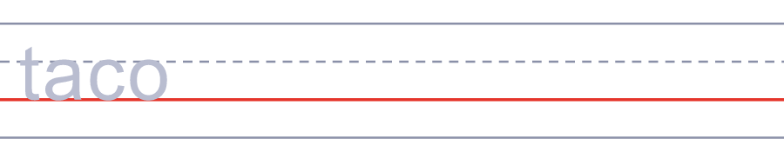

🥑 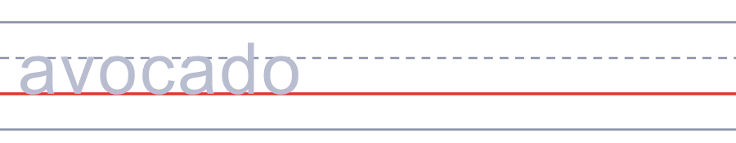
🎺 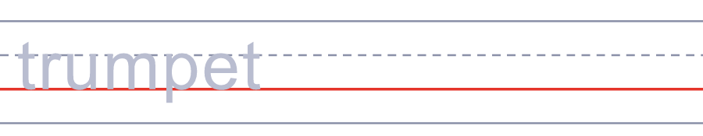
🎸 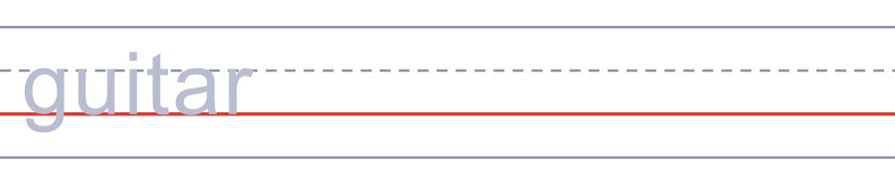
💃 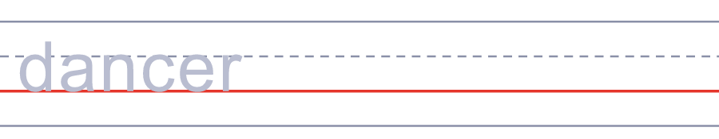
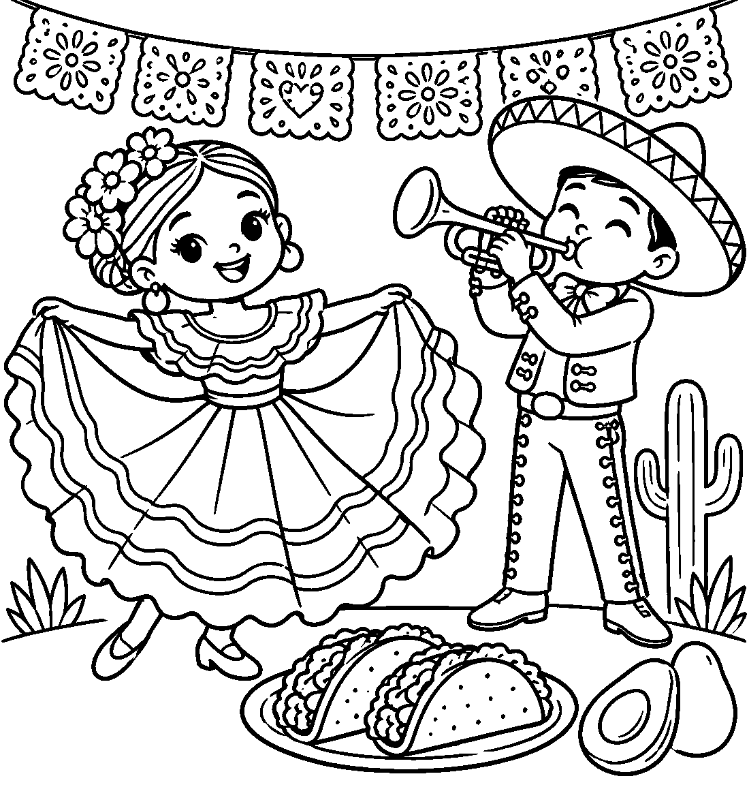

🇲🇽 Cinco de Mayo Worksheet
Answer Key 解答
Reading Check: 1.B 2.C 3.B 4.D 5.A 6.C 7.A 8.D
True or False: 1.T 2.F 3.T 4.F 5.T 6.F
Match: 🌮=taco 🥑=avocado 🎺=trumpet 🎸=guitar 💃=dancer 🥁=drum 🐴=horse 🌽=corn
Unscramble: 1.BATTLE 2.ARMY 3.PARADE 4.SPANISH 5.VICTORY 6.PRIDE
Fill in the blanks: (1)Puebla (2)5 (3)parade (4)march (5)dress (6)flag (7)battle (8)army (9)mole (10)proud
Sentence order: 1. Cinco de Mayo means May 5 in Spanish. 2. A small army won a big battle. 3. Mexico's Independence Day is in September. 4. People in Los Angeles dance in the street. 5. We eat tacos and guacamole on May 5.
Secret Code: VIVA MEXICO
Maze: PUEBLA
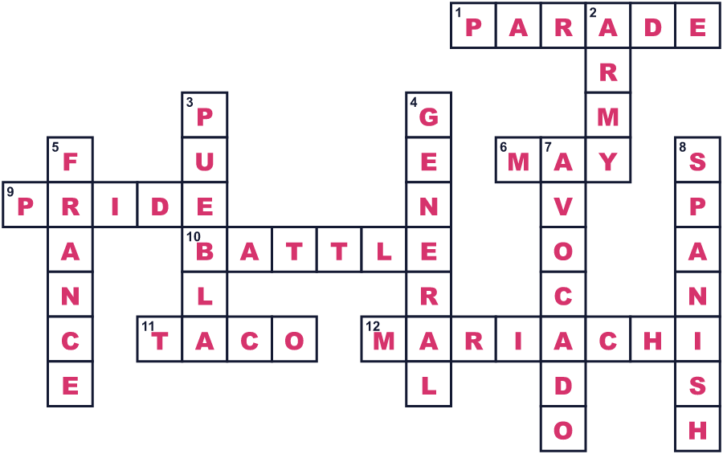
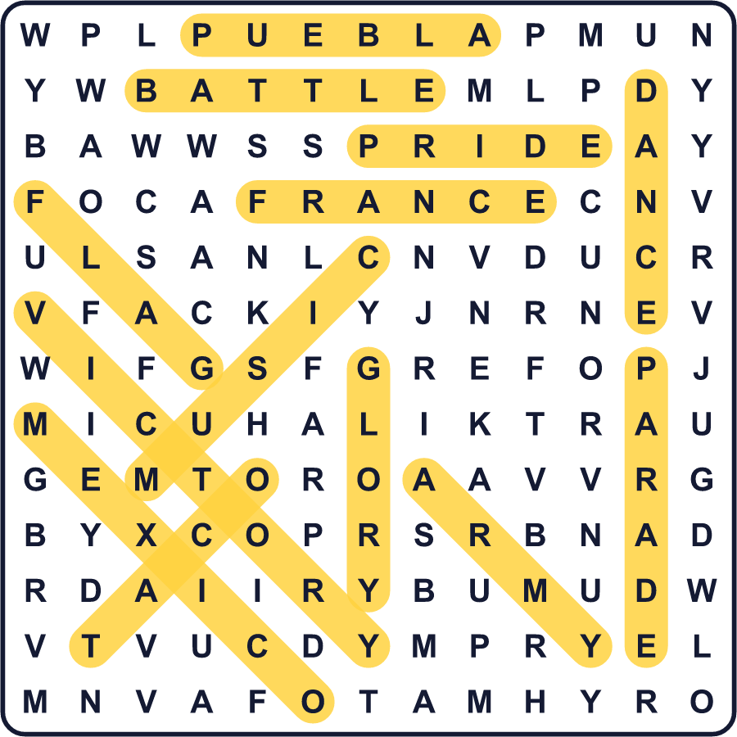
全訳
1 アメリカでは、5月5日をメキシコの誕生日だと思っている人がたくさんいます。でも、それは正しくありません。メキシコの独立記念日は9月16日です。シンコ・デ・マヨはスペイン語で「5月5日」という意味で、ある有名な戦いを記念する日です。
2 1861年、メキシコには借金を返すだけのお金がありませんでした。そこでフランスは、国を支配するために強い軍隊を送りこみました。約6,000人のフランス兵が、プエブラの町に向かって進みました。彼らは1日で勝てると信じていました。しかし、町を見下ろす2つの丘で、もっと小さなメキシコ軍が待ちかまえていました。その指揮官、イグナシオ・サラゴサ将軍はまだ33歳でした。
3 戦いは5月5日の正午ごろに始まりました。フランス軍は何度も丘をかけ上がり、そのたびに押し返されました。夕方には、彼らはあきらめて引き上げました。サラゴサは大統領に短い報告を送りました。「わが軍は栄光に包まれた」。けれども、戦争は終わっていませんでした。1年後、ずっと大きなフランス軍が戻ってきて、メキシコシティを占領したのです。
4 では、なぜシンコ・デ・マヨはアメリカでこんなに大きなお祭りなのでしょう。戦いの知らせは、約3週間後にカリフォルニアに届きました。そこに住むメキシコの人々は大喜びし、毎年お祝いを開くようになりました。1960〜70年代には、メキシコ系アメリカ人の若者たちが、自分たちの文化への誇りを示す日としてこの日を使いました。その後1980年代には、ビール会社がこの日の大きな広告を出しました。
5 今では、ロサンゼルスやシカゴなどの都市で、マリアッチ楽団やあざやかなドレスのパレードが開かれます。人々はタコスやワカモレを食べます。プエブラでは、何千人もの生徒や兵士が通りを行進します。そして日本では5月5日はこどもの日でもあるので、2つの記念日を一度にお祝いできます。

