🌕 Chuseok Worksheet
The Great Middle of Autumn
Read the story. 英文を読もう。
Class ______ No. ____ Name ______________________________

🔊 音声を聞こう（スマホで読みとってね）
1 Every fall, the highways in South Korea fill with cars. Trains and planes are full, too. People call it the great migration. It is Chuseok, one of the biggest holidays of the year. It comes on the 15th day of the eighth month of the old moon calendar, under a full moon.
2 Chuseok may be about 2,000 years old. An old history book tells a story about a king in the kingdom of Silla. He put the women of the city into two teams. For one month, they made cloth every day. On the night of the full moon, the losing team made a big dinner for the winners. Then everyone sang and danced.
3 Today, families get up early on Chuseok morning. They put rice, fruit, fish, and rice cakes on a table for their ancestors. There are old rules: red fruit goes on the east side, and white fruit goes on the west. Later, they visit family graves and cut the grass around them.
4 The most famous Chuseok food is songpyeon. These small rice cakes are shaped like a half moon. People steam them on a bed of pine needles. Song means pine in Korean. An old saying tells young women that pretty songpyeon will bring a good husband. At night, women in hanbok hold hands and dance in a big circle under the moon.
Words 単語
highway（幹線道路、高速道路） / migration（（大勢の）移動） / calendar（暦、カレンダー） / cloth（布） / ancestor（先祖） / grave（墓） / steam（蒸す） / needle（（松などの）葉、針）

🌕 Chuseok Worksheet
Reading Check
Choose the best answer. 正しいものを選ぼう。
Class ______ No. ____ Name ______________________________
1. What is the reading mainly about?
(A) How to drive on Korean highways (B) The history and customs of Chuseok (C) Why the moon is round (D) How to make cloth by hand
2. In the old story, what did the losing team do?
(A) They made a big dinner for the winners. (B) They left the city. (C) They made more cloth for the king. (D) They cut the grass around graves.
3. Where does red fruit go on the table?
(A) On the west side (B) In the middle (C) On the north side (D) On the east side
4. Why are the rice cakes called songpyeon?
(A) Because they are shaped like a song (B) Because people sing when they eat them (C) Because they are steamed on pine needles, and song means pine (D) Because a king named Song made them
5. In the dialogue, why does the trip take longer than usual?
(A) Because the car is broken (B) Because of heavy traffic (C) Because they are making songpyeon in the car (D) Because Grandma moved to Japan
True or False? T か F に○
1. Chuseok is a three-day holiday in South Korea. T / F
2. Songpyeon are shaped like a full moon. T / F
3. On Chuseok, many Koreans visit family graves. T / F
4. Chuseok is always on September 15. T / F

🌕 Chuseok Worksheet
Word Work
単語のれんしゅう
Class ______ No. ____ Name ______________________________
① Match the pictures and the words. 絵と単語を線でむすぼう。
🌕 | ● | ● | pine tree
🌲 | ● | ● | apple
🚗 | ● | ● | car
🍎 | ● | ● | grandmother
🌾 | ● | ● | full moon
👵 | ● | ● | rice plant
③ Fill in the blanks. 語群から選んで入れよう。
[ traffic / moon / hanbok / pumpkin / snow / wish / songpyeon / village / graves ]
It is Chuseok. Mina and her family drive to her grandmother's (1) __________ . The (2) __________ is very slow. In the evening, they make (3) __________ together. Mina's rice cakes look like a half (4) __________ . The next morning, they visit the family (5) __________ . Mina wears a pink (6) __________ . At night, she looks up at the big, round moon and makes a (7) __________ .

🌕 Chuseok Worksheet
Crossword Puzzle
ヒントを読んでクロスワードを完成させよう。
Class ______ No. ____ Name ______________________________
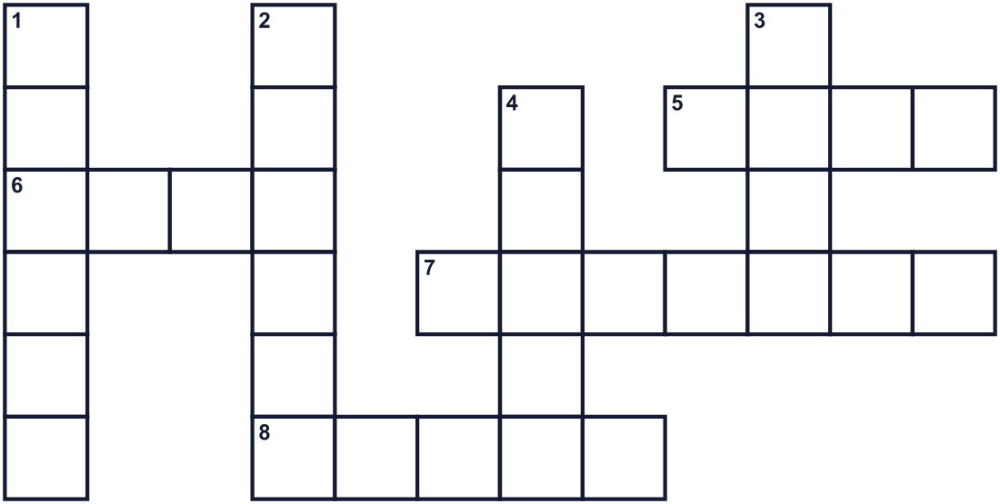
Across →
5. A white grain. Many people in Asia eat it every day. (4)
6. It shines in the night sky. On this holiday, it is full and round. (4)
7. The time when farmers collect rice and fruit. (7)
8. The country where Seoul is. (5)
Down ↓
1. Parents, children, and grandparents. (6)
2. Traditional Korean clothes. (6)
3. A tree with thin, sharp leaves. Rice cakes are steamed on them. (4)
4. A place where a dead person lies. (5)

🌕 Chuseok Worksheet
Word Search
かくれた単語をさがそう（→ ↓ ↘ ↗）
Class ______ No. ____ Name ______________________________
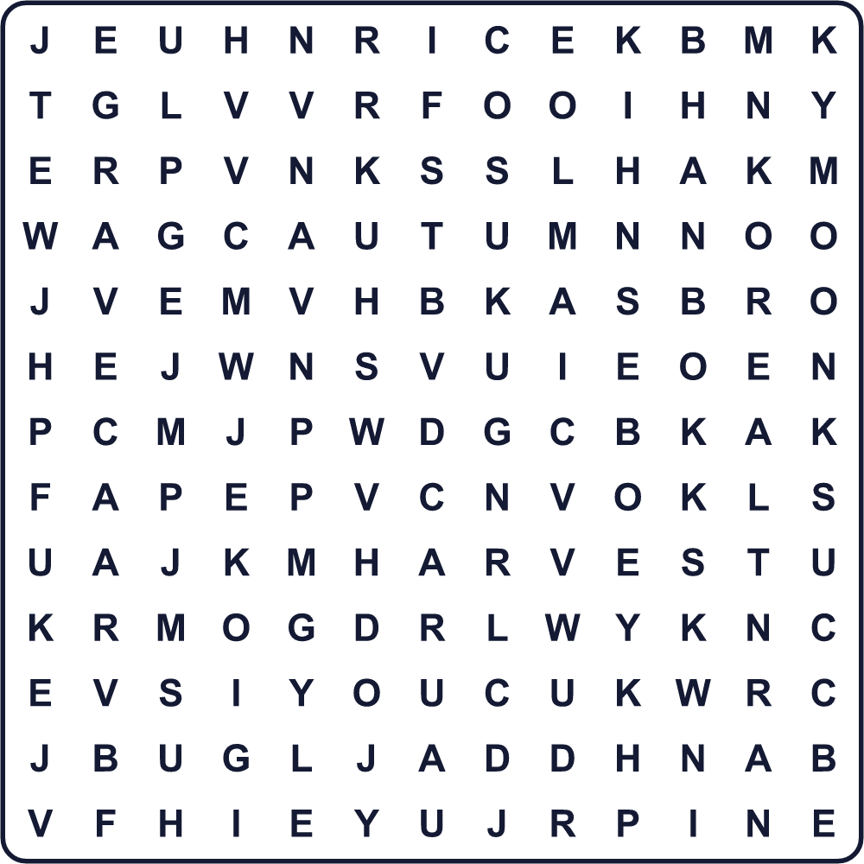
AUTUMN DANCE FAMILY GRAVE HANBOK HARVEST KOREA MOON PINE RICE

🌕 Chuseok Worksheet
Maze & Sentences
Class ______ No. ____ Name ______________________________
Help the family get to Grandma's house! 家族をおばあちゃんの家まで連れていこう！
正しい道の文字を集めると、ひみつの言葉になるよ。 START 🚗 → GOAL 🏡
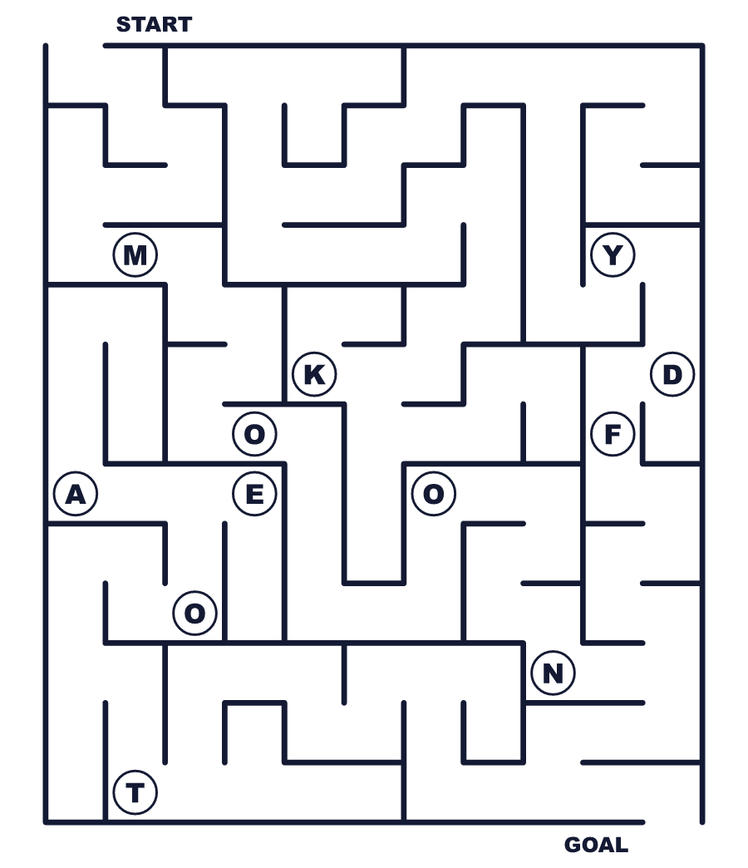
Secret word: ＿ ＿ ＿ ＿

🌕 Chuseok Worksheet
Class Activity & Writing
Class ______ No. ____ Name ______________________________
Let's Write! 英語で書いてみよう。
On the night of the full moon, I would wish for ______.
満月の夜、私は______を願いたい。
______________________________________________________________
______________________________________________________________
Chuseok is like Obon because ______.
チュソクはお盆に似ています。なぜなら______だからです。
______________________________________________________________
______________________________________________________________

🌕 Chuseok Worksheet
Trace & Color
なぞって書こう。絵に色をぬろう。
Class ______ No. ____ Name ______________________________
🌕 

🌲 
🚗 
🍎 
🌾 

🌕 Chuseok Worksheet
Answer Key 解答
Reading Check: 1.B 2.A 3.D 4.C 5.B
True or False: 1.T 2.F 3.T 4.F
Match: 🌕=full moon 🌲=pine tree 🚗=car 🍎=apple 🌾=rice plant 👵=grandmother
Fill in the blanks: (1)village (2)traffic (3)songpyeon (4)moon (5)graves (6)hanbok (7)wish
Maze: MOON
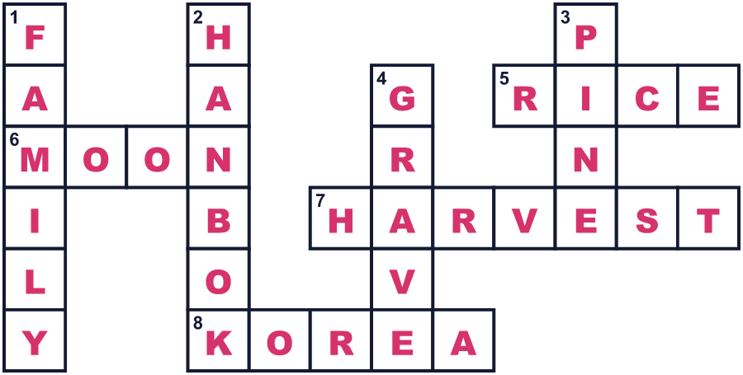
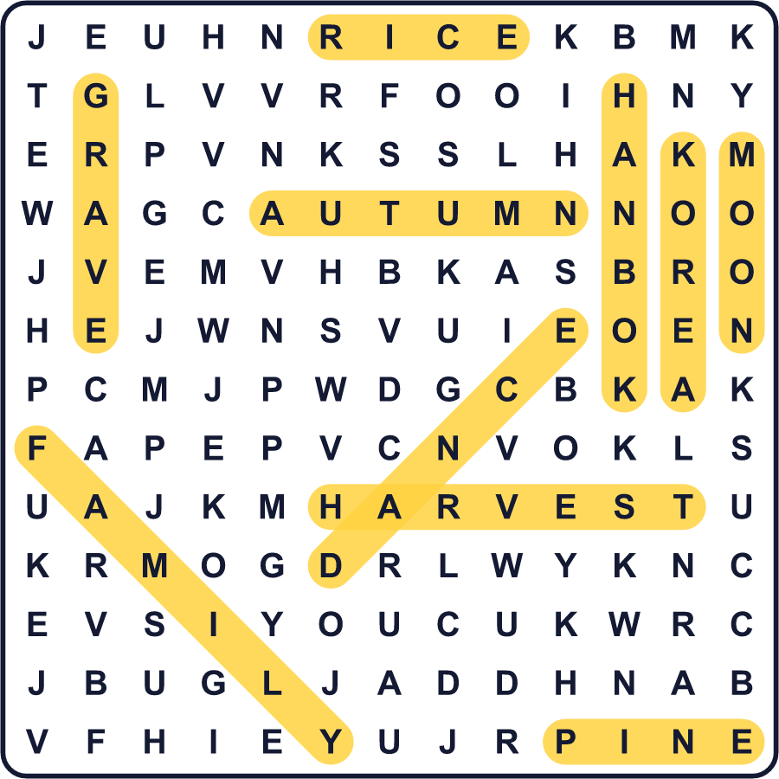
全訳
1 毎年秋になると、韓国の高速道路は車でいっぱいになります。列車も飛行機も満員です。人々はそれを「民族大移動」と呼びます。チュソク、1年でいちばん大きな祝日のひとつです。それは旧暦8月15日、満月の下にやってきます。
2 チュソクは約2000年の歴史があるのかもしれません。ある古い歴史書が、新羅という国の王の話を伝えています。王は都の女性たちを2つのチームに分けました。1か月の間、彼女たちは毎日布を織りました。満月の夜、負けたチームが勝ったチームのために大きなごちそうを作りました。そしてみんなで歌い、踊りました。
3 今、家族はチュソクの朝に早起きします。先祖のために、ごはん、果物、魚、餅を台の上に並べます。昔からのルールがあります。赤い果物は東側、白い果物は西側です。そのあと、家族のお墓を訪ね、まわりの草を刈ります。
4 チュソクのいちばん有名な食べ物はソンピョンです。この小さな餅は、半月の形をしています。人々は松の葉を敷いて、その上で蒸します。ソンは韓国語で松という意味です。昔の言い伝えでは、きれいなソンピョンを作る若い女性はよい夫に出会えるそうです。夜には、韓服を着た女性たちが手をつなぎ、月の下で大きな輪になって踊ります。

