🎄 Christmas Worksheet
A Birthday Without a Date
Read the story. 英文を読もう。
Class ______ No. ____ Name ______________________________

🔊 音声を聞こう（スマホで読みとってね）
1 Nobody knows the real birthday of Jesus. The Bible tells his story, but it does not give a date. The oldest record of Christmas on December 25 comes from Rome in the year 336. Today, billions of people around the world celebrate Christmas.
2 Christians believe Jesus was born in a small town called Bethlehem. In the story, there was no room for his family at the inn. So his mother put the baby in a manger, a box for animal food. Shepherds and wise men came to see him.
3 Santa Claus has a long story, too. He comes from Saint Nicholas, a kind bishop in what is now Turkey. He lived about 1,700 years ago and gave secret gifts to poor people. Dutch people called him Sinterklaas, and in New York the name became Santa Claus. Many people say Coca-Cola made Santa red, but red Santas were in magazines before that.
4 Today, families decorate a tree with lights and put a star on top. Children hang stockings and hope for presents in the morning. In Britain, people pull paper crackers at dinner. They go bang, and a paper crown falls out.
5 But Christmas looks very different around the world. In Australia, it is summer, so many families go to the beach. In the Philippines, the season starts in September. In Italy, a kind old woman on a broom brings presents in January. And in Japan, many people eat fried chicken and strawberry cake.
Words 単語
record（記録） / celebrate（祝う） / Bible（聖書） / inn（宿屋） / manger（飼い葉おけ（家畜のえさ入れ）） / shepherd（羊飼い） / bishop（司教） / secret（秘密の、こっそりの） / decorate（飾る） / stocking（（クリスマスの）くつした） / cracker（クリスマスクラッカー） / season（季節、時期）

🎄 Christmas Worksheet
Reading Check
Choose the best answer. 正しいものを選ぼう。
Class ______ No. ____ Name ______________________________
1. What is the main idea of the reading?
(A) Christmas has a long history, and people celebrate it in many different ways. (B) Christmas started in Japan and later moved to Europe and America. (C) Christmas is only for children who get presents from Santa. (D) Christmas is the same in every country in the world.
2. When is the oldest record of Christmas on December 25?
(A) The year 1 (B) The year 1823 (C) The year 336 (D) The year 1,700
3. Why did Mary put the baby in a manger?
(A) Because it was warm in the box (B) Because there was no room at the inn (C) Because the shepherds asked her to (D) Because it was a custom in Rome
4. Which is the correct order of Santa's names?
(A) Santa Claus, Sinterklaas, Saint Nicholas (B) Sinterklaas, Saint Nicholas, Santa Claus (C) Saint Nicholas, Santa Claus, Sinterklaas (D) Saint Nicholas, Sinterklaas, Santa Claus
5. In paragraph 3, the word "secret" is closest in meaning to:
(A) very expensive (B) hidden, so others do not know (C) very large (D) made by hand
6. Which sentence is true about the reading?
(A) The Bible says Jesus was born on December 25. (B) Red Santas appeared in magazines before Coca-Cola's ads. (C) In Italy, Santa brings presents in September. (D) In Australia, Christmas comes in winter.
7. Why do many Australian families go to the beach at Christmas?
(A) Because Santa lives near the sea (B) Because the shops are closed in September (C) Because it is hot in December there (D) Because the Bible tells them to
8. In the dialogue, what is different about Christmas Eve in Japan and in Australia?
(A) In Japan, many couples go on dates. In Australia, it is a family night. (B) In Japan, people go to the beach. In Australia, people eat cake. (C) In Japan, it is a holiday. In Australia, people work. (D) In Japan, people eat prawns. In Australia, people eat chicken.
True or False? T か F に○
1. The Bible says Jesus was born on December 25. T / F
2. Santa Claus comes from Saint Nicholas. T / F
3. Red Santas appeared before Coca-Cola's ads. T / F
4. In Australia, Christmas is in winter. T / F
5. In Britain, people pull crackers at Christmas dinner. T / F
6. Christmas is a national holiday in Japan. T / F

🎄 Christmas Worksheet
Word Work
単語のれんしゅう
Class ______ No. ____ Name ______________________________
① Match the pictures and the words. 絵と単語を線でむすぼう。
🎄 | ● | ● | reindeer
🎅 | ● | ● | tree
🦌 | ● | ● | Santa
🧦 | ● | ● | star
🔔 | ● | ● | bell
⭐ | ● | ● | snowman
🎁 | ● | ● | present
⛄ | ● | ● | stocking
② Unscramble the words. 並べかえて単語にしよう。
1. S A N A T (サンタ) → ____________________
2. S E P E R N T (プレゼント) → ____________________
3. R D E E R N I E (トナカイ) → ____________________
4. C Y N E H I M (煙突) → ____________________
5. C L O R A (クリスマスの歌) → ____________________
6. E I R T W N (冬) → ____________________
③ Fill in the blanks. 語群から選んで入れよう。
[ rice / hat / snow / Canada / call / prawns / presents / pumpkin / Christmas / sweater / beach / spring / summer ]
Ana lives in Australia. Her cousin Ben lives in (1) __________ . On December 25, Ben wakes up and looks out the window. There is white (2) __________ everywhere. He opens his (3) __________ under the tree. In Australia, it is (4) __________ . Ana and her family go to the (5) __________ . They eat (6) __________ for lunch. In the evening, the cousins have a video (7) __________ . Ben wears a warm (8) __________ . Ana wears a (9) __________ for the sun. "Merry (10) __________ !" they both say and laugh.

🎄 Christmas Worksheet
Crossword Puzzle
ヒントを読んでクロスワードを完成させよう。
Class ______ No. ____ Name ______________________________
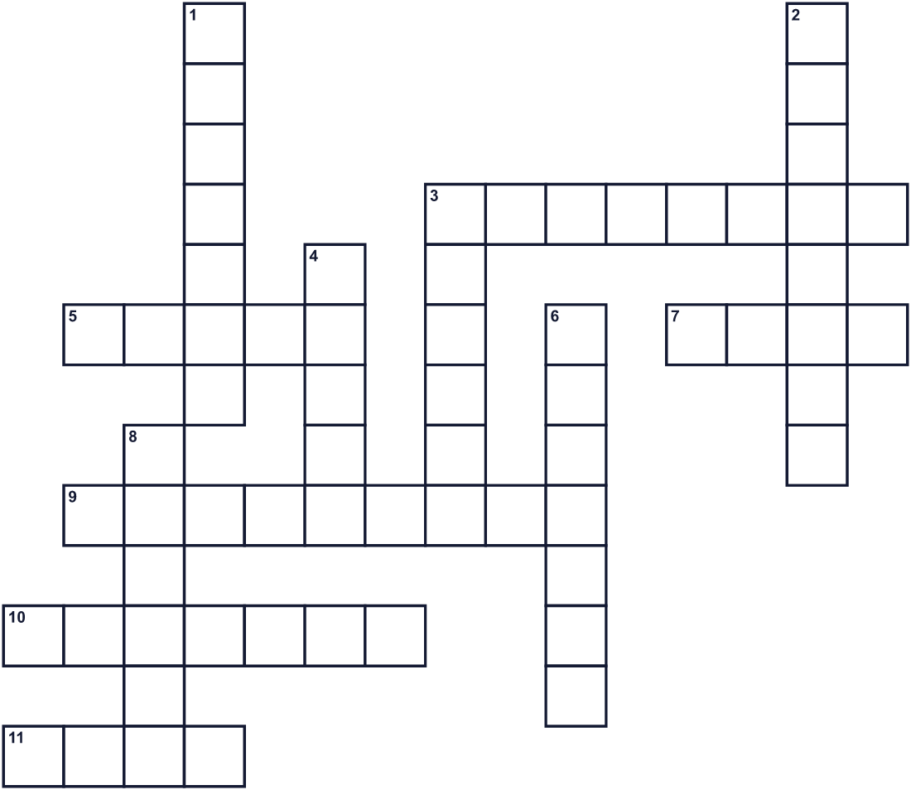
Across →
3. A big sock. Children hang it by the bed. (8)
5. He brings presents and has a white beard. (5)
7. People put lights and a star on it. (4)
9. The small town where Jesus was born. (9)
10. In Britain, two people pull it and it goes bang. (7)
11. It shines at the top of the tree. (4)
Down ↓
1. A gift in pretty paper. (7)
2. Animals that pull a sleigh through the sky. (8)
3. Santa rides in it over the snow. (6)
4. A Christmas song, like Silent Night. (5)
6. Santa comes down it into the house. (7)
8. An old woman in Italy. She flies on a broom. (6)

🎄 Christmas Worksheet
Word Search
かくれた単語をさがそう（→ ↓ ↘ ↗）
Class ______ No. ____ Name ______________________________
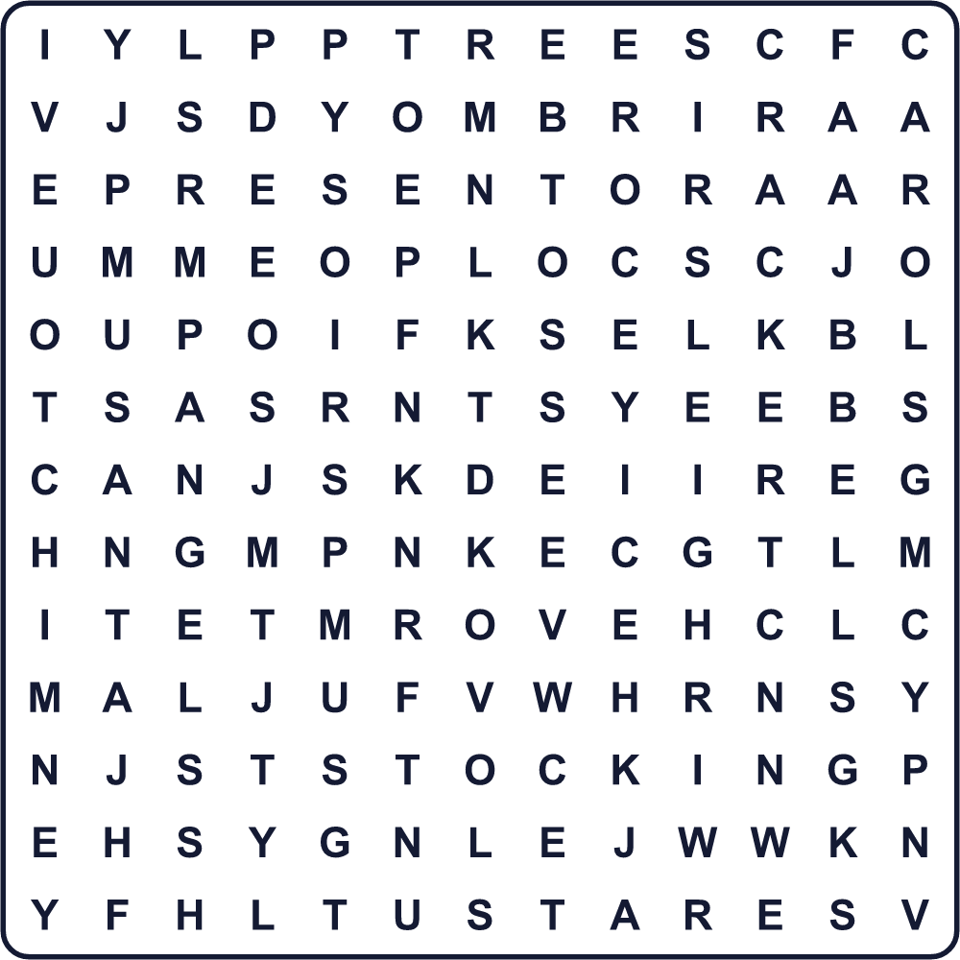
ANGEL BELLS CAROL CHIMNEY CRACKER PRESENT REINDEER SANTA SLEIGH SNOW STAR STOCKING TREE TURKEY
Secret Code 暗号を解こう
☎=A ☂=C ✎=E ▲=H ✂=I ●=M ◎=R ☺=S ◆=T ☾=Y
● ✎ ◎ ◎ ☾ ☂ ▲ ◎ ✂ ☺ ◆ ● ☎ ☺
______________________________________________________________

🎄 Christmas Worksheet
Maze & Sentences
Class ______ No. ____ Name ______________________________
Help Santa find the chimney! サンタを煙突まで連れていこう！
正しい道の文字を集めると、ひみつの言葉になるよ。 START 🎅 → GOAL 🏠
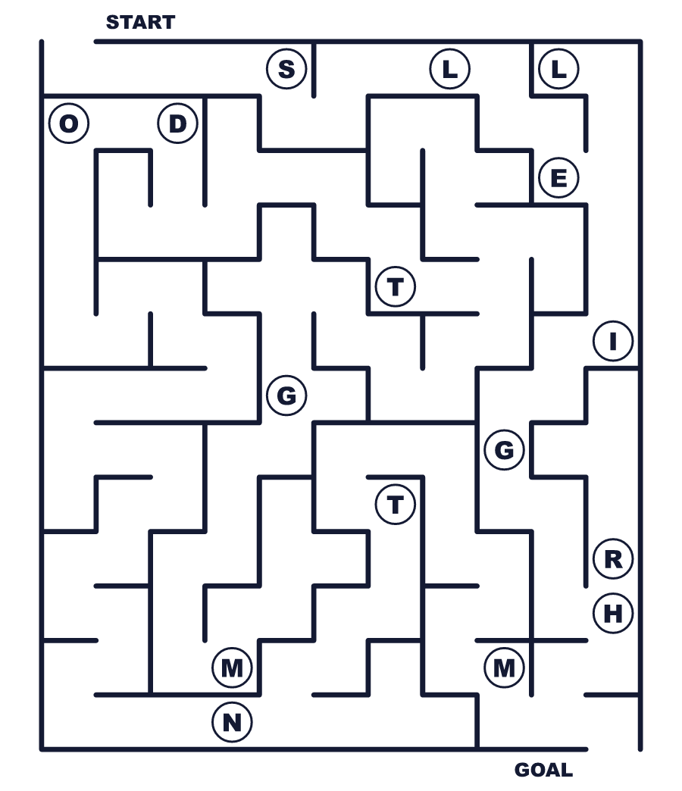
Secret word: ＿ ＿ ＿ ＿ ＿ ＿
Put the words in order. 並べかえよう。
1. decorate / colorful / the / We / tree / lights / with . (私たちはツリーをカラフルな明かりで飾ります。)
______________________________________________________________
2. comes / Claus / Saint / Nicholas / from / Santa . (サンタクロースのもとは聖ニコラウスです。)
______________________________________________________________
3. bed / the / their / hang / by / Children / stockings . (子どもたちはベッドのそばに靴下をつるします。)
______________________________________________________________
4. Australia, / Christmas / In / is / summer / in . (オーストラリアでは、クリスマスは夏です。)
______________________________________________________________
5. Eve / on / fried / Christmas / eats / family / My / chicken . (私の家族はクリスマスイブにフライドチキンを食べます。)
______________________________________________________________

🎄 Christmas Worksheet
Class Activity & Writing
Class ______ No. ____ Name ______________________________
Find Someone Who… クラスで聞いて回ろう！
Find someone who … | Name
… has decorated a Christmas tree クリスマスツリーを飾ったことがある
… has written a letter to Santa サンタに手紙を書いたことがある
… likes strawberry cake いちごのケーキが好き
… can sing a Christmas song in English 英語でクリスマスの歌を歌える
… knows the name of a reindeer トナカイの名前を1つ知っている
… has seen snow on Christmas Day クリスマスの日に雪を見たことがある
… knows what Xmas means Xmas の意味を知っている
… likes fried chicken フライドチキンが好き
Let's Write! 英語で書いてみよう。
If I could spend Christmas in another country, I would go to ______ because ______.
ほかの国でクリスマスを過ごせるなら、______に行きたい。なぜなら______だから。
______________________________________________________________
______________________________________________________________
Dear Santa, this year I ______. Please bring me ______.
サンタさんへ。今年、私は______しました。______を持ってきてください。
______________________________________________________________
______________________________________________________________
Christmas in Japan is different from Christmas in ______ because ______.
日本のクリスマスは______のクリスマスとちがいます。なぜなら______だからです。
______________________________________________________________
______________________________________________________________

🎄 Christmas Worksheet
Trace & Color
なぞって書こう。絵に色をぬろう。
Class ______ No. ____ Name ______________________________
🎄 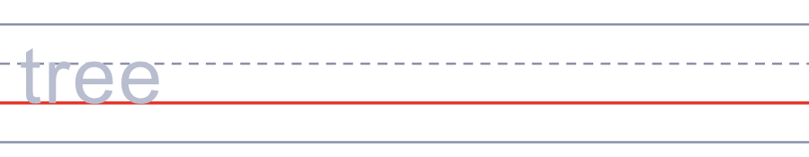

🎅 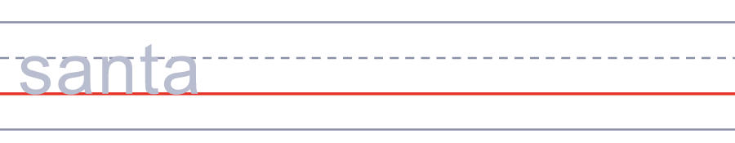
🦌 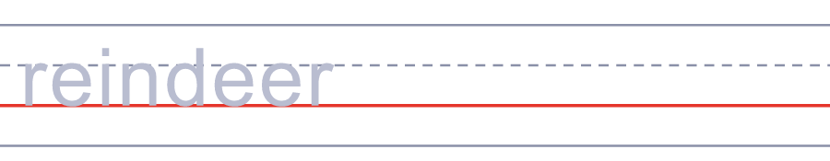
🧦 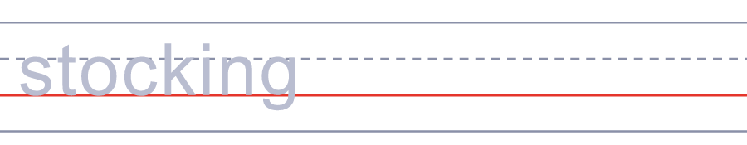
🔔 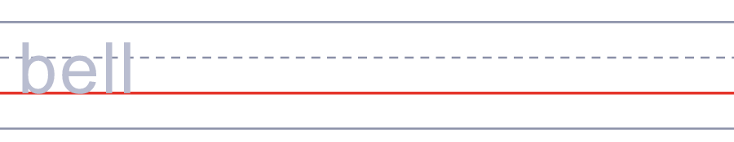
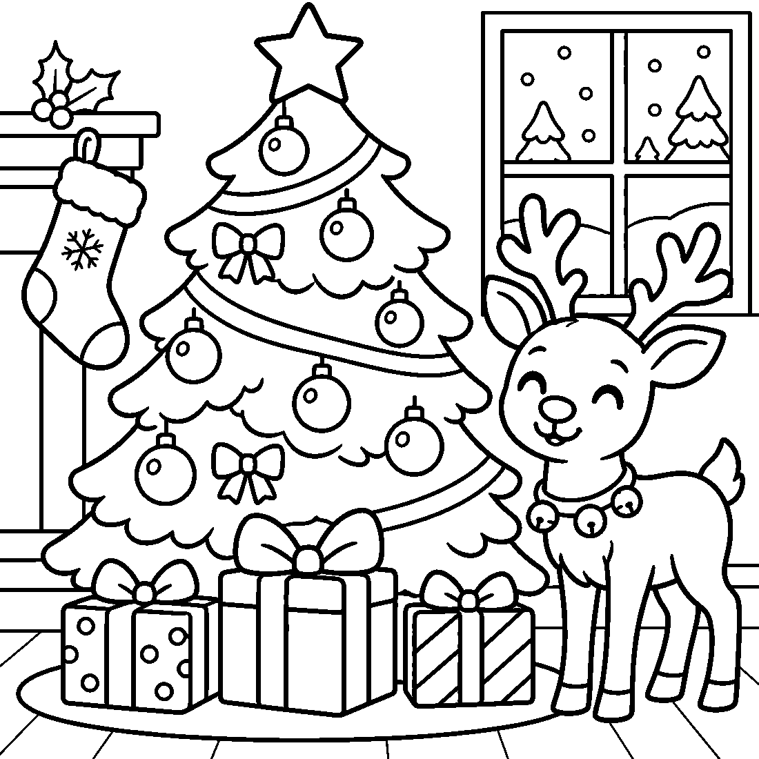

🎄 Christmas Worksheet
Answer Key 解答
Reading Check: 1.A 2.C 3.B 4.D 5.B 6.B 7.C 8.A
True or False: 1.F 2.T 3.T 4.F 5.T 6.F
Match: 🎄=tree 🎅=Santa 🦌=reindeer 🧦=stocking 🔔=bell ⭐=star 🎁=present ⛄=snowman
Unscramble: 1.SANTA 2.PRESENT 3.REINDEER 4.CHIMNEY 5.CAROL 6.WINTER
Fill in the blanks: (1)Canada (2)snow (3)presents (4)summer (5)beach (6)prawns (7)call (8)sweater (9)hat (10)Christmas
Sentence order: 1. We decorate the tree with colorful lights. 2. Santa Claus comes from Saint Nicholas. 3. Children hang their stockings by the bed. 4. In Australia, Christmas is in summer. 5. My family eats fried chicken on Christmas Eve.
Secret Code: MERRY CHRISTMAS
Maze: SLEIGH
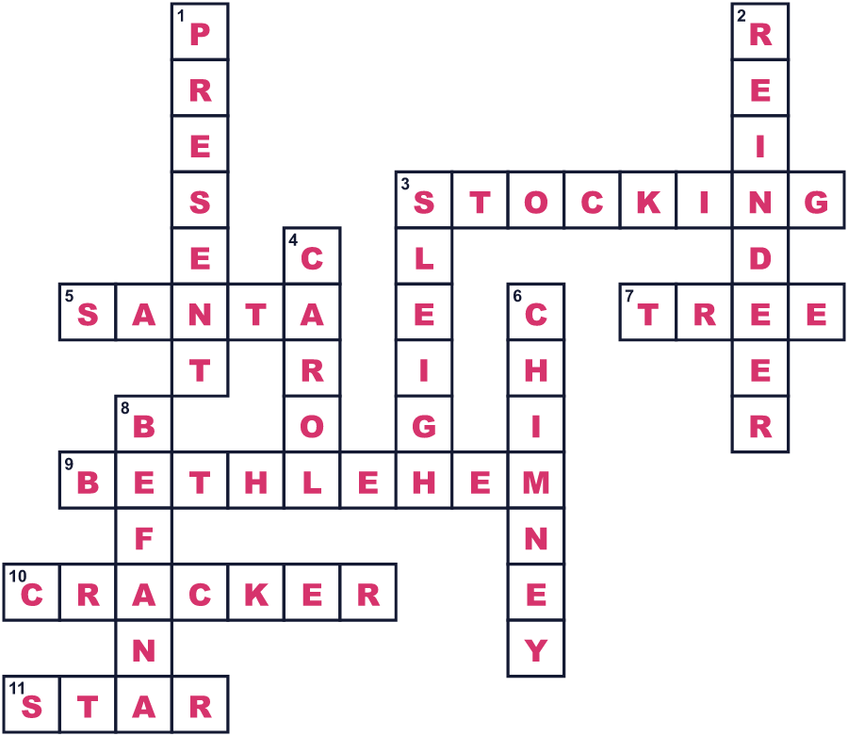
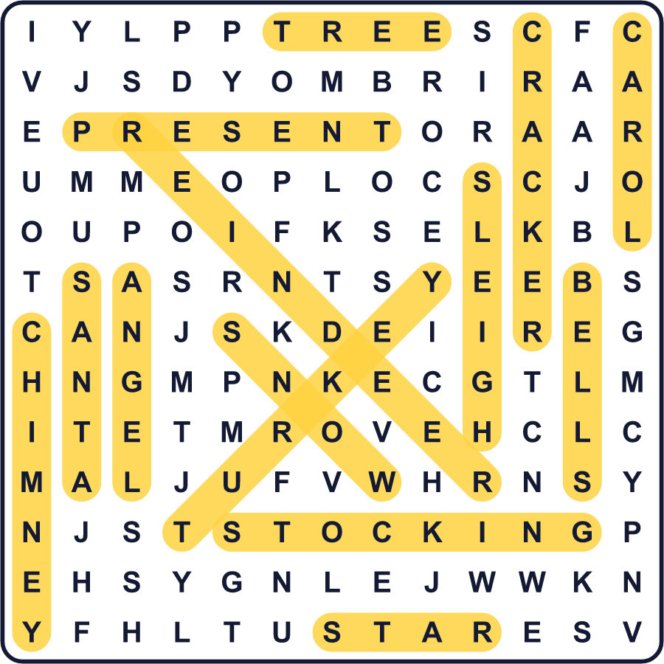
全訳
1 イエスの本当の誕生日は、だれも知りません。聖書はイエスの物語を伝えていますが、日付は書いていません。12月25日のクリスマスの最古の記録は、336年のローマのものです。今では世界中の何十億もの人が、この日を祝います。
2 キリスト教徒は、イエスがベツレヘムという小さな町で生まれたと信じています。物語では、宿屋にはイエスの家族が泊まる部屋がありませんでした。そこで母親は、赤ちゃんを飼い葉おけ、つまり家畜のえさ入れに寝かせました。羊飼いや博士たちが、イエスに会いにやってきました。
3 サンタクロースにも長い物語があります。サンタのもとは、今のトルコにいたやさしい司教、聖ニコラウスです。彼は約1700年前に生き、貧しい人たちにこっそり贈り物をしました。オランダの人々は彼をシンタクラースと呼び、ニューヨークでその名前がサンタクロースになりました。コカ・コーラがサンタを赤くしたと言う人は多いですが、赤いサンタはそれより前から雑誌に載っていました。
4 今、家族はツリーを明かりで飾り、てっぺんに星をのせます。子どもたちは靴下をつるし、朝のプレゼントを楽しみに待ちます。イギリスでは、夕食のときに紙のクラッカーを引っぱります。パンと鳴って、紙の王冠が出てきます。
5 でも、クリスマスの姿は世界でまったくちがいます。オーストラリアは夏なので、多くの家族がビーチへ行きます。フィリピンでは、クリスマスの季節は9月に始まります。イタリアでは、ほうきに乗ったやさしいおばあさんが1月にプレゼントを届けます。そして日本では、多くの人がフライドチキンといちごのケーキを食べます。

