🎭 Carnival & Mardi Gras Worksheet
One Tuesday, Many Parties
Read the story. 英文を読もう。
Class ______ No. ____ Name ______________________________

🔊 音声を聞こう（スマホで読みとってね）
1 On one Tuesday in February or March, many cities go a little crazy. In Rio de Janeiro, people dance samba in the streets. In New Orleans, they catch beads from big floats. In Venice, they hide behind beautiful masks. And in England, they flip pancakes. Why do they all party on the same day?
2 The answer is Lent. Lent is a time of 40 days before Easter. In the past, many Christians did not eat meat, eggs, or butter during Lent. So before it started, they had one last big party and ate all the rich food in their homes. This party is called Carnival. The word probably comes from Latin words that mean "to take away meat."
3 Rio has the biggest Carnival in the world. About two million people fill the streets every day. At night, samba schools march through a long stadium called the Sambadrome. Each school has thousands of dancers and drummers. It has about 75 minutes to show its music and costumes, and judges give points.
4 In New Orleans, the last day is called Mardi Gras. It means "Fat Tuesday" in French. People on floats throw plastic beads, and the colors of the party are purple, green, and gold. In Venice, Italy, people wear masks and long capes. Long ago, masks were so popular that the city made laws about them.
5 In England, the day is called Shrove Tuesday, or Pancake Day. Families make thin pancakes with lemon and sugar. In the town of Olney, women run a race with frying pans in their hands. The story says it started in 1445, when a busy cook ran to church with her pan. The next morning, the party is over, and Lent begins.
Words 単語
Lent（四旬節（レント）） / Easter（イースター、復活祭） / rich（（食べ物が）こってりした、栄養たっぷりの） / parade（パレード、行進） / float（（パレードの）山車） / bead（ビーズ、玉） / mask（仮面、お面） / cape（マント） / judge（審査員） / costume（衣装、仮装） / flip（ひっくり返す、ぽんと投げ上げる） / probably（たぶん、おそらく）

🎭 Carnival & Mardi Gras Worksheet
Reading Check
Choose the best answer. 正しいものを選ぼう。
Class ______ No. ____ Name ______________________________
1. What is the passage mainly about?
(A) How to make pancakes in England (B) Why and how people celebrate Carnival in different cities (C) The history of samba music in Africa (D) Why Easter is on Sunday
2. How long is Lent?
(A) 7 days (B) 47 days (C) 75 minutes (D) 40 days
3. Why did people have a big party before Lent?
(A) Because they could not eat rich food during Lent (B) Because Easter was on Tuesday (C) Because the king ordered it (D) Because it was summer
4. How many people fill the streets of Rio every day?
(A) About 75,000 (B) About 2,000 (C) About two million (D) About 1,445
5. In paragraph 4, what does "floats" mean?
(A) Boats on a river (B) Decorated cars or platforms in a parade (C) Plastic balls in a pool (D) Large masks
6. Which sentence matches the passage?
(A) Mardi Gras means "Happy Sunday" in Spanish. (B) The colors of the New Orleans party are red and white. (C) In Olney, men race with pancakes. (D) Venice once made laws about masks.
7. What can we guess about Carnival from the passage?
(A) It is a quiet day for most people. (B) Each city celebrates the same day in its own way. (C) It is only for children. (D) It always happens in summer.
8. In the dialogue, why does Ana tell Yuto to bring good shoes?
(A) Because Rio is very cold in February (B) Because he will run in a pancake race (C) Because he will dance all night (D) Because the streets have no lights
True or False? T か F に○
1. Carnival happens before Lent. T / F
2. Mardi Gras means "Fat Tuesday" in French. T / F
3. Mardi Gras is on the same date every year. T / F
4. The colors of the New Orleans Mardi Gras are purple, green, and gold. T / F
5. People in England eat sushi on Pancake Day. T / F
6. Carnival started in Japan. T / F

🎭 Carnival & Mardi Gras Worksheet
Word Work
単語のれんしゅう
Class ______ No. ____ Name ______________________________
① Match the pictures and the words. 絵と単語を線でむすぼう。
🎭 | ● | ● | trumpet
🥁 | ● | ● | pancake
🥞 | ● | ● | crown
💃 | ● | ● | orange
🍊 | ● | ● | dancer
🎺 | ● | ● | party
👑 | ● | ● | drum
🎉 | ● | ● | mask
② Unscramble the words. 並べかえて単語にしよう。
1. B M S A A (ブラジルのダンス) → ____________________
2. K S M A (仮面) → ____________________
3. S D A E B (ビーズ) → ____________________
4. P R A E D A (パレード) → ____________________
5. L N T E (四旬節) → ____________________
6. T O L A F (山車) → ____________________
③ Fill in the blanks. 語群から選んで入れよう。
[ Germany / costumes / ten / flower / pirate / throw / season / quiet / summer / November / street / sleep / parade ]
Lena lives in Cologne, (1) __________ . Her city's Carnival starts at 11:11 on (2) __________ 11. But the biggest day comes months later. On that Monday, Lena and her brother wear (3) __________ . She is a (4) __________ , and he is a lion. They stand on the (5) __________ with a big bag. Music plays, and the (6) __________ comes. People on the floats (7) __________ candy and chocolate bars. Lena catches (8) __________ candies! Her brother catches a (9) __________ . "Carnival is the best (10) __________ of the year!" Lena shouts.

🎭 Carnival & Mardi Gras Worksheet
Crossword Puzzle
ヒントを読んでクロスワードを完成させよう。
Class ______ No. ____ Name ______________________________
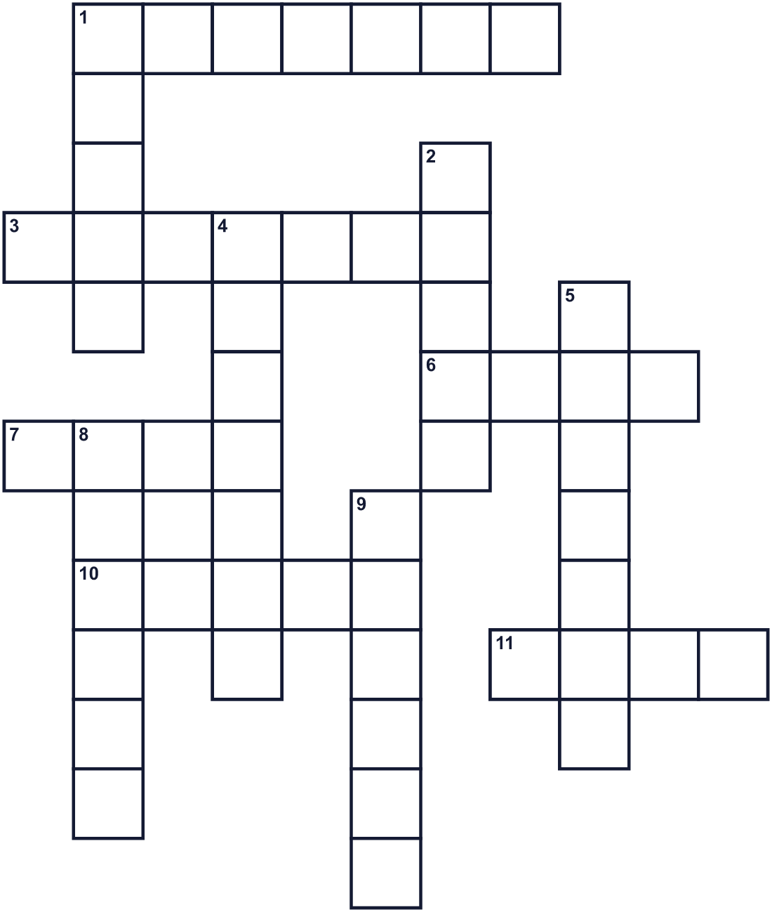
Across →
1. Birds have many. Dancers wear them on their heads. (7)
3. Thin, flat food. In England, people eat it with lemon and sugar. (7)
6. You hit it with sticks to make a beat. (4)
7. Forty days before Easter. Some people give up food then. (4)
10. A dance and music from Brazil. (5)
11. You wear it on your face. People in Venice love it. (4)
Down ↓
1. A big decorated car in a parade. (5)
2. Small balls on a string. People catch them in New Orleans. (5)
4. Special clothes for a show or a party. (7)
5. The day after Monday. Mardi Gras is on this day. (7)
8. A Christian holiday in spring. Carnival comes before it. (6)
9. Many people walk or dance down the street in a long line. (6)

🎭 Carnival & Mardi Gras Worksheet
Word Search
かくれた単語をさがそう（→ ↓ ↘ ↗）
Class ______ No. ____ Name ______________________________
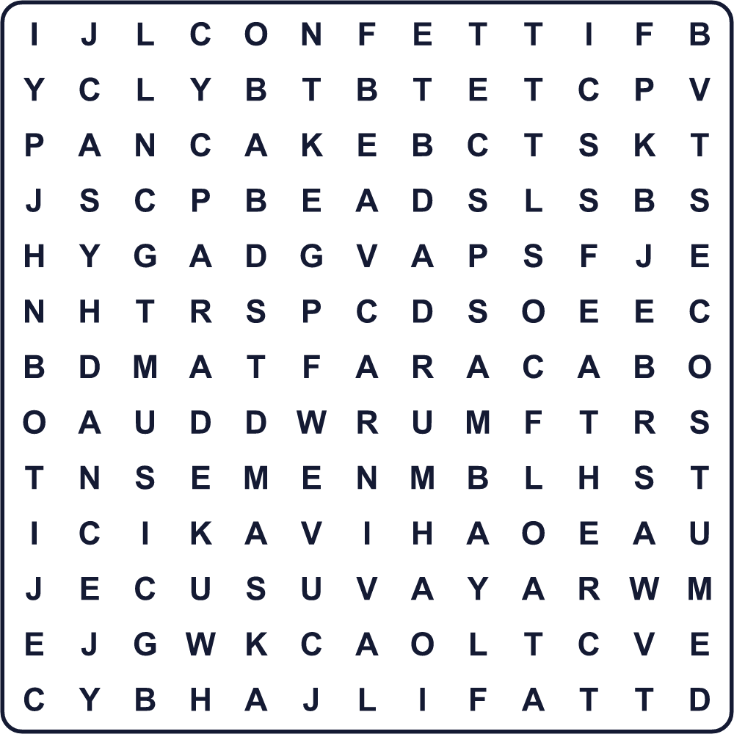
BEADS CARNIVAL CONFETTI COSTUME DANCE DRUM FEATHER FLOAT MASK MUSIC PANCAKE PARADE SAMBA
Secret Code 暗号を解こう
♠=A ☺=D ♦=E ✂=F ✎=H ✈=P ☂=S ☃=T ■=U ★=Y
✎ ♠ ✈ ✈ ★ ✂ ♠ ☃ ☃ ■ ♦ ☂ ☺ ♠ ★
______________________________________________________________

🎭 Carnival & Mardi Gras Worksheet
Maze & Sentences
Class ______ No. ____ Name ______________________________
Help the dancer get to the parade! ダンサーをパレードまで連れていこう！
正しい道の文字を集めると、ひみつの言葉になるよ。 START 💃 → GOAL 🎭
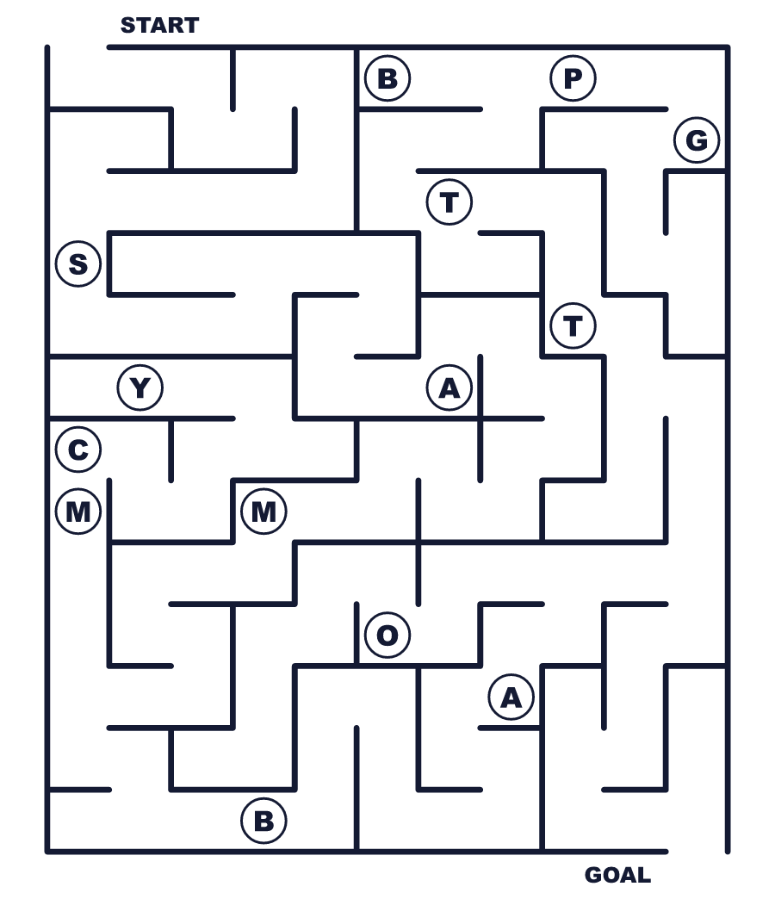
Secret word: ＿ ＿ ＿ ＿ ＿
Put the words in order. 並べかえよう。
1. before / Carnival / is / a / party / Lent / big . (カーニバルは四旬節の前の大きなお祭りです。)
______________________________________________________________
2. samba / of / Rio / the / streets / People / in / dance . (リオの通りで人々がサンバを踊ります。)
______________________________________________________________
3. on / crowd / throw / floats / the / to / People / beads . (山車の上の人たちが観客にビーズを投げます。)
______________________________________________________________
4. with / sugar / Families / lemon / thin / and / pancakes / make . (家族でレモンと砂糖をかけた薄いパンケーキを作ります。)
______________________________________________________________
5. Fat / Tuesday / Mardi / in / means / French / Gras . (マルディグラはフランス語で「太った火曜日」という意味です。)
______________________________________________________________

🎭 Carnival & Mardi Gras Worksheet
Class Activity & Writing
Class ______ No. ____ Name ______________________________
Find Someone Who… クラスで聞いて回ろう！
Find someone who … | Name
… has worn a mask at a party パーティーで仮面をつけたことがある
… can dance a little samba サンバを少し踊れる
… likes pancakes with lemon レモンをかけたパンケーキが好き
… has seen a parade パレードを見たことがある
… knows the date of Easter this year 今年のイースターの日付を知っている
… can play a drum 太鼓（ドラム）をたたける
… has been to a summer festival in Japan 日本の夏祭りに行ったことがある
… can flip a pancake パンケーキをひっくり返せる
Let's Write! 英語で書いてみよう。
If I joined Carnival, I would wear a ______ costume because ______.
もしカーニバルに参加するなら、私は______の衣装を着ます。なぜなら______だからです。
______________________________________________________________
______________________________________________________________
Before 40 days without ______, I would eat a lot of ______.
40日間______なしで過ごす前に、私は______をたくさん食べるでしょう。
______________________________________________________________
______________________________________________________________
The Carnival I want to see most is in ______ because ______.
いちばん見たいカーニバルは______のものです。なぜなら______だからです。
______________________________________________________________
______________________________________________________________

🎭 Carnival & Mardi Gras Worksheet
Trace & Color
なぞって書こう。絵に色をぬろう。
Class ______ No. ____ Name ______________________________
🎭 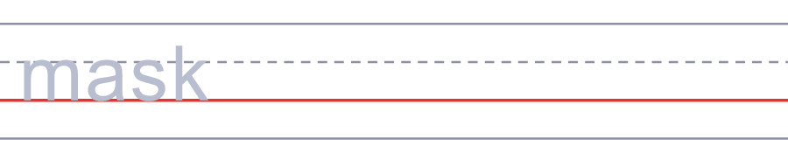

🥁 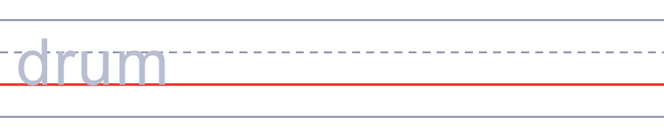
🥞 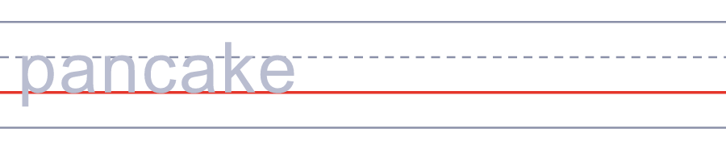
💃 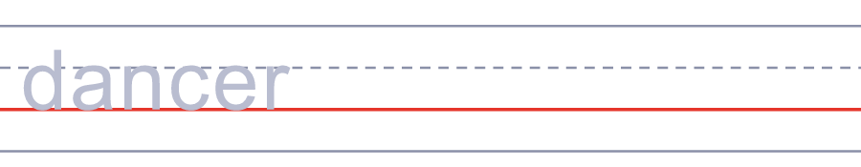
🍊 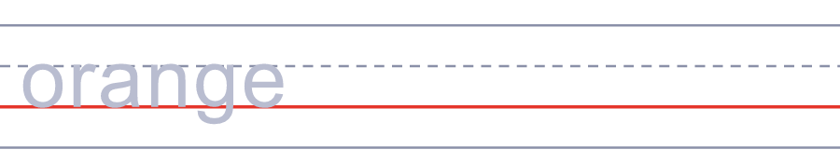
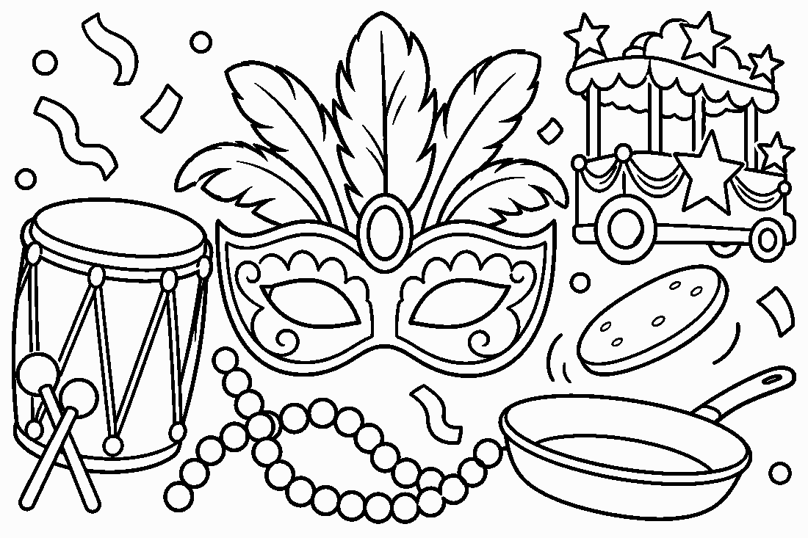

🎭 Carnival & Mardi Gras Worksheet
Answer Key 解答
Reading Check: 1.B 2.D 3.A 4.C 5.B 6.D 7.B 8.C
True or False: 1.T 2.T 3.F 4.T 5.F 6.F
Match: 🎭=mask 🥁=drum 🥞=pancake 💃=dancer 🍊=orange 🎺=trumpet 👑=crown 🎉=party
Unscramble: 1.SAMBA 2.MASK 3.BEADS 4.PARADE 5.LENT 6.FLOAT
Fill in the blanks: (1)Germany (2)November (3)costumes (4)pirate (5)street (6)parade (7)throw (8)ten (9)flower (10)season
Sentence order: 1. Carnival is a big party before Lent. 2. People dance samba in the streets of Rio. 3. People on floats throw beads to the crowd. 4. Families make thin pancakes with lemon and sugar. 5. Mardi Gras means Fat Tuesday in French.
Secret Code: HAPPY FAT TUESDAY
Maze: SAMBA
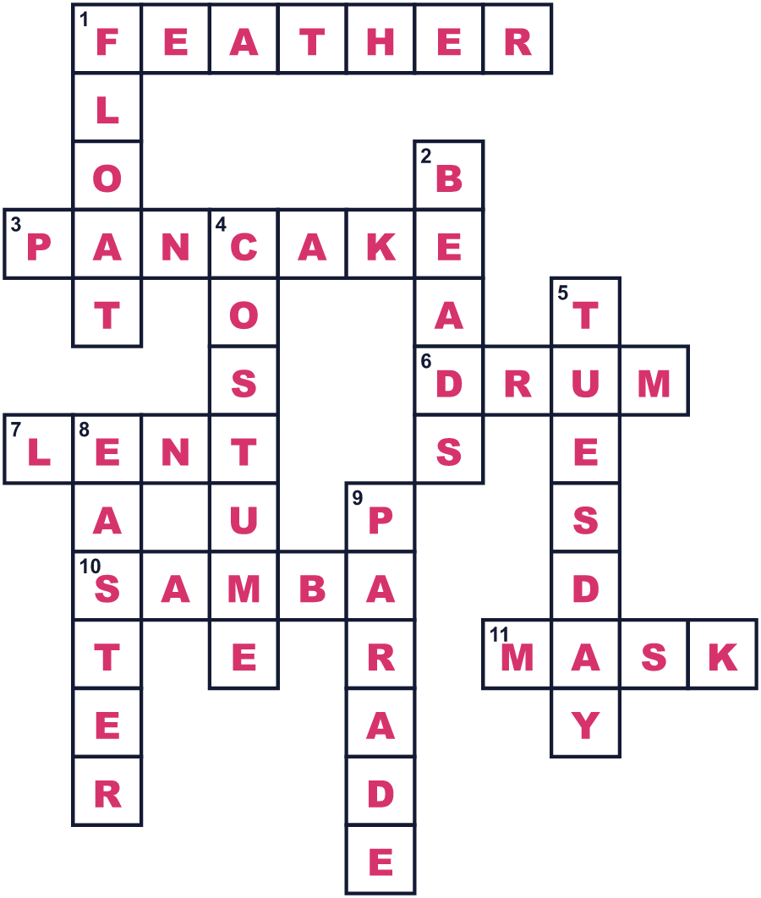
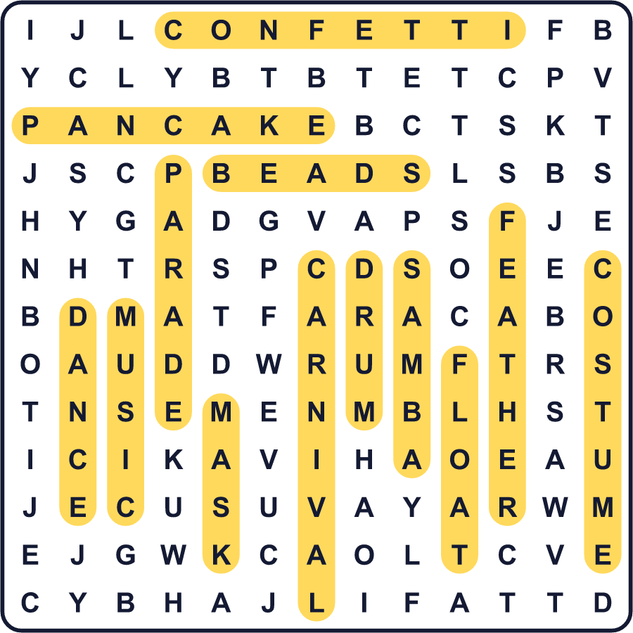
全訳
1 2月か3月のある火曜日、たくさんの町がちょっとおかしくなります。リオデジャネイロでは、人々が通りでサンバを踊ります。ニューオーリンズでは、大きな山車から飛んでくるビーズを受け止めます。ヴェネツィアでは、美しい仮面の後ろに顔をかくします。そしてイギリスでは、パンケーキをひっくり返します。なぜみんな同じ日にお祭りをするのでしょう。
2 答えは「四旬節（レント）」です。四旬節は、イースターの前の40日間です。昔、多くのキリスト教徒は、四旬節の間、肉や卵やバターを食べませんでした。だから四旬節が始まる前に、最後の大きなパーティーを開き、家にあるごちそうを食べつくしたのです。このお祭りがカーニバルです。この言葉は、たぶん「肉を取り除く」という意味のラテン語から来ています。
3 リオには世界最大のカーニバルがあります。毎日約200万人が通りを埋めつくします。夜には、サンバ学校が「サンボードロモ」という細長い会場を行進します。どの学校にも、何千人ものダンサーと太鼓の奏者がいます。持ち時間は約75分で、音楽と衣装を見せ、審査員が点数をつけます。
4 ニューオーリンズでは、最後の日をマルディグラと呼びます。フランス語で「太った火曜日」という意味です。山車の上の人たちがプラスチックのビーズを投げ、祭りの色は紫・緑・金です。イタリアのヴェネツィアでは、人々が仮面と長いマントを身につけます。昔は仮面があまりに流行したので、町が仮面についての法律を作ったほどです。
5 イギリスでは、この日をシュローブ・チューズデー、またはパンケーキデーと呼びます。家族でレモンと砂糖をかけた薄いパンケーキを作ります。オルニーという町では、女性たちがフライパンを手に競走をします。言い伝えでは、1445年、忙しく料理をしていた女性がフライパンを持ったまま教会へ走ったのが始まりです。翌朝、お祭りは終わり、四旬節が始まります。

