🍁 Canada Day Worksheet
A Birthday in Red and White
Read the story. 英文を読もう。
Class ______ No. ____ Name ______________________________

🔊 音声を聞こう（スマホで読みとってね）
1 On July 1, Canada turns red and white. People wear red shirts and paint maple leaves on their faces. It is Canada Day, the birthday of the country. Families have picnics, watch parades, and enjoy fireworks at night. Some people even wear funny red and white hats.
2 On July 1, 1867, a new country with four provinces was born. At first, it was called the Dominion of Canada. It was not yet a fully independent country, and it was still part of the British world. So the holiday was called Dominion Day. Today, Canada has ten provinces and three territories. It took 115 years for Canada to get full control of its own laws.
3 In 1982, the name of the holiday changed to Canada Day. Only 12 lawmakers were in the room when they voted. It took just five minutes! The red maple leaf flag is also quite new. It first flew in 1965.
4 In Ottawa, the capital, there is a big show at noon. Jets fly over the crowd, and people sing O Canada together. In many cities, people from other countries become new Canadians on this day. They promise to be good citizens and get a certificate. But in Quebec, July 1 is also Moving Day, so many people are busy carrying sofas and boxes. Canada is a big country, and its birthday has many faces.
Words 単語
maple leaf（カエデの葉） / join（まとまる、加わる） / province（州） / lawmaker（議員、立法者） / vote（投票する） / capital（首都） / fireworks（花火） / crowd（群衆、人だかり）

🍁 Canada Day Worksheet
Reading Check
Choose the best answer. 正しいものを選ぼう。
Class ______ No. ____ Name ______________________________
1. What is the main idea of the reading?
(A) Canada Day celebrates the birthday of Canada in many ways. (B) Canada Day is a day to move to a new house in every city. (C) Canada Day started in Ottawa in 1982. (D) Canada Day is a quiet day when everyone stays home.
2. What was the first name of the holiday?
(A) Maple Day (B) Independence Day (C) Dominion Day (D) Moving Day
3. How long did the vote to change the name take?
(A) Five minutes (B) Twelve hours (C) Five days (D) One year
4. Why are many people in Quebec busy on July 1?
(A) Because they work at the Parliament (B) Because they fly jets (C) Because they sing O Canada all day (D) Because it is also Moving Day
5. In the dialogue, how is Canada Day different from Independence Day in America?
(A) Canada Day is in winter. (B) Canada did not fight a war to become a country. (C) Canada Day has no fireworks. (D) Canada Day is only for children.
True or False? T か F に○
1. Canada Day is on July 1. T / F
2. The holiday was once called Dominion Day. T / F
3. Canada started with ten provinces in 1867. T / F
4. The maple leaf flag first flew in 1867. T / F

🍁 Canada Day Worksheet
Word Work
単語のれんしゅう
Class ______ No. ____ Name ______________________________
① Match the pictures and the words. 絵と単語を線でむすぼう。
🍁 | ● | ● | box
🎆 | ● | ● | beaver
🥞 | ● | ● | fireworks
🦫 | ● | ● | pancakes
🏒 | ● | ● | hockey
📦 | ● | ● | maple leaf
③ Fill in the blanks. 語群から選んで入れよう。
[ capital / anthem / pumpkin / snow / leaf / show / crowd / red / fireworks ]
Today is July 1. Emma and her brother go to Ottawa, the (1) __________ of Canada. They wear (2) __________ shirts. Emma's dad paints a maple (3) __________ on her face. At noon, they see a big (4) __________ . Jets fly over the (5) __________ . Everyone sings the national (6) __________ . At night, they watch beautiful (7) __________ .

🍁 Canada Day Worksheet
Crossword Puzzle
ヒントを読んでクロスワードを完成させよう。
Class ______ No. ____ Name ______________________________
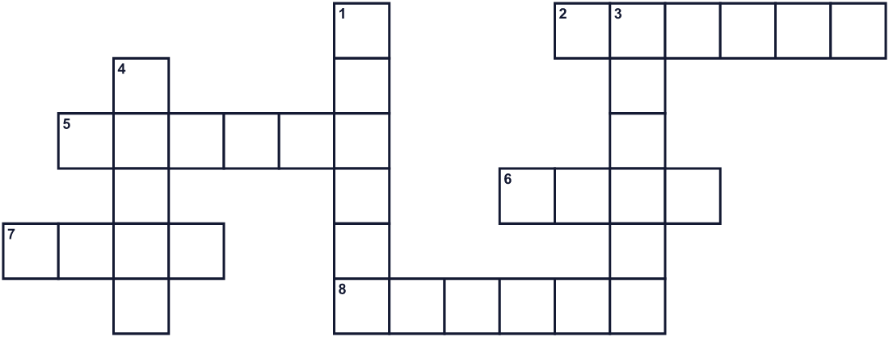
Across →
2. Taking your things to a new home. (6)
5. People walk and play music in the street. (6)
6. A piece of cloth with a country's colors. (4)
7. The month after June. (4)
8. A big country north of the United States. (6)
Down ↓
1. A province where many people speak French. (6)
3. The capital city of Canada. (6)
4. A tree. Its red leaf is on a famous flag. (5)

🍁 Canada Day Worksheet
Word Search
かくれた単語をさがそう（→ ↓ ↘ ↗）
Class ______ No. ____ Name ______________________________
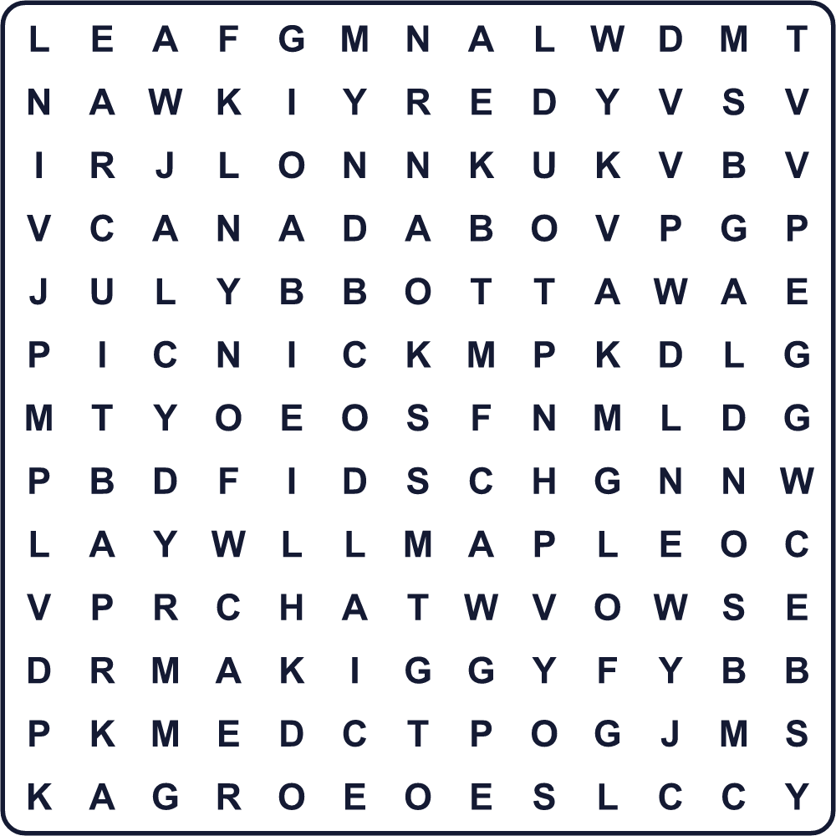
CANADA FLAG JULY LEAF MAPLE OTTAWA PARADE PICNIC RED WHITE

🍁 Canada Day Worksheet
Maze & Sentences
Class ______ No. ____ Name ______________________________
Help Emma get to the Canada Day fireworks! エマをカナダ・デーの花火まで連れていこう！
正しい道の文字を集めると、ひみつの言葉になるよ。 START 👧 → GOAL 🎆
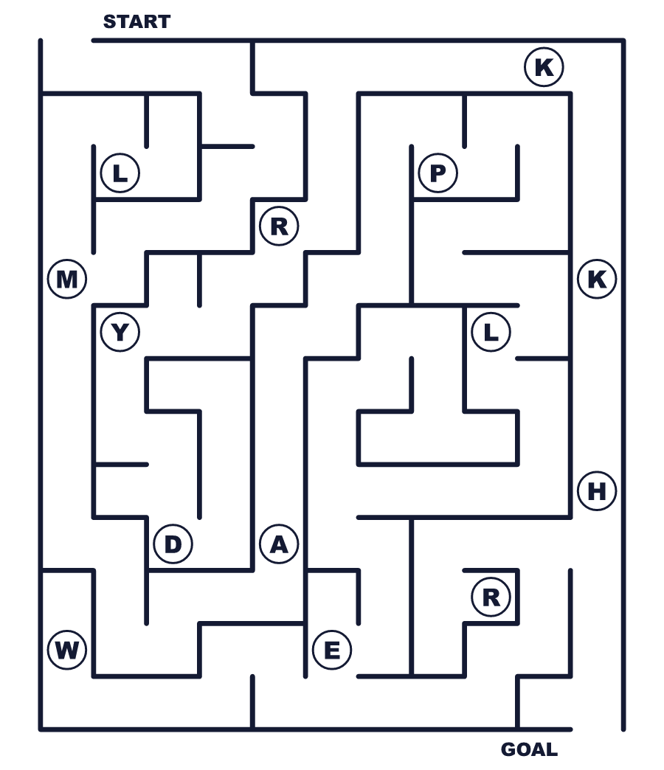
Secret word: ＿ ＿ ＿ ＿ ＿

🍁 Canada Day Worksheet
Class Activity & Writing
Class ______ No. ____ Name ______________________________
Let's Write! 英語で書いてみよう。
If I went to Canada on July 1, I would ______.
7月1日にカナダに行ったら、私は______したいです。
______________________________________________________________
______________________________________________________________
One thing I like about Canada is ______.
カナダについて好きなことの一つは______です。
______________________________________________________________
______________________________________________________________

🍁 Canada Day Worksheet
Trace & Color
なぞって書こう。絵に色をぬろう。
Class ______ No. ____ Name ______________________________
🍁 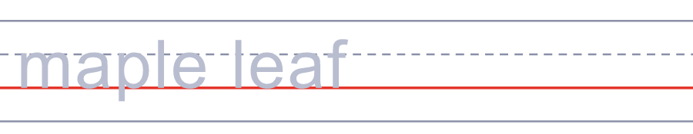

🎆 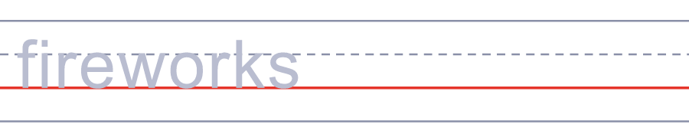
🥞 
🦫 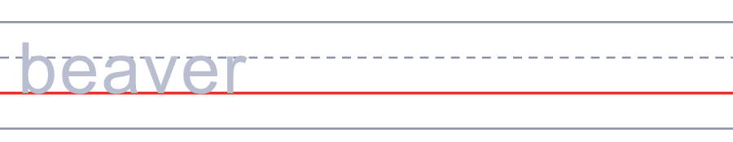
🏒 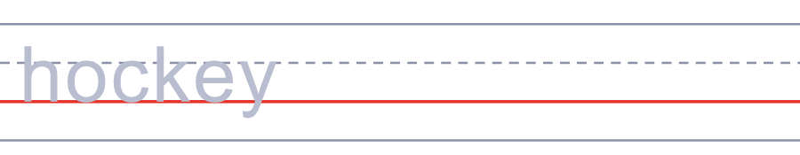

🍁 Canada Day Worksheet
Answer Key 解答
Reading Check: 1.A 2.C 3.A 4.D 5.B
True or False: 1.T 2.T 3.F 4.F
Match: 🍁=maple leaf 🎆=fireworks 🥞=pancakes 🦫=beaver 🏒=hockey 📦=box
Fill in the blanks: (1)capital (2)red (3)leaf (4)show (5)crowd (6)anthem (7)fireworks
Maze: MAPLE
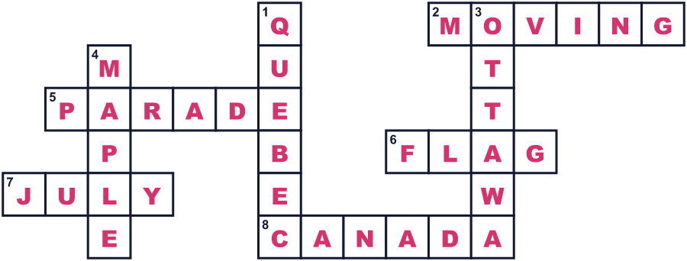
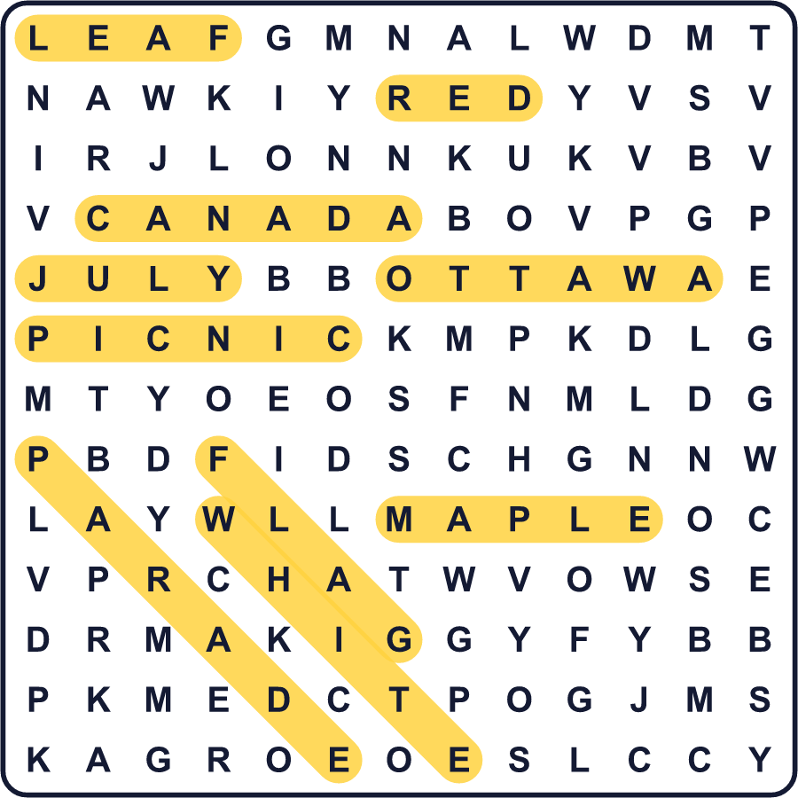
全訳
1 7月1日、カナダは赤と白に染まります。人々は赤いシャツを着て、顔にメープルリーフを描きます。それはカナダ・デー、国の誕生日です。家族はピクニックをし、パレードを見て、夜には花火を楽しみます。赤と白のおもしろい帽子をかぶる人までいます。
2 1867年7月1日、4つの州からなる新しい国が生まれました。はじめは、カナダ自治領と呼ばれていました。まだ完全に独立した国ではなく、イギリスの世界の一部でした。そのため、祝日はドミニオン・デーと呼ばれていました。今のカナダには、10の州と3つの準州があります。カナダが自分の法律を完全に自分で決められるようになるまで、115年かかりました。
3 1982年、祝日の名前はカナダ・デーに変わりました。投票したとき、部屋にいた議員はたった12人でした。かかった時間はたった5分でした！赤いメープルリーフの国旗も、わりと新しいものです。初めて掲げられたのは1965年です。
4 首都オタワでは、正午に大きなショーがあります。ジェット機が人々の上を飛び、みんなで「オー・カナダ」を歌います。多くの都市で、ほかの国から来た人たちがこの日に新しいカナダ人になります。彼らはよい市民になることを誓い、証明書を受け取ります。でもケベックでは、7月1日は引っ越しの日でもあるので、多くの人がソファや箱を運ぶのに大忙しです。カナダは大きな国で、その誕生日にはいろいろな顔があるのです。

