🏴󠁧󠁢󠁳󠁣󠁴󠁿 Burns Night Worksheet
A Poem for a Pudding
Read the story. 英文を読もう。
Class ______ No. ____ Name ______________________________

🔊 音声を聞こう（スマホで読みとってね）
1 On the night of January 25, people in Scotland sit down at long tables. Then they hear bagpipes. A man walks in slowly with a big plate, and on it is a round food called haggis. Everyone stands up and claps. Then someone reads a poem to the food!
2 This party is called a Burns supper. It is for Robert Burns, Scotland's most famous poet. He was born on January 25, 1759, in a small house in a village called Alloway. He worked on a farm, but he loved to write. He wrote many poems in Scots, the language of ordinary people in his part of Scotland. He died in 1796, when he was only 37.
3 Five years later, people who loved his poems held a dinner to remember him. Soon, Burns clubs started their own suppers on his birthday. But one club thought his birthday was January 29! In 1803, they found the right date in old church records. Today, people have Burns suppers all around the world.
4 So what is haggis? It is made from parts of a sheep, like the heart and lungs, mixed with oats and onions. Some people love it, and some people do not. At the end of the night, everyone holds hands and sings an old song called "Auld Lang Syne." Burns wrote down the words to this song. In Japan, you may know the tune from graduation day!
Words 単語
poet（詩人） / poem（詩） / supper（夕食） / bagpipes（バグパイプ） / clap（拍手する） / ordinary（ふつうの） / record（記録） / tune（メロディー、曲）

🏴󠁧󠁢󠁳󠁣󠁴󠁿 Burns Night Worksheet
Reading Check
Choose the best answer. 正しいものを選ぼう。
Class ______ No. ____ Name ______________________________
1. What is the reading mainly about?
(A) How to play the bagpipes (B) A dinner party for a famous Scottish poet (C) The history of Japanese graduation songs (D) How to raise sheep on a farm
2. When was Robert Burns born?
(A) January 29, 1802 (B) January 25, 1796 (C) July 21, 1759 (D) January 25, 1759
3. What mistake did one Burns club make?
(A) They thought his birthday was January 29. (B) They cooked the haggis too long. (C) They sang the wrong song. (D) They thought he was English.
4. In paragraph 2, what does "ordinary" mean?
(A) Rich (B) Famous (C) Normal or usual (D) Very old
5. Why does Yuki say "No problem" in the dialogue?
(A) She has eaten haggis many times. (B) She can play the bagpipes. (C) She already knows the song from Japan. (D) She does not want to go.
True or False? T か F に○
1. Burns Night is on January 25. T / F
2. Robert Burns lived to be 80 years old. T / F
3. Haggis is a small wild animal. T / F
4. People sing "Auld Lang Syne" at the end of a Burns supper. T / F

🏴󠁧󠁢󠁳󠁣󠁴󠁿 Burns Night Worksheet
Word Work
単語のれんしゅう
Class ______ No. ____ Name ______________________________
① Match the pictures and the words. 絵と単語を線でむすぼう。
🐑 | ● | ● | hands
🥔 | ● | ● | birthday
📜 | ● | ● | poem
🎂 | ● | ● | knife
🔪 | ● | ● | potato
🤝 | ● | ● | sheep
③ Fill in the blanks. 語群から選んで入れよう。
[ bagpipes / pumpkin / summer / claps / table / haggis / song / hands / kilt / poem ]
Every year on January 25, Grandpa wears his (1) __________ . We sit at a long (2) __________ . Then my uncle plays the (3) __________ . My mom brings in the (4) __________ on a big plate. Grandpa stands up and reads a (5) __________ to it. Everyone laughs and (6) __________ . At the end, we hold (7) __________ and sing an old (8) __________ .

🏴󠁧󠁢󠁳󠁣󠁴󠁿 Burns Night Worksheet
Crossword Puzzle
ヒントを読んでクロスワードを完成させよう。
Class ______ No. ____ Name ______________________________
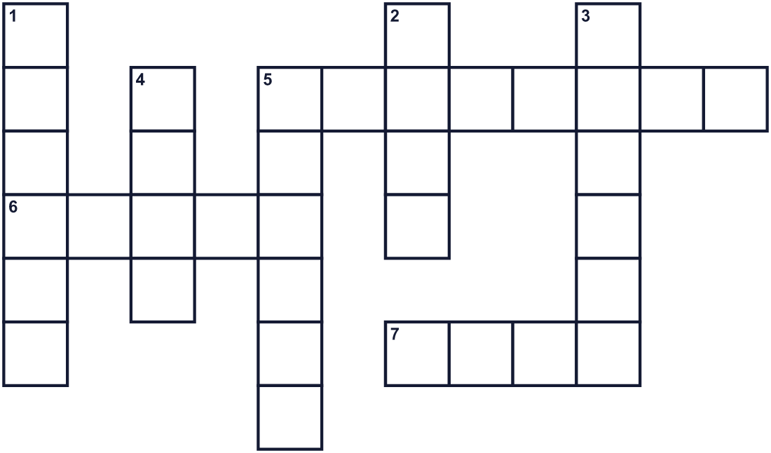
Across →
5. A country in the north of Great Britain. (8)
6. A farm animal with white wool. (5)
7. A grain. People eat it for breakfast as porridge. (4)
Down ↓
1. A strong drink for adults. Scotland is famous for it. (6)
2. Music with words that you sing. (4)
3. A Scottish dish made from sheep and oats. (6)
4. A person who writes poems. (4)
5. An evening meal. (6)

🏴󠁧󠁢󠁳󠁣󠁴󠁿 Burns Night Worksheet
Word Search
かくれた単語をさがそう（→ ↓ ↘ ↗）
Class ______ No. ____ Name ______________________________
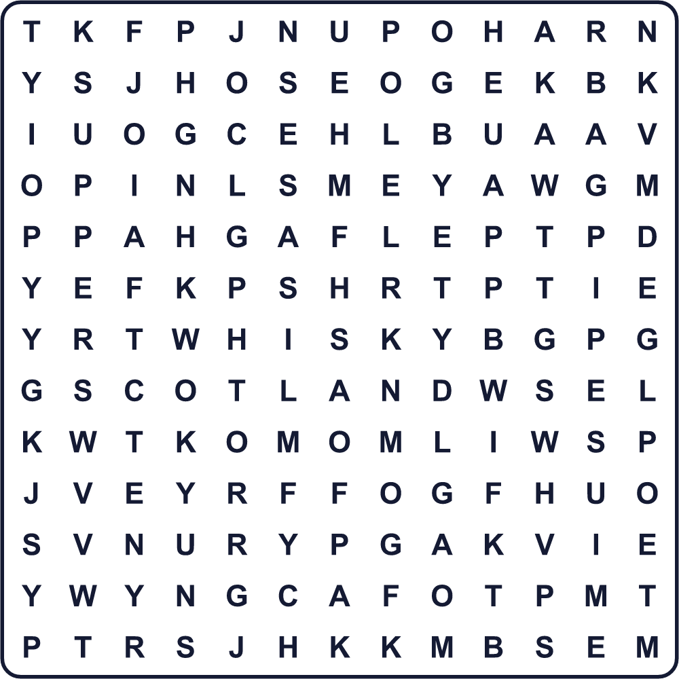
BAGPIPES HAGGIS OATS POEM POET SCOTLAND SHEEP SONG SUPPER WHISKY

🏴󠁧󠁢󠁳󠁣󠁴󠁿 Burns Night Worksheet
Maze & Sentences
Class ______ No. ____ Name ______________________________
Help the piper bring the haggis to the table! バグパイプ奏者がハギスをテーブルまで運ぶのを手伝おう！
正しい道の文字を集めると、ひみつの言葉になるよ。 START 🎶 → GOAL 🍽️
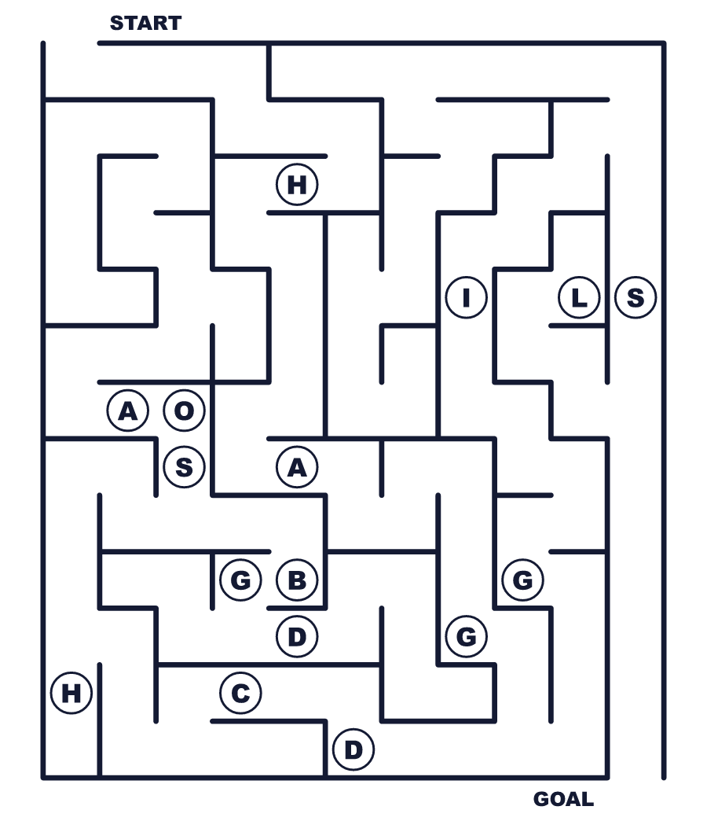
Secret word: ＿ ＿ ＿ ＿ ＿ ＿

🏴󠁧󠁢󠁳󠁣󠁴󠁿 Burns Night Worksheet
Class Activity & Writing
Class ______ No. ____ Name ______________________________
Let's Write! 英語で書いてみよう。
If I wrote a poem to my favorite food, it would be about ______ because ______.
好きな食べ物に詩を書くなら、＿＿＿についての詩にします。なぜなら＿＿＿だからです。
______________________________________________________________
______________________________________________________________
The most famous writer in my country is ______. People remember him or her because ______.
私の国でいちばん有名な作家は＿＿＿です。人々がその人を覚えているのは＿＿＿だからです。
______________________________________________________________
______________________________________________________________

🏴󠁧󠁢󠁳󠁣󠁴󠁿 Burns Night Worksheet
Trace & Color
なぞって書こう。絵に色をぬろう。
Class ______ No. ____ Name ______________________________
🐑 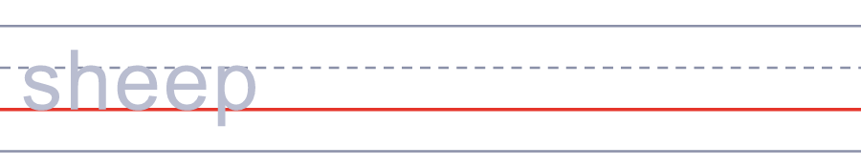

🥔 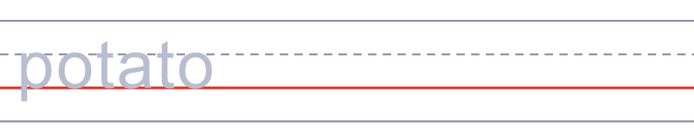
📜 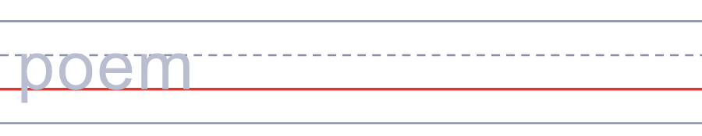
🎂 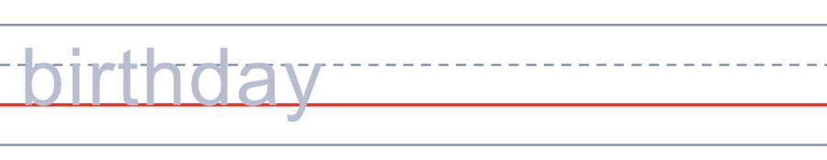
🔪 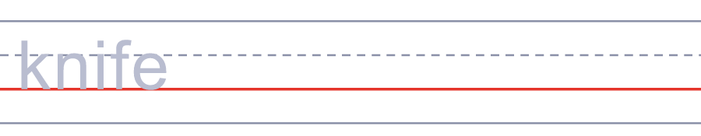

🏴󠁧󠁢󠁳󠁣󠁴󠁿 Burns Night Worksheet
Answer Key 解答
Reading Check: 1.B 2.D 3.A 4.C 5.C
True or False: 1.T 2.F 3.F 4.T
Match: 🐑=sheep 🥔=potato 📜=poem 🎂=birthday 🔪=knife 🤝=hands
Fill in the blanks: (1)kilt (2)table (3)bagpipes (4)haggis (5)poem (6)claps (7)hands (8)song
Maze: HAGGIS
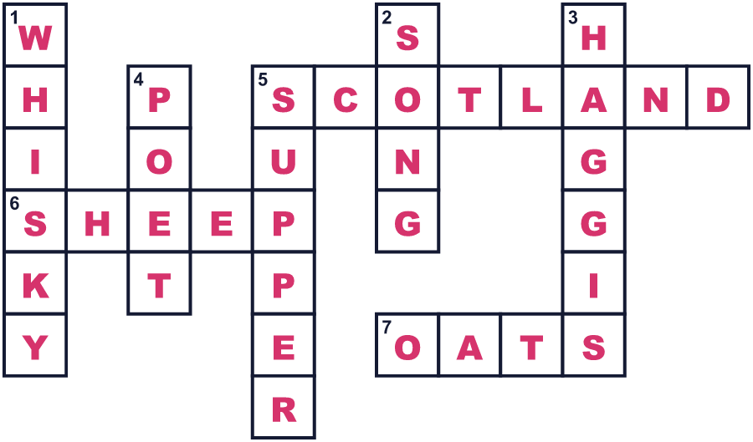
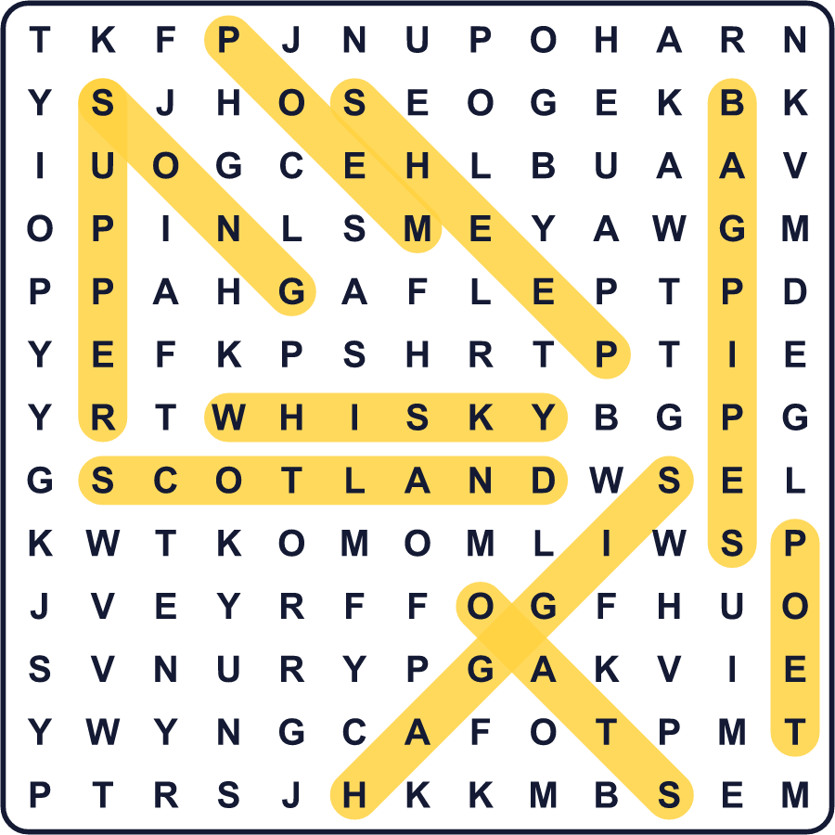
全訳
1 1月25日の夜、スコットランドの人々は長いテーブルにつきます。するとバグパイプの音が聞こえてきます。1人の男性が大きな皿を持ってゆっくり入ってきます。皿の上には、ハギスという丸い料理がのっています。みんな立ち上がって拍手します。それから、だれかがその料理にむかって詩を読むのです！
2 このパーティーはバーンズ・サパーと呼ばれます。スコットランドでいちばん有名な詩人、ロバート・バーンズのための会です。彼は1759年1月25日、アロウェイという村の小さな家で生まれました。農場で働いていましたが、書くことが大好きでした。彼は多くの詩をスコッツ語で書きました。スコットランドの彼の地方で、ふつうの人々が話していた言葉です。1796年、わずか37歳で亡くなりました。
3 5年後、彼の詩を愛する人たちが、彼をしのぶ夕食会を開きました。まもなく、バーンズ・クラブが彼の誕生日に夕食会を開くようになりました。ところが、あるクラブは彼の誕生日を1月29日だと思っていたのです！1803年、彼らは古い教会の記録で正しい日付を見つけました。今では、世界中でバーンズ・サパーが開かれています。
4 では、ハギスとは何でしょう。羊の心臓や肺などの部分に、オート麦と玉ねぎをまぜて作ります。大好きな人もいれば、そうでない人もいます。夜の最後には、みんなで手をつなぎ、「オールド・ラング・サイン」という古い歌を歌います。バーンズがこの歌の歌詞を書き留めたのです。日本では、卒業式でこのメロディーを知っているかもしれませんね！

