🎨 Culture Day Worksheet
One Day, Many Stories: November 3 in Japan
Read the story. 英文を読もう。
Class ______ No. ____ Name ______________________________

🔊 音声を聞こう（スマホで読みとってね）
1 In Japan, November 3 has had many different lives. First, it was the birthday of Emperor Meiji. From 1873, the whole country celebrated it as a holiday. After he died in 1912, it became an ordinary day. Then in 1927, it became a holiday again called Meiji Setsu.
2 Then something big happened. On November 3, 1946, Japan announced its new constitution. This constitution says that Japan gives up war. Two years later, lawmakers made November 3 a new holiday called Bunka no Hi, or Culture Day.
3 Why culture? The law says the day is for loving freedom and peace and for moving culture forward. The writer Yamamoto Yuzo helped choose the new holidays. He said the new constitution was special because no country had ever given up war before. Lawmakers even thought about calling it Peace Day.
4 Today, Culture Day is full of art and learning. At the Imperial Palace, the emperor gives the Order of Culture to great scientists, artists, and writers. In 1969, the three Apollo 11 astronauts received it too. Many museums hold special events, and some open their doors for free. Schools often have culture festivals around this time.
5 Many people also say that November 3 is usually sunny. From 1961 to 2000, Tokyo was sunny on 80 percent of these days. So take a walk, visit a museum, or try a new hobby. Culture is not only in museums. It is in everything people make and share.
Words 単語
constitution（憲法） / announce（発表する、公布する） / emperor（天皇、皇帝） / ordinary（ふつうの） / lawmaker（国会議員、立法者） / give up（あきらめる、放棄する） / freedom（自由） / peace（平和） / order（勲章） / astronaut（宇宙飛行士） / museum（博物館、美術館） / festival（祭り）

🎨 Culture Day Worksheet
Reading Check
Choose the best answer. 正しいものを選ぼう。
Class ______ No. ____ Name ______________________________
1. What is the passage mainly about?
(A) How to visit museums for free (B) The history and meaning of November 3 in Japan (C) The life of the Apollo 11 astronauts (D) Why it is sunny in fall
2. When did Japan announce its new constitution?
(A) In 1873 (B) In 1912 (C) On November 3, 1946 (D) In 1969
3. What happened to November 3 after 1912?
(A) It became an ordinary day. (B) It became Culture Day. (C) It became Constitution Day. (D) It became Peace Day.
4. Why was the new constitution special, according to Yamamoto Yuzo?
(A) It was very long. (B) It was written by an emperor. (C) It gave people free museums. (D) No country had given up war before.
5. In paragraph 1, the word ordinary is closest in meaning to ____.
(A) normal (B) famous (C) happy (D) holy
6. Which is true about the passage?
(A) Culture Day started in 1873. (B) The Apollo 11 astronauts received the Order of Culture. (C) Every museum is free on Culture Day. (D) The team chose the name Peace Day.
7. What can we guess about the writer's idea of culture?
(A) Culture is only for famous artists. (B) Culture is only found in museums. (C) Everyone can make and share culture. (D) Culture is less important than sports.
8. In the dialogue, where will Emma and Daiki go tomorrow?
(A) To the Imperial Palace (B) To a museum in Tokyo (C) To an American party (D) To a culture festival at Daiki's old high school
True or False? T か F に○
1. Culture Day is on November 3. T / F
2. Japan's constitution was announced on November 3, 1946. T / F
3. November 3 was a holiday every year from 1873 to today. T / F
4. The Order of Culture is given at the Imperial Palace. T / F
5. Only Japanese people can receive the Order of Culture. T / F
6. Constitution Day and Culture Day are on the same day. T / F

🎨 Culture Day Worksheet
Word Work
単語のれんしゅう
Class ______ No. ____ Name ______________________________
① Match the pictures and the words. 絵と単語を線でむすぼう。
🎨 | ● | ● | medal
🎵 | ● | ● | drama
📚 | ● | ● | painting
🏅 | ● | ● | sunny
🕊️ | ● | ● | rocket
☀️ | ● | ● | books
🚀 | ● | ● | music
🎭 | ● | ● | peace
② Unscramble the words. 並べかえて単語にしよう。
1. T R L U E C U (文化) → ____________________
2. E E C A P (平和) → ____________________
3. R O F E M D E (自由) → ____________________
4. U M E U S M (博物館、美術館) → ____________________
5. R M E R P O E (天皇) → ____________________
6. M A L D E (メダル、勲章) → ____________________
③ Fill in the blanks. 語群から選んで入れよう。
[ snow / music / swimming / smiled / holiday / play / weather / painting / cookies / cafe / angry / happy / culture ]
On November 3, Sora's school had a (1) __________ festival. Her class made a small (2) __________ and sold tea and (3) __________ . In the gym, the brass band played (4) __________ , and the drama club did a short (5) __________ . Sora showed her (6) __________ of autumn leaves. Her grandmother came and (7) __________ at it for a long time. In the evening, Sora was tired but (8) __________ . The (9) __________ was sunny all day, just like people say. It was a perfect (10) __________ .

🎨 Culture Day Worksheet
Crossword Puzzle
ヒントを読んでクロスワードを完成させよう。
Class ______ No. ____ Name ______________________________
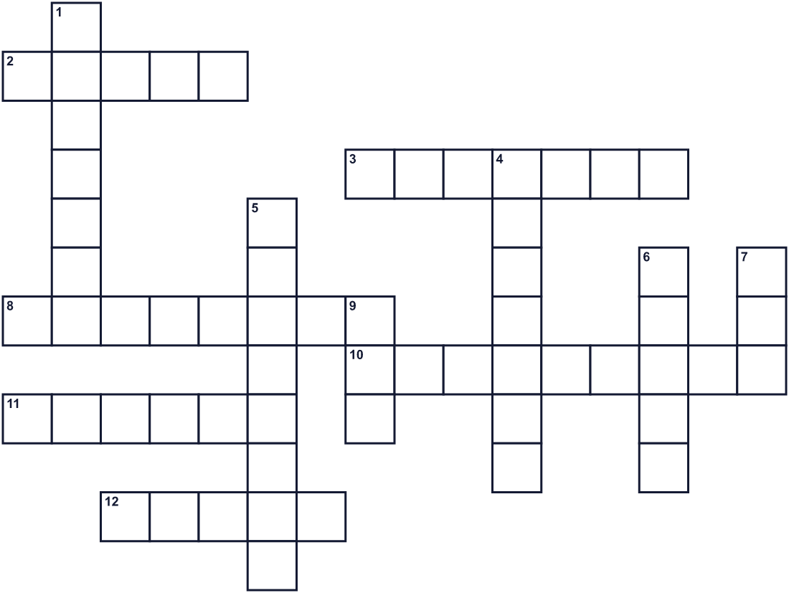
Across →
2. Weather with a clear sky and lots of light. (5)
3. Being able to think and act as you want. (7)
8. A big happy event. Schools have one in fall. (8)
10. A person who travels into space. (9)
11. A building where you can see art or old things. (6)
12. A special medal. Great artists get one on this holiday. (5)
Down ↓
1. Art, music, books, and ways of life of a group of people. (7)
4. Meiji was one. He was born in 1852. (7)
5. The eleventh month of the year. (8)
6. A time with no war. (5)
7. Paintings and drawings are this. (3)
9. A rule made by a country. (3)

🎨 Culture Day Worksheet
Word Search
かくれた単語をさがそう（→ ↓ ↘ ↗）
Class ______ No. ____ Name ______________________________
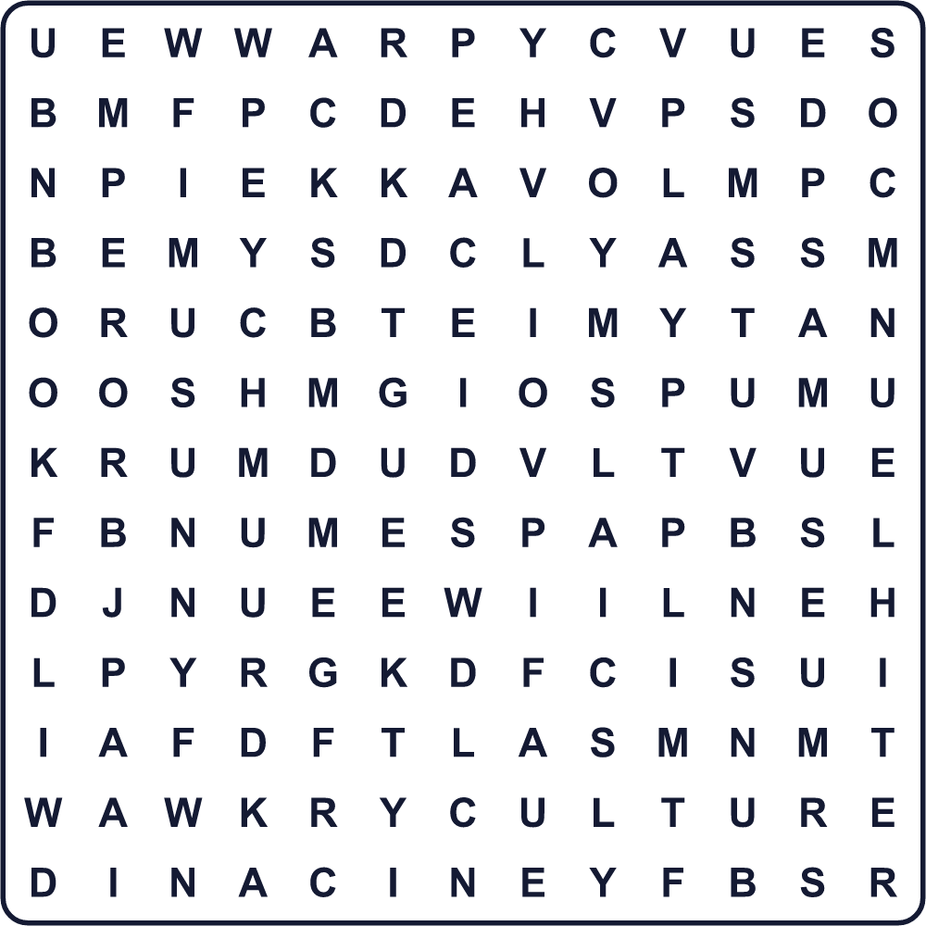
ART BOOK CULTURE EMPEROR FESTIVAL FREEDOM LAW MEDAL MUSEUM MUSIC PEACE PLAY SUNNY
Secret Code 暗号を解こう
⚓=A ☘=C ◎=D ✎=E ☎=L ■=N ★=O ✚=P ✿=R ◆=T ♥=U ⚑=V
☎ ★ ⚑ ✎ ✚ ✎ ⚓ ☘ ✎ ⚓ ■ ◎ ☘ ♥ ☎ ◆ ♥ ✿ ✎
______________________________________________________________

🎨 Culture Day Worksheet
Maze & Sentences
Class ______ No. ____ Name ______________________________
Help Sora get to the art museum! ソラを美術館まで連れていこう！
正しい道の文字を集めると、ひみつの言葉になるよ。 START 👧 → GOAL 🖼️
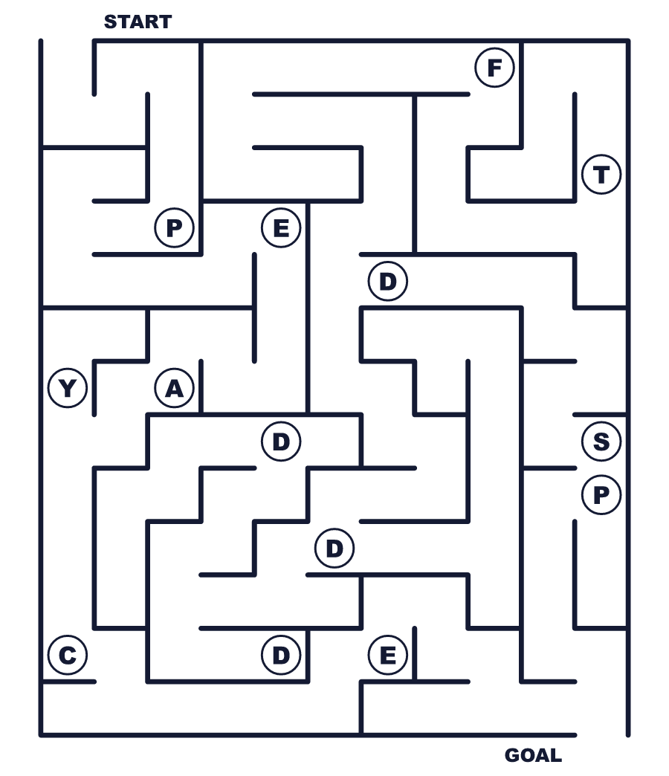
Secret word: ＿ ＿ ＿ ＿ ＿
Put the words in order. 並べかえよう。
1. is / holiday / Culture / in / Day / a / national / Japan . (文化の日は日本の祝日です。)
______________________________________________________________
2. November / on / third / the / of / It / is . (それは11月3日です。)
______________________________________________________________
3. this / day / The / on / constitution / was / announced . (この日に憲法が公布されました。)
______________________________________________________________
4. Day / free / on / museums / are / Some / Culture . (文化の日には無料の美術館もあります。)
______________________________________________________________
5. is / to / It / day / peace / love / a . (それは平和を愛する日です。)
______________________________________________________________

🎨 Culture Day Worksheet
Class Activity & Writing
Class ______ No. ____ Name ______________________________
Find Someone Who… クラスで聞いて回ろう！
Find someone who … | Name
… has been to an art museum this year 今年、美術館に行ったことがある
… likes to draw pictures 絵をかくのが好き
… can play a musical instrument 楽器を演奏できる
… knows the year of Japan's constitution 日本国憲法の年を知っている
… has been in a school play 学校の劇に出たことがある
… likes reading books 本を読むのが好き
… can say thank you in three languages 3つの言葉で「ありがとう」が言える
… has made something by hand this month 今月、何かを手作りした
Let's Write! 英語で書いてみよう。
One Japanese culture I want to show the world is ______ because ______.
世界に見せたい日本の文化は＿＿です。なぜなら＿＿だからです。
______________________________________________________________
______________________________________________________________
On Culture Day, I want to ______.
文化の日に、私は＿＿したいです。
______________________________________________________________
______________________________________________________________
Peace is important to me because ______.
平和は私にとって大切です。なぜなら＿＿だからです。
______________________________________________________________
______________________________________________________________

🎨 Culture Day Worksheet
Trace & Color
なぞって書こう。絵に色をぬろう。
Class ______ No. ____ Name ______________________________
🎨 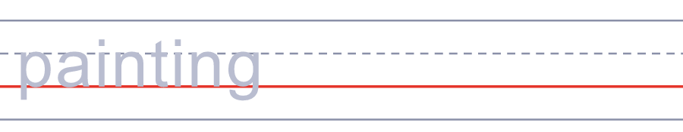

🎵 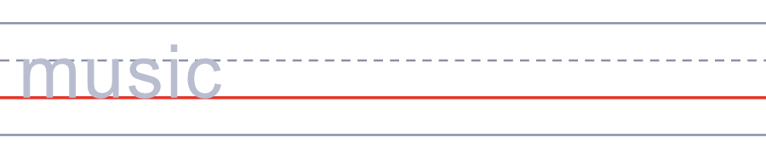
📚 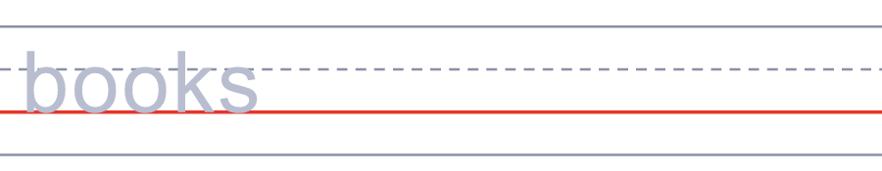
🏅 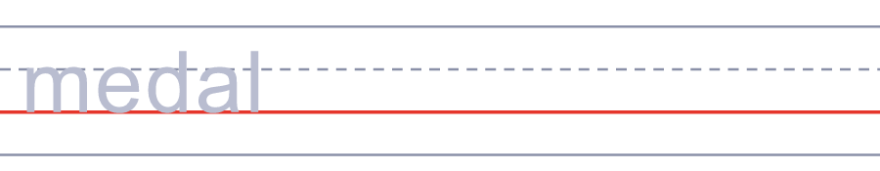
🕊️ 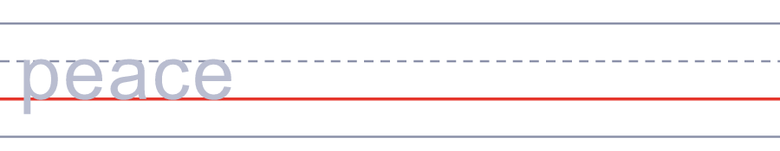
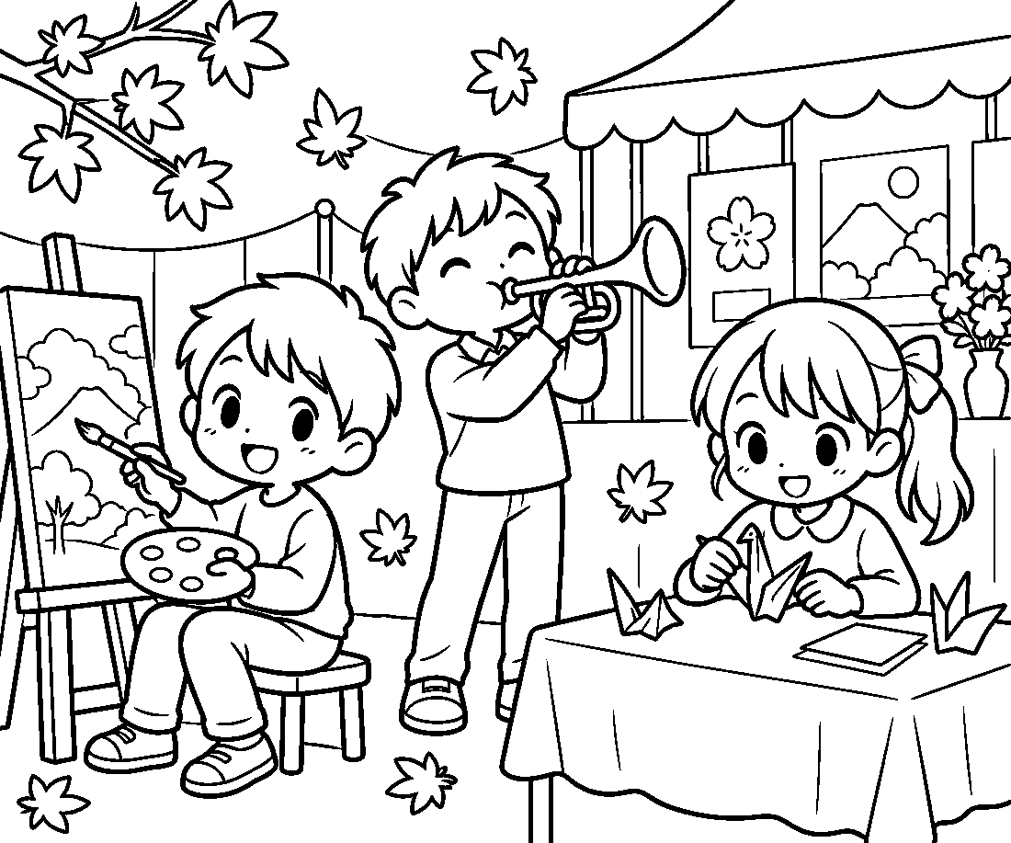

🎨 Culture Day Worksheet
Answer Key 解答
Reading Check: 1.B 2.C 3.A 4.D 5.A 6.B 7.C 8.D
True or False: 1.T 2.T 3.F 4.T 5.F 6.F
Match: 🎨=painting 🎵=music 📚=books 🏅=medal 🕊️=peace ☀️=sunny 🚀=rocket 🎭=drama
Unscramble: 1.CULTURE 2.PEACE 3.FREEDOM 4.MUSEUM 5.EMPEROR 6.MEDAL
Fill in the blanks: (1)culture (2)cafe (3)cookies (4)music (5)play (6)painting (7)smiled (8)happy (9)weather (10)holiday
Sentence order: 1. Culture Day is a national holiday in Japan. 2. It is on the third of November. 3. The constitution was announced on this day. 4. Some museums are free on Culture Day. 5. It is a day to love peace.
Secret Code: LOVE PEACE AND CULTURE
Maze: PEACE
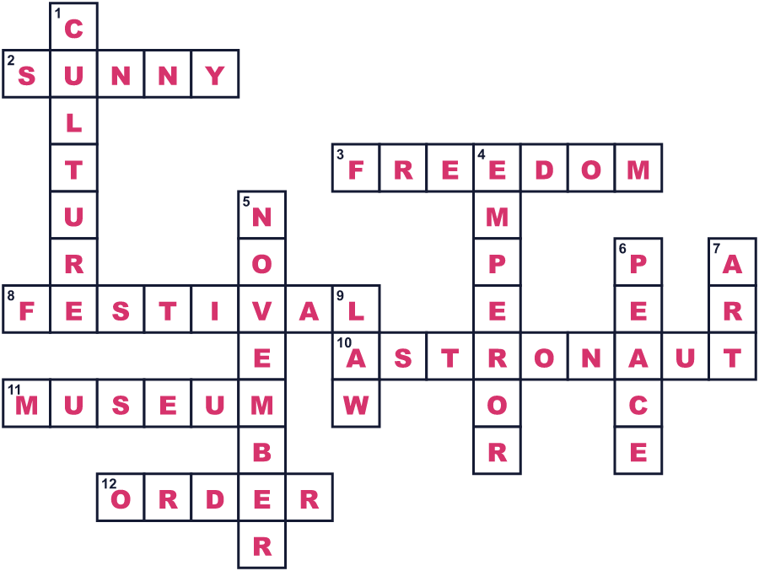
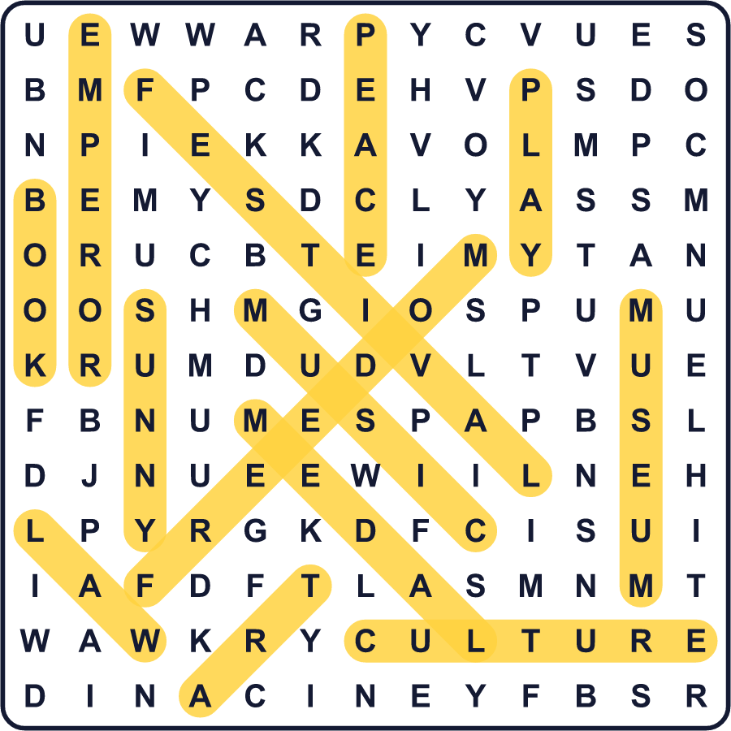
全訳
1 日本では、11月3日はいくつもの違う顔を持ってきました。最初、それは明治天皇の誕生日でした。1873年から、国じゅうがこの日を祝日として祝いました。1912年に天皇が亡くなると、この日はふつうの日になりました。そして1927年、明治節という名前で再び祝日になりました。
2 その後、大きなできごとがありました。1946年11月3日、日本は新しい憲法を公布したのです。この憲法は、日本が戦争を放棄すると定めています。2年後、国会議員たちは11月3日を「文化の日」という新しい祝日にしました。
3 なぜ「文化」なのでしょう。法律は、この日を自由と平和を愛し、文化をすすめる日だとしています。作家の山本勇造（山本有三）は、新しい祝日を選んだ一人でした。彼は、それまで戦争を放棄した国はなかったので、新しい憲法は特別だと語りました。議員たちは、この日を「平和の日」と呼ぶことまで考えていました。
4 今、文化の日は芸術と学びでいっぱいです。皇居では、天皇がすぐれた科学者や芸術家、作家に文化勲章を授けます。1969年には、アポロ11号の3人の宇宙飛行士もこの勲章を受けました。多くの美術館や博物館が特別な催しを開き、無料で入れるところもあります。学校では、この時期によく文化祭が開かれます。
5 11月3日はたいてい晴れる、と言う人も多くいます。1961年から2000年まで、東京ではこの日の80パーセントが晴れでした。だから散歩をしたり、美術館に行ったり、新しい趣味を試したりしてみましょう。文化は美術館の中だけにあるのではありません。人々が作り、分かち合うすべてのものの中にあるのです。

