🎀 Breast Cancer Awareness Month Worksheet
The Story of a Pink Ribbon
Read the story. 英文を読もう。
Class ______ No. ____ Name ______________________________
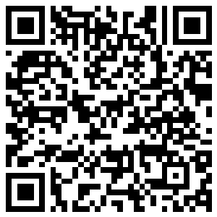
🔊 音声を聞こう（スマホで読みとってね）
1 Around 1991, a woman in California made small ribbons by hand at her home. Her name was Charlotte Haley, and she was in her late sixties. Her grandmother, her sister, and her daughter all had breast cancer. But her ribbons were not pink. They were peach.
2 Haley put the ribbons on cards and mailed them to people. The cards said that only 5 percent of the National Cancer Institute's money went to prevention. In 1992, a magazine called Self wanted to work with her. But she said no because the plan felt too much like business. So the magazine chose a new color, pink. With help from Evelyn Lauder of a cosmetics company, stores gave out 1.5 million pink ribbons that year.
3 Today, the pink ribbon is the symbol of Breast Cancer Awareness Month. The month started in the United States in 1985, and it comes every October. Around the world, famous buildings light up in pink. In Japan, Tokyo Tower first turned pink in October 2000. People join walks, wear pink clothes, and learn about health checkups.
4 Breast cancer is the most common cancer for women in Japan and in many other countries. Men can get it too, but this is rare. Some people say that companies sell too many pink things but give very little money to charity. So one group tells shoppers, "Think before you pink." A small ribbon cannot do everything. But it can start a talk about health and remind us to care for each other.
Words 単語
ribbon（リボン） / peach（桃、桃色（の）） / budget（予算） / prevention（予防） / cosmetics（化粧品） / symbol（シンボル、象徴） / checkup（健康診断、検診） / rare（まれな、めったにない）

🎀 Breast Cancer Awareness Month Worksheet
Reading Check
Choose the best answer. 正しいものを選ぼう。
Class ______ No. ____ Name ______________________________
1. What is the reading mainly about?
(A) How to make ribbons at home (B) The story of the pink ribbon and the month it stands for (C) The history of Tokyo Tower (D) How to start a magazine
2. What color were Charlotte Haley's ribbons?
(A) Pink (B) Red (C) Yellow (D) Peach
3. How many pink ribbons did stores give out in 1992?
(A) 1.5 million (B) 5 (C) 5 million (D) 1985
4. In paragraph 4, what does "rare" mean?
(A) Very common (B) Very new (C) Not happening often (D) Very expensive
5. In the dialogue, why is this month special to Grace?
(A) Her birthday is in October. (B) Her aunt had breast cancer. (C) She works at Tokyo Tower. (D) She makes pink clothes.
True or False? T か F に○
1. The first ribbon for breast cancer was peach. T / F
2. Breast Cancer Awareness Month is in May. T / F
3. Tokyo Tower turned pink in 2000. T / F
4. Only women can get breast cancer. T / F

🎀 Breast Cancer Awareness Month Worksheet
Word Work
単語のれんしゅう
Class ______ No. ____ Name ______________________________
① Match the pictures and the words. 絵と単語を線でむすぼう。
🎀 | ● | ● | ribbon
🗼 | ● | ● | tower
🍑 | ● | ● | heart
💗 | ● | ● | shoes
🏥 | ● | ● | hospital
👟 | ● | ● | peach
③ Fill in the blanks. 語群から選んで入れよう。
[ pink / rice / tower / hug / ribbons / summer / October / says / cancer ]
In (1) __________ , Hana's school has a pink day. Students wear (2) __________ shirts and make paper (3) __________ . Her teacher talks about breast (4) __________ . "Men can get it too," she says. That night, Hana sees a tall (5) __________ glowing pink. She tells her family about the ribbon. Her grandma smiles and gives her a big (6) __________ . "Thank you for caring," she (7) __________ .

🎀 Breast Cancer Awareness Month Worksheet
Crossword Puzzle
ヒントを読んでクロスワードを完成させよう。
Class ______ No. ____ Name ______________________________
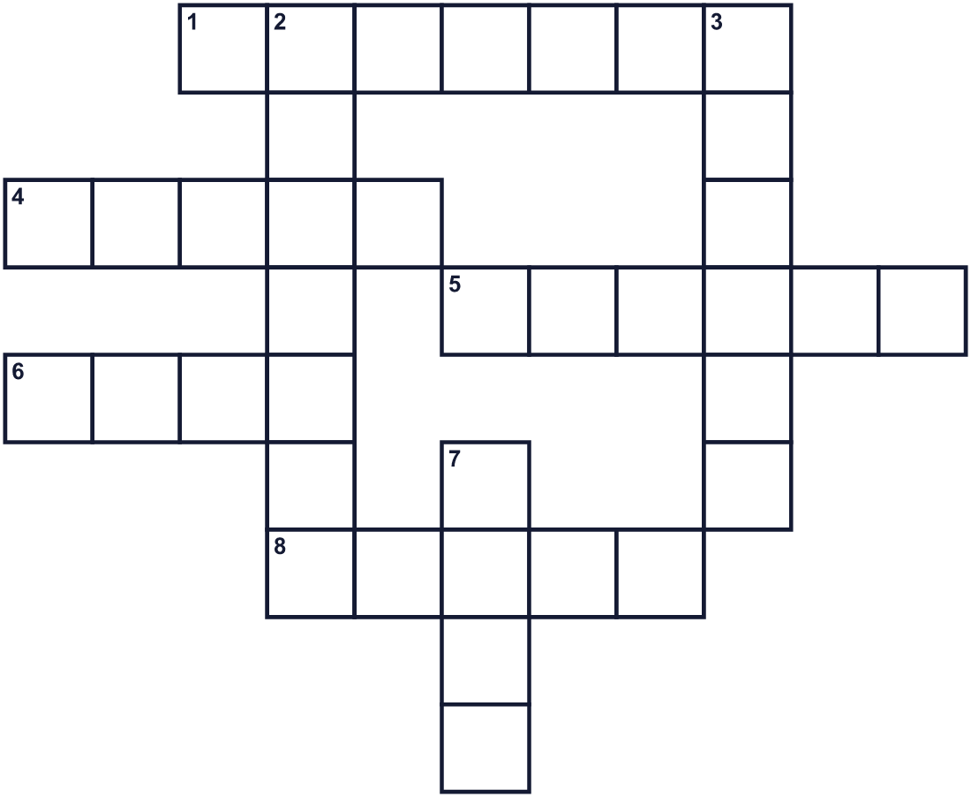
Across →
1. The tenth month of the year. (7)
4. A very tall building. A famous one in Tokyo turns pink. (5)
5. A picture or thing that shows an idea. A dove is one for peace. (6)
6. A light red color. It is the color of this month. (4)
8. A soft sweet fruit. The first ribbon had this color. (5)
Down ↓
2. A visit to a doctor to see if you are healthy. (7)
3. A long thin piece of cloth. People make a loop with it and wear it. (6)
7. You move on your feet. Many people do this together for charity. (4)

🎀 Breast Cancer Awareness Month Worksheet
Word Search
かくれた単語をさがそう（→ ↓ ↘ ↗）
Class ______ No. ____ Name ______________________________
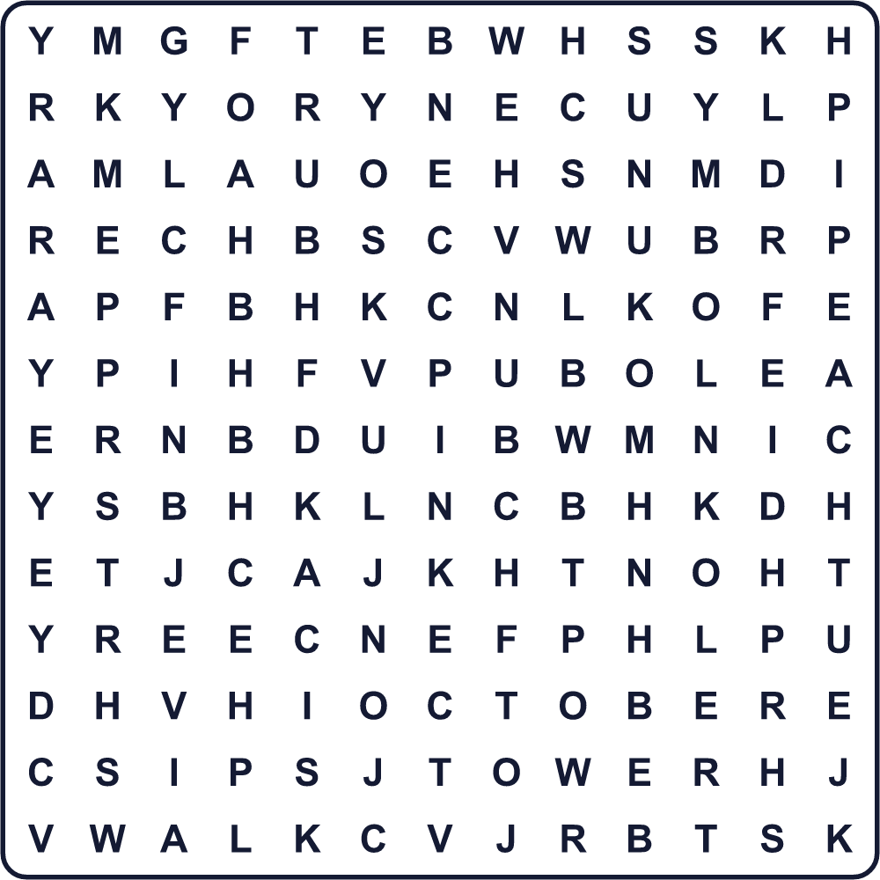
CARE CHECKUP HOPE OCTOBER PEACH PINK RIBBON SYMBOL TOWER WALK

🎀 Breast Cancer Awareness Month Worksheet
Maze & Sentences
Class ______ No. ____ Name ______________________________
Help Grace get to the charity walk! グレースをチャリティーウォークの会場まで連れていこう！
正しい道の文字を集めると、ひみつの言葉になるよ。 START 👧 → GOAL 🎀
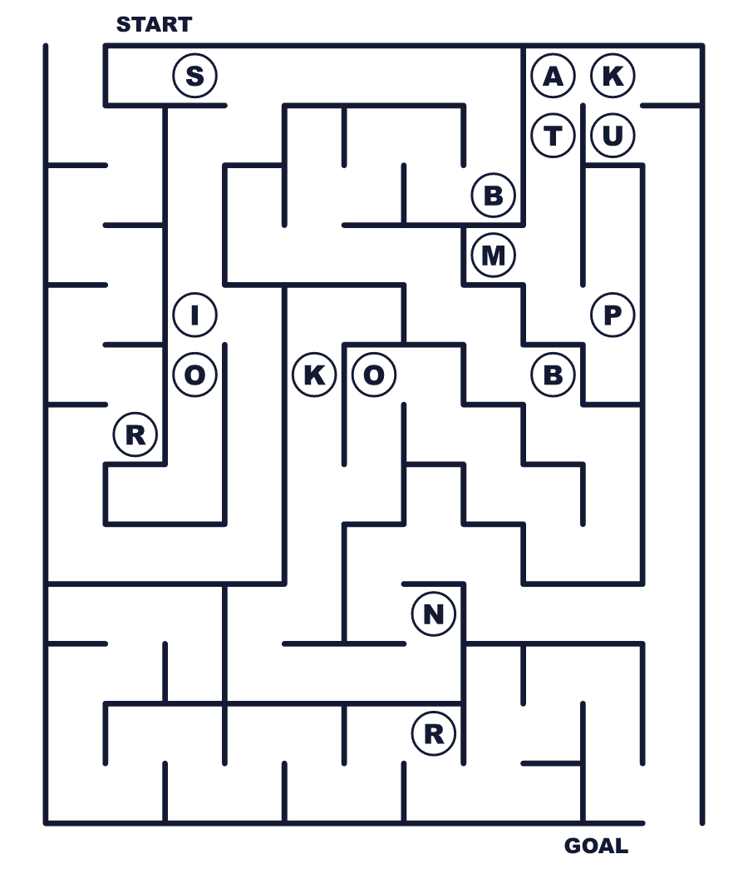
Secret word: ＿ ＿ ＿ ＿ ＿ ＿

🎀 Breast Cancer Awareness Month Worksheet
Class Activity & Writing
Class ______ No. ____ Name ______________________________
Let's Write! 英語で書いてみよう。
If I make a poster for this month, I will draw ______ because ______.
この月間のポスターを作るなら、＿＿＿をかきます。なぜなら＿＿＿だからです。
______________________________________________________________
______________________________________________________________
To show that I care about others, I can ______.
人を思いやっていることを伝えるために、私は＿＿＿ができます。
______________________________________________________________
______________________________________________________________

🎀 Breast Cancer Awareness Month Worksheet
Trace & Color
なぞって書こう。絵に色をぬろう。
Class ______ No. ____ Name ______________________________
🎀 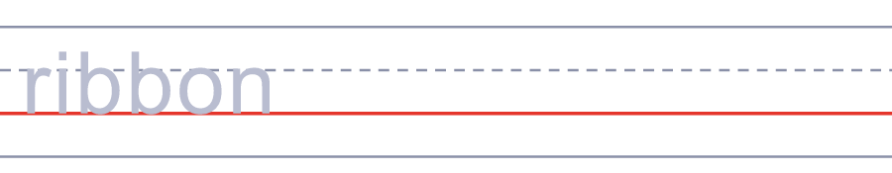

🗼 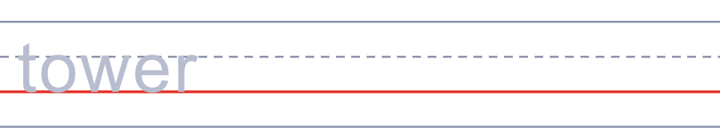
🍑 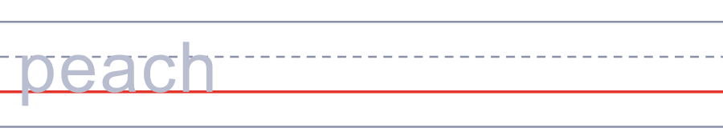
💗 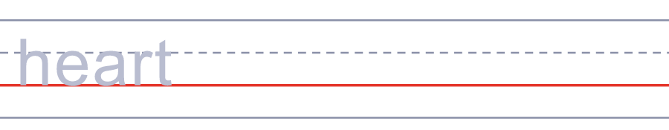
🏥 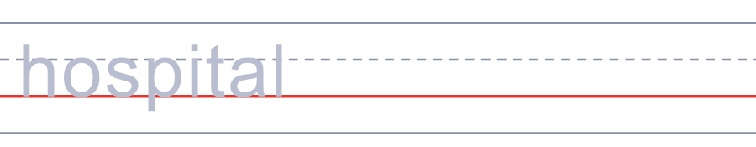

🎀 Breast Cancer Awareness Month Worksheet
Answer Key 解答
Reading Check: 1.B 2.D 3.A 4.C 5.B
True or False: 1.T 2.F 3.T 4.F
Match: 🎀=ribbon 🗼=tower 🍑=peach 💗=heart 🏥=hospital 👟=shoes
Fill in the blanks: (1)October (2)pink (3)ribbons (4)cancer (5)tower (6)hug (7)says
Maze: RIBBON
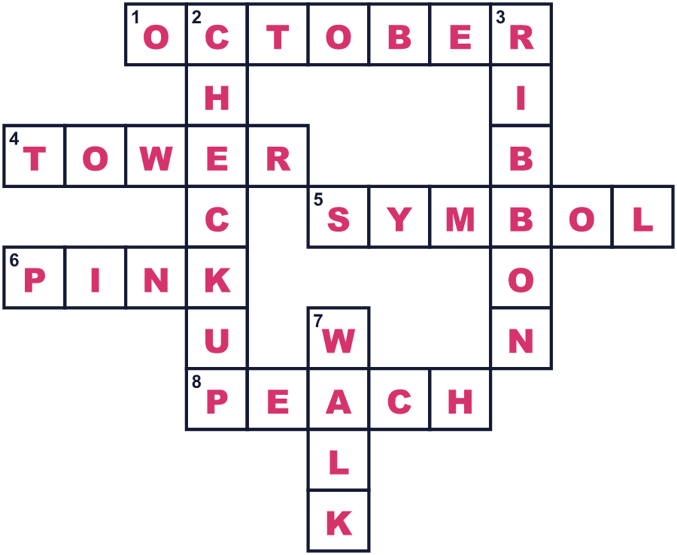
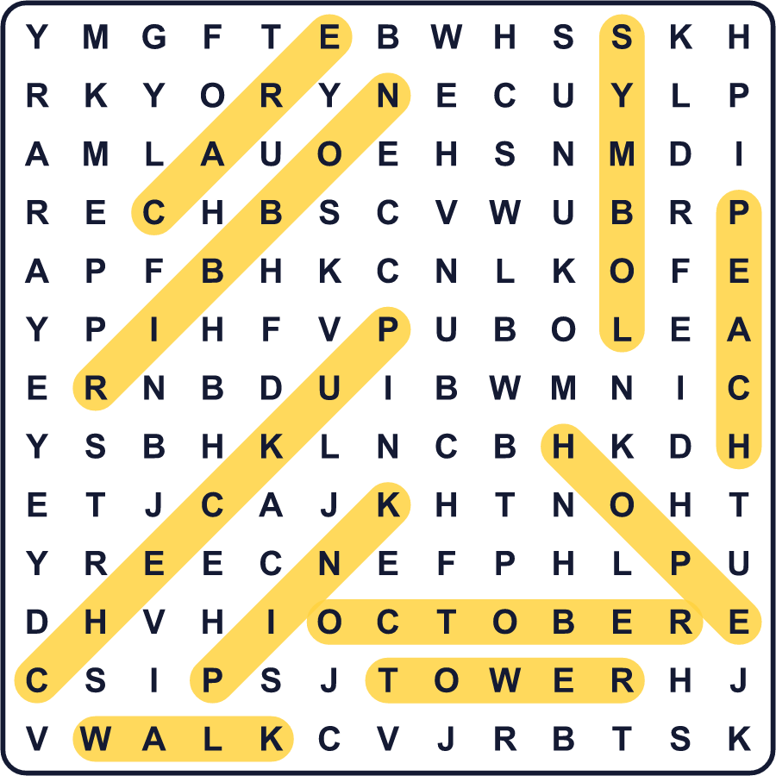
全訳
1 1991年ごろ、カリフォルニアに住む1人の女性が、自宅で小さなリボンを手作りしていました。彼女の名前はシャーロット・ヘイリー。60代後半でした。祖母も、姉も、娘も、みな乳がんになっていました。でも、彼女のリボンはピンクではありませんでした。桃色だったのです。
2 ヘイリーはリボンをカードにつけて、人々に郵送しました。カードには、国立がん研究所のお金のうち予防に使われるのは5%だけだと書かれていました。1992年、『SELF』という雑誌が彼女といっしょに活動したいと考えました。でも、その計画は商売のようだと感じて、彼女は断りました。そこで雑誌は新しい色を選びました。ピンクです。化粧品会社のエヴリン・ローダーの協力で、その年、お店で150万本のピンクリボンが配られました。
3 今、ピンクリボンは乳がん啓発月間のシンボルです。この月間は1985年にアメリカで始まり、毎年10月にやってきます。世界中で、有名な建物がピンク色に光ります。日本では、2000年10月に東京タワーが初めてピンクになりました。人々はウォークに参加したり、ピンクの服を着たり、検診について学んだりします。
4 乳がんは、日本でもほかの多くの国でも、女性に最も多いがんです。男性もかかることがありますが、それはまれです。企業はピンクの商品をたくさん売るのに、寄付はほんの少しだと言う人もいます。そこで、ある団体は買い物客に「ピンクにする前に考えて」と呼びかけています。小さなリボン1本で、何もかもできるわけではありません。でも、健康について話すきっかけになり、おたがいを思いやることを思い出させてくれます。

