🎁 Boxing Day Worksheet
The Mystery of the Box
Read the story. 英文を読もう。
Class ______ No. ____ Name ______________________________

🔊 音声を聞こう（スマホで読みとってね）
1 In Britain, the day after Christmas has a strange name. It is called Boxing Day, but it has nothing to do with boxing gloves. The word box here means a box for gifts or money. But what was in the box, and who got it?
2 Nobody is completely sure. One idea is about servants in big houses. They worked hard on Christmas Day, so the next day they got a box of presents, money, and leftover food. Then they went home to see their families. Another idea is about church boxes. People put money in them, and the church gave it to poor people.
3 The name Boxing Day was first written down in 1743. In 1871, it became an official holiday in Britain. Later, it spread to countries like Canada, Australia, and New Zealand. In Ireland, people call it St Stephen's Day. In South Africa, its name is the Day of Goodwill.
4 Today, Boxing Day is a lazy and busy day at the same time. Families eat cold turkey from the day before. Football fans go to big matches, and shoppers line up early for big sales. In Australia, it is summer, and people on many boats watch a yacht race start in Sydney Harbour.
5 Some people still give a Christmas box to workers like postmen. It is usually a little money and a card. So the old idea is still alive. After Christmas, it is a good time to say thank you to the people who help us every day.
Words 単語
servant（使用人） / leftover（残り物（の）） / church（教会） / poor（貧しい） / official（公式の、正式な） / spread（広がる） / lazy（のんびりした、怠けた） / sale（セール、特売） / line up（列に並ぶ） / harbor（港、湾） / postman（郵便配達員） / thank（感謝する）

🎁 Boxing Day Worksheet
Reading Check
Choose the best answer. 正しいものを選ぼう。
Class ______ No. ____ Name ______________________________
1. What is the main idea of the reading?
(A) Boxing Day is a day for boxing matches in Britain. (B) Boxing Day is the day after Christmas, and its name comes from boxes of gifts or money. (C) Boxing Day is a new holiday that started in Australia. (D) Boxing Day is the day when people clean their houses.
2. When was the name Boxing Day first written down?
(A) In 1871 (B) In 1663 (C) In 1945 (D) In 1743
3. Why did servants get a box on the day after Christmas?
(A) Because they worked hard on Christmas Day (B) Because they won a boxing match (C) Because they were going to a new job (D) Because it was their birthday
4. What do people in Ireland call December 26?
(A) Box Day (B) Goodwill Day (C) St Stephen's Day (D) Second Christmas
5. In paragraph 4, the word "lazy" is closest in meaning to:
(A) very busy and tiring (B) slow and relaxed (C) cold and dark (D) loud and exciting
6. Which sentence is true about the reading?
(A) Boxing Day is in winter in Australia. (B) Boxing Day became a holiday in Britain in 1743. (C) Some people give a little money to workers like postmen. (D) Boxing Day started in Canada.
7. What is the writer's main message in the last paragraph?
(A) Shopping is the most important part of Boxing Day. (B) It is a good idea to thank the people who help us. (C) Postmen should not work in December. (D) The old idea of Boxing Day is gone.
8. In the dialogue, why did Chloe wake Sota up early?
(A) To watch a boxing match (B) To open more presents (C) To make turkey sandwiches (D) To go to the sales
True or False? T か F に○
1. Boxing Day is the day after Christmas. T / F
2. Boxing Day got its name from the sport of boxing. T / F
3. Boxing Day became an official holiday in Britain in 1871. T / F
4. In Ireland, December 26 is called St Stephen's Day. T / F
5. Boxing Day is a national holiday in Japan. T / F
6. In Australia, Boxing Day comes in winter. T / F

🎁 Boxing Day Worksheet
Word Work
単語のれんしゅう
Class ______ No. ____ Name ______________________________
① Match the pictures and the words. 絵と単語を線でむすぼう。
🎁 | ● | ● | football
⚽ | ● | ● | horse
⛵ | ● | ● | sandwich
🏏 | ● | ● | money
🐎 | ● | ● | cricket
🥪 | ● | ● | gift
⛪ | ● | ● | church
💰 | ● | ● | yacht
② Unscramble the words. 並べかえて単語にしよう。
1. N I O G B X (ボクシング（ここでは「箱の」）) → ____________________
2. L S E A (セール) → ____________________
3. H C C U R H (教会) → ____________________
4. K T E R U Y (七面鳥) → ____________________
5. L I D O H A Y (休日) → ____________________
6. M S O A P T N (郵便配達員) → ____________________
③ Fill in the blanks. 語群から選んで入れよう。
[ Boxing / much / morning / teacher / rain / summer / box / postman / pumpkin / help / card / year / money ]
Mr. Hill is our (1) __________ . He brings our letters every day, in the (2) __________ and in the snow. On (3) __________ Day, my mom and I made a small box for him. We put a (4) __________ , some cookies, and a little (5) __________ inside. The next (6) __________ , Mr. Hill came to our door. I gave him the (7) __________ . He smiled and said, "Thank you so (8) __________ !" Mom said, "Thank you for your (9) __________ all (10) __________ ." It was a small gift, but it made everyone happy.

🎁 Boxing Day Worksheet
Crossword Puzzle
ヒントを読んでクロスワードを完成させよう。
Class ______ No. ____ Name ______________________________
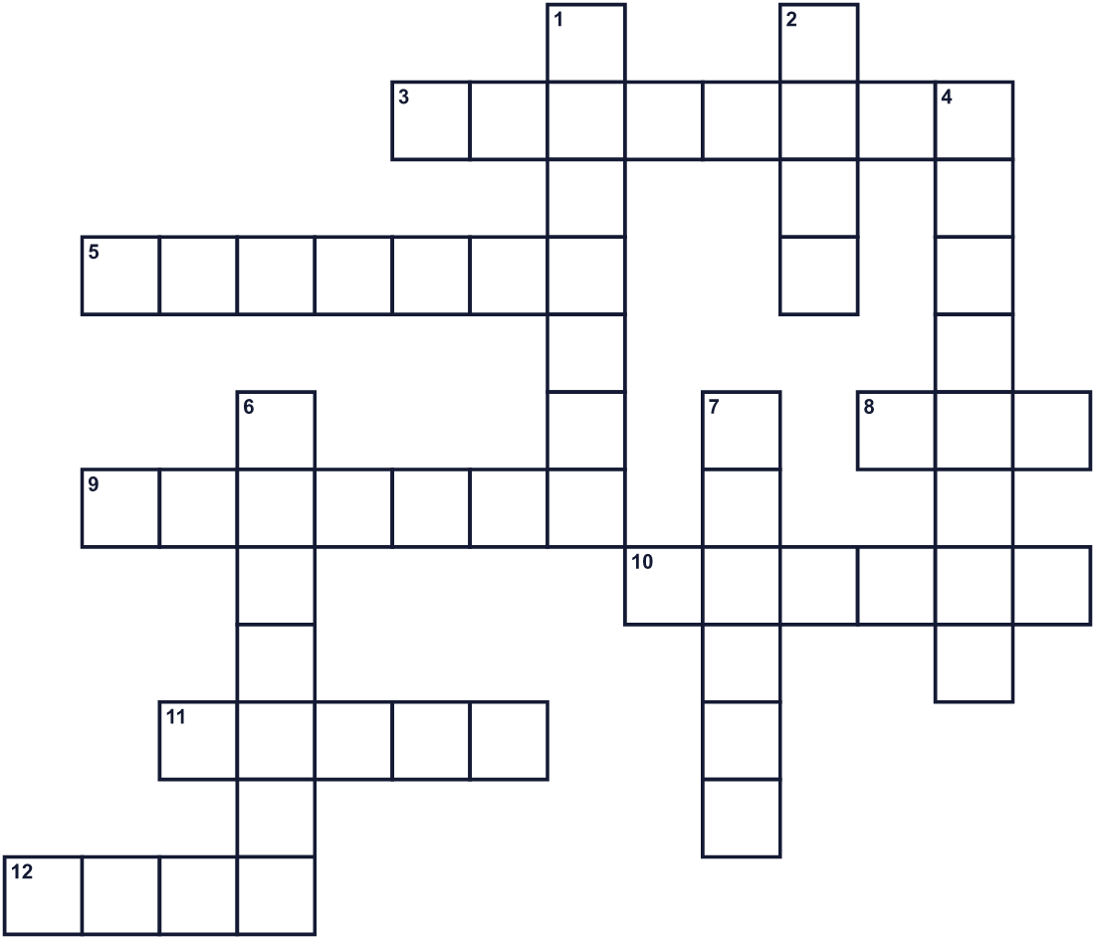
Across →
3. A sport. Many big matches are on December 26 in the UK. (8)
5. A bat-and-ball sport. A big match starts in Melbourne. (7)
8. A container for gifts. It gives this day its name. (3)
9. In Ireland, the day is named after this saint. (7)
10. A big bird. People eat it cold in sandwiches. (6)
11. A boat with sails. A big race starts in Sydney. (5)
12. Another word for a present. (4)
Down ↓
1. A worker who brings letters to your house. (7)
2. When shops make things cheap. (4)
4. Food that is still there after a meal. (8)
6. A person who worked in a big house long ago. (7)
7. A building where Christians pray. It had a money box. (6)

🎁 Boxing Day Worksheet
Word Search
かくれた単語をさがそう（→ ↓ ↘ ↗）
Class ______ No. ____ Name ______________________________
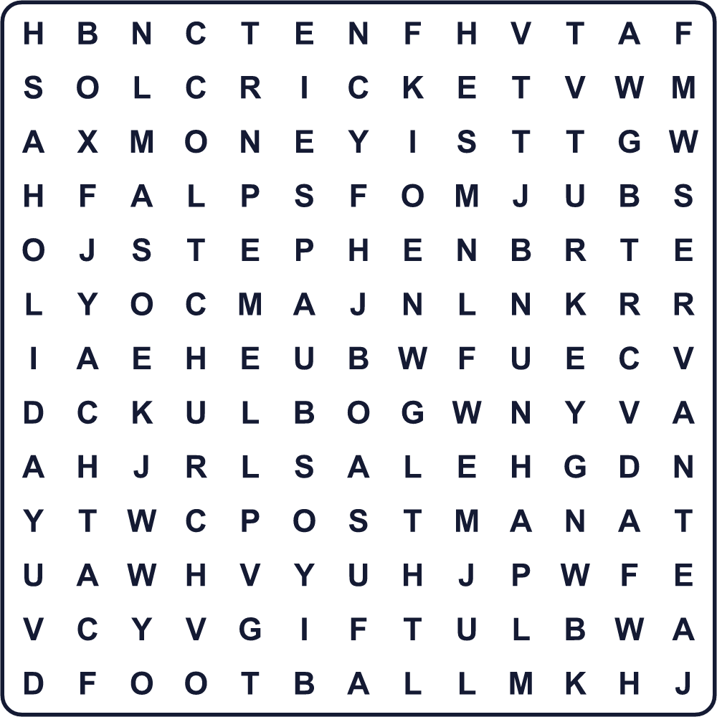
BOX CHURCH CRICKET FOOTBALL GIFT HOLIDAY MONEY POSTMAN SALE SERVANT STEPHEN TURKEY YACHT
Secret Code 暗号を解こう
◎=A ▲=E ■=F ◆=H ♦=K ☘=L ♠=N ☺=O ⚑=P ♣=R ☂=T ✚=U ✎=Y
☂ ◆ ◎ ♠ ♦ ✎ ☺ ✚ ■ ☺ ♣ ✎ ☺ ✚ ♣ ◆ ▲ ☘ ⚑
______________________________________________________________

🎁 Boxing Day Worksheet
Maze & Sentences
Class ______ No. ____ Name ______________________________
Help Mia take the box to the postman! ミアが箱を郵便配達の人に届けられるように手伝おう！
正しい道の文字を集めると、ひみつの言葉になるよ。 START 👧 → GOAL 📮
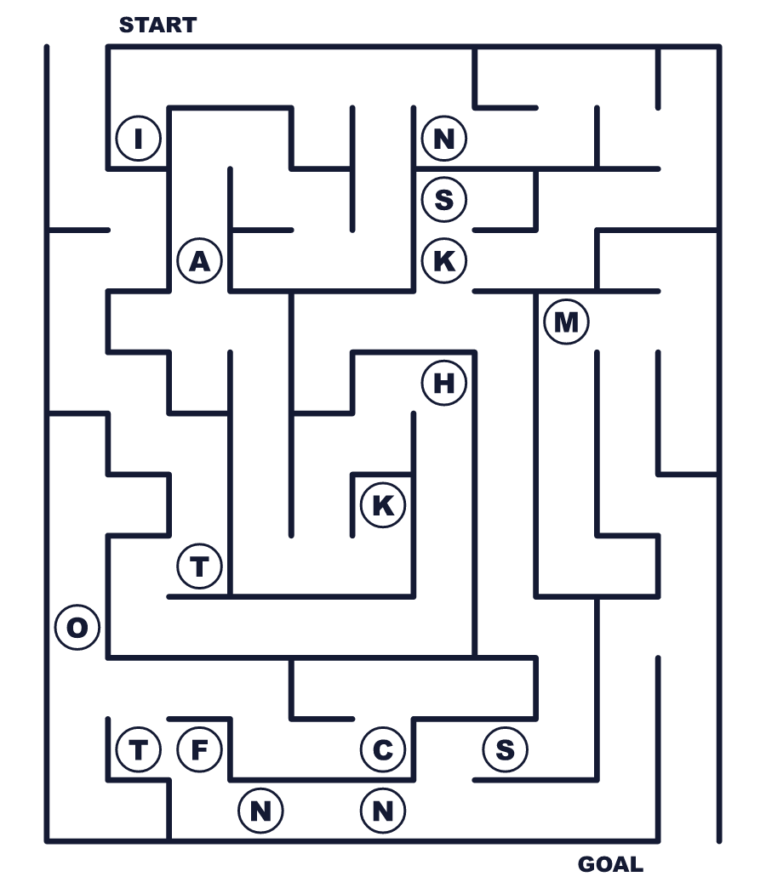
Secret word: ＿ ＿ ＿ ＿ ＿ ＿
Put the words in order. 並べかえよう。
1. Christmas / is / Day / the / after / day / Boxing . (ボクシング・デーはクリスマスの翌日です。)
______________________________________________________________
2. box / box / a / word / means / The / gift . (box という語はプレゼントの箱を意味します。)
______________________________________________________________
3. eat / for / cold / lunch / We / turkey . (お昼に冷たいターキーを食べます。)
______________________________________________________________
4. My / football / father / on / Boxing / Day / watches . (父はボクシング・デーにサッカーを見ます。)
______________________________________________________________
5. the / sales / Many / line / up / people / for . (多くの人がセールのために並びます。)
______________________________________________________________

🎁 Boxing Day Worksheet
Class Activity & Writing
Class ______ No. ____ Name ______________________________
Find Someone Who… クラスで聞いて回ろう！
Find someone who … | Name
… has gone to a big sale 大セールに行ったことがある
… has bought a lucky bag 福袋を買ったことがある
… likes turkey or chicken sandwiches ターキーかチキンのサンドイッチが好き
… has watched a football match in a stadium スタジアムでサッカーの試合を見たことがある
… knows the meaning of Boxing Day ボクシング・デーの意味を知っている
… can name a sport played with a bat バットを使うスポーツを1つ言える
… has given a thank-you card to someone だれかにお礼のカードを渡したことがある
… has been on a boat 船に乗ったことがある
Let's Write! 英語で書いてみよう。
If I could give a Christmas box to someone, I would give it to ______ because ______.
だれかにクリスマス・ボックスを渡せるなら、______に渡したい。なぜなら______だから。
______________________________________________________________
______________________________________________________________
On December 26, I usually ______. If Japan had Boxing Day, I would ______.
12月26日、私はふだん______。もし日本にボクシング・デーがあったら、______。
______________________________________________________________
______________________________________________________________
Boxing Day sales and Japanese New Year sales are similar because ______.
ボクシング・デーのセールと日本の初売りは______という点で似ています。
______________________________________________________________
______________________________________________________________

🎁 Boxing Day Worksheet
Trace & Color
なぞって書こう。絵に色をぬろう。
Class ______ No. ____ Name ______________________________
🎁 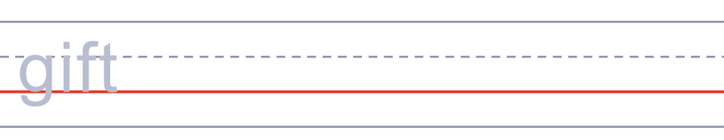

⚽ 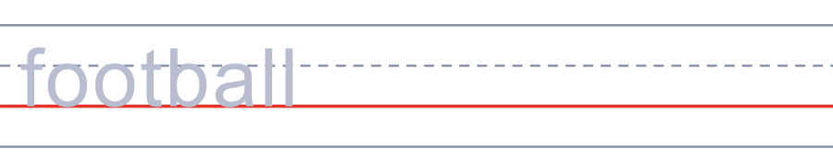
⛵ 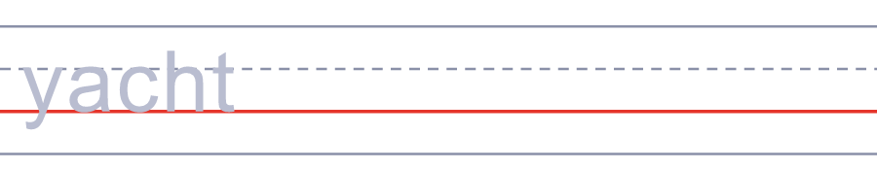
🏏 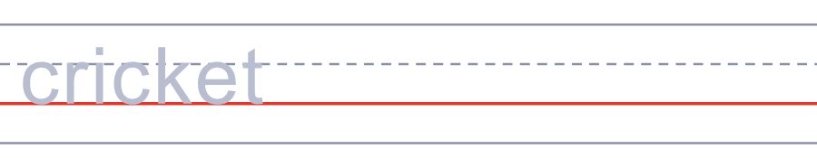
🐎 
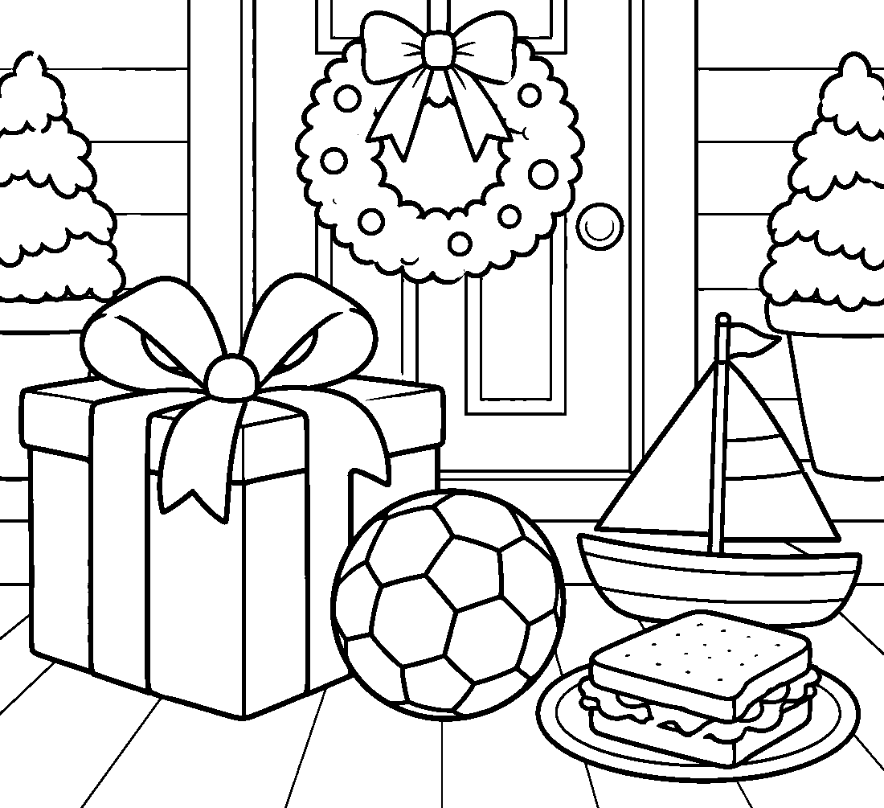

🎁 Boxing Day Worksheet
Answer Key 解答
Reading Check: 1.B 2.D 3.A 4.C 5.B 6.C 7.B 8.D
True or False: 1.T 2.F 3.T 4.T 5.F 6.F
Match: 🎁=gift ⚽=football ⛵=yacht 🏏=cricket 🐎=horse 🥪=sandwich ⛪=church 💰=money
Unscramble: 1.BOXING 2.SALE 3.CHURCH 4.TURKEY 5.HOLIDAY 6.POSTMAN
Fill in the blanks: (1)postman (2)rain (3)Boxing (4)card (5)money (6)morning (7)box (8)much (9)help (10)year
Sentence order: 1. Boxing Day is the day after Christmas. 2. The word box means a gift box. 3. We eat cold turkey for lunch. 4. My father watches football on Boxing Day. 5. Many people line up for the sales.
Secret Code: THANK YOU FOR YOUR HELP
Maze: THANKS
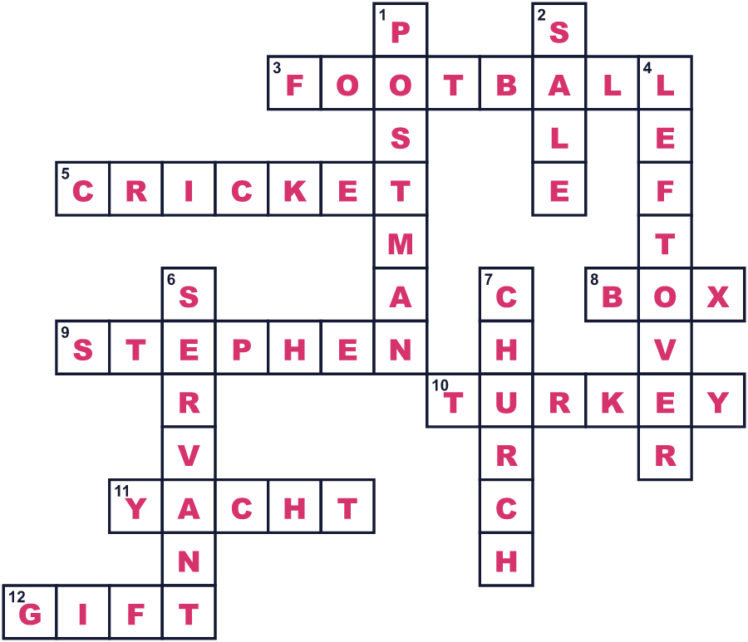
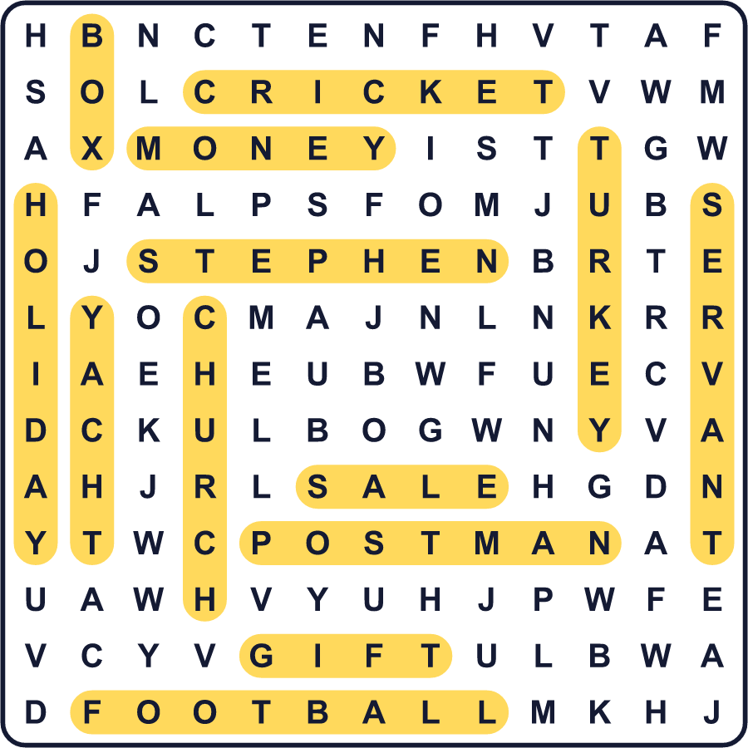
全訳
1 イギリスでは、クリスマスの翌日に不思議な名前がついています。ボクシング・デーと呼ばれますが、ボクシングのグローブとは何の関係もありません。ここでの box は、贈り物やお金を入れる箱のことです。では、箱には何が入っていて、だれがもらったのでしょうか。
2 完全にわかっている人はいません。一つの説は、大きな屋敷の使用人についてのものです。彼らはクリスマス当日に一生懸命働いたので、翌日に贈り物とお金と残り物の入った箱をもらいました。それから家族に会いに家へ帰りました。もう一つの説は、教会の箱についてのものです。人々がそこにお金を入れ、教会はそれを貧しい人に配りました。
3 ボクシング・デーという名前が初めて書き残されたのは1743年です。1871年、イギリスで正式な休日になりました。その後、カナダやオーストラリア、ニュージーランドなどの国に広がりました。アイルランドでは、聖ステファノの日と呼びます。南アフリカでは、善意の日という名前です。
4 今のボクシング・デーは、のんびりしていて、同時に忙しい日です。家族は前の日の冷たいターキーを食べます。サッカーファンは大きな試合に出かけ、買い物客は大セールのために朝早くから並びます。オーストラリアは夏で、たくさんの船に乗った人たちが、シドニー湾でヨットレースのスタートを見守ります。
5 今でも、郵便配達の人などの働く人にクリスマス・ボックスを渡す人がいます。たいていは少しのお金とカードです。だから、昔の考え方は今も生きています。クリスマスのあとは、毎日私たちを助けてくれる人たちにありがとうを言うのにぴったりの時なのです。

