⛑️ Disaster Prevention Day Worksheet
Two Minutes Before Noon
Read the story. 英文を読もう。
Class ______ No. ____ Name ______________________________

🔊 音声を聞こう（スマホで読みとってね）
1 On September 1, a bell rings in many schools in Japan. Students quickly hide under their desks. Then they cover their heads and walk out to the schoolyard. It is only a drill, but everyone takes it seriously. Some children wear soft hoods to protect their heads. This is Bosai no Hi, Disaster Prevention Day.
2 Why September 1? On this day in 1923, a huge earthquake hit Tokyo and Yokohama. It came at 11:58, just before lunch. Many families were cooking with fire, so fires started all over the city. About 105,000 people died or went missing, and most of them were killed by fire. Large parts of Tokyo and Yokohama burned down.
3 After the earthquake, false stories spread quickly. Because of these rumors, many Korean people and others were killed. A government report says no other disaster in Japan has led to killings like this. So the day also teaches us to check the news carefully in an emergency.
4 Japan made September 1 Disaster Prevention Day in 1960. This time of year is also typhoon season. The old calendar calls this time the 210th day. Farmers watched the sky carefully because storms often came. So on this day, many families open their emergency bags. Is the food still good? Do the batteries in the flashlight still work? A few minutes of checking today can save lives tomorrow.
Words 単語
disaster（災害、大惨事） / drill（訓練） / seriously（真剣に） / missing（行方不明の、見つからない） / rumor（うわさ） / emergency（緊急事態、非常時） / typhoon（台風） / battery（電池）

⛑️ Disaster Prevention Day Worksheet
Reading Check
Choose the best answer. 正しいものを選ぼう。
Class ______ No. ____ Name ______________________________
1. What is the main idea of the reading?
(A) September 1 is a day to remember a disaster and get ready for the next one. (B) September 1 is the first day of summer vacation. (C) Typhoons never come to Japan in September. (D) Disaster Prevention Day started in 1923.
2. Why did so many fires start in 1923?
(A) Because it was very cold (B) Because a typhoon came at the same time (C) Because many families were cooking lunch with fire (D) Because people were watching fireworks
3. What does the reading say about rumors after the earthquake?
(A) They helped people find water. (B) They were all true. (C) They were only about typhoons. (D) They led to the killing of many people.
4. In paragraph 4, what does "save lives" mean?
(A) Keep money in a bank (B) Help people stay alive (C) Buy new batteries (D) Write a story about life
5. In the dialogue, what will Ben and Haruka do this weekend?
(A) Make an emergency bag (B) Go to Tokyo (C) Buy a new helmet (D) Have an earthquake drill at school
True or False? T か F に○
1. The 1923 earthquake happened in the evening. T / F
2. Most of the people who died in 1923 were killed by fire. T / F
3. Japan made Disaster Prevention Day in 1960. T / F
4. We should believe every story we hear in an emergency. T / F

⛑️ Disaster Prevention Day Worksheet
Word Work
単語のれんしゅう
Class ______ No. ____ Name ______________________________
① Match the pictures and the words. 絵と単語を線でむすぼう。
⛑️ | ● | ● | flashlight
🔦 | ● | ● | bag
🎒 | ● | ● | radio
💧 | ● | ● | water
🔥 | ● | ● | helmet
📻 | ● | ● | fire
③ Fill in the blanks. 語群から選んで入れよう。
[ flashlight / list / batteries / swimsuit / water / kite / cookies / candy cane / bag / ready ]
On September 1, Mom and I opened our emergency (1) __________ . First, we checked the (2) __________ . Next, I turned on the (3) __________ . It did not work! The (4) __________ were dead. We put in new ones. Then Mom found old (5) __________ . "These are too old," she said. We wrote a new (6) __________ and bought fresh food. Now we are (7) __________ .

⛑️ Disaster Prevention Day Worksheet
Crossword Puzzle
ヒントを読んでクロスワードを完成させよう。
Class ______ No. ____ Name ______________________________
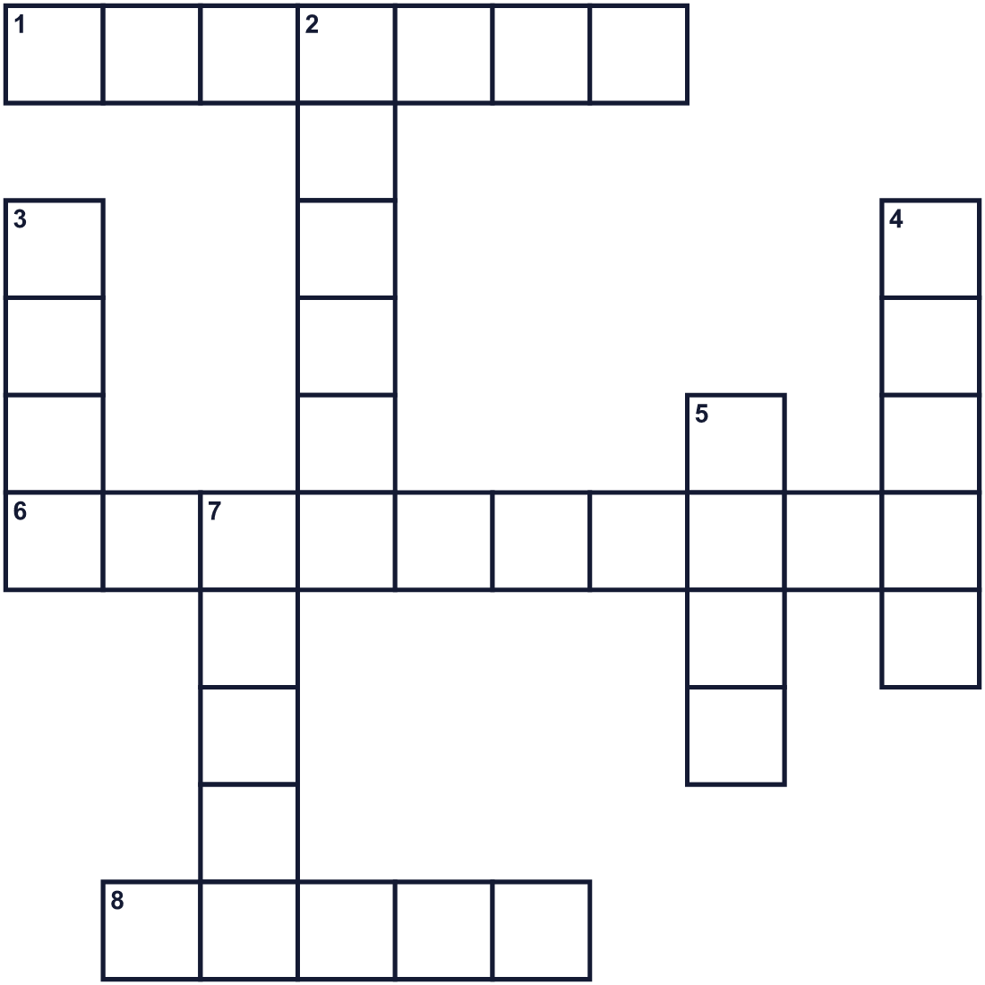
Across →
1. A big storm with strong wind and heavy rain in Asia. (7)
6. The ground shakes hard. Japan has many of these. (10)
8. Practice for an emergency at school. (5)
Down ↓
2. A hard hat that keeps your head safe. (6)
3. It is hot and burns. It spread fast in 1923. (4)
4. You drink it. Keep some in your emergency bag. (5)
5. Not in danger. (4)
7. A story that people tell, but it may not be true. (5)

⛑️ Disaster Prevention Day Worksheet
Word Search
かくれた単語をさがそう（→ ↓ ↘ ↗）
Class ______ No. ____ Name ______________________________
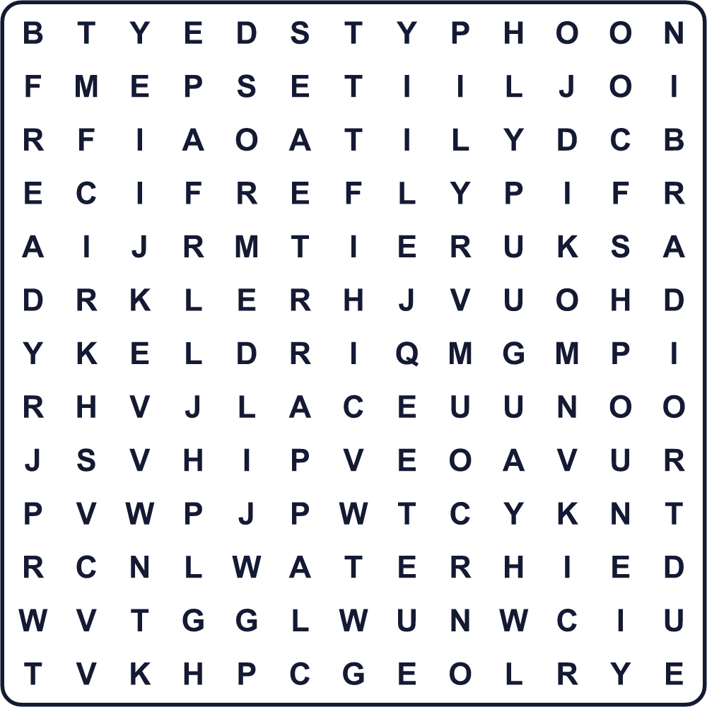
DRILL EARTHQUAKE FIRE HELMET RADIO READY RUMOR SAFE TYPHOON WATER

⛑️ Disaster Prevention Day Worksheet
Maze & Sentences
Class ______ No. ____ Name ______________________________
Help Haruka get to the safe park! ハルカを安全な公園まで連れていこう！
正しい道の文字を集めると、ひみつの言葉になるよ。 START 👧 → GOAL 🏞️
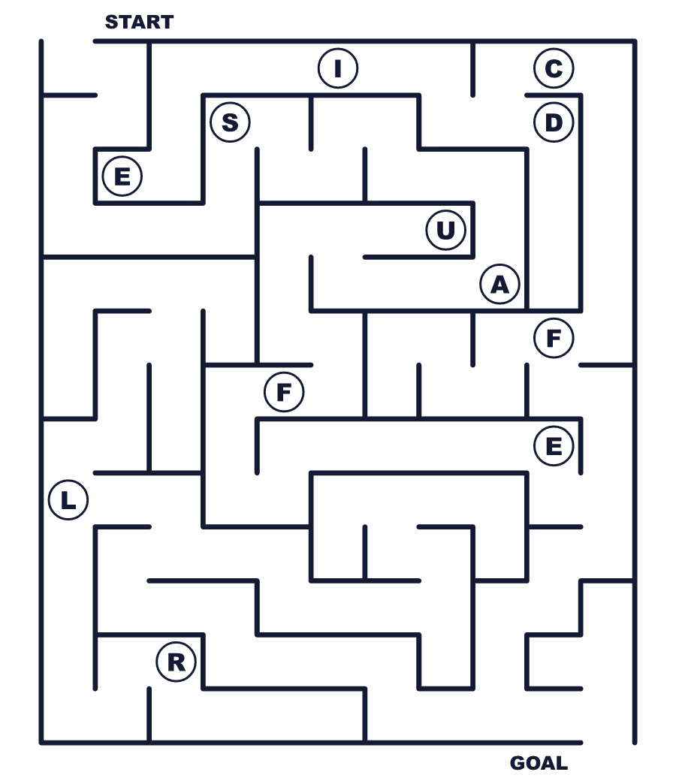
Secret word: ＿ ＿ ＿ ＿

⛑️ Disaster Prevention Day Worksheet
Class Activity & Writing
Class ______ No. ____ Name ______________________________
Let's Write! 英語で書いてみよう。
In my emergency bag, I will put ______ because ______.
私の非常持ち出し袋には＿＿を入れます。なぜなら＿＿だからです。
______________________________________________________________
______________________________________________________________
If a big earthquake happens, my family will meet at ______.
大きな地震が起きたら、私の家族は＿＿に集まります。
______________________________________________________________
______________________________________________________________

⛑️ Disaster Prevention Day Worksheet
Trace & Color
なぞって書こう。絵に色をぬろう。
Class ______ No. ____ Name ______________________________
⛑️ 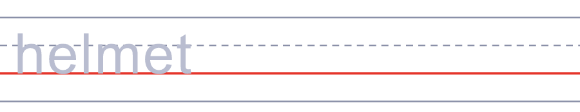

🔦 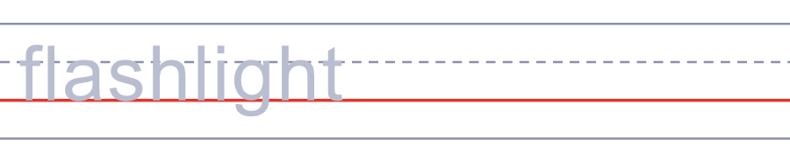
🎒 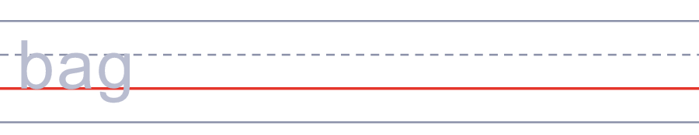
💧 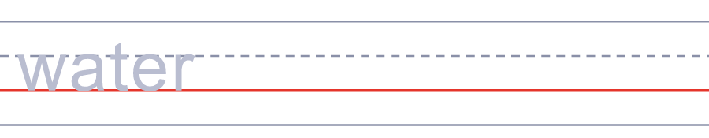
🔥 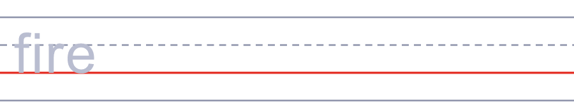

⛑️ Disaster Prevention Day Worksheet
Answer Key 解答
Reading Check: 1.A 2.C 3.D 4.B 5.A
True or False: 1.F 2.T 3.T 4.F
Match: ⛑️=helmet 🔦=flashlight 🎒=bag 💧=water 🔥=fire 📻=radio
Fill in the blanks: (1)bag (2)water (3)flashlight (4)batteries (5)cookies (6)list (7)ready
Maze: SAFE
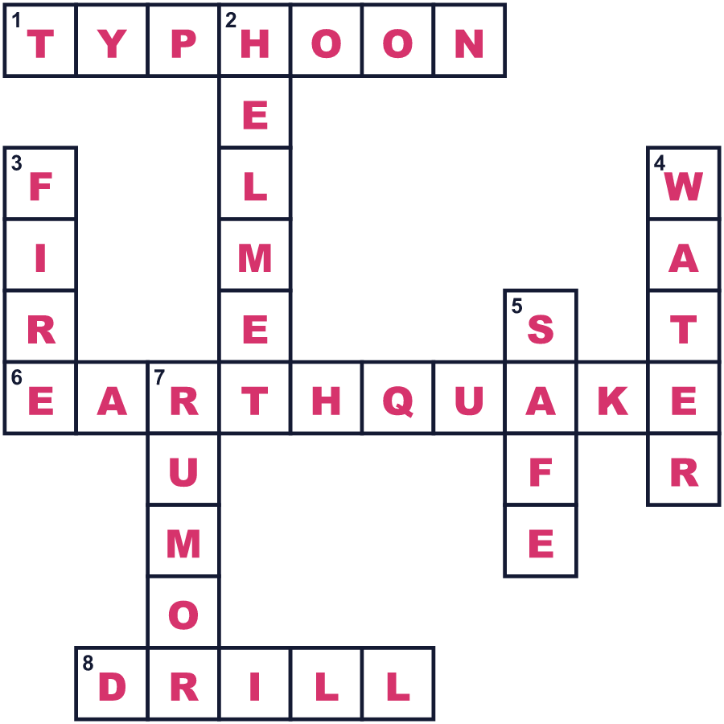
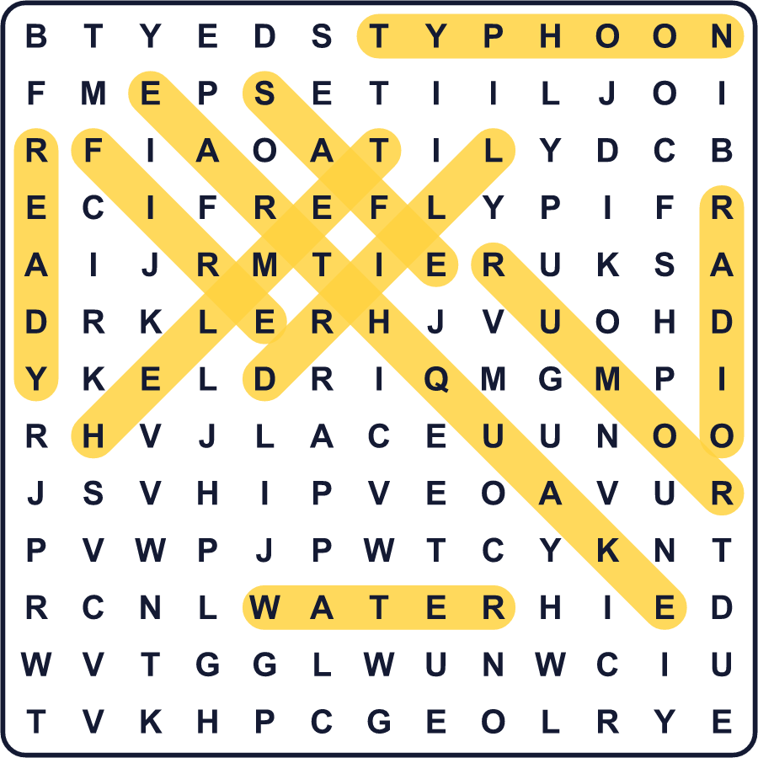
全訳
1 9月1日、日本の多くの学校でベルが鳴ります。生徒たちはすぐに机の下にかくれます。それから頭を守って、校庭へ歩いて出ます。ただの訓練ですが、みんな真剣です。頭を守るために、やわらかい頭巾をかぶる子どももいます。これが防災の日です。
2 なぜ9月1日なのでしょう。1923年のこの日、巨大な地震が東京と横浜をおそいました。それは11時58分、昼ごはんの直前に起きました。多くの家族が火を使って料理をしていたので、町じゅうで火事が起きました。約10万5千人が亡くなったり行方不明になったりし、その多くは火事の犠牲でした。東京と横浜の広い地域が焼けてしまいました。
3 地震のあと、うその話があっという間に広がりました。そのうわさのせいで、多くの朝鮮人やほかの人々が殺されました。政府の報告書は、日本の災害でこのような殺害につながった例はほかにないと述べています。だからこの日は、非常時には情報を注意深く確かめることも教えてくれます。
4 日本は1960年に9月1日を防災の日にしました。この時期は台風の季節でもあります。昔の暦では、この時期を「二百十日」と呼びます。嵐がよく来るので、農家の人たちは空を注意深く見ていました。だからこの日、多くの家族が非常持ち出し袋を開けます。食べ物はまだ食べられるかな。懐中電灯の電池はまだ使えるかな。今日の数分間の点検が、明日の命を救うかもしれません。

