📚 Black History Month Worksheet
A Week That Grew into a Month
Read the story. 英文を読もう。
Class ______ No. ____ Name ______________________________

🔊 音声を聞こう（スマホで読みとってね）
1 In 1926, a Black historian had a big idea. His name was Carter G. Woodson. His parents were once enslaved, and as a boy he worked in coal mines. But he never stopped learning, and he earned a doctorate in history at Harvard University. Then he saw a problem. Black people were mostly missing from school history books.
2 So Woodson started Negro History Week. He chose the second week of February. Why? Two famous birthdays were in that week. Abraham Lincoln was born on February 12. Frederick Douglass, a great speaker against slavery, chose February 14 as his birthday. Black communities already celebrated these two days.
3 The idea slowly spread to schools and cities. In the 1960s, college students said one week was not enough. In 1970, students at Kent State University in Ohio held the first Black History Month. Then, in 1976, President Gerald Ford asked all Americans to honor the work of Black Americans. Since then, February has been Black History Month in the United States.
4 Today, students learn about people like Harriet Tubman, Rosa Parks, and Martin Luther King Jr. Some young students dress up as these heroes and tell their life stories. Canada also has Black History Month in February. But in the United Kingdom and Ireland, it is in October.
5 Some people say February was chosen because it is the shortest month. That is not true. Woodson picked it himself, and at first it was only one week long. In 2026, the celebration turned 100 years old. Woodson's dream was simple. He wanted Black history to be part of everyone's history.
Words 単語
enslaved（奴隷にされた） / coal mine（炭鉱） / doctorate（博士号） / missing（欠けている、見当たらない） / slavery（奴隷制） / speaker（演説家、話し手） / community（地域社会、共同体） / spread（広がる） / honor（たたえる、敬意を表す） / hero（英雄、ヒーロー） / dress up（仮装する、正装する） / shortest（いちばん短い）

📚 Black History Month Worksheet
Reading Check
Choose the best answer. 正しいものを選ぼう。
Class ______ No. ____ Name ______________________________
1. What is the story mainly about?
(A) How Black History Month began and grew (B) Why February has only 28 days (C) How Lincoln became president (D) Why students like wax museums
2. When did Woodson start Negro History Week?
(A) In 1912 (B) In 1926 (C) In 1970 (D) In 1976
3. Why did Woodson choose the second week of February?
(A) Schools had a vacation that week. (B) It was the coldest week of the year. (C) Two famous birthdays were in that week. (D) Harvard University asked him to.
4. Where was the first Black History Month held?
(A) At Harvard University (B) In a school in Canada (C) At the White House (D) At Kent State University
5. In paragraph 3, "honor the work of Black Americans" means to ...
(A) pay Black Americans for their work (B) show respect for what Black Americans did (C) give Black Americans more work (D) write a test about Black Americans
6. Which is true according to the story?
(A) Woodson's parents went to Harvard University. (B) Black History Month is in October in Canada. (C) Douglass chose his own birthday. (D) February was chosen because it is the shortest month.
7. What can we guess about Woodson from the story?
(A) He wanted children to learn a fuller history. (B) He did not like school when he was young. (C) He wanted a holiday with no classes. (D) He thought one week was too long.
8. In the dialogue, why is Jasmine wearing goggles?
(A) She is going swimming after school. (B) She is playing Bessie Coleman, a pilot. (C) She is working in a science lab. (D) She wants to look like Haruto.
True or False? T か F に○
1. Black History Month is in February in the United States. T / F
2. It started as one week in 1926. T / F
3. February was chosen because it is the shortest month. T / F
4. Lincoln and Douglass have birthdays in February. T / F
5. In the United Kingdom, Black History Month is in May. T / F
6. Carter G. Woodson studied at a university in Japan. T / F

📚 Black History Month Worksheet
Word Work
単語のれんしゅう
Class ______ No. ____ Name ______________________________
① Match the pictures and the words. 絵と単語を線でむすぼう。
📅 | ● | ● | peanut
📚 | ● | ● | airplane
🚌 | ● | ● | star
🎂 | ● | ● | calendar
⭐ | ● | ● | microphone
🥜 | ● | ● | book
🎤 | ● | ● | cake
✈️ | ● | ● | bus
② Unscramble the words. 並べかえて単語にしよう。
1. T Y S R H I O (歴史) → ____________________
2. R E O M F D E (自由) → ____________________
3. U B A E Y F R R (2月) → ____________________
4. O E R H (英雄、ヒーロー) → ____________________
5. O T M M I Y U N C (地域社会) → ____________________
6. C E A B L E E T R (祝う) → ____________________
③ Fill in the blanks. 語群から選んで入れよう。
[ bus / pilot / button / speak / history / summer / pizza / February / sleepy / museum / goggles / clapped / person ]
Every (1) __________ , Jasmine's school learns about Black (2) __________ . This year, the students made a living wax (3) __________ . Each student chose a famous (4) __________ and read many books about that hero. Jasmine became Bessie Coleman, a (5) __________ . She wore old (6) __________ and a brown jacket. Her friend Mia was Rosa Parks. She sat in a chair like a (7) __________ seat. When visitors pushed a (8) __________ , the students started to (9) __________ . Jasmine said, "I flew planes in the 1920s!" Everyone (10) __________ for her.

📚 Black History Month Worksheet
Crossword Puzzle
ヒントを読んでクロスワードを完成させよう。
Class ______ No. ____ Name ______________________________
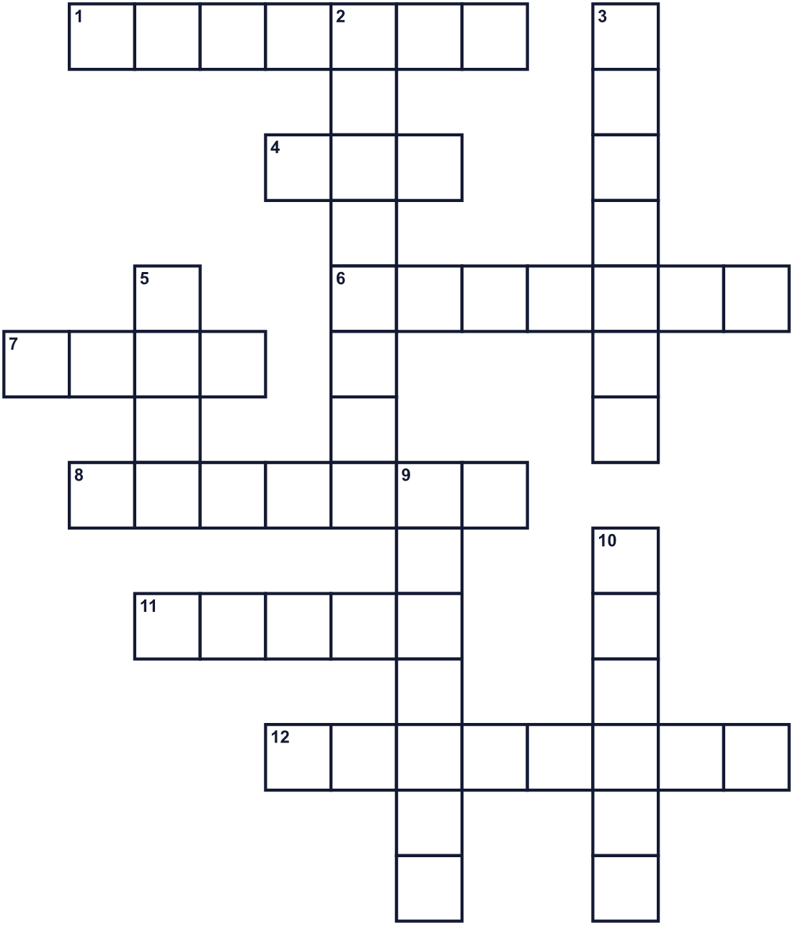
Across →
1. Harriet Tubman led about 70 people to this. (7)
4. Rosa Parks did not give up her seat on this. (3)
6. The president who was born on February 12. (7)
7. Seven days. The first celebration was this long. (4)
8. Carter G. ___ started Negro History Week in 1926. (7)
11. Bessie Coleman flew planes. She was a ___. (5)
12. The second month of the year. (8)
Down ↓
2. Frederick ___ was a great speaker against slavery. (8)
3. The study of the past. (7)
5. A person people admire for being brave or great. (4)
9. The UK and Ireland celebrate in this tenth month. (7)
10. This country north of the United States also celebrates in February. (6)

📚 Black History Month Worksheet
Word Search
かくれた単語をさがそう（→ ↓ ↘ ↗）
Class ______ No. ____ Name ______________________________
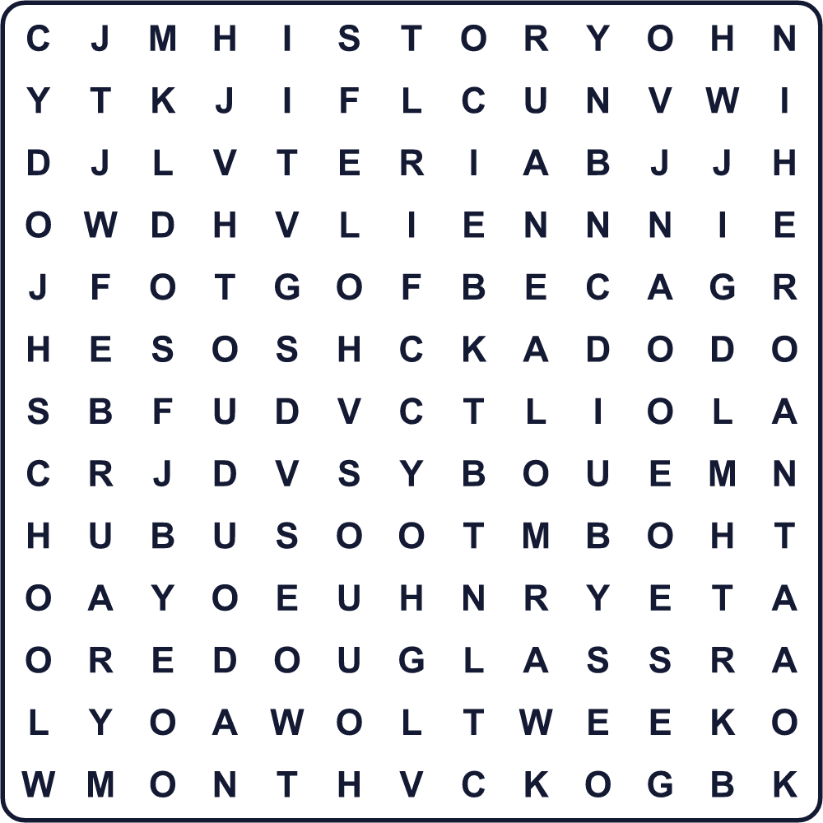
BUS CANADA DOUGLASS FEBRUARY FREEDOM HERO HISTORY LINCOLN MONTH OCTOBER SCHOOL WEEK WOODSON
Secret Code 暗号を解こう
♦=A ☀=B ◆=C ✂=H ✎=I ✉=K ✚=L ☾=M ☂=N ♪=O ✿=R ✈=S ★=T ⚓=Y
☀ ✚ ♦ ◆ ✉ ✂ ✎ ✈ ★ ♪ ✿ ⚓ ☾ ♪ ☂ ★ ✂
______________________________________________________________

📚 Black History Month Worksheet
Maze & Sentences
Class ______ No. ____ Name ______________________________
Help Jasmine get to the school library! ジャスミンを学校の図書館まで連れていこう！
正しい道の文字を集めると、ひみつの言葉になるよ。 START 👧 → GOAL 📚
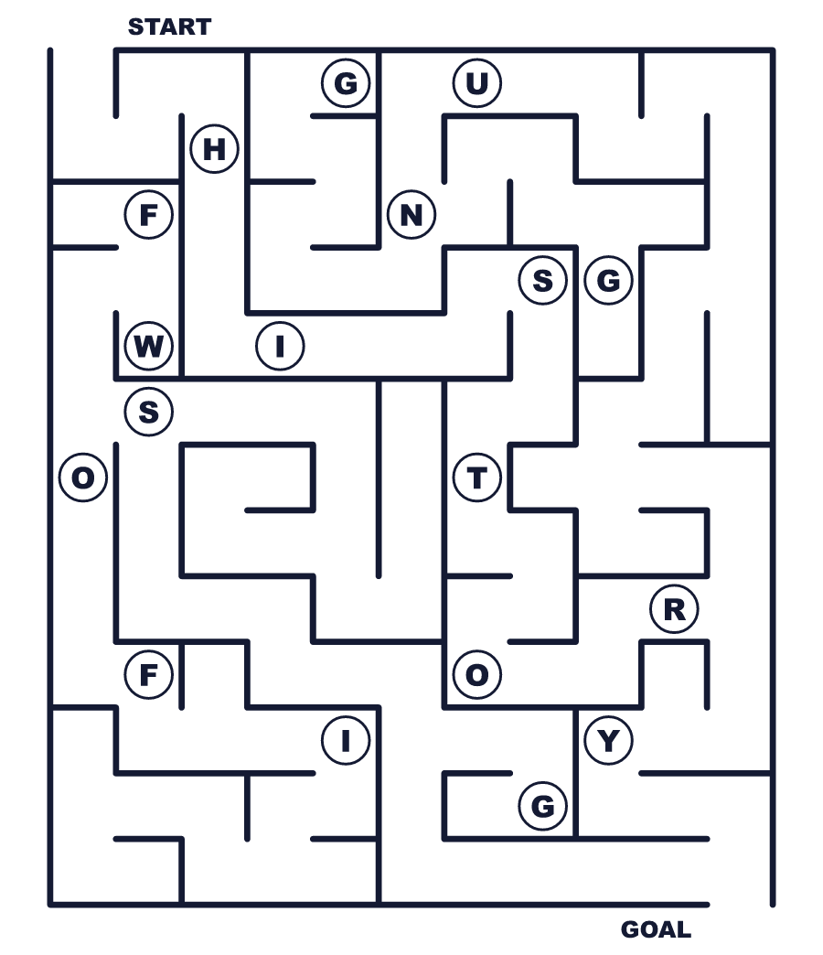
Secret word: ＿ ＿ ＿ ＿ ＿ ＿ ＿
Put the words in order. 並べかえよう。
1. Woodson / Week / started / History / Negro / in / 1926 . (ウッドソンは1926年にニグロ歴史週間を始めました。)
______________________________________________________________
2. February / Lincoln / was / born / on / 12 . (リンカーンは2月12日に生まれました。)
______________________________________________________________
3. students / not / week / for / was / the / enough / One . (生徒たちにとって1週間では足りませんでした。)
______________________________________________________________
4. famous / up / as / dress / Black / Americans / Students . (生徒たちは有名な黒人アメリカ人の格好をします。)
______________________________________________________________
5. October / is / it / In / UK, / the / in . (イギリスでは、それは10月です。)
______________________________________________________________

📚 Black History Month Worksheet
Class Activity & Writing
Class ______ No. ____ Name ______________________________
Find Someone Who… クラスで聞いて回ろう！
Find someone who … | Name
… has a birthday in February 誕生日が2月
… knows who Abraham Lincoln was エイブラハム・リンカーンがだれか知っている
… likes peanuts ピーナッツが好き
… has been to a history museum 歴史博物館に行ったことがある
… can name a famous Black American 有名な黒人アメリカ人の名前を言える
… has read a biography 伝記を読んだことがある
… has dressed up as a famous person 有名人の仮装をしたことがある
… likes jazz or hip-hop music ジャズかヒップホップが好き
Let's Write! 英語で書いてみよう。
My history hero is ______ because ______.
私の歴史上のヒーローは＿＿です。なぜなら＿＿だからです。
______________________________________________________________
______________________________________________________________
If I were in a living wax museum, I would be ______. I would say, "______."
もし生きたろう人形館に出るなら、私は＿＿になります。「＿＿」と言います。
______________________________________________________________
______________________________________________________________
Black History Month is important because ______.
黒人歴史月間が大切なのは＿＿だからです。
______________________________________________________________
______________________________________________________________

📚 Black History Month Worksheet
Trace & Color
なぞって書こう。絵に色をぬろう。
Class ______ No. ____ Name ______________________________
📅 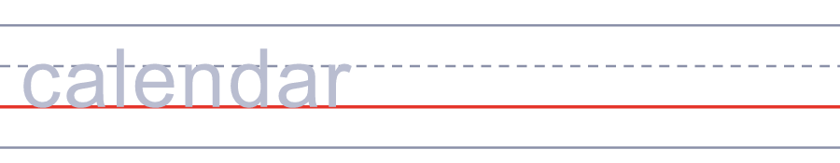

📚 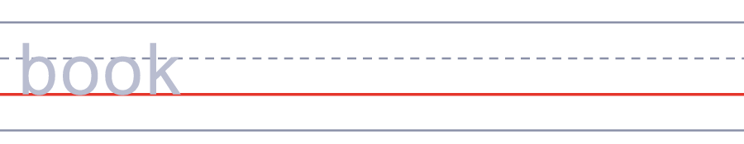
🚌 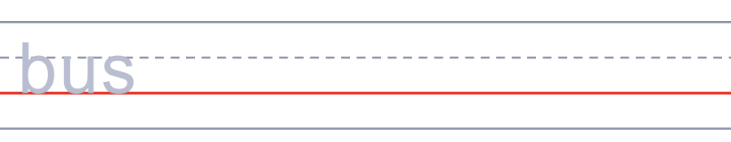
🎂 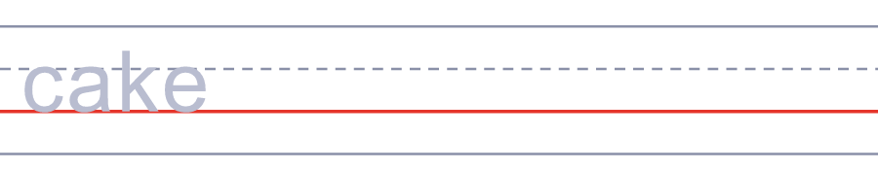
⭐ 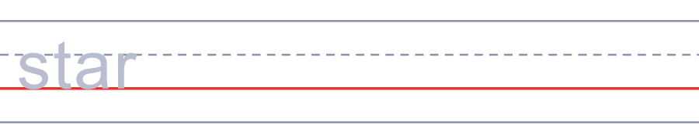
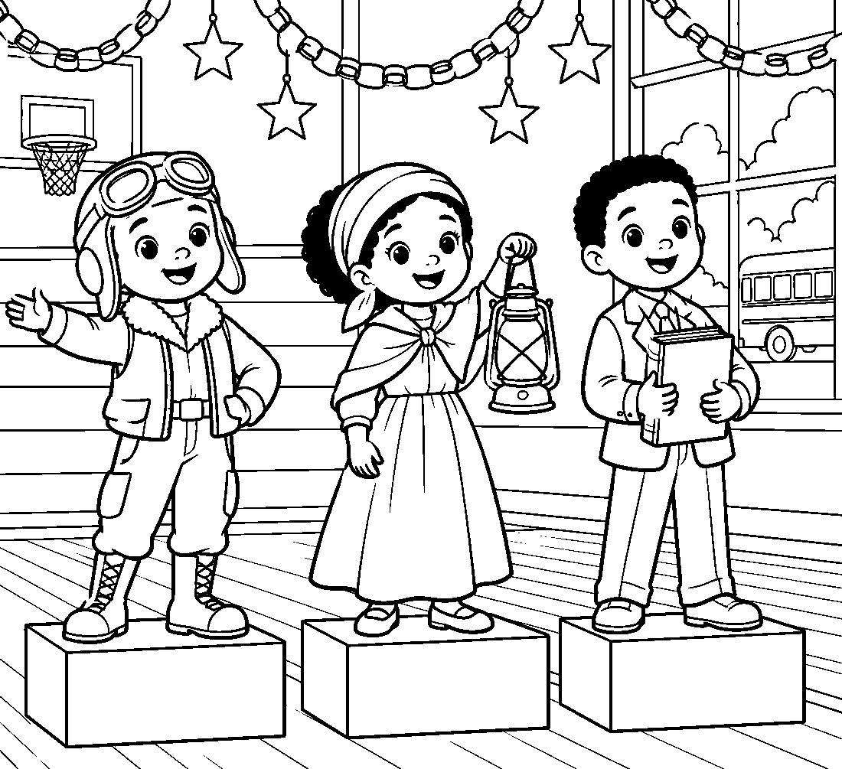

📚 Black History Month Worksheet
Answer Key 解答
Reading Check: 1.A 2.B 3.C 4.D 5.B 6.C 7.A 8.B
True or False: 1.T 2.T 3.F 4.T 5.F 6.F
Match: 📅=calendar 📚=book 🚌=bus 🎂=cake ⭐=star 🥜=peanut 🎤=microphone ✈️=airplane
Unscramble: 1.HISTORY 2.FREEDOM 3.FEBRUARY 4.HERO 5.COMMUNITY 6.CELEBRATE
Fill in the blanks: (1)February (2)history (3)museum (4)person (5)pilot (6)goggles (7)bus (8)button (9)speak (10)clapped
Sentence order: 1. Woodson started Negro History Week in 1926. 2. Lincoln was born on February 12. 3. One week was not enough for the students. 4. Students dress up as famous Black Americans. 5. In the UK, it is in October.
Secret Code: BLACK HISTORY MONTH
Maze: HISTORY
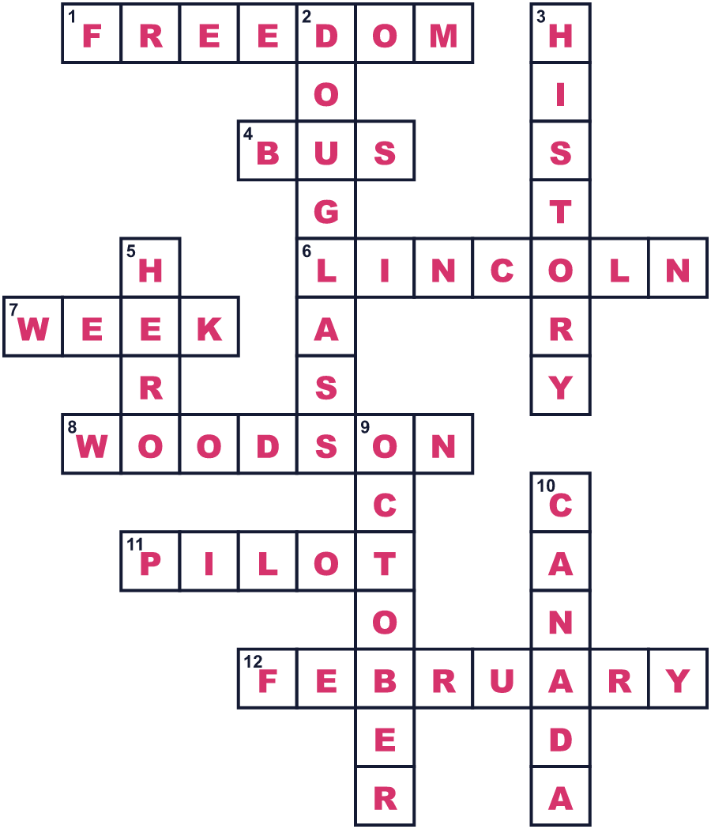
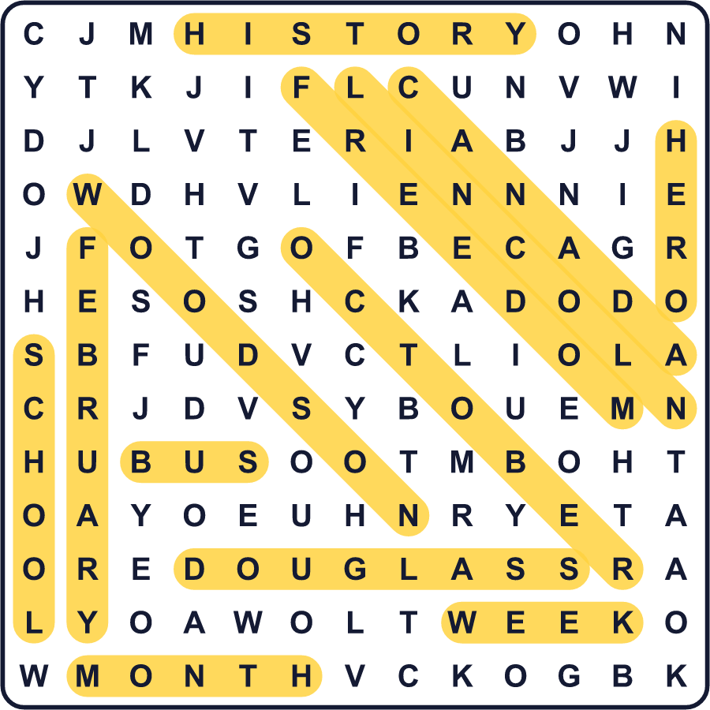
全訳
1 1926年、ある黒人の歴史学者が大きなアイデアを思いつきました。彼の名前はカーター・G・ウッドソンです。両親はかつて奴隷にされていた人で、彼自身も少年のころ炭鉱で働いていました。それでも学ぶことをやめず、ハーバード大学で歴史学の博士号を取りました。そして彼は、ある問題に気づきました。学校の歴史の教科書に、黒人がほとんど出てこなかったのです。
2 そこでウッドソンは「ニグロ歴史週間」を始めました。彼は2月の第2週を選びました。なぜでしょう。その週には、有名な2人の誕生日があったからです。エイブラハム・リンカーンは2月12日に生まれました。奴隷制に反対したすばらしい演説家フレデリック・ダグラスは、2月14日を自分の誕生日に選びました。黒人の地域社会では、すでにこの2つの日を祝っていました。
3 このアイデアは、少しずつ学校や町に広がりました。1960年代、大学生たちは1週間では足りないと言いました。1970年、オハイオ州のケント州立大学の学生たちが、最初の黒人歴史月間を開きました。そして1976年、ジェラルド・フォード大統領が、黒人アメリカ人の功績をたたえるよう国民に呼びかけました。それ以来、アメリカでは2月が黒人歴史月間になっています。
4 今では生徒たちが、ハリエット・タブマンやローザ・パークス、キング牧師のような人々について学びます。小さな子どもたちの中には、こうしたヒーローの服装をして、その人生を語る子もいます。カナダでも2月が黒人歴史月間です。でも、イギリスとアイルランドでは10月です。
5 2月が選ばれたのは一番短い月だからだ、と言う人もいます。それは本当ではありません。ウッドソンが自分で選び、しかも最初はたった1週間だったのです。2026年、このお祝いは100周年を迎えました。ウッドソンの夢はシンプルでした。黒人の歴史を、すべての人の歴史の一部にしたかったのです。

