🛍️ Black Friday Worksheet
Why Is Black Friday Black?
Read the story. 英文を読もう。
Class ______ No. ____ Name ______________________________
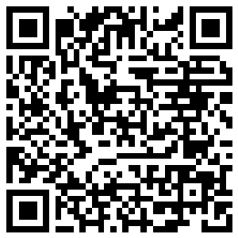
🔊 音声を聞こう（スマホで読みとってね）
1 In the United States, the day after Thanksgiving is a huge shopping day. Stores open very early, and some people wait outside in the cold. They want the best deals before Christmas. This day is called Black Friday.
2 But why black? Many people say stores are in the red, or losing money, for most of the year. Then on this day, they go into the black and make money. It is a nice story, but it came later. It first appeared in a newspaper in 1981.
3 The real story starts with the police in Philadelphia in the 1950s. On the day after Thanksgiving, huge crowds came into the city to shop. On Saturday, there was also a big Army-Navy football game in the city. The police had to work long hours in the traffic and noise. So they called these days Black Friday and Black Saturday. In 1961, stores tried to change the name to Big Friday, but nobody used it.
4 Today, Black Friday sales happen in many countries. In Japan, a toy store had one in 2014, and many shops joined after that. Some Japanese shops sell things for 96 yen. The numbers 9 and 6 can sound like kuro, the Japanese word for black. But not everyone loves this day. Some people join Buy Nothing Day and do not spend a single yen or dollar.
Words 単語
deal（お買い得品、取引） / crowd（人混み、群衆） / traffic（交通、交通量） / in the red（赤字で） / in the black（黒字で） / huge（とても大きな） / appear（現れる、（記事に）出る） / spend（（お金を）使う）

🛍️ Black Friday Worksheet
Reading Check
Choose the best answer. 正しいものを選ぼう。
Class ______ No. ____ Name ______________________________
1. What is the main idea of the text?
(A) Black Friday is a sad day for stores. (B) Black Friday got its name from Japanese shops. (C) Black Friday is a big sale day, and its name came from the police. (D) Black Friday is a day when people buy nothing.
2. When did the red-to-black story first appear in a newspaper?
(A) In the 1950s (B) In 1961 (C) In 2014 (D) In 1981
3. Why did the police call the day Black Friday?
(A) They had to work long hours in heavy traffic. (B) The city had no lights that day. (C) Stores made a lot of money. (D) People wore black clothes.
4. Why do some Japanese shops sell things for 96 yen?
(A) Because 96 is a lucky number in America (B) Because 9 and 6 can sound like kuro (C) Because the sale started in 1996 (D) Because the shops have 96 items
5. In the dialogue, what does Emily want to do?
(A) Watch a football game (B) Stay home and buy nothing (C) Visit the police in Philadelphia (D) Go to the mall early in the morning
True or False? T か F に○
1. Black Friday is the day after Thanksgiving. T / F
2. The red-to-black story is the first and real origin of the name. T / F
3. Police in Philadelphia used the name in the 1950s. T / F
4. Black Friday is a national holiday in the United States. T / F

🛍️ Black Friday Worksheet
Word Work
単語のれんしゅう
Class ______ No. ____ Name ______________________________
① Match the pictures and the words. 絵と単語を線でむすぼう。
🛒 | ● | ● | football
🏷️ | ● | ● | price tag
💳 | ● | ● | cart
🚓 | ● | ● | card
🏈 | ● | ● | police car
🎁 | ● | ● | gift
③ Fill in the blanks. 語群から選んで入れよう。
[ summer / line / morning / deal / runs / beach / price / dark / sleeps / mall ]
On Black Friday, Sam gets up at four in the (1) __________ . It is cold and (2) __________ outside. He goes to the (3) __________ with his sister. There is already a long (4) __________ . When the doors open, everyone (5) __________ inside. Sam finds a game for half (6) __________ . "What a great (7) __________ !" he says. Then he goes home and (8) __________ .

🛍️ Black Friday Worksheet
Crossword Puzzle
ヒントを読んでクロスワードを完成させよう。
Class ______ No. ____ Name ______________________________
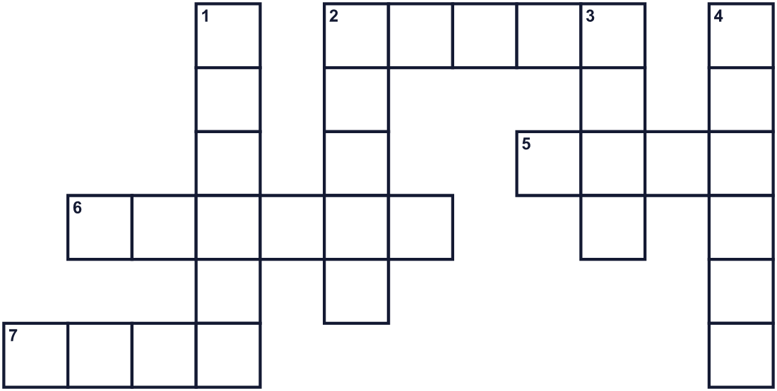
Across →
2. A lot of people in one place. (5)
5. A big building with many stores. (4)
6. The day after Thursday. (6)
7. A time when things in stores cost less. (4)
Down ↓
1. They keep people safe and help with traffic. (6)
2. It does not cost much money. (5)
3. Something you buy at a very good price. (4)
4. You shop this way with a phone or a computer. (6)

🛍️ Black Friday Worksheet
Word Search
かくれた単語をさがそう（→ ↓ ↘ ↗）
Class ______ No. ____ Name ______________________________
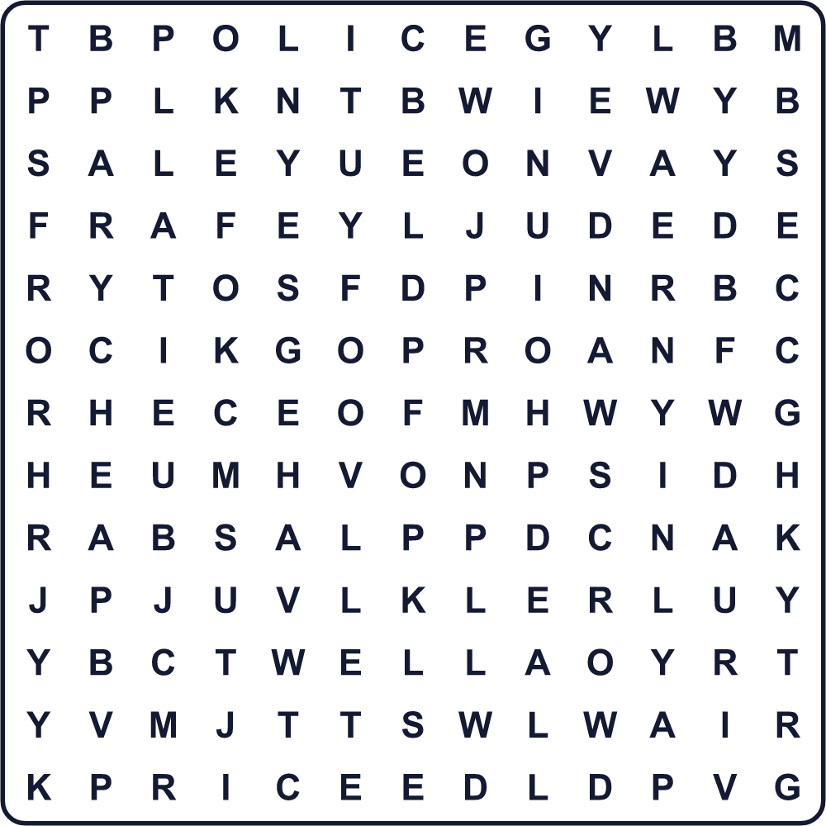
CHEAP CROWD DEAL FRIDAY MALL MONEY POLICE PRICE SALE SHOP

🛍️ Black Friday Worksheet
Maze & Sentences
Class ______ No. ____ Name ______________________________
Help the shopper get to the big sale! 買い物客を大セールの店まで連れていこう！
正しい道の文字を集めると、ひみつの言葉になるよ。 START 🧑 → GOAL 🛍️
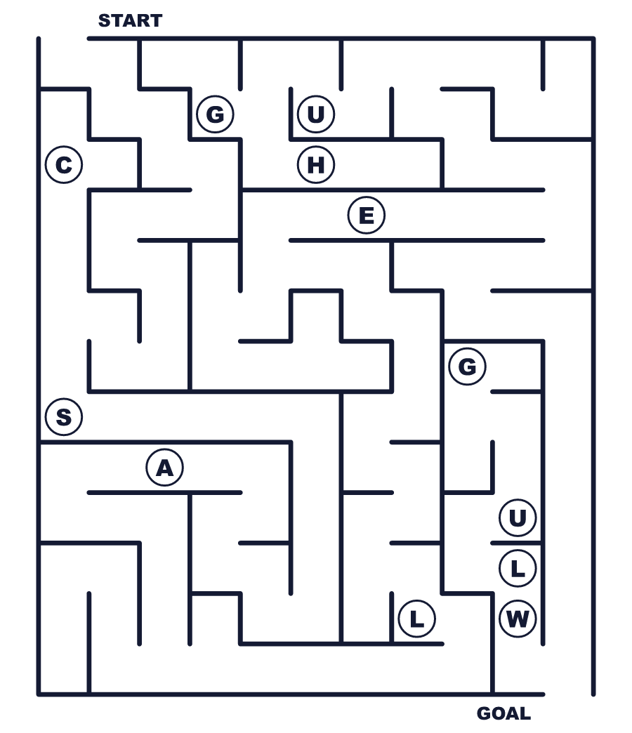
Secret word: ＿ ＿ ＿ ＿

🛍️ Black Friday Worksheet
Class Activity & Writing
Class ______ No. ____ Name ______________________________
Let's Write! 英語で書いてみよう。
If I had 10,000 yen on Black Friday, I would buy ______ because ______.
ブラックフライデーに1万円あったら、______を買います。なぜなら______だからです。
______________________________________________________________
______________________________________________________________
I think big sales are good / bad because ______.
大セールはよい／よくないと思います。なぜなら______。
______________________________________________________________
______________________________________________________________

🛍️ Black Friday Worksheet
Trace & Color
なぞって書こう。絵に色をぬろう。
Class ______ No. ____ Name ______________________________
🛒 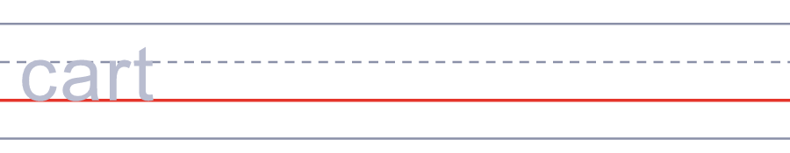

🏷️ 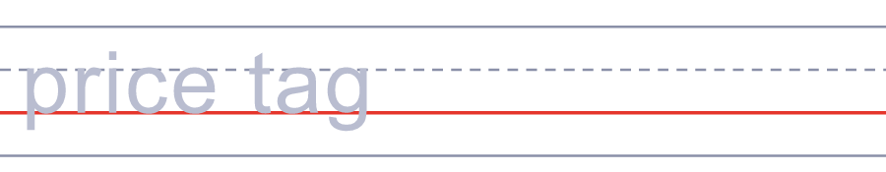
💳 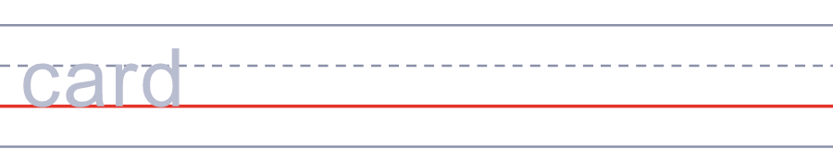
🚓 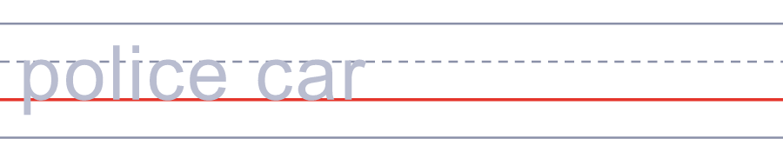
🏈 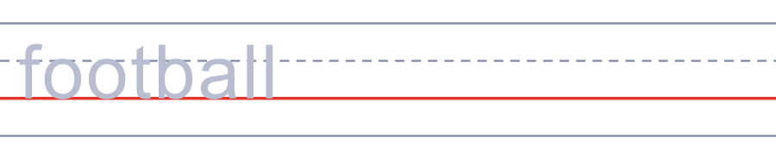

🛍️ Black Friday Worksheet
Answer Key 解答
Reading Check: 1.C 2.D 3.A 4.B 5.D
True or False: 1.T 2.F 3.T 4.F
Match: 🛒=cart 🏷️=price tag 💳=card 🚓=police car 🏈=football 🎁=gift
Fill in the blanks: (1)morning (2)dark (3)mall (4)line (5)runs (6)price (7)deal (8)sleeps
Maze: SALE
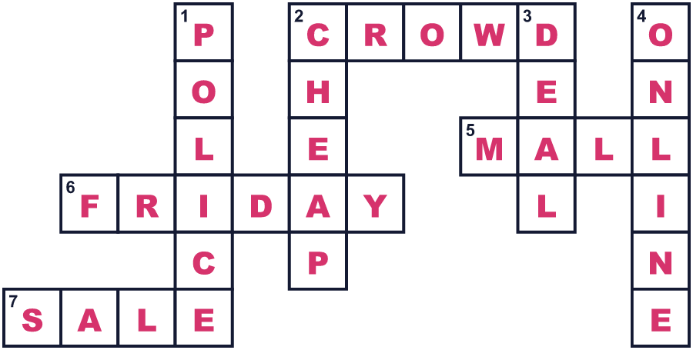
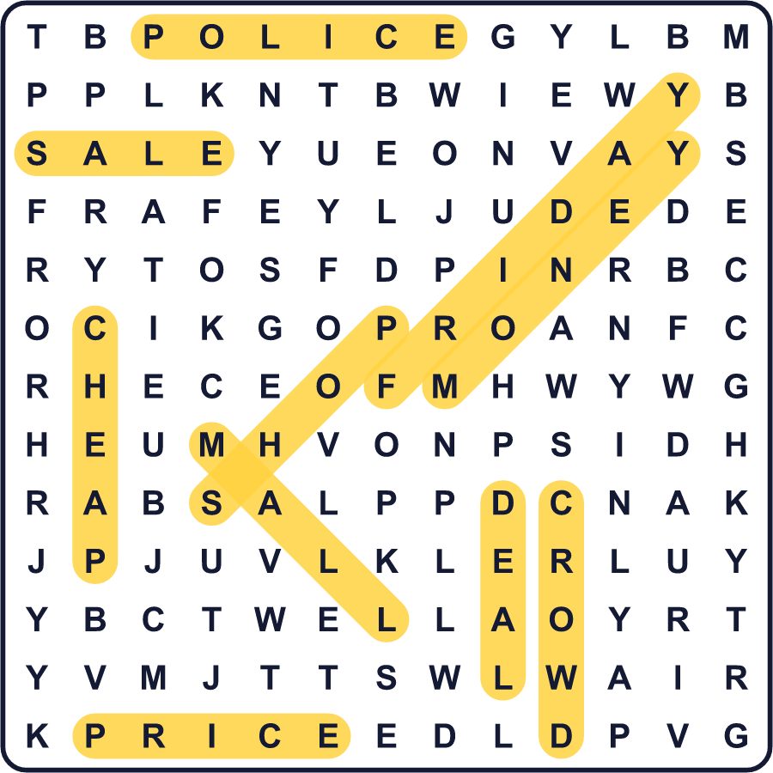
全訳
1 アメリカでは、感謝祭の翌日は買い物の大イベントの日です。お店はとても早く開き、寒い外で待つ人もいます。クリスマスの前に、いちばんのお買い得品がほしいのです。この日はブラックフライデーと呼ばれています。
2 でも、なぜ「ブラック」なのでしょう。多くの人は、お店は1年の大半が赤字、つまりお金を失っているのだと言います。そしてこの日に黒字になって、もうかるのだと。すてきな話ですが、これはあとからできた話です。新聞に初めて出たのは1981年でした。
3 本当の話は、1950年代のフィラデルフィアの警察から始まります。感謝祭の翌日には、大勢の人が買い物に街へやってきました。土曜日には、街で陸軍対海軍の大きなアメフトの試合もありました。警察は、渋滞と騒音の中で長い時間働かなければなりませんでした。そこで彼らは、この2日を「ブラックフライデー」「ブラックサタデー」と呼んだのです。1961年、お店はこの名前を「ビッグフライデー」に変えようとしましたが、だれも使いませんでした。
4 今では、ブラックフライデーのセールは多くの国で行われています。日本では2014年にあるおもちゃ屋さんがセールを開き、そのあと多くの店が加わりました。日本には、96円で商品を売るお店もあります。9と6は、「黒」を意味する日本語の「クロ」と読めるからです。でも、だれもがこの日を好きなわけではありません。「何も買わない日」に参加して、1円も1ドルも使わない人もいます。

