🇦🇺 Australia Day Worksheet
One Day, Two Stories
Read the story. 英文を読もう。
Class ______ No. ____ Name ______________________________

🔊 音声を聞こう（スマホで読みとってね）
1 On January 26, the water of Sydney Harbour is full of boats. Big city ferries race each other, and people cheer from the shore. In parks and on beaches, families cook sausages on the barbecue. It is summer, and it is Australia Day.
2 The date comes from 1788. On January 26 that year, 11 British ships arrived at Sydney Cove. They carried soldiers and prisoners from Britain. Their leader, Arthur Phillip, raised the British flag on the shore. A new British colony started there.
3 But people already lived in this land. Aboriginal people had lived in Australia for more than 50,000 years, and they spoke over 250 languages. After 1788, many of them lost their land, their families, and their lives. So for many Aboriginal people, January 26 is a sad day. Some people call it Invasion Day, and some call it Survival Day.
4 Today, Australians do not all agree about this day. Some people want to change the date, but others want to keep it. In many surveys, more people want to keep it, but many young people want a change. In Sydney, the day now starts with a quiet time at sunrise and a ceremony for First Nations culture. Also, thousands of people from other countries become Australian citizens on this day. For them, January 26 is the first day of a new life.
Words 単語
harbour（港、湾） / ferry（フェリー、渡し船） / prisoner（囚人） / colony（植民地） / invasion（侵略） / survival（生き残ること） / agree（賛成する、意見が合う） / citizen（市民、国民）

🇦🇺 Australia Day Worksheet
Reading Check
Choose the best answer. 正しいものを選ぼう。
Class ______ No. ____ Name ______________________________
1. What is the reading mainly about?
(A) How to cook sausages on a barbecue (B) The history of ferries in Sydney (C) Australia Day and why people feel differently about it (D) How to become a citizen of Japan
2. How many British ships arrived at Sydney Cove in 1788?
(A) 11 (B) 26 (C) 50 (D) 250
3. Why is January 26 a sad day for many Aboriginal people?
(A) Because summer ends on that day (B) Because the ferries stop running (C) Because it is the start of the school year (D) Because many of them lost their land and lives after 1788
4. In paragraph 4, what does "agree" mean?
(A) To have the same opinion (B) To be very angry (C) To travel by boat (D) To cook food outside
5. What will Liam's sister do on Australia Day?
(A) Go to the beach (B) Join a march in the city (C) Become a citizen (D) Race a ferry
True or False? T か F に○
1. Australia Day is on January 26. T / F
2. Australia Day is in winter. T / F
3. Aboriginal people lived in Australia before 1788. T / F
4. All Australians agree about the date of Australia Day. T / F

🇦🇺 Australia Day Worksheet
Word Work
単語のれんしゅう
Class ______ No. ____ Name ______________________________
① Match the pictures and the words. 絵と単語を線でむすぼう。
⛴️ | ● | ● | ferry
🏖️ | ● | ● | sunrise
🎆 | ● | ● | sausage
🌅 | ● | ● | kangaroo
🦘 | ● | ● | beach
🌭 | ● | ● | fireworks
③ Fill in the blanks. 語群から選んで入れよう。
[ beach / winter / sea / snow / citizen / ceremony / Australia / sausages / India ]
Ava was born in (1) __________ . Now she lives in Sydney. On January 26, she goes to a big (2) __________ in the park. She makes a promise to (3) __________ . Then she gets a paper. Now she is a (4) __________ ! After that, her friends take her to the (5) __________ . They cook (6) __________ and swim in the warm (7) __________ .

🇦🇺 Australia Day Worksheet
Crossword Puzzle
ヒントを読んでクロスワードを完成させよう。
Class ______ No. ____ Name ______________________________
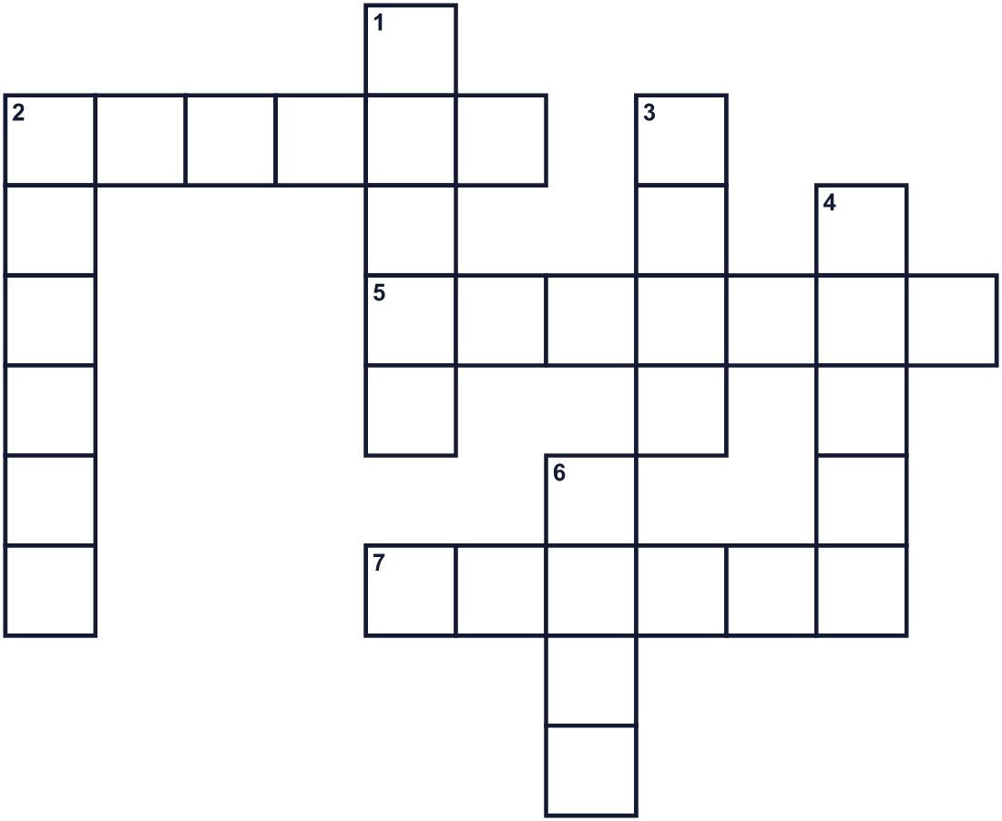
Across →
2. The hottest season of the year. (6)
5. A person who officially belongs to a country. (7)
7. Land that another country controls. (6)
Down ↓
1. A sandy place next to the sea. (5)
2. A big city in Australia. It has a famous opera house. (6)
3. A very big boat. (4)
4. A boat that carries people across water every day. (5)
6. A piece of cloth with colors. Each country has one. (4)

🇦🇺 Australia Day Worksheet
Word Search
かくれた単語をさがそう（→ ↓ ↘ ↗）
Class ______ No. ____ Name ______________________________
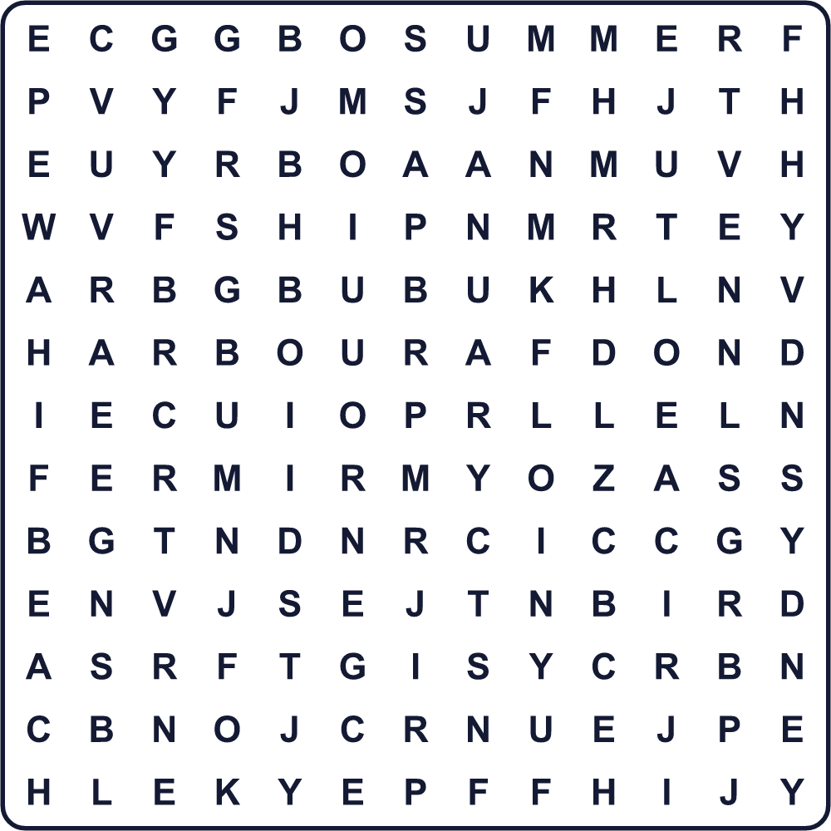
BEACH CITIZEN COLONY FERRY FLAG HARBOUR JANUARY SHIP SUMMER SYDNEY

🇦🇺 Australia Day Worksheet
Maze & Sentences
Class ______ No. ____ Name ______________________________
Help the ferry get across Sydney Harbour! フェリーをシドニー湾の向こう岸まで連れていこう！
正しい道の文字を集めると、ひみつの言葉になるよ。 START ⛴️ → GOAL 🏖️
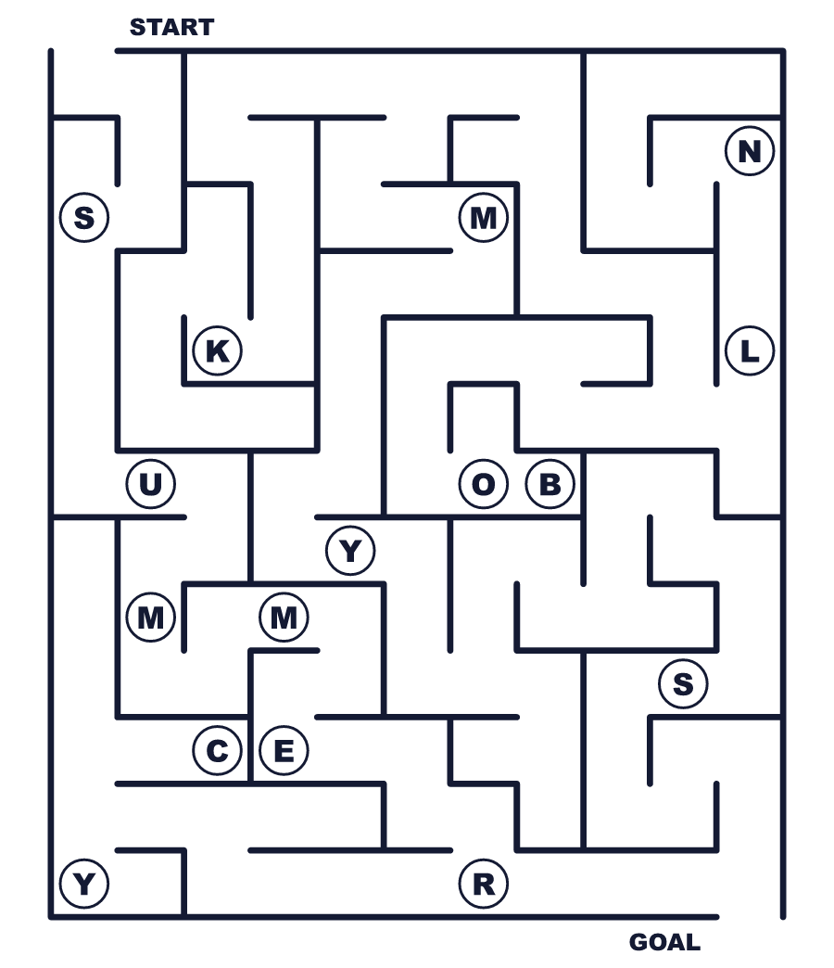
Secret word: ＿ ＿ ＿ ＿ ＿ ＿

🇦🇺 Australia Day Worksheet
Class Activity & Writing
Class ______ No. ____ Name ______________________________
Let's Write! 英語で書いてみよう。
If I were in Australia on January 26, I would ______ because ______.
もし1月26日にオーストラリアにいたら、＿＿＿をします。なぜなら＿＿＿だからです。
______________________________________________________________
______________________________________________________________
I think a national day should be a day when ______.
国の祝日は、＿＿＿な日であるべきだと思います。
______________________________________________________________
______________________________________________________________

🇦🇺 Australia Day Worksheet
Trace & Color
なぞって書こう。絵に色をぬろう。
Class ______ No. ____ Name ______________________________
⛴️ 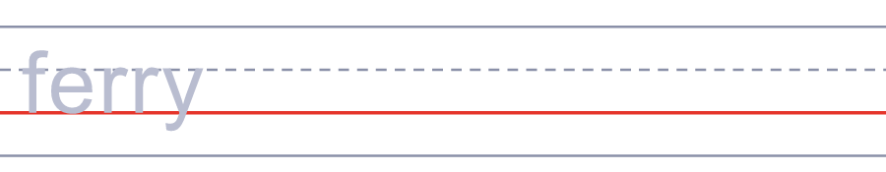

🏖️ 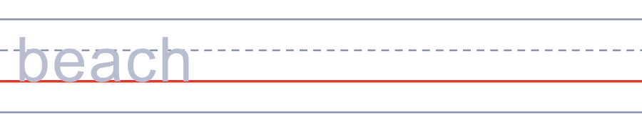
🎆 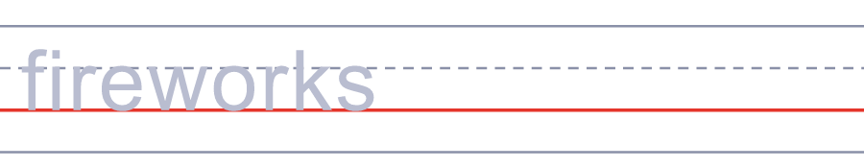
🌅 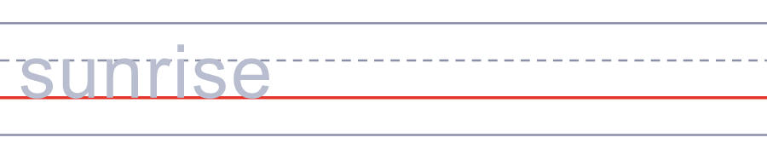
🦘 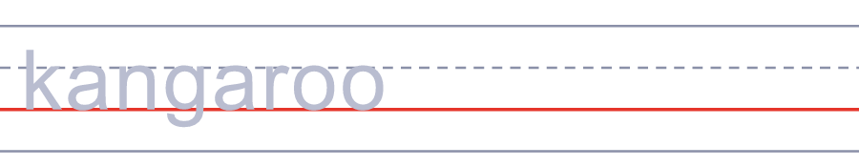

🇦🇺 Australia Day Worksheet
Answer Key 解答
Reading Check: 1.C 2.A 3.D 4.A 5.B
True or False: 1.T 2.F 3.T 4.F
Match: ⛴️=ferry 🏖️=beach 🎆=fireworks 🌅=sunrise 🦘=kangaroo 🌭=sausage
Fill in the blanks: (1)India (2)ceremony (3)Australia (4)citizen (5)beach (6)sausages (7)sea
Maze: SUMMER
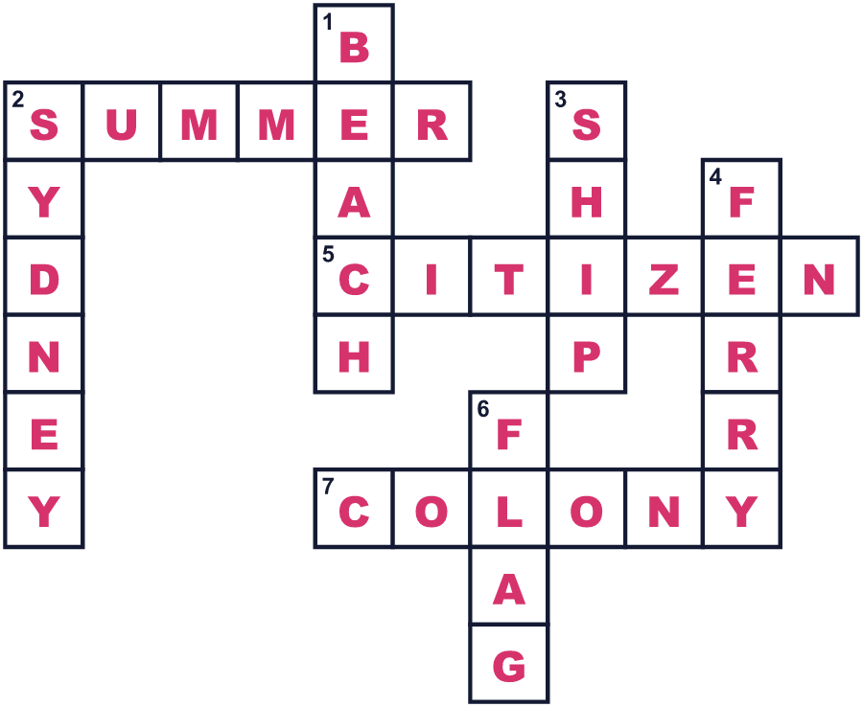
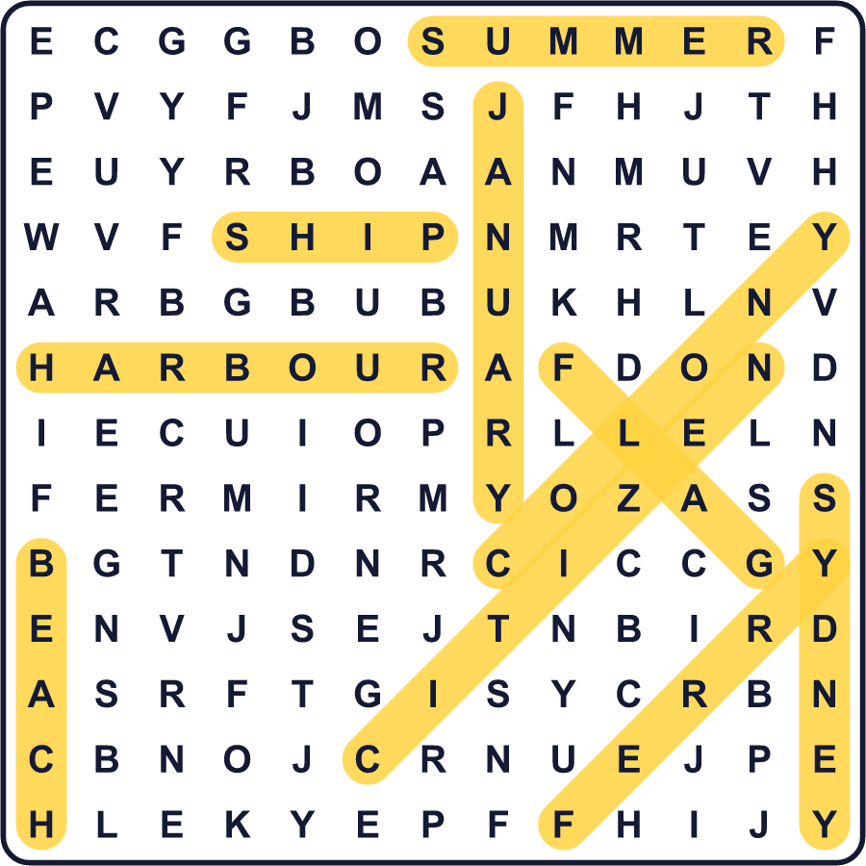
全訳
1 1月26日、シドニー湾の水面はたくさんの船でいっぱいです。大きな通勤フェリーが競走し、人々は岸から声援を送ります。公園や浜辺では、家族がバーベキューでソーセージを焼きます。季節は夏。オーストラリア・デーです。
2 この日付は1788年から来ています。その年の1月26日、イギリスの船11隻がシドニー・コーブに着きました。船には、イギリスからの兵士と囚人が乗っていました。リーダーのアーサー・フィリップは、岸にイギリスの旗をかかげました。そこで新しいイギリスの植民地が始まったのです。
3 でも、この土地にはすでに人が住んでいました。アボリジナルの人々は5万年以上オーストラリアに住み、250をこえる言葉を話していました。1788年のあと、その多くが土地や家族、命を失いました。だから多くのアボリジナルの人々にとって、1月26日は悲しい日なのです。この日を「侵略の日」と呼ぶ人もいれば、「生き延びた日」と呼ぶ人もいます。
4 今、オーストラリアの人々の意見は、この日について一つではありません。日付を変えたい人もいれば、そのままにしたい人もいます。多くの調査ではそのままがよいという人が多いのですが、変えたいという若者も多くいます。シドニーでは今、この日は日の出の静かな時間と、先住民の文化をたたえる儀式から始まります。また、この日には外国から来た何千人もの人がオーストラリア市民になります。その人たちにとって、1月26日は新しい人生の最初の日なのです。

