🤡 April Fools' Day Worksheet
The Day Spaghetti Grew on Trees
Read the story. 英文を読もう。
Class ______ No. ____ Name ______________________________
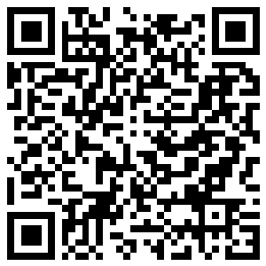
🔊 音声を聞こう（スマホで読みとってね）
1 On April 1, 1957, British families sat down to watch a serious TV news show called Panorama. On the screen, a family in Switzerland was picking long noodles from trees. A calm voice said it was a great year for the spaghetti harvest.
2 Hundreds of viewers called the BBC after the show. Many of them wanted to grow their own spaghetti trees at home. The BBC gave them a funny answer. Put a piece of spaghetti in a can of tomato sauce, and hope for the best! Of course, the whole story was a joke for April Fools' Day.
3 April Fools' Day is a day for jokes and tricks. Nobody knows exactly how it started. A popular story says it began in France when the new year moved to January 1. But a poem from 1561 already talks about tricks on April 1. In the poem, a rich man sends his servant on silly errands all day long.
4 Today, people play tricks in many countries. In France and Italy, children secretly stick paper fish on people's backs. Then they shout, "April fish!" In Britain, many people say the tricks must stop at noon. If you play a trick in the afternoon, you are the fool! In Scotland, the day was once called Hunt the Gowk Day, and a gowk is a cuckoo bird.
5 Big companies join the fun, too. In 1998, Burger King said it had a new burger for left-handed people. Thousands of customers went to its restaurants and asked for one. Then in 2004, Google announced a new email service, Gmail, on April 1. Many people thought it was a joke, but it was real. So be careful on April 1. Even true news can sound like a trick!
Words 単語
trick（いたずら、（人を）だます） / joke（冗談） / fool（ばか者、だまされた人／だます） / harvest（収穫、とり入れ） / viewer（（テレビの）視聴者） / servant（召使い） / errand（お使い、使い走り） / secretly（こっそり） / noon（正午、昼の12時） / cuckoo（カッコウ（鳥）） / customer（（お店の）客） / announce（発表する）

🤡 April Fools' Day Worksheet
Reading Check
Choose the best answer. 正しいものを選ぼう。
Class ______ No. ____ Name ______________________________
1. What is the main topic of the reading?
(A) The history of spaghetti in Italy (B) April Fools' Day and some famous tricks (C) How to grow trees in Switzerland (D) How TV news started in Britain
2. When did the BBC show the spaghetti trees?
(A) In 1561 (B) In 1998 (C) In 1957 (D) In 2004
3. What did the BBC tell the viewers to do?
(A) Buy a tree from Switzerland (B) Watch the show again (C) Write a letter to Panorama (D) Put spaghetti in tomato sauce
4. In the 1561 poem, what does the rich man do?
(A) He sends his servant on silly errands. (B) He moves the new year to January. (C) He sticks paper fish on people's backs. (D) He grows spaghetti in his garden.
5. In paragraph 4, what is a "gowk"?
(A) A kind of fish (B) A cuckoo bird (C) A paper hat (D) A long noodle
6. Which sentence is true about the reading?
(A) Everyone knows how the day started. (B) Gmail was only a joke by Google. (C) In Britain, many say tricks stop at noon. (D) Burger King really sold left-handed burgers.
7. Why did so many people believe the spaghetti story?
(A) It was on a serious news show. (B) It was shown in the year 2004. (C) A cuckoo bird told the story. (D) It was written in an old poem.
8. In the dialogue, why does Chloe say Yuta is the April fool?
(A) He believed the spaghetti story. (B) He played his trick after noon. (C) He came to school very late. (D) He forgot it was April 1.
True or False? T か F に○
1. The oldest clear record of April Fools' Day is a poem from 1561. T / F
2. April Fools' Day is a national holiday in Britain. T / F
3. In France, children stick paper fish on people's backs. T / F
4. The BBC really found spaghetti trees in Switzerland. T / F
5. Gmail started on April 1, 2004, and it was not a joke. T / F
6. An April fool is the person who tells the lie. T / F

🤡 April Fools' Day Worksheet
Word Work
単語のれんしゅう
Class ______ No. ____ Name ______________________________
① Match the pictures and the words. 絵と単語を線でむすぼう。
🐟 | ● | ● | newspaper
🍝 | ● | ● | noon
🌳 | ● | ● | TV
🍔 | ● | ● | spaghetti
🕛 | ● | ● | fish
📺 | ● | ● | burger
😂 | ● | ● | tree
📰 | ● | ● | laugh
② Unscramble the words. 並べかえて単語にしよう。
1. K N R A P (いたずら) → ____________________
2. J E K O (冗談) → ____________________
3. I T K C R (いたずら、だます) → ____________________
4. H R S T V A E (収穫) → ____________________
5. N T R E V A S (召使い) → ____________________
6. O C C O K U (カッコウ) → ____________________
③ Fill in the blanks. 語群から選んで入れよう。
[ year / noodle / laugh / angry / joke / fish / back / careful / plan / fish / banana / summer / first ]
Lucas lives in Paris. On April (1) __________ , he woke up early with a secret (2) __________ . He cut a small (3) __________ out of blue paper. At school, he quietly stuck it on his teacher's (4) __________ . The whole class tried hard not to (5) __________ . At lunch, the teacher turned around and smiled. "Lucas, look at your back," she said. There was a pink paper fish on his back, too! Everybody shouted, "April (6) __________ !" Lucas laughed. "You got me," he said. "Next (7) __________ , I will be more (8) __________ ." It was the best (9) __________ of the day, and nobody was (10) __________ .

🤡 April Fools' Day Worksheet
Crossword Puzzle
ヒントを読んでクロスワードを完成させよう。
Class ______ No. ____ Name ______________________________
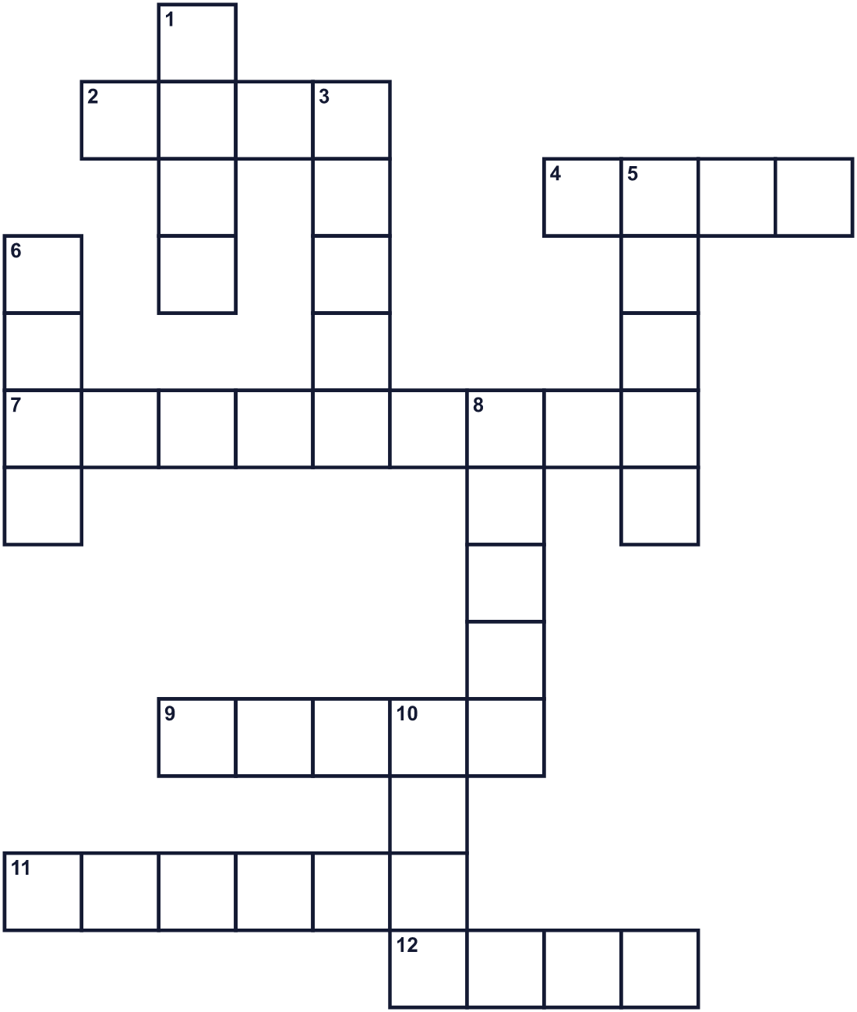
Across →
2. A person who believes a silly trick. (4)
4. Not real. It is the opposite of true. (4)
7. Long Italian noodles. The BBC said they grew on trees. (9)
9. Another word for a trick or a joke. (5)
11. A bird. In Scotland, people called it a gowk. (6)
12. TV shows tell you this every day. It is about things that happen. (4)
Down ↓
1. Something funny you say to make people smile. (4)
3. You do this when something is very funny. (5)
5. The fourth month of the year. (5)
6. In France, a paper one goes on your back. (4)
8. You play this on a friend to fool them. (5)
10. Twelve o'clock in the daytime. (4)

🤡 April Fools' Day Worksheet
Word Search
かくれた単語をさがそう（→ ↓ ↘ ↗）
Class ______ No. ____ Name ______________________________
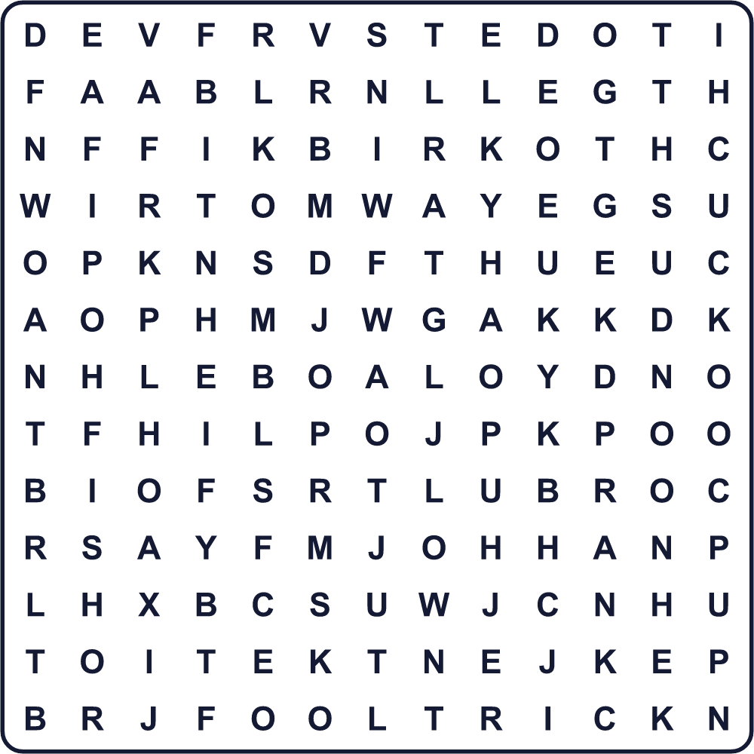
APRIL CUCKOO FAKE FISH FOOL HOAX JOKE LAUGH NOON PRANK SMILE SPAGHETTI TRICK
Secret Code 暗号を解こう
☃=A ⚓=F ✚=I ☀=L ☾=O ☂=P ✈=R
☃ ☂ ✈ ✚ ☀ ⚓ ☾ ☾ ☀
______________________________________________________________

🤡 April Fools' Day Worksheet
Maze & Sentences
Class ______ No. ____ Name ______________________________
Help Lucas stick the fish on his teacher's back! ルーカスを先生のところまで連れていって、背中に魚を貼らせよう！
正しい道の文字を集めると、ひみつの言葉になるよ。 START 🧒 → GOAL 🐟
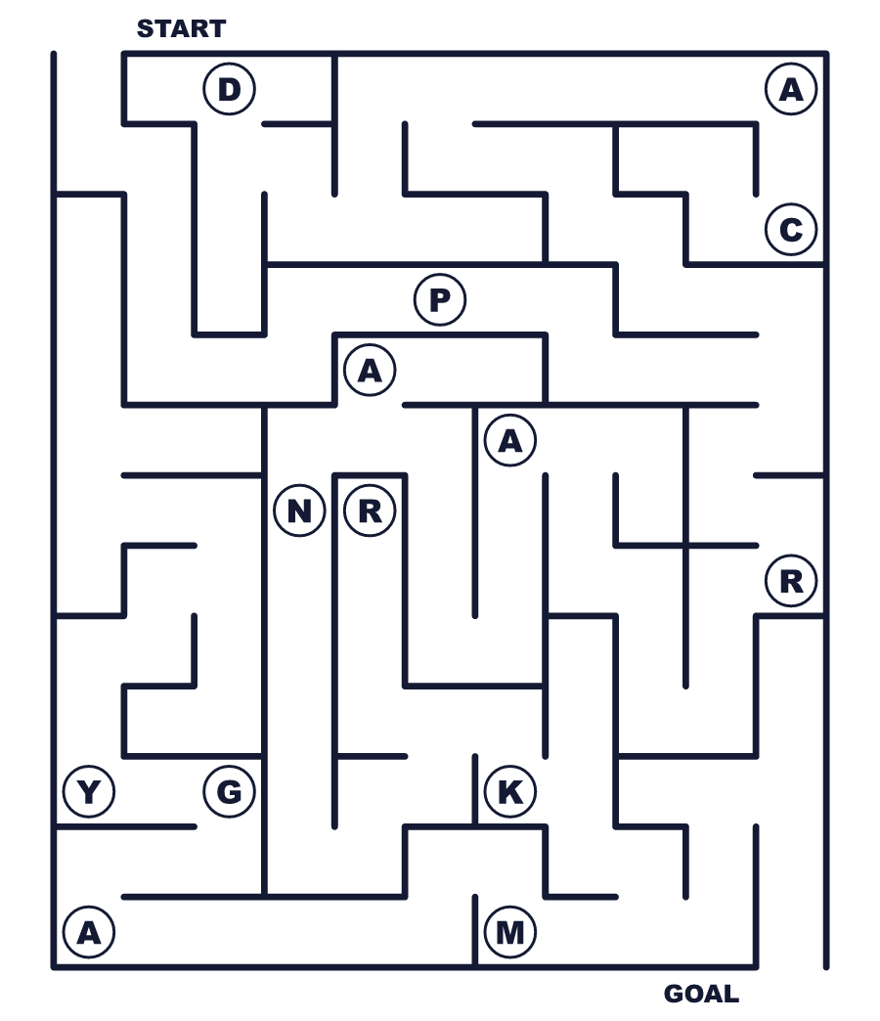
Secret word: ＿ ＿ ＿ ＿ ＿
Put the words in order. 並べかえよう。
1. April / play / on / People / tricks / 1 . (人々は4月1日にいたずらをします。)
______________________________________________________________
2. fish / paper / people's / backs / Children / stick / on . (子どもたちは紙の魚を人の背中に貼ります。)
______________________________________________________________
3. Britain, / must / noon / at / In / tricks / stop . (イギリスでは、いたずらは正午までです。)
______________________________________________________________
4. story / the / Many / spaghetti / viewers / believed . (多くの視聴者がスパゲッティの話を信じました。)
______________________________________________________________
5. Day / April / Gmail / Fools' / on / started . (Gmailはエイプリルフールに始まりました。)
______________________________________________________________

🤡 April Fools' Day Worksheet
Class Activity & Writing
Class ______ No. ____ Name ______________________________
Find Someone Who… クラスで聞いて回ろう！
Find someone who … | Name
… has played a trick on April 1 4月1日にいたずらをしたことがある
… has been fooled on April Fools' Day エイプリルフールにだまされたことがある
… likes spaghetti スパゲッティが好き
… knows a good joke in English 英語のおもしろい冗談を知っている
… can keep a straight face 笑わずにまじめな顔をしていられる
… has seen a funny fake news story おもしろいウソのニュースを見たことがある
… knows the meaning of "prank" prank の意味を知っている
… knows someone who is left-handed 左利きの人を知っている
Let's Write! 英語で書いてみよう。
The best April Fools' joke I know is ______. It is funny because ______.
私が知っている最高のエイプリルフールのウソは______です。おもしろいのは______だからです。
______________________________________________________________
______________________________________________________________
If I had a company, I would announce a fake product called ______. It can ______.
もし会社を持っていたら、______というウソの商品を発表します。それは______ができます。
______________________________________________________________
______________________________________________________________
I think April Fools' jokes are not OK when ______.
エイプリルフールの冗談がよくないのは、______なときだと思います。
______________________________________________________________
______________________________________________________________

🤡 April Fools' Day Worksheet
Trace & Color
なぞって書こう。絵に色をぬろう。
Class ______ No. ____ Name ______________________________
🐟 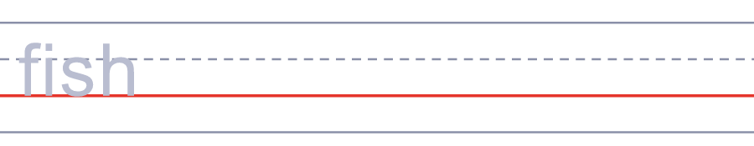

🍝 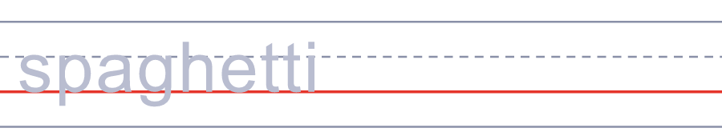
🌳 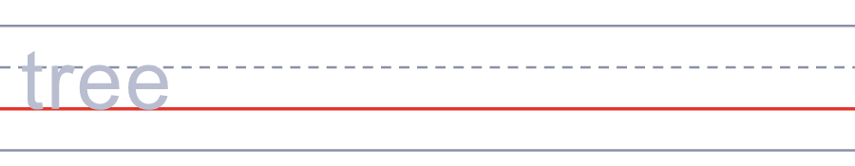
🍔 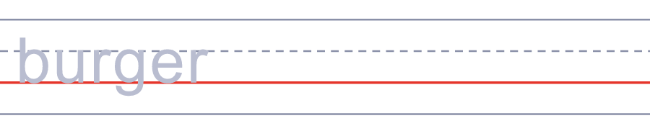
🕛 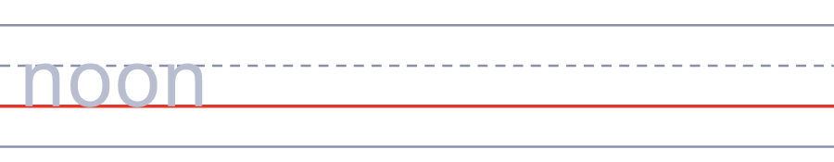
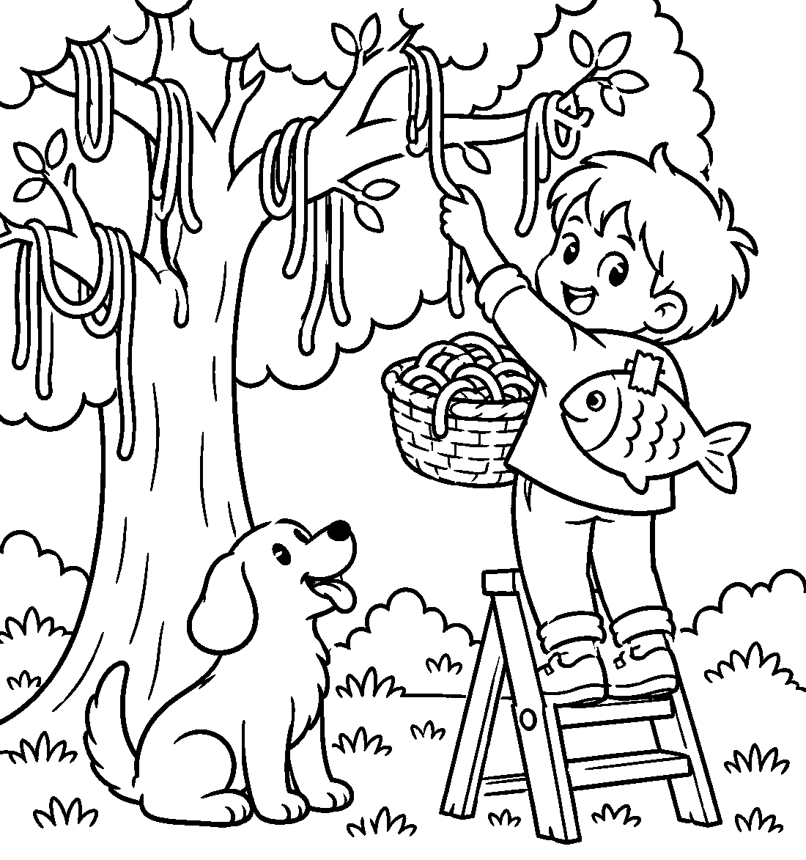

🤡 April Fools' Day Worksheet
Answer Key 解答
Reading Check: 1.B 2.C 3.D 4.A 5.B 6.C 7.A 8.B
True or False: 1.T 2.F 3.T 4.F 5.T 6.F
Match: 🐟=fish 🍝=spaghetti 🌳=tree 🍔=burger 🕛=noon 📺=TV 😂=laugh 📰=newspaper
Unscramble: 1.PRANK 2.JOKE 3.TRICK 4.HARVEST 5.SERVANT 6.CUCKOO
Fill in the blanks: (1)first (2)plan (3)fish (4)back (5)laugh (6)fish (7)year (8)careful (9)joke (10)angry
Sentence order: 1. People play tricks on April 1. 2. Children stick paper fish on people's backs. 3. In Britain, tricks must stop at noon. 4. Many viewers believed the spaghetti story. 5. Gmail started on April Fools' Day.
Secret Code: APRIL FOOL
Maze: PRANK
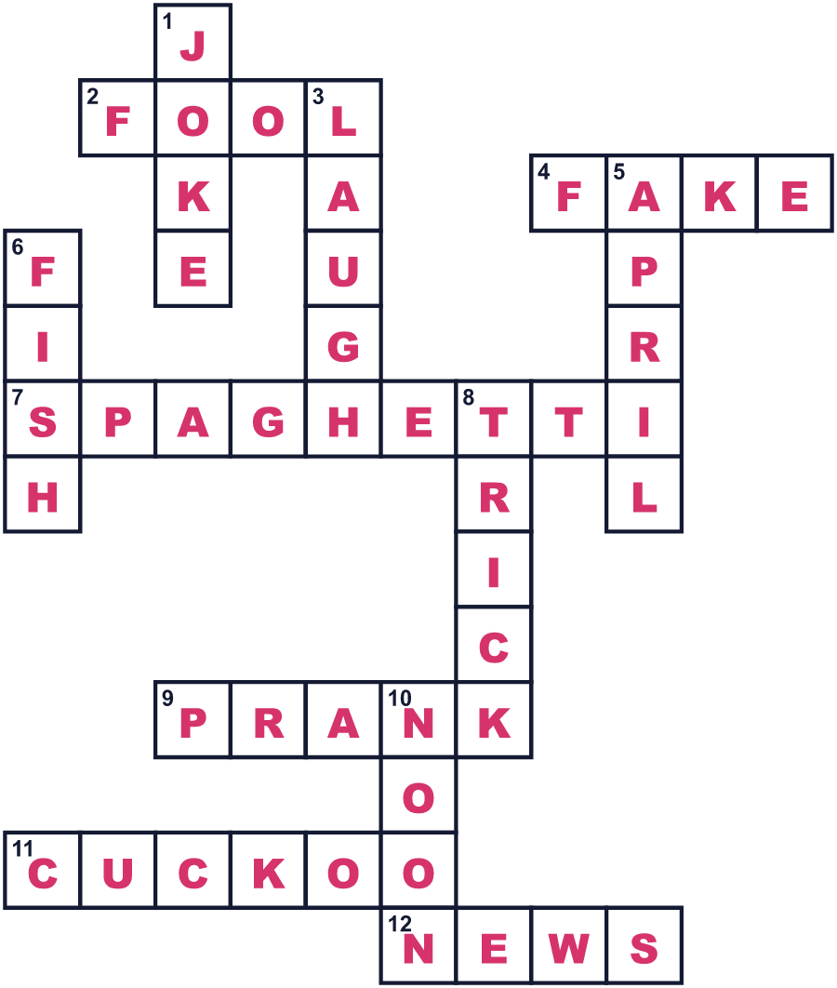
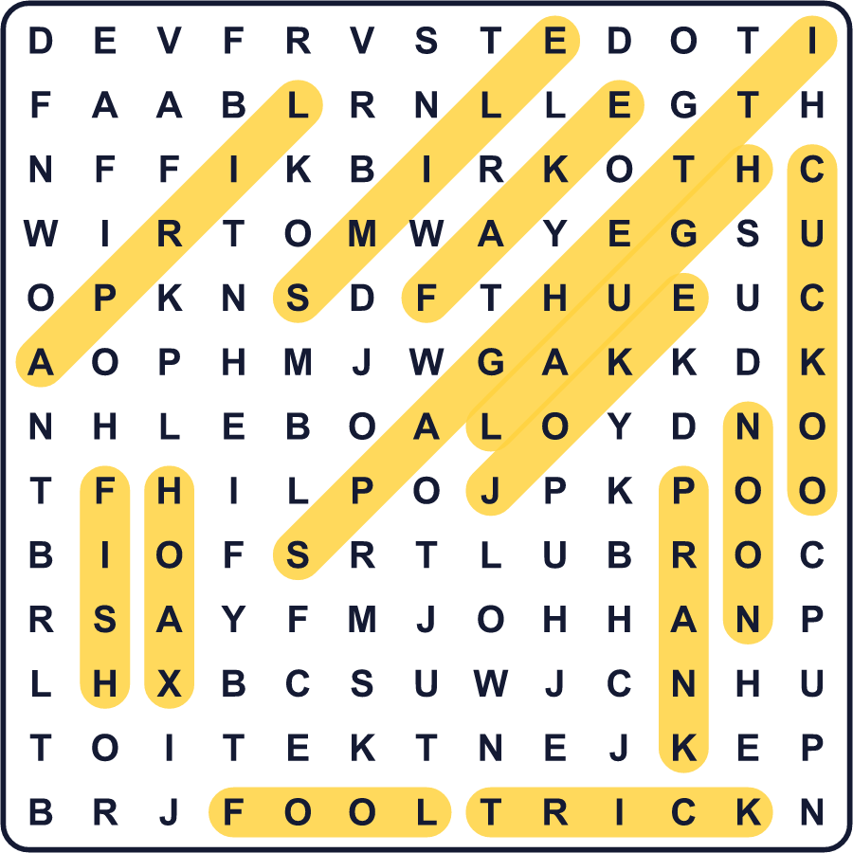
全訳
1 1957年4月1日、イギリスの家族はテレビの前に座り、『パノラマ』というまじめなニュース番組を見ていました。画面の中では、スイスのある家族が木から長いめんを摘み取っていました。落ち着いた声が、今年はスパゲッティの収穫がすばらしい年だと伝えました。
2 放送のあと、何百人もの視聴者がBBCに電話をかけました。その多くは、自分の家でスパゲッティの木を育てたいという人たちでした。BBCはおもしろい答えを返しました。「トマトソースの缶にスパゲッティを1本さして、うまくいくよう祈ってください！」もちろん、この話はまるごとエイプリルフールの冗談でした。
3 エイプリルフールは、冗談やいたずらを楽しむ日です。どうやって始まったのか、正確に知っている人はいません。よく知られた話では、フランスで新年が1月1日に変わったときに始まったとされます。でも、1561年の詩にはすでに4月1日のいたずらが書かれています。その詩では、お金持ちの男が召使いに、一日じゅうばかげたお使いをさせるのです。
4 今では、たくさんの国の人たちがいたずらをします。フランスやイタリアでは、子どもたちが紙の魚をこっそり人の背中に貼ります。そして「4月の魚！」と叫びます。イギリスでは、いたずらは正午までにやめなければならない、と言う人がたくさんいます。午後にいたずらをしたら、あなたのほうがおばかさんになるのです！スコットランドでは、この日はかつて「ゴウク狩りの日」と呼ばれました。ゴウクとはカッコウのことです。
5 大きな会社もこの遊びに加わります。1998年、バーガーキングは左利きの人のための新しいハンバーガーができたと発表しました。何千人ものお客さんが店に行き、それを注文しました。そして2004年、グーグルは4月1日に新しいメールサービス「Gmail」を発表しました。多くの人が冗談だと思いましたが、それは本物でした。だから、4月1日は気をつけて。本当のニュースでさえ、いたずらに聞こえることがあるのですから！

