🌅 Anzac Day Worksheet
Before the Sun Comes Up
Read the story. 英文を読もう。
Class ______ No. ____ Name ______________________________

🔊 音声を聞こう（スマホで読みとってね）
1 It is four in the morning on April 25. The streets are dark and cold, but people are walking quietly to a war memorial. Some are old soldiers, and some are small children with their parents. This is Anzac Day in Australia and New Zealand.
2 ANZAC means the Australian and New Zealand Army Corps. On April 25, 1915, these soldiers landed at Gallipoli in Turkey. Their boats arrived at the wrong beach, and there were steep hills in front of them. That place is now called Anzac Cove. The fighting lasted about eight months. More than 8,700 Australians and 2,700 New Zealanders died. Many Turkish soldiers died, too.
3 Anzac Day is not a happy holiday. It is a day to remember people who died in all wars. At the dawn service, someone reads a short poem, and everyone says together, "Lest we forget." Then someone plays a sad song called the Last Post on a bugle. After that, everyone is silent for one minute. Some people wear a small piece of rosemary. Later in the morning, old soldiers march through the city. Some children wear the medals of their great-grandparents on the right side.
4 In the afternoon, the mood changes a little. Friends meet and share stories about their grandparents. Some play two-up, a game with two coins from the war years. At home, families bake Anzac biscuits with oats and golden syrup. In shops, you must not call them cookies!
Words 単語
memorial（記念碑、記念館） / soldier（兵士） / land（上陸する、着陸する） / remember（思い出す、心に留める） / dawn（夜明け） / silent（静かな、だまっている） / march（行進する） / bugle（（軍隊の）ラッパ）

🌅 Anzac Day Worksheet
Reading Check
Choose the best answer. 正しいものを選ぼう。
Class ______ No. ____ Name ______________________________
1. What is the main idea of the reading?
(A) Anzac Day is a big party to celebrate winning a war. (B) Anzac Day is a day to remember people who died in wars, with old and new traditions. (C) Anzac Day is a holiday for baking cookies in Turkey. (D) Anzac Day is only for old soldiers, not for children.
2. When did the ANZAC soldiers land at Gallipoli?
(A) April 25, 1916 (B) November 1914 (C) January 1916 (D) April 25, 1915
3. In paragraph 3, what does "silent" mean?
(A) singing loudly (B) not talking or making noise (C) walking fast (D) very happy
4. Which is true about Anzac biscuits?
(A) Shops must not call them cookies. (B) They are made with rice and eggs. (C) Soldiers bake them at the dawn service. (D) They come from Turkey.
5. In the dialogue, why does Grace say "Not really"?
(A) Because Haruto cannot get up at four. (B) Because Anzac Day is a quiet day, not a happy one. (C) Because Haruto has no rosemary. (D) Because the service is in the evening.
True or False? T か F に○
1. Anzac Day is on April 25. T / F
2. ANZAC soldiers came from Australia and New Zealand. T / F
3. Anzac Day celebrates a big victory. T / F
4. The dawn service starts in the evening. T / F

🌅 Anzac Day Worksheet
Word Work
単語のれんしゅう
Class ______ No. ____ Name ______________________________
① Match the pictures and the words. 絵と単語を線でむすぼう。
🌅 | ● | ● | coin
🎺 | ● | ● | biscuit
🎖️ | ● | ● | dawn
🪙 | ● | ● | medal
🍪 | ● | ● | bugle
🕊️ | ● | ● | peace
③ Fill in the blanks. 語群から選んで入れよう。
[ bugle / pumpkin / medals / biscuits / dawn / snow / memorial / march / party / silent / forget ]
On Anzac Day, Lily woke up before (1) __________ . She put her great-grandpa's (2) __________ on her right side. At the (3) __________ , everyone said, "Lest we (4) __________ ." Then a man played a sad song on a (5) __________ . Everyone was (6) __________ for one minute. After the (7) __________ , Lily and her mum went home and baked (8) __________ together.

🌅 Anzac Day Worksheet
Crossword Puzzle
ヒントを読んでクロスワードを完成させよう。
Class ______ No. ____ Name ______________________________
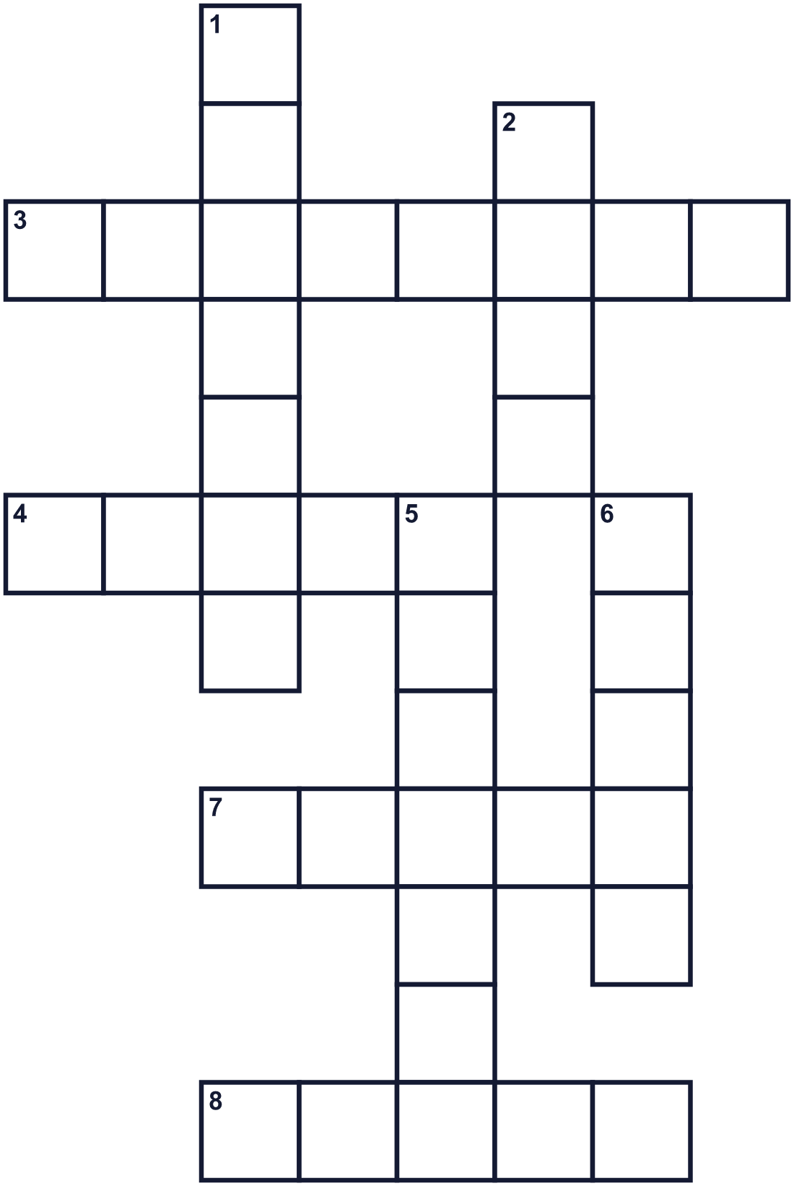
Across →
3. A green herb that people wear to remember. (8)
4. Money made of metal. Two of them are used in two-up. (5)
7. A small metal prize. People wear it on their chest. (5)
8. To walk together in lines, like in a parade. (5)
Down ↓
1. A sweet snack made with oats and golden syrup. (7)
2. The time when the sun comes up. (4)
5. A person in an army. (7)
6. A small horn. Someone plays the Last Post on it. (5)

🌅 Anzac Day Worksheet
Word Search
かくれた単語をさがそう（→ ↓ ↘ ↗）
Class ______ No. ____ Name ______________________________
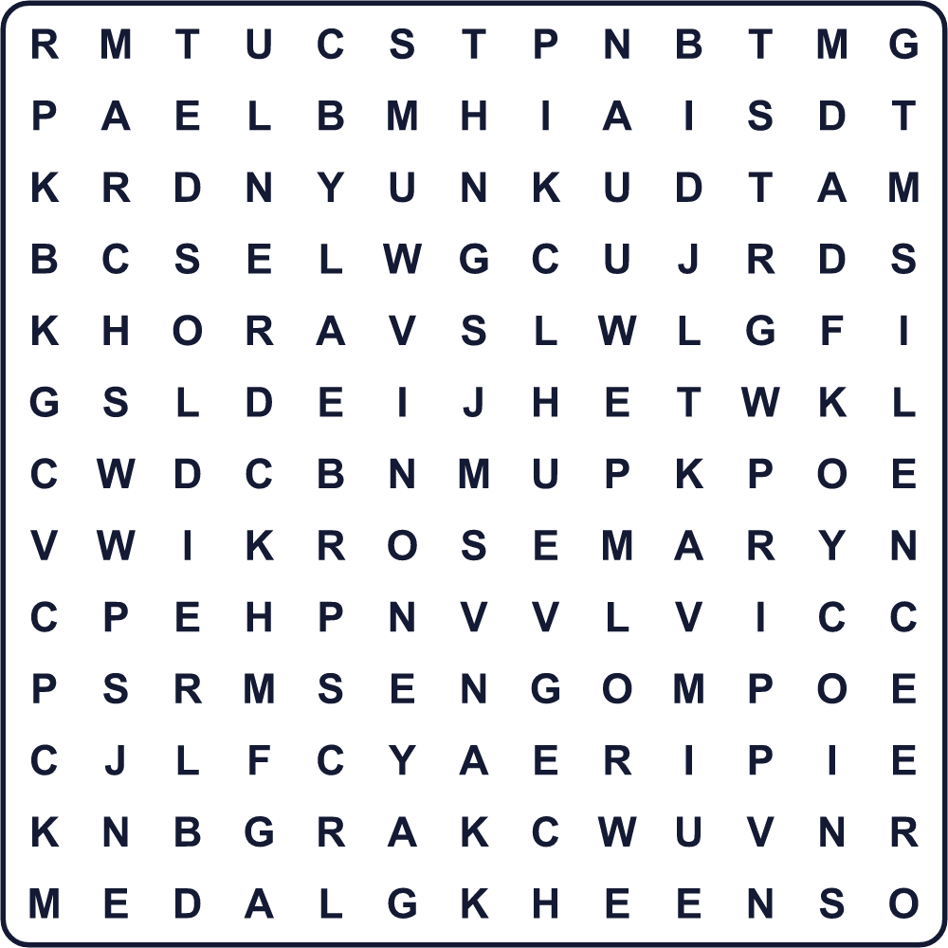
BISCUIT BUGLE COINS DAWN MARCH MEDAL PEACE ROSEMARY SILENCE SOLDIER

🌅 Anzac Day Worksheet
Maze & Sentences
Class ______ No. ____ Name ______________________________
Help Lily get to the dawn service! リリーを夜明けの式典まで連れていこう！
正しい道の文字を集めると、ひみつの言葉になるよ。 START 👧 → GOAL 🌅
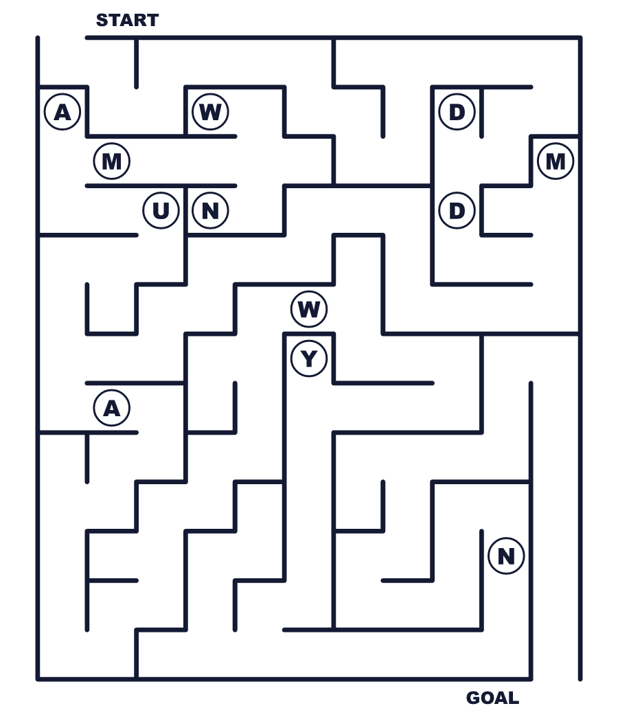
Secret word: ＿ ＿ ＿ ＿

🌅 Anzac Day Worksheet
Class Activity & Writing
Class ______ No. ____ Name ______________________________
Let's Write! 英語で書いてみよう。
I think it is important to remember the past because ______.
過去を忘れないことが大切だと思うのは、______だからです。
______________________________________________________________
______________________________________________________________
If I went to a dawn service, I would ______.
もし夜明けの式典に行ったら、私は______するだろう。
______________________________________________________________
______________________________________________________________

🌅 Anzac Day Worksheet
Trace & Color
なぞって書こう。絵に色をぬろう。
Class ______ No. ____ Name ______________________________
🌅 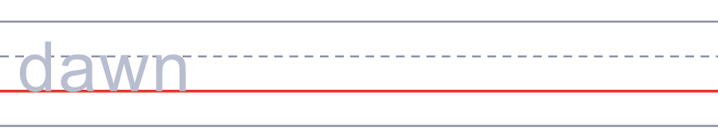

🎺 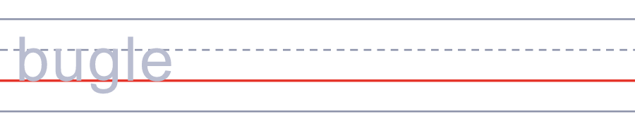
🎖️ 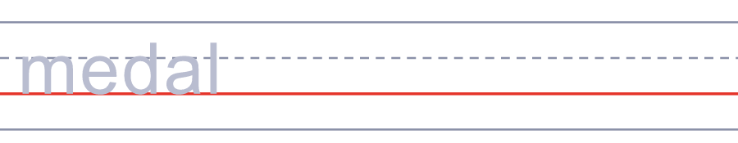
🪙 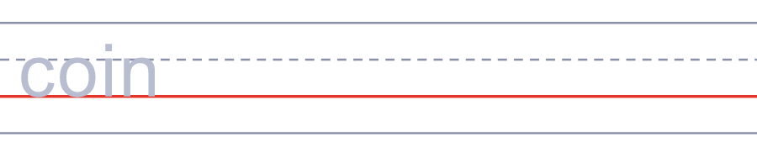
🍪 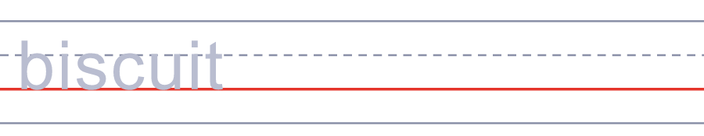

🌅 Anzac Day Worksheet
Answer Key 解答
Reading Check: 1.B 2.D 3.B 4.A 5.B
True or False: 1.T 2.T 3.F 4.F
Match: 🌅=dawn 🎺=bugle 🎖️=medal 🪙=coin 🍪=biscuit 🕊️=peace
Fill in the blanks: (1)dawn (2)medals (3)memorial (4)forget (5)bugle (6)silent (7)march (8)biscuits
Maze: DAWN
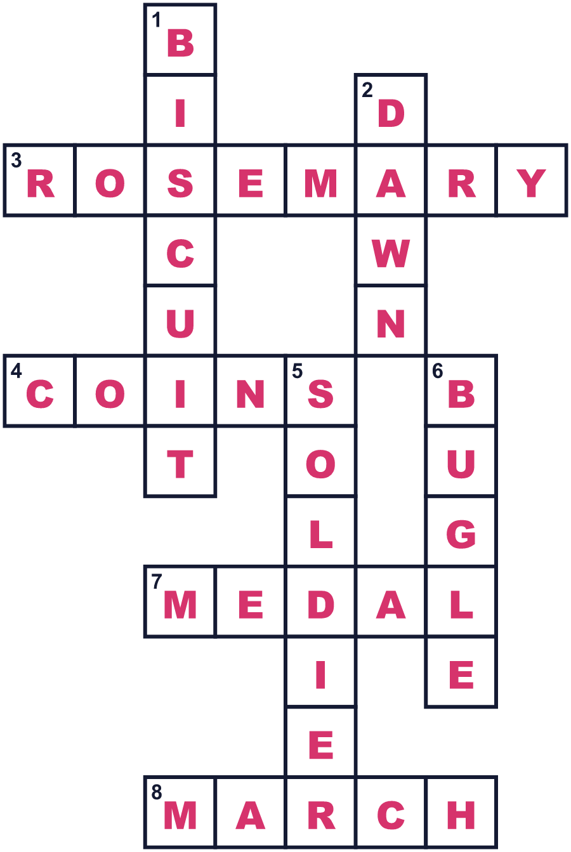
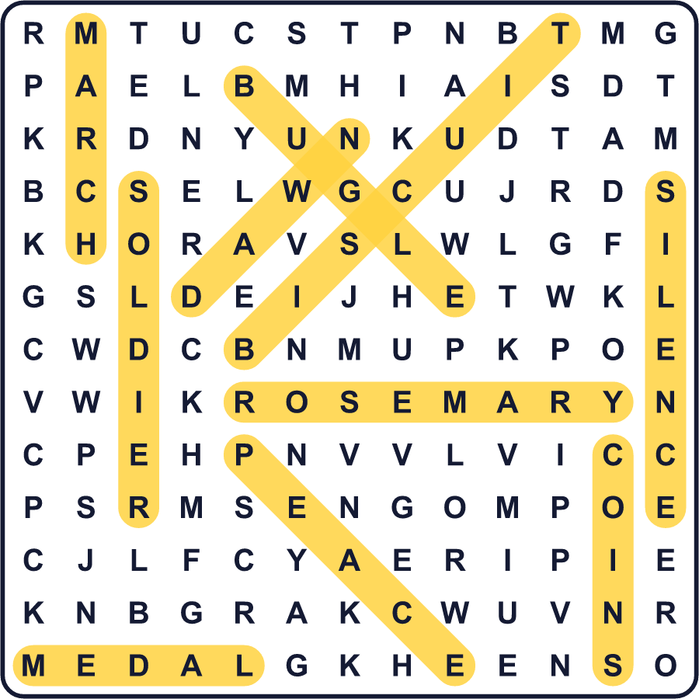
全訳
1 4月25日、朝の4時です。通りは暗くて寒いのに、人々が静かに戦争記念碑へと歩いていきます。年老いた元兵士もいれば、親と一緒の小さな子どももいます。これがオーストラリアとニュージーランドのアンザック・デーです。
2 ANZACは、オーストラリア・ニュージーランド軍団という意味です。1915年4月25日、この兵士たちはトルコのガリポリに上陸しました。ボートはまちがった浜に着き、目の前には急な丘がありました。その場所は、今ではアンザック湾と呼ばれています。戦いは約8か月続きました。8,700人以上のオーストラリア兵と、2,700人のニュージーランド兵が亡くなりました。多くのトルコの兵士も亡くなりました。
3 アンザック・デーは楽しい祝日ではありません。すべての戦争で亡くなった人々を思い出す日です。夜明けの式典では、短い詩が読まれ、みんなで「忘れることのないように」と唱えます。続いて、ラスト・ポストという悲しい曲がラッパで吹かれます。そのあと、全員が1分間黙とうします。ローズマリーの小枝を胸につける人もいます。朝のうちに、元兵士たちが町を行進します。曾祖父母の勲章を右胸につけて歩く子どももいます。
4 午後になると、雰囲気が少し変わります。友だち同士で集まり、祖父母の話をします。戦争のころから続く、2枚の硬貨を使う遊び「ツーアップ」をする人もいます。家では、家族がオートミールとゴールデンシロップでアンザックビスケットを焼きます。お店では、これを「クッキー」と呼んではいけないんです！

