🌺 Asian American and Pacific Islander Heritage Month Worksheet
Two Stories from May
Read the story. 英文を読もう。
Class ______ No. ____ Name ______________________________

🔊 音声を聞こう（スマホで読みとってね）
1 In 1841, a 14-year-old Japanese fisherman named Manjiro was lost at sea. An American whaling ship found him and four friends on a small island. Manjiro chose to sail on with the kind captain. In May 1843, he arrived in Massachusetts. Many people call him the first Japanese immigrant to the United States. His arrival is one reason that May is Asian American and Pacific Islander Heritage Month.
2 The second reason is a railroad. On May 10, 1869, workers finished the first railroad across the country. Thousands of Chinese workers built the western part. They cut tunnels through snowy mountains, often by hand. But in the famous photo of that day, you can hardly see them. In 2019, their descendants came to the same place and took a new photo.
3 The idea for the month came from a woman named Jeanie Jew. Her great-grandfather helped build that railroad. In 1978, President Jimmy Carter signed a law for a special week in May. In 1990, the week became a month. Then, in 1992, Congress made every May a heritage month.
4 Today, more than 25 million people in the United States have Asian roots. Their families came from China, India, the Philippines, Korea, Japan, and many other places. In May, people enjoy festivals, music, and food like Spam musubi from Hawaii. They also learn hard lessons from history. During World War Two, about 120,000 Japanese Americans were sent to camps. In 1988, the government said sorry and paid the survivors. The month helps people remember all of these stories.
Words 単語
heritage（受けつがれてきた文化、遺産） / immigrant（（外国から来た）移民） / whaling ship（捕鯨船） / railroad（鉄道） / tunnel（トンネル） / descendant（子孫） / roots（ルーツ、家族の出身） / camp（収容所、キャンプ）

🌺 Asian American and Pacific Islander Heritage Month Worksheet
Reading Check
Choose the best answer. 正しいものを選ぼう。
Class ______ No. ____ Name ______________________________
1. What is the reading mainly about?
(A) How to make Spam musubi (B) The life of President Carter (C) Why May is a heritage month and what people remember (D) How to build a railroad
2. When was the first railroad across the country finished?
(A) May 7, 1843 (B) May 10, 1869 (C) In 1978 (D) In 1992
3. Who had the idea for the month?
(A) Manjiro (B) Jimmy Carter (C) A ship captain (D) Jeanie Jew
4. In paragraph 4, what does "have Asian roots" mean?
(A) Their families came from Asia (B) They grow plants from Asia (C) They visit Asia every year (D) They work for Asian companies
5. In the dialogue, what does Emily say about her family?
(A) They came to Hawaii last year (B) They all speak Japanese well (C) Her great-grandpa's parents worked on a sugar farm (D) They work in the school library
True or False? T か F に○
1. AAPI Heritage Month is in May. T / F
2. May was chosen because of a big holiday in China. T / F
3. Chinese workers helped build the first railroad across the United States. T / F
4. AAPI Heritage Month is a day off for all schools. T / F

🌺 Asian American and Pacific Islander Heritage Month Worksheet
Word Work
単語のれんしゅう
Class ______ No. ____ Name ______________________________
① Match the pictures and the words. 絵と単語を線でむすぼう。
🚂 | ● | ● | ship
🚢 | ● | ● | shave ice
🍙 | ● | ● | flower
🌺 | ● | ● | train
🏝️ | ● | ● | island
🍧 | ● | ● | rice ball
③ Fill in the blanks. 語群から選んで入れよう。
[ Hawaii / Month / history / family / musubi / snow / January / ship / farms ]
Kai lives in (1) __________ . In May, his class learns about AAPI Heritage (2) __________ . His teacher shows a picture of an old (3) __________ . "Japanese workers came here in 1868," she says. "They worked on sugar (4) __________ ." After school, Kai eats Spam (5) __________ with his grandma. She tells him about her (6) __________ . "Our story is part of American (7) __________ ," she says.

🌺 Asian American and Pacific Islander Heritage Month Worksheet
Crossword Puzzle
ヒントを読んでクロスワードを完成させよう。
Class ______ No. ____ Name ______________________________

Across →
1. Traditions and history that families pass down. (8)
3. Land with water all around it. (6)
6. Trains run on this. The first one across the country was finished in 1869. (8)
7. A big boat that sails on the sea. (4)
8. The fifth month of the year. (3)
Down ↓
2. A long hole through a mountain for trains or cars. (6)
4. Your parents, brothers, sisters, and grandparents. (6)
5. These Pacific islands became a US state in 1959. (6)

🌺 Asian American and Pacific Islander Heritage Month Worksheet
Word Search
かくれた単語をさがそう（→ ↓ ↘ ↗）
Class ______ No. ____ Name ______________________________

CAMP FAMILY HAWAII HERITAGE ISLAND MAY MUSUBI RAILROAD SHIP TUNNEL

🌺 Asian American and Pacific Islander Heritage Month Worksheet
Maze & Sentences
Class ______ No. ____ Name ______________________________
Help Kai get to the Spam musubi! カイをスパムむすびのところまで連れていこう！
正しい道の文字を集めると、ひみつの言葉になるよ。 START 🧒 → GOAL 🍙
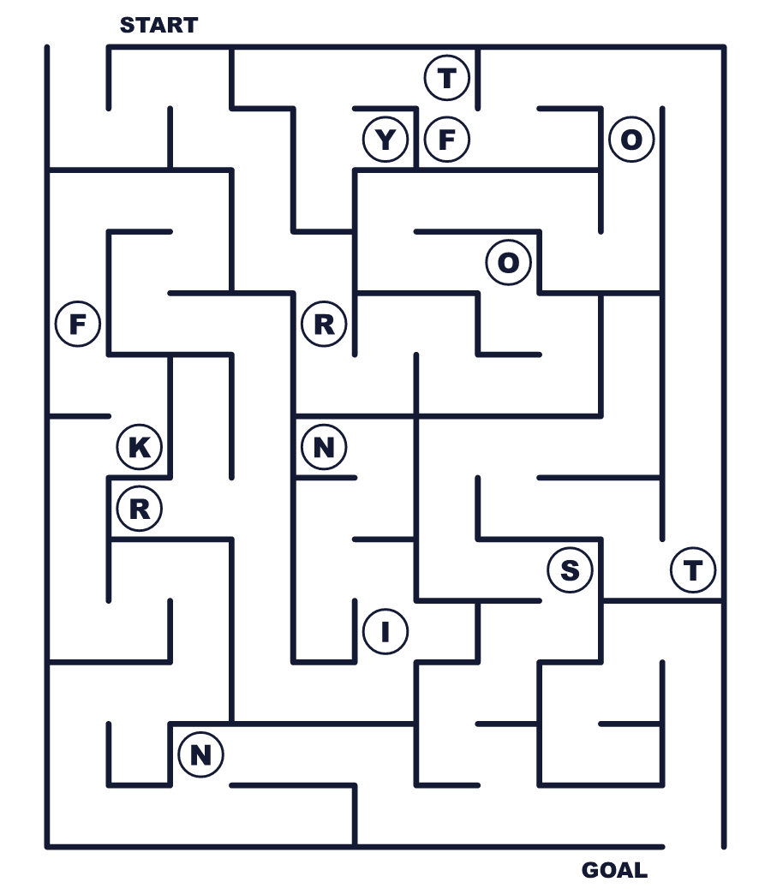
Secret word: ＿ ＿ ＿ ＿ ＿

🌺 Asian American and Pacific Islander Heritage Month Worksheet
Class Activity & Writing
Class ______ No. ____ Name ______________________________
Let's Write! 英語で書いてみよう。
My family's heritage includes ______.
私の家族が受けついできた文化には＿＿＿があります。
______________________________________________________________
______________________________________________________________
If I could ask Manjiro one question, I would ask ______.
万次郎に1つ質問できるなら、＿＿＿と聞きたいです。
______________________________________________________________
______________________________________________________________

🌺 Asian American and Pacific Islander Heritage Month Worksheet
Trace & Color
なぞって書こう。絵に色をぬろう。
Class ______ No. ____ Name ______________________________
🚂 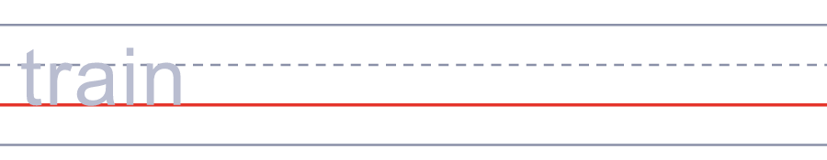

🚢 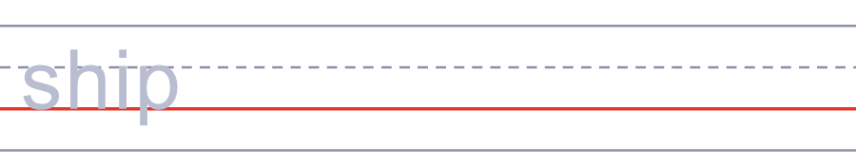
🍙 
🌺 
🏝️ 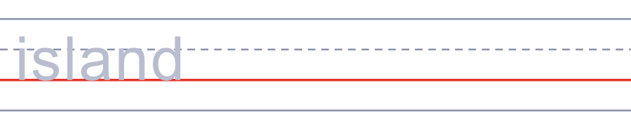

🌺 Asian American and Pacific Islander Heritage Month Worksheet
Answer Key 解答
Reading Check: 1.C 2.B 3.D 4.A 5.C
True or False: 1.T 2.F 3.T 4.F
Match: 🚂=train 🚢=ship 🍙=rice ball 🌺=flower 🏝️=island 🍧=shave ice
Fill in the blanks: (1)Hawaii (2)Month (3)ship (4)farms (5)musubi (6)family (7)history
Maze: ROOTS
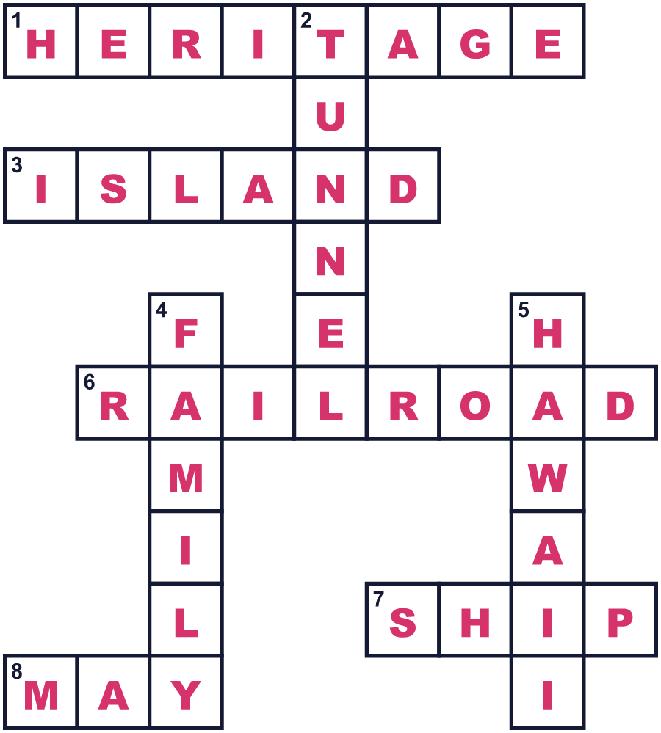

全訳
1 1841年、万次郎という14歳の日本の漁師が海で遭難しました。アメリカの捕鯨船が、小さな島にいた彼と4人の仲間を見つけました。万次郎は、親切な船長といっしょに航海を続けることを選びました。1843年5月、彼はマサチューセッツに着きました。多くの人が、彼をアメリカに来た最初の日本人移民と呼んでいます。彼の到着は、5月がアジア太平洋系文化継承月間になっている理由の一つです。
2 2つ目の理由は鉄道です。1869年5月10日、労働者たちが国を横断する最初の鉄道を完成させました。何千人もの中国系の労働者が、その西側を造りました。彼らは雪の山に、多くは手作業でトンネルを掘りました。でも、その日の有名な写真には、彼らの姿はほとんど見えません。2019年、彼らの子孫が同じ場所に集まり、新しい写真を撮りました。
3 この月間のアイデアは、ジーニー・ジューという女性から生まれました。彼女の曾祖父は、あの鉄道の建設を手伝った人でした。1978年、ジミー・カーター大統領が、5月の特別な週のための法律に署名しました。1990年、その週は月になりました。そして1992年、議会が毎年の5月を文化継承月間にしました。
4 今、アメリカでは2,500万人以上がアジアにルーツを持っています。その家族は、中国、インド、フィリピン、韓国、日本、そして多くの国や地域から来ました。5月には、人々はお祭りや音楽、ハワイのスパムむすびのような食べ物を楽しみます。歴史からつらい教訓も学びます。第二次世界大戦中、約12万人の日系アメリカ人が収容所に送られました。1988年、政府は謝罪し、生き残った人たちにお金を支払いました。この月間は、こうした物語のすべてを人々が思い出す助けになっています。

